Summary of September 2026 KY K-12 Education
Technology Leaders’ Virtual Meeting

In case you missed it or want a refresher, the following is what we talked about during the September 15, 2026, EdTech leaders’ virtual meeting. A copy of the video and audio can be found at:
https://mediaportal.education.ky.gov/technology/2026/09/edtech-webcast-september-15-2026/.

Public viewing of the archived webcasts and written summaries are also available on the KDE Media Portal at: https://mediaportal.education.ky.gov/technology/district-technology-leadership-webcast/ . Numbers in RED indicate the timestamp for that portion of the discussion so it can be easily located on the full digital recording.

This was a joint meeting with our OET staff and all the districts joining via Microsoft Teams and/or YouTube. We will continue to make these available from our KDE media portal so that you can watch the archived discussion and share with the appropriate people in your district. Poll questions were posed throughout the meeting and district EdTech leaders were asked to respond as it assists us in planning and getting a feel for how to best move forward. Your voice and your feedback are important and extremely helpful to us. Please remember that in addition to these webcasts being available on the KDE Media Portal, each month’s webcast is accompanied by these written summaries. We encourage you to share the link and all or any portion of these summary notes with staff throughout your district who may find the information beneficial to them in their position.

(00:54) School Year 2026-2027 Kentucky Education Technology System (KETS) Operational Budget/KETS Offers of Assistance Update: The operational budget for SY 2026-2027 was approved by the KY Board of Education (KBE) on 6 August during their regular board meeting and then by the School Facility Construction Committee (SFCC) on 2 September. David commented that we are 35-0 in receiving approval for disbursement of these funds and also 35-0 in districts being able to receive the approved offers.

Mike explained that SFCC approval is the final state approval for KETS offers, after which districts will receive October notifications for an initial offer of $13/ADA and must respond or provide matching evidence within the required timeframe.
- Offer Notification: Mike said KDE will work with the School Facilities Construction Commission to notify districts of their first offers during October. The planned amount for this year is $25/ADA with the first offer being $13/ADA.
- District Response: Districts are expected to have approximately 30 days to indicate whether they will match the offer or escrow the funds. For districts choosing to match, the School Facilities Construction Commission will require evidence through its established process before funds are transferred.
- Eligibility Reports: Mike reminded districts that the Digital Readiness Report and the Technology Activity Report (TAR) are required for eligibility and were due on September 15. Districts that have not submitted them may experience a delay in receiving their first KETS offer, and KETS Engineers will be reaching out to those districts who still need to submit one or both reports. Additionally, the Technology Plan and Top 5 Feedback are required for eligibility.

(4:33) Quality Screen Use and AI in KY K-12: David outlined KDE’s effort to preserve district, school, principal, and teacher discretion over educational technology use while distinguishing purposeful education technology from recreational / entertainment-based smartphone use, and asked district leaders to prepare superintendents, chief academic officers, boards, and legislators for upcoming policy discussions. These points were also discussed with legislators during the September 1 meeting of the Interim Joint Committee on Education (IJCE) and we recommend listening to and sharing this presentation with your superintendents, chief academic officers, boards, and legislators for upcoming policy discussions. The presentation begins right after the 54:00 mark.

The main teaching point is for the district to retain the decision and choice of when and how much screen time to use for individual courses/classrooms. Secondly, we want to make sure this doesn’t result in funding cuts to existing services and staffing. This is why it is so important to educate your superintendent and district leadership on this topic. David and Marty spent time reviewing the five key messages and associated resources. These are included in their entirety below the summarization; however, there were comments made for each message/resource. Note: Following along using the audio of today’s webcast is recommended as you are working to build your talking points to advocate for this topic in your schools/districts and local legislators.
- Local Decision-Making: David stated that technology-use decisions should remain with districts, schools, principals, and teachers rather than being governed by a legislated grade-level screen-time limit or “shot clock.” Districts may independently reduce technology use when local evidence indicates that a different balance better supports learning, but KDE opposes statewide mandated number of minutes.
- Educational Value: David presented five core messages: Kentucky already has substantial technology infrastructure and practices in place; technology is a means to improve student learning rather than the goal itself; students need progressively developed technology skills before graduation; technology use must be balanced with non-digital instruction; and districts should ensure that technology investments deliver value for students, teachers, and staff. The U.S. Department of Education guidance similarly emphasizes educational value and learning outcomes over arbitrary screen-time limits.
- Technology And Funding: David explained that technology-related spending represents roughly 3–4% of K–12 funding nationally and approximately 3.72% of Kentucky’s available education funding. They warned that policy changes framed around screen use could result in reductions to KETS or SEEK-related funding, affecting technology products, services, and staffing, and asked district leaders to communicate the operational and instructional value of these investments.
- Purposeful Tool Evaluation: David asked districts to evaluate technology-enabled tools regularly with their superintendents and chief academic officers. They cited a statewide professional-development tool that was discontinued after data showed only about 3% of districts were using it, illustrating that KDE supports discontinuing tools that do not produce sufficient value rather than treating all technology use as inherently beneficial.
- Technology Services Scope: David explained that district technology teams support far more than student computers, including Munis financial systems, Infinite Campus, internet-based phone systems, school security and video systems, cybersecurity, heating and air-conditioning controls, instructional applications, online assessment, non-traditional instruction, assistive technology, and differentiated learning. These responsibilities help explain technology staffing levels and the broader impact of funding decisions.
- Student Device Distinctions: David distinguished school-owned computers from personally owned smartphones. School-managed devices are subject to filtering and monitoring both on and off campus under district controls and federal E-rate-related requirements, while smartphones using personal internet service operate differently. KDE supports reducing smartphone distractions in schools but does not equate that issue with purposeful use of managed educational devices.
- AI Preparation: David described artificial intelligence as a skill set students will need after graduation and said instruction should build those skills progressively through elementary, middle, and high school. They compared the policy discussion with earlier concerns about calculators, spreadsheets, word processors, and search engines, emphasizing responsible use, foundational knowledge, and measures to reduce cheating without eliminating educational access.
- Outreach Actions: David asked district leaders to begin conversations locally rather than waiting for legislation, involving superintendents, chief academic officers, teachers, boards, and legislators. KDE is considering traveling to educational cooperatives to reinforce the message. District leaders were encouraged to use these five key messages and resources to help KDE educate, advocate, and balance discussions on the screen use time issue.

Five Key Messages:
- Kentucky has been a national leader and pioneer in K-12 educational technology since the creation of KETS in 1992, but we are always trying to get better. For example, Kentucky became the first state to provide Internet access to every Kentucky public school district in 1995 and is currently the national leader in K-12 cloud-based computing.
- Technology is not the goal. Student learning is the goal. Technology-enabled services are tools that can add value and support district educational plans, academic standards, and student success.
- We want students to be well prepared for their next steps in life. Kentucky students should graduate with the technology and nontechnology skills necessary for postsecondary education, military service, and the workforce.
- We support a balanced and healthy use of technology, including appropriate screen use, digital citizenship, Internet safety, and responsible AI integration. We recommend continuing to allow teachers and schools to determine whether, when, how, and how much technology is used or not used in their classrooms and schools.
- We want to ensure technology investments are maximizing value for students, teachers, staff, and leaders. Kentucky's education technology investments support both educational outcomes and operational efficiency, allowing districts to share services, reduce duplication, and focus more resources on students while supporting an efficient system of common schools.
Eighteen resources that support these Five Key Messages:
- KY K-12 Educational Plan. It is important to first have a strong educational plan in the district and then use technology-enabled services to support the goals in that plan when appropriate. Every district is required to have a district technology plan (2026-2027 Technology Plan Template (1).pdf). Within those district technology plans is how the district is supporting the overall educational priorities of their district. 2024 - 2030 KETS Master Plan - Kentucky Department of Education.
- KY Auditor of Public Accounts (APA) report on KY Education Technology Services in August 2025. The Kentucky Education Technology System (KETS) was identified as a Top 4 noteworthy accomplishment: APA Audit KETS Snippet. Through statewide technology services, Kentucky districts avoid significant local infrastructure costs while benefiting from shared statewide platforms that support instruction, financial management, student information systems, cybersecurity, co​mmunications, and digital learning. KETS is not primarily about student devices. It is the infrastructure that supports teaching, learning, school finance, student records, cybersecurity, communications, testing, safety systems, and operational efficiency across Kentucky schools.
- The KY K-12 student technology leadership program (STLP). Kentucky's Student Technology Leadership Program (STLP) is the best student technology leadership program in the nation. The program serves nearly 60,000 Kentucky students and is an outstanding example of project-based learning through which students apply academic standards using technology to solve real-world problems.
• This short STLP segment was featured on Kentucky Tonight on 24 August 2026:https://ket.org/program/kentucky-edition/stlp-2024/
• More about how STLP helps with academic and real-life project-based learning can be found at: STLP – Design. Make. Connect. LEARN!
- On 20 August 2026, the U.S. Department of Education released its perspective on the topics of K-12 screen use and AI: https://tinyurl.com/nationalguidance. This national guidance is consistent with our KY K-12 EdTech perspective on both topics.
- KY K-12 Computer Use Guide. This is a link to the document KDE recently released publicly on August 18, 2026:​ screen-use-full.pdf - Google Drive
- KY K-12 technology-enabled services: mission-critical services beyond the student computer. As the son of a Kentucky K-12 teacher, I joined KDE in 1992 to help launch KETS following my education at the United States Military Academy at West Point and my service in the U.S. Army after Operation Desert Storm. I wanted to be part of an initiative that would improve Kentucky operationally, educationally, and economically. Today, as the father of a Kentucky K-12 teacher, that mission remains deeply personal to me. Kentucky's Constitution and laws call for an efficient system of common schools that applies to curriculum, administration, instructional content, and facilities. The KETS timeline demonstrates how technology-enabled services have supported that mission since 1992. Kentucky became the first state to provide Internet access to every public school district and is now the national leader in statewide K-12 cloud-based services. These shared services have saved hundreds of millions of dollars and improved operational efficiency throughout Kentucky schools.
- Mission-critical services supported through this infrastructure include:
- Munis financial management
- Infinite Campus student information management
- Phone systems
- Email systems
- Video systems
- School security systems
- Cybersecurity systems
- HVAC systems
- Instructional applications
- Simulations
- Online testing
- Project-based learning​
These services are supported by the KDE-provided Internet service delivered to every Kentucky district, school, and classroom through Zayo Education Internet Services.
- This is a recent Infographic on KY K-12 Edtech was provided to the KY Board of Education on 9 August 2026: 2024 - 2030 KETS Master Plan - Appendix B - Kentucky Department of Education
- Kentucky Education Technology System (KETS) timeline of historic achievements in KY K-12 EdTech since the birth of KETS in 1992 through today was provided to the KY Board of Education on 9 August 2026. KETS Timeline_2026. KETS and KY K-12 have been a pioneer and national leader in most aspects of education technology since 1992, but are always trying to be better.
- KY K-12 academic standards for technology. Kentucky has long recognized technology competency as an important workforce and postsecondary readiness skill. A 2006 Kentucky law requires students to demonstrate technology competency upon graduation. The updated Kentucky Academic Standards for Technology were presented to the Local Superintendents Advisory Council (LSAC) and the Kentucky Board of Education (KBE) during summer 2026. Both organizations supported the updated standards and continued support for the technology competency requirement: ​
• ​https://portal.ksba.org/public/Meeting/Attachments/DisplayAttachment.aspx?AttachmentID=974324
We’ll also be updating the KY K-12 academic standards for computer science and library media in December 2026.
- KY K-12 IT certifications and Computer Science. Our KDE Office of Education Technology also works closely with KDE’s Office of Career and Technical Education on marketable IT certifications and Computer Science (CS) advanced placement opportunities through our KY K-12 IT Academy. Here is the most current 2025 Kentucky Annual Computer Science Report.
- KY K-12 Digital Learning Coaches. There are close to 600 digital learning coaches in KY K-12 districts that help teachers maximize the use of the investment in technology in the classroom:​ Digital Learning Coaches - Kentucky Department of Education
- KY K-12 digital citizenship skills for KY K-12 students and adults. Since the early days of KETS, we have had a focus on helping KY K-12 students and adults be good digital citizens; Digital Citizenship - Kentucky Department of Education. We have also established the nation’s first digital driver’s license for KY K-12 students and adults.
- The KY K-12 Digital Learning Guidelines: Kentucky Digital Learning Guidelines
- KY K-12 Internet Content Management System (ICMS). Since a 1998 law, there has been an ICMS (i.e., GoGuardian since 2025, Lightspeed and Microsoft Proxy before then) made available to all 171 KY K-12 school districts and all KDE organizations for all KY K-12 students and adults. This tool allows each school district to identify the Internet sites that they want to allow their students to go to or not go to as well as tracking Internet activity when using a district-provided device over the KETS Internet service that is provided to all school districts. This service extends beyond the school campus when using a school district-provided computer, which means when KY K-12 students and adults use a school-issued computer over their home’s Internet service or some other location (e.g., from a hotel or restaurant), they can still only go to the locations on the Internet that their school wants them to go to and not go to, as well as continuing to track their Internet activity while using that school-provided computer. The GoGuardian service also has the ability to allow the school and parents to see where students are going and how long they went there.
- Internet Content Management System - Kentucky Department of Education
- Title 701 Chapter 5 Regulation 120 • Kentucky Administrative Regulations
- Healthy digital diet of KY K-12 students.
Teachers and principals have always been responsible for deciding whether, when, and how much technology is used and not used in their classrooms and schools. We recommend preserving that local instructional decision-making. Technology should be used when it adds educational value, not simply because it is available. A school where every student spends 6-7 hours per day on a computer every day of the school year would be an outlier, not the Kentucky norm. We support teachers and principals who identify excessive usage and want to move toward a healthier instructional balance. It is also important to distinguish educational use of school-provided technology from recreational use of personally owned smartphones and other devices at home or beyond the school campus. Kentucky districts have long used Internet content management tools to limit entertainment and social media access on school-issued devices, and many districts have also limited students' use of personally owned smartphones during the school day. During the committee presentation, we will share information regarding typical technology usage in Kentucky schools, including the very limited use often seen in K-2 classrooms and usage patterns in older grades. The evidence does not indicate that the average Kentucky student spends all day or most of the school day using a school computer.
- If you go to the following link, you’ll be able to see and listen to our discussion with KY K-12 district CIOs/EdTech leaders on this topic on August 18th: EdTech Webcast – August 18, 2026 | KDE MEDIA PORTAL.
- If you go to the following link, you’ll see the topic of screen time and AI discussed during Kentucky Tonight on 24 August 2026: Screen Time in Schools | Kentucky Tonigh​t​
- Regarding AI in KY K-12, I encourage you to visit the following link on KDE’s Office of Education Technology landing page. It includes information, resources, and guidance we have provided to Kentucky school districts on AI since 2023: AI in Kentucky K-12, August 2026 - Kentucky Department of Education. We believe students must learn how to use AI responsibly because they will graduate into a world where AI technologies are increasingly common in higher education, the workforce, and everyday life. However, how much AI is or isn’t used in a KY K-12 district, school, and classroom will be the comfort and confidence that the superintendent, principal, and teacher have or don’t have in AI as it relates to their educational goals, needs, and values as it relates to instruction, student learning, assessment, and appropriate classroom use of AI technologies.

In closing, Kentucky K-12’s educational technology efforts have never been about technology for technology's sake. Since the creation of KETS in 1992, the goal has remained constant: leveraging technology-enabled services to improve teaching, learning, operational efficiency, student opportunity, and Kentucky's economic future while maintaining appropriate safeguards for student well-being, privacy, and safety.

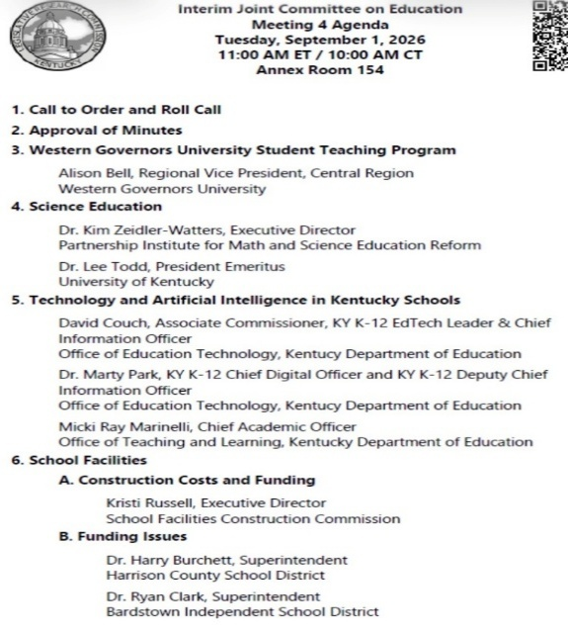
• On 20 August 2026, the U.S. Department of Education released its perspective on the topics of K-12 screen use and AI: https://tinyurl.com/nationalguidance. This national guidance is consistent with our KY K-12 EdTech perspective on both topics.

• This short STLP segment was featured on Kentucky Tonight on 24 August 2026:https://ket.org/program/kentucky-edition/stlp-2024/

• Quality Screen Use for KY K-12 Students - Kentucky Department of Education – this link goes to the five key message and 18 resources/speaking points to support these key messages.

• KY-K12 Quality Screen Use House Senate Committee - Kentucky Department of Education on 1 Sept 2026 this link goes directly to the September 1 presentation, both the audio and video

• House Budget Review Subcommittee on Primary & Secondary Education & Workforce Development (1-13-26)

• screen-use-full.pdf - Google Drive

• 2026KETSInfographic.pdf

• The topic of screen time and AI discussed during Kentucky Tonight on 24 August 2026: Screen Time in Schools | Kentucky Tonigh​t​

• Oct 7th KY legislative committee presentation. This is the Budget Review Subcommittee on Education.

Poll questions on this topic:
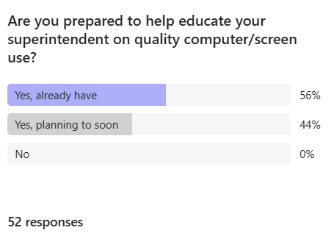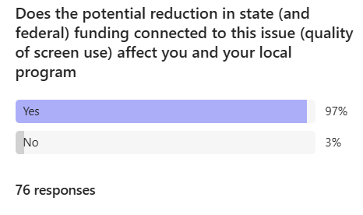

(1:04:13) KY K-12 Connected User Experience System (CUES) Update: Chuck reported that Kentucky is nearing completion of phase one of the statewide Rapid Identity implementation, with remaining provisioning, claiming, federation, documentation, and stabilization work planned before the next phase begins. Chuck applauded the efforts of everyone “on the field” who has worked tirelessly these last several months and he shared the graphic/quote below:

- Remaining Deployment: Chuck reported that only one district had not started provisioning or gone live; two have not claimed students; two have not claimed staff; seven have not federated Entra; five have not federated Google; and a larger number still need to federate Infinite Campus. The team plan to focus on closing these gaps over the following weeks.
- Stabilization Work: After phase one, the initiative will enter a stabilization and normalization period. Chuck said the team must clean up and document processes, provide continued professional development, and address data errors that affect user comfort and provisioning.
- Identity Security: A November 6 KAST session will focus on strengthening identity security after establishing a single identity for students, staff, and teachers; this is being termed a “cybersecurity level-up”. The discussion will address differentiated security for users with access to decisions, dollars, and data and may prompt a review of existing standards.
- Active Directory Transition: KDE is preparing for the next phase, Active Directory decommissioning. An advisory group is planning the required environment and infrastructure work, and monthly updates may be limited for a few months while the team prepares to decommission the first domain.

(1:12:09) Student Voice Participation: Marty and encouraged districts to participate in the 2026–27 Kentucky Speak Up survey so they can use student, educator, and family perspectives to guide instructional planning, technology decisions, and policy discussions.
- Survey Participation: Districts were encouraged to join Kentucky Speak Up, with a statewide goal of reaching 100 participating districts. The survey is intended to capture students’ activities, attitudes, and aspirations related to technology and learning, with participation options designed for different levels of district support.
- Planning Uses: David and Marty explained that participating districts own and can use their resulting data to compare local findings with other districts and national results, support board and funding discussions, and incorporate student perspectives into education technology plans, instructional planning, and comprehensive improvement planning.
- Quality Screen Evidence: Student voice data has been used to inform discussions about quality screen use and artificial intelligence in schools. Districts were asked to contact Ben Maynard with questions and to use the data as evidence when discussing technology’s educational role.
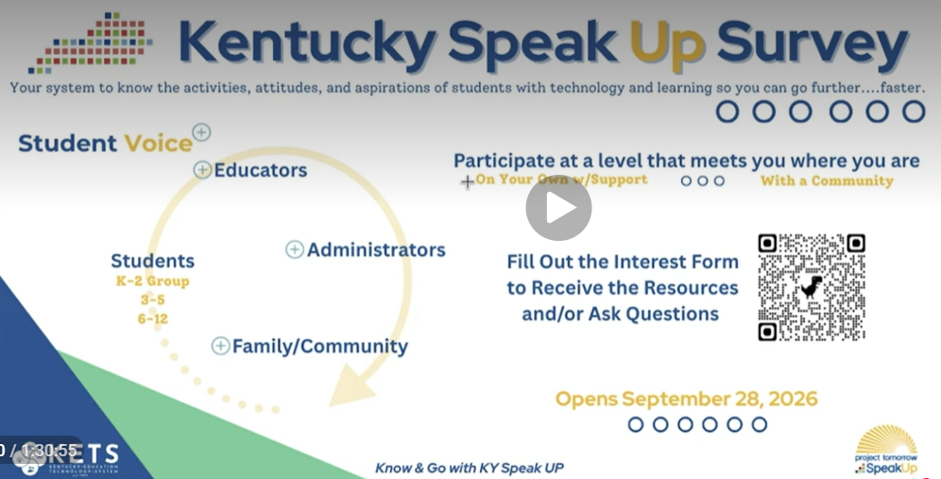

(1:14:28) E-Rate Proposed Rulemaking Update: Mike provided deadlines and response plans for two FCC proposed rulemakings that could affect E-rate eligibility, administration, and funding, urging districts to submit individual comments in addition to KDE’s statewide response.
- E-rate Program Info: Since the birth of the federal e-rate program in 1996, KY K-12 has regularly been a top 5 recipient in the amount of funds received per student. In 2026 it will bring in $62M ($45M to districts and $9M to KDE and $8M local match) for KY K-12 education technology. The FCC recently announced that they are considering making major changes to the E-rate program. This could have major negative financial consequences to every school, district office, and KDE office.
- Screen-Use NPRM: The first proposed rulemaking addresses E-rate eligibility and how recipients use the program, including issues connected to screen use. Public comments are due October 13, reply comments are due November 12, and KDE plans to submit a response on behalf of Kentucky districts while collecting district input.
- Administrative NPRM: The second proposed rulemaking concerns administration of the Universal Service Administrative Company. Its comment deadline is September 30 and its reply-comment deadline is October 30. KDE also plans to review and respond to this proposal.
- District Responses: Mike encouraged districts to submit their own comments on issues especially relevant to them, noting that E-rate supports multiple millions of dollars in Kentucky through both statewide and individual district activities. He said KDE is monitoring the proposals and hopes any changes are productive rather than detrimental.

(1:18:09) KY K-12 Data Systems Update: Dede reviewed upcoming School Report Card deadlines, new House Bill 307 postsecondary-readiness functions, social-security-number removal guidance, and Infinite Campus training opportunities.
- School Report Card: Districts must enter, approve, and complete access-to-technology data for the School Report Card by September 25. Dede reported that fewer than half of districts had completed the required steps at the time of the meeting. The tentative embargo date is October 13, with public release planned for October 15.
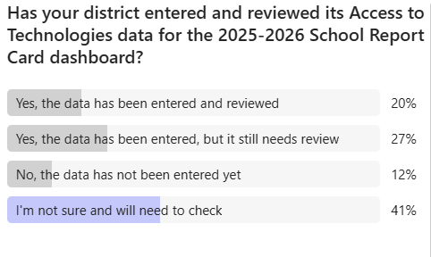
- House Bill 307: Two components of the proactive postsecondary-readiness program are live: locally defined directory elements and a FERPA tool for recording parent or eligible-student opt-outs. The proactive postsecondary admissions opt-in form is expected within the next few weeks, and a related seal is planned for later in October.
- SSN Removal: Dede reported that 65 districts had used the Social Security Number tool and the miscellaneous tool had been used by one district. KDE updated the SSN removal guidance and will make it available through the chat and website.
- Training Calendar: Infinite Campus user-group training is scheduled for September 21 in Franklin County, September 22 in Laurel County, September 29 in Bowling Green, and virtually on September 30. The Infinite Campus Interchange is scheduled for December 3–4 in Louisville, and districts were encouraged to send representatives.
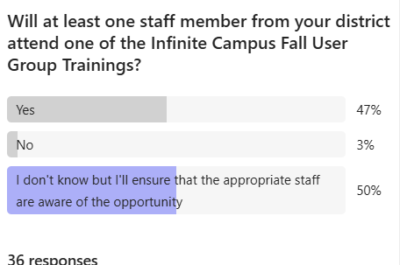

(1:24:51) Technology Operations Updates: Matt reported service improvements for GoGuardian, upcoming district-MFA integration for the enterprise VPN, and a Tyler ERP migration plan.
- GoGuardian Reliability: Matt said GoGuardian experienced administrative-service challenges the prior week and that KDE discussed the issue with the CEO. GoGuardian added horizontal DNS scaling to handle traffic surges, began upgrading DNS servers, and implemented traffic tagging to analyze future delays; changes are being rolled out during non-peak periods. KAST GoGuardian Session: GoGuardian will attend the KAST fall event and plans to tailor its presentation to district interests. A survey listing possible presentation topics was being finalized for distribution to districts.
- KETS Enterprise VPN Authentication: The KETS Enterprise VPN Service will transition to SAML authentication using each district’s multifactor authentication. Additional information is expected through regional agendas.
- Tyler ERP Migration: Tyler is upgrading its enterprise ERP system so it will no longer depend on the existing VPN-based approach. Fayette County was the first Kentucky district to migrate successfully, and Tyler plans a three-phase effort concluding by spring 2028, with phase one targeted for fall. A special webcast will explain the phases and timelines. Districts currently running versions 2024.6 or 2024.7 are required to upgrade all environments to version 2024.8 or higher by early fall, as future statewide initiatives will only be supported on version 2024.8 and higher. A separate communication will be sent directly to those districts with additional information. A statewide initiative planned for this fall will only be available in v2024.8 or higher.

Other Items to Note:
- KEPS and TEDS System Transitions - Both now meet the decision criteria of could we, should we, how much, who pays and do we have a legal purchasing mechanism.
  - KEPS functions as the official web-based job board and registry for public school system openings throughout the Commonwealth.
  - TEDS serves as the authoritative, state-level repository for student data regarding all secondary and postsecondary Career and Technical Education (CTE) programs taught in Kentucky.
- Computer Science RFP - Marty Park shared regarding an RFP being formulated for a statewide resource for computer science instruction.
- KY’s $358M settlement from META - Ky. AG’s Office announces historic big tech settlement in Meta lawsuit. At this time, we don’t anticipate receiving any of these funds, but the settlement was just announced and the legislature is being briefed in front of several committees.
- Network Procurement - Mike reported that KDE continues moving forward for new networking contracts. Although logistical issues caused some delay, KDE expects multiple contracts to be available to districts before the January E-rate filing window.

