Summary of July 2026 KY K-12 Education
Technology Leaders’ Virtual Meeting

In case you missed it or want a refresher, the following is what we talked about during the July 21, 2026, EdTech leaders’ virtual meeting. A copy of the video and audio can be found at:
https://mediaportal.education.ky.gov/technology/2026/07/edtech-webcast-july-21-2026/.

Public viewing of the archived webcasts and written summaries are also available on the KDE Media Portal at: https://mediaportal.education.ky.gov/technology/district-technology-leadership-webcast/ . Numbers in RED indicate the timestamp for that portion of the discussion so it can be easily located on the full digital recording.

This was a joint meeting with our OET staff and all the districts joining via Microsoft Teams and/or YouTube. We will continue to make these available from our KDE media portal so that you can watch the archived discussion and share with the appropriate people in your district. Poll questions were posed throughout the meeting and district EdTech leaders were asked to respond as it assists us in planning and getting a feel for how to best move forward. Your voice and your feedback are important and extremely helpful to us. Please remember that in addition to these webcasts being available on the KDE Media Portal, each month’s webcast is accompanied by these written summaries. We encourage you to share the link and all or any portion of these summary notes with staff throughout your district who may find the information beneficial to them in their position.

(2:07) KETS Operational Budget and Funding Sources: David Couch led a comprehensive review of the Kentucky Education Technology System (KETS) operational budget for the 2026-27 school year, detailing funding sources, legislative impacts, and the allocation of $436M for education technology, with input from Lisa Moore, Marty Park, and other team members. We are required to present this annually to the Kentucky Board of Education (KBE) to receive approval for disbursement of the $15.4M KETS funds. We also take this opportunity to share all the available funding sources to go towards education technology along with our most recent KETS Infographic and KETS Timeline.
- Budget Overview and Legislative Impact: David explained the annual requirement to present the KETS operational budget to the board, highlighting the $15.4M in pure KETS funds and the unsuccessful attempts during the last three budget bills to raise it to $30M. He noted the historical context of budget cuts following the housing market crash and the difficulty in restoring funding, emphasizing the importance of maintaining current funding while continuing to advocate for additional technology funding.
- Funding Source Breakdown: The team discussed the various funding sources contributing to the $436M available for education technology for SY2026-2027, including federal E-rate rebates, local district matching funds, state appropriations, and supplemental offers. David and Lisa clarified the posting and accessibility of the updated KETS Timeline and KETS Infographic, and Marty provided poll questions to gather district input on construction and digital content expenditures.

Kentucky Education Technology System (KETS)

2026-2027 Operational Plan

The State Shared Discounted Services categories and the estimated expenditure amounts associated with each in the 2026-2027 KETS Operational Plan are:

Instructional/Administrative Software Maintenance Licenses that are for or go directly to School Districts  Financial Management System (MUNIS), Student/Teacher Technology Usage Analytics, Microsoft Network Licensing | $1.5M
Instructional/Administrative Systems Operations and Maintenance Services that Students, Teachers and Staff Depend on Daily  Help Desk Service (Levels 1-3, KDE and Vendor Partners), Customer Relationship and Resource Management (e.g., KETS Field Staff), Student Technology Leadership, Digital Learning Coach Services | $7.0M
Administrative Systems Operations and Maintenance that are regularly used by Teachers, Staff or School District Leadership  School Report Card Suite, Kentucky Educator Placement Service, District Digital Readiness Survey, Student Voice, Open House | $1.9M
KETS Leadership, Planning, Management, Research and Evaluation  KETS Engineering, KETS Vendor Management, KETS Planning,  KETS Product Testing and Evaluation, KETS Project Management | $1.6M
SY 2026-2027 Funds for KETS State Shared Discounted Services (subtotal of above lines) | $12.0M
SY 2026-2027 Funds from OET for the KETS Offers of Assistance for all districts projected as | $3.4M
Grand Total SY 2026-2027 KETS Trust Fund Allocation from the Legislature | $15.4M

In addition to the KETS Trust Fund Allocation, the SY 2026-2027 Operational Plan includes other local, state and federal funding resources that can address the KETS unmet need:

Possible federal E-rate rebates on KDE-provided Internet services through the K-12 internet services to all school districts that are projected as $9.6M. These resources will be used for the following:

- KETS Offers of Assistance that will go from OET to school districts projected to be $7.2M.
- KDE technology infrastructure updates projected as $0.6M.
- Student Information System State Portion projected as $1.6M.
- E-rate Management and Administration projected as $0.2M.

Interest gained on the KETS Trust Fund and Escrow account that will also go toward KETS Offers to school districts. This is projected as $1.3M.

Supplemental KETS Offers of Assistance that will also go to school districts from savings and/or unallocated funds. This is projected as $2.8M.

Local district funds that are used to equally match KETS Offers of Assistance funds. This is projected as $14.7M.

Federal E-rate that districts apply for themselves that are sent directly to districts through the federal E-Rate program. This is projected as $45.5M.

Kentucky K-12 Internet Resources: The state legislature appropriated $17.2M in annual operational resources to support the continued growth of the high-speed K-12 Internet network used by KDE and all Kentucky school districts.

- In 1995, Kentucky became the first state in the nation to provide high speed Internet services to every school district. KDE provides equity of Internet access speed, price, and service to every one of the 171 school districts through a highly available and high-quality fiber network. Based on previous surveys of all 171 Kentucky school district education technology leaders, the reliability and speed of the Kentucky Education Network (KEN) continues to exceed expectations in support of instructional practices. This high level of satisfaction is important as it allows students, teachers and staff reliable Internet access to resources/content, on-line testing sites, and cloud-based systems such as the student information system, email/communication tools, and financial management system. Additionally, many school districts utilize cloud-based management of security, facilities and school safety technologies, which need reliable Internet access to facilitate these critical systems. The 2026-2027 school year will be the 4th year of the 10-year Next Generation K-12 Internet (NGKI) contract that continues to provide a minimum access of 1 Mbps per student statewide.

- To provide a safe and secure infrastructure for all K-12 students, teachers and staff, Kentucky K-12 Internet is fortified by firewalls, a variety of Internet defense/protection services and an Internet Content Management System on the school campus and beyond the school campus. This also meets Senate Bill 230, 701 KAR 5:120 and Federal Children’s Internet Protection Act (CIPA) regulations that are required for (a) KDE to meet state Internet safety/security requirements for K-12 students/adults and (b) for K-12 t to receive up to an estimated $55.1M in federal E-rate rebate (KDE-$9.6M, school districts-$45.5M).

Kentucky K-12 Computer Science and IT Academy prepares educators and students for industry-recognized certifications. This is projected as $760K.

State School Facility Construction Resources for new construction or renovations that can go toward: (1) internal wiring of voice, video and data lines within the school, (2) phone systems (including phone handsets), and (3) electronic projectors/boards or televisions. This is approximately $15M per year.

Contingency available in the KETS Trust Fund. This is projected as $1.0M.

KDE Program Area Resources: The following are used to directly support instructional and administrative systems for K-12 customers; Office of Education Technology (OET) Operational Resources, Child Nutrition Information Payment Systems (CNIPS), School and Community Nutrition (SCN) Point of Sale, Technology Education Database System (TEDS), Ky Summative Assessments (KSA), School Report Card Dashboard, Continuous Improvement Platform (eProve), Grant Management System, eTranscripts, Student Data Review & Roster (SDRR), Kentucky Facility Inventory and Classification System (KFICS), Kentucky Educator Certification and Ethics System, Kentucky Educator Placement System (KEPS+), Kentucky School for The Deaf and Kentucky School for the Blind Technology, Area Technology Centers Technology, Professional Learning Management System, Support Education Excellence in Kentucky (SEEK), KDE Managed Print Services, EMARS and KHRIS, Title IVA. This is approximately $15.2M per year.

The total for all resources (KETS Trust Fund and other local, state and federal) listed above is $138.5M.

Additional resources available as reported by school districts that can go toward technology services for students estimated at $297.6M:

Other resources that may be available to go towards technology services would include Special Education Funds, SEEK Funds, Corporate Donations, Local District General/Tax Funds, other Federal Funds (not technology specific) and Local Fund Raisers.

The Grand Total for all funding sources available to school districts is $436.1M.
- Impacts of Unfunded Budget Requests: David described immediate impacts from unfunded budget requests, such as districts absorbing costs for Infinite Campus online registration and campus learning, resulting in higher district level expenses. Antivirus and Trellix funding also transitioned to districts, with most moving to Windows Defender. Another item not accounted for is the increases and ongoing costs for the student information system. The team stressed the loss of cost-saving benefits from bulk purchasing under KETS. Also discussed was the assistance from other KDE offices to help pay for items in lieu of the approved KETS additional budget request—very much appreciated and also helped us to raise the KETS offer of assistance from $21 to $25/ADA for this coming school year.
- E-rate Funding and Risks: David and Mike highlighted the critical role of federal E-rate funding, estimating its annual impact at $61 million. They discussed the risks of potential cuts, the dependency on E-rate rebates for ongoing costs, and the need to educate the board about these financial dynamics. Mike provided updates on FCC rulemaking and the importance of district and vendor feedback. This funding is also tied to the screen use time discussion.
- Construction and Technology Activity Reporting: David and Chuck examined the challenges in accurately capturing technology expenditures related to new construction and renovations, noting that most costs are not broken out in technology activity reports but are instead bundled in construction budgets. Poll questions were launched to assess district practices, and the team committed to refining estimates based on feedback.

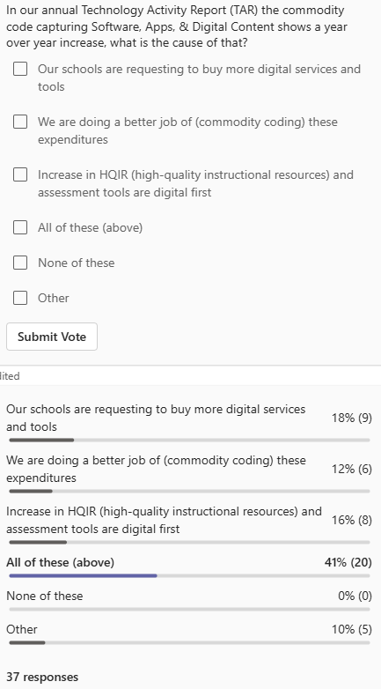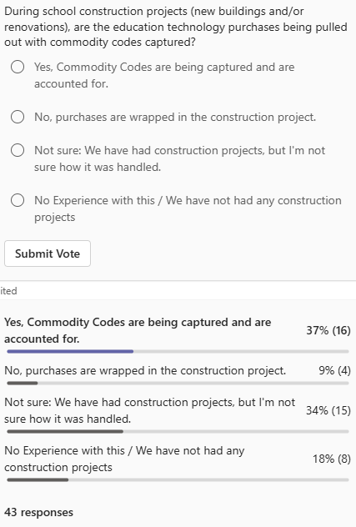

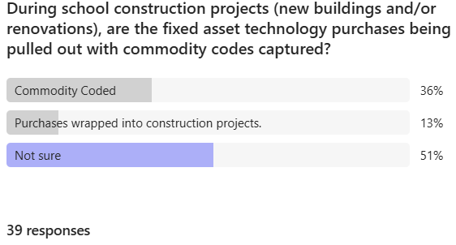

(30:58) KY K-12 Student Technology Academic Standards Reminder: We discussed this in greater detail during a previous webcast; however, this is a reminder that that these revised technology standards will be presented for approval to the Local Superintendents’ Advisory Council (LSAC) on 28 July and to the Kentucky Board of Education (KBE) during their meeting on 6 August.

These standards are also tied to the screen-use time discussions happening right now. We are finalizing the creation of a Screen Use Guidelines document to help provide some context and balance to the current discussions and presentations being made to legislators; this document will be published and distributed to CIOs for your review and comments.

(34:11) CUES Initiative and Identity Management Implementation Updates: Chuck provided a detailed update on the CUES initiative, focusing on the Rapid Identity implementation, InfoBlox migration, Active Directory decommissioning, and upcoming technical events. This is, by far, the most difficult, complex, and disruptive initiatives we have undertaken. It has multiple layers and each one is complex all in itself from both the technology perspective as well as the people perspective.
- Rapid Identity Implementation: Chuck outlined the phase one baseline implementation of Rapid Identity, targeting completion by August 31. He acknowledged anticipated challenges at the start of the school year, including disruptions from claiming and federating processes, and assured participants that partners are prepared to support districts during this transition.
- Known Microsoft Federation Issue: Chuck announced a known issue between Microsoft and Rapid Identity related to cloud-joined devices and Intune management, with a hotfix scheduled for early August. Districts affected by this scenario will have their federation paused until the fix is released, and a guidance document will be distributed. Chuck also announced that a back-to-school checklist will be available to CIOs later this week.
- InfoBlox Migration Progress: The InfoBlox implementation for DNS and DHCP services is nearly complete, with Jefferson County Schools scheduled on July 23 as the final migration. This marks full adoption of the new IP services standard across all districts.
- Active Directory Decommissioning: A draft readiness guide for Active Directory decommissioning is under review, and Chuck noted that some districts may need to reestablish their own on-premise Active Directory. The team is partnering with districts like Hopkins, Jefferson, and Boone Counties to address local needs and ensure smooth transitions.
- Technical Event Planning: Chuck shared plans for the upcoming fall KAST event, which will feature technology strands on Cybersecurity Level-up and Active Directory decommissioning. The goal is to share progress and best practices with the broader community by November.

(46:34) Federal E-Rate Program Updates and Advocacy: Mike Leadingham presented updates on the federal E-Rate program, discussing FCC rulemaking, potential impacts on Kentucky, and the importance of district and vendor feedback, with support from Jody Rose and other field staff. Since the birth of the federal E-rate program in 1996, KY K-12 has regularly been a top 5 recipient in the amount of funds received per student. In 2026 it will bring in $54M ($45M to districts and $9M to KDE) for education technology. The FCC recently announced that they are considering making major changes to the E-rate program that could have major negative financial consequences to every school, district office, and KDE office.

- FCC Rulemaking and the Notice of Proposed Rule Making (NPRM): Mike explained the FCC's NPRM process, which allows for public comment and potential changes to the E-Rate program. He emphasized that the NPRM covers a wide range of issues, including consultant influence, eligibility criteria, and the program's original mission.
- Financial Impact Estimates: The team estimated the annual financial impact of E-Rate funding on Kentucky at $40-60 million, with worst-case scenarios reaching $62.7 million if the E-rate program weren’t in place. This includes district-level maximization of eligible items and state-level offers of assistance and matching funds.
- Feedback Mechanisms and Deadlines: Mike noted that the deadline for submitting feedback has not yet been established, but districts are encouraged to provide input via the KETS tool or direct communication. Jody shared a Google Form link for districts to submit impactful statements, https://forms.gle/C7SMHKn9DTGTX4pD8, which may be used in advocacy efforts. Input is requested to be included by the end of July.
- USAC Administration Review: Mike mentioned a separate NPRM that focuses on the Universal Service Administration Company (USAC), which administers E-Rate. The review aims to improve audit and operational mechanisms, though it is considered less critical than the main E-Rate NPRM.

(55:41) K-12 Data Systems Updates and Healthy Data Diet: Linda Burton delivered updates on K-12 data systems, including school report card suite changes, House Bill 307 guidance, SSN removal initiatives, and upcoming training opportunities, with additional input from David Couch.
- School Report Card Suite Transition: Linda announced the opening of the dashboard for 25-26 data, noting the transition from MicroStrategy to React platforms. Districts will see changes in data validation and collection views, with public release tentatively scheduled for October 15th.
- House Bill 307 Guidance: Guidance for the proactive post-secondary admissions program was distributed via the July 10th Commissioner's Weekly Update and July 15th Infinite Campus newsletter. Linda urged districts to ensure relevant staff receive the guidance, especially those handling FERPA directory information and opt-outs.
- SSN Removal Tool and Data Diet: Infinite Campus deployed a new SSN removal tool that removes additional SSNs from 4 additional areas, but uptake has been slow. Linda and David stressed the importance of removing unnecessary SSNs, especially for younger students and graduates, to reduce cybersecurity risks. Updated guidance is available at SSN Removal Tool Guidance.
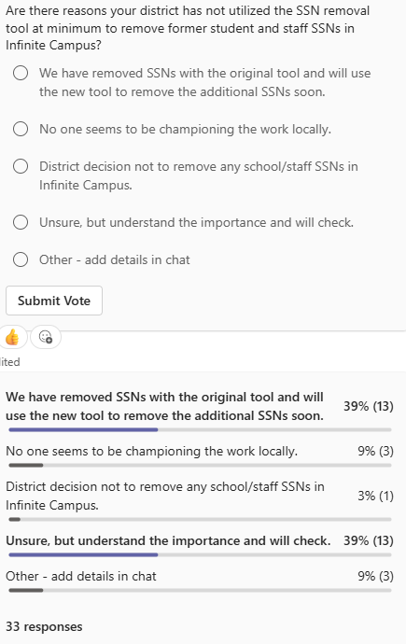
- Training Opportunities: Linda highlighted upcoming training sessions, including the beginning-of-year training and US Department of Education Privacy Technical Assistance Center (PTAC) events. She recommended participation for staff involved in data privacy and security. For information about training and registration links: KDE KSIS Training page.
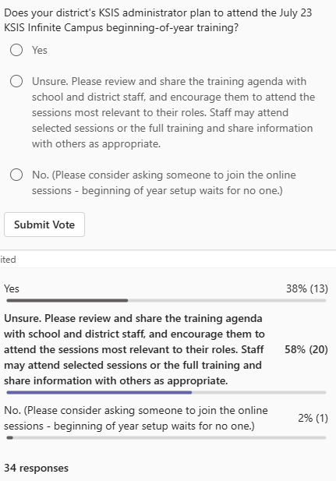
- Job Posting Announcement: Linda announced an IT business analyst senior position supporting the Kentucky Student Information System, with the job posting closing soon. She encouraged sharing the opportunity with interested candidates.

(1:04:57) KY K-12 Network Components RFP & Networking Contracts Update: Mike provided a status update on the KETS components RFP for networking products and services, confirming the posting and upcoming deadlines for proposals, with the goal of establishing new contracts before the E-rate application window opens.
- RFP Timeline and Objectives: The RFP for networking products and services posted on July 13th, with proposals due by August 14th. The intent is to have new contracts in place before the end of the calendar year, ensuring districts have access to eligible products for E-rate applications.

(1:06:21) Zayo Ticketing System Launch and Training: Matt Jury updated the group on Zayo's new ticketing system, Zinsights, which launched on July 13th, and outlined upcoming training sessions for CIOs and districts, with support from Brian Spellman.
  - System Launch and Transition: Zinsights went live for new service issues and tickets, while legacy tickets remain in the old system. Reporting features will be added before retiring the legacy platform, and users will receive training and email notifications about the transition.
  - Training Schedule: Training sessions for new CIOs and regional groups are scheduled throughout August, with registration details provided via email and chat. Matt emphasized the importance of attending these sessions to ensure smooth adoption of the new system. Below is the current schedule as shared in the meeting chat.

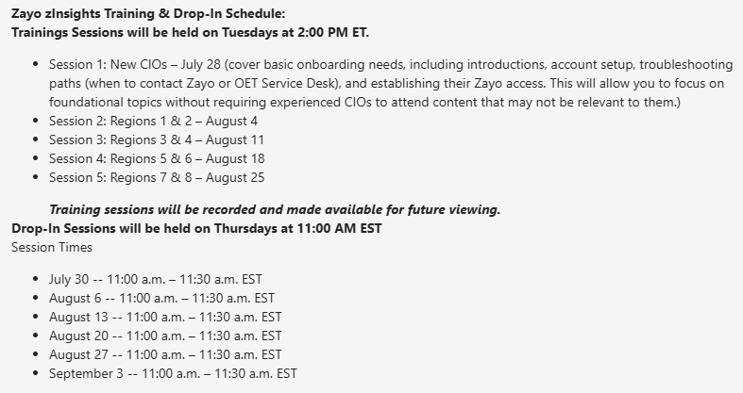

(1:08:33) Cybersecurity Health Check and Self-Assessment: Bob Hackworth reminded participants to complete their cybersecurity health check, sharing a workbook tool for self-assessment and providing links to more comprehensive resources.
- Health Check Reminder: Bob shared a workbook tool with the KE’s that district CIOs may utilize to conduct a small-scale cybersecurity self-assessment, including a list of items to consider and links to more involved assessments. He encouraged districts to use the tool as part of their ongoing cybersecurity health check. This tool also has items that you should consider including in your cybersecurity health check report to your local boards of education.

