Summary of the June 2026 KY K-12 Education
Technology Leaders’ Virtual Meeting

In case you missed it or want a refresher, the following is what we talked about during the June 16, 2026, EdTech leaders’ virtual meeting. A copy of the video and audio can be found at:
https://mediaportal.education.ky.gov/technology/2026/06/edtech-webcast-june-16-2026/.

Public viewing of the archived webcasts and written summaries are also available on the KDE Media Portal at: https://mediaportal.education.ky.gov/technology/district-technology-leadership-webcast/ . Numbers in RED indicate the timestamp for that portion of the discussion so it can be easily located on the full digital recording.

This was a joint meeting with our OET staff and all the districts joining via Microsoft Teams and/or YouTube. We will continue to make these available from our KDE media portal so that you can watch the archived discussion and share with the appropriate people in your district. Poll questions were posed throughout the meeting and district EdTech leaders were asked to respond as it assists us in planning and getting a feel for how to best move forward. Your voice and your feedback are important and extremely helpful to us. Please remember that in addition to these webcasts being available on the KDE Media Portal, each month’s webcast is accompanied by these written summaries. We encourage you to share the link and all or any portion of these summary notes with staff throughout your district who may find the information beneficial to them in their position.

(1:53) FCC E-Rate Program Proposed Rulemaking: Mike Leadingham and David Couch discussed the announcement made June 4th on the FCC's intent to initiate a proposed rulemaking for the federal E-Rate program, highlighting the potential impacts on KETS funding, the timeline for public comments, and the importance of district engagement in the process. Any and everything “top to bottom review” related to the program is up for discussion and review. We hope that any changes are not an over-correction for any perceived problems.
  - FCC Rulemaking Timeline: Mike Leadingham explained that the FCC will decide on June 25th whether to proceed with the proposed rulemaking for the E-Rate program. If approved, there will be a 60-day window for public comments, followed by a 30-day reply period, during which the state and individual districts can submit feedback.
  - Potential Impacts on KETS: Mike Leadingham emphasized that the E-Rate program provides $55-60 million annually to Kentucky districts and KDE organizations, and any significant changes or dismantling of the program could have catastrophic financial consequences for education technology statewide.
  - Discussion of Program Integrity and Screen Time: Both Mike Leadingham and David Couch noted that the rulemaking will address program necessity, program integrity, discount rates, streamlined administration, and the use of funds for educational purposes, with national debates about student screen time influencing the review.
  - District Engagement and Advocacy: David Couch encouraged district leaders to participate in the conversation, highlighting the need to provide accurate information about technology use in schools and to counter misconceptions about excessive screen time.

(11:07) Revision of Kentucky Academic Standards for Technology: Marty Park and David Couch presented on the current, ongoing revision of the Kentucky Academic Standards (KAS) for Technology, detailing the process, the integration of artificial intelligence, and the timeline for review by the Local Superintendents’ Advisory Council (LSAC) and the Kentucky Board of Education (KBE).
- Revision Process and Timeline: Marty Park described the standards revision process, which was led by Laura Raganas and began over a year ago and follows the same methodology as other academic standards, with the revised standards scheduled for presentation to the LSAC on July 28 and to the KBE at their August 6 retreat meeting. While technology standards are considered required--it is required as a demonstrated competency in the minimum graduation requirements.
- Integration of Artificial Intelligence: The revised standards explicitly incorporate artificial intelligence, with over 40 references to AI in learning priorities and performance indicators, ensuring students are prepared for emerging technologies. The writing team for the standards revision did an excellent job.
- Structure and Grade Bands: The standards are organized by grade bands (K–2, 3–5, 6–8, 9–12) and align with international ISTE standards, covering concepts such as empowered learner, digital citizen, and computational thinker.
- Connection to Screen Time Debate: Marty Park and David Couch linked the standards revision to the ongoing screen time debate, emphasizing that schools focus on quality technology use versus quantity. Digital citizenship, and the student technology skill standards provide a framework for responsible technology integration. Because of this, we are primed and ready to have the use of screen time conversations. We believe the current landscape is an over correction and we will be publishing a piece on this in our KETS Master Plan as part of the research section. We always need to go back and see if what we have put in place is making a difference—how much is it being used and what is it being used for. This process will continue as we complete these student technology skill standards and continue working on both the computer science and library media standards.
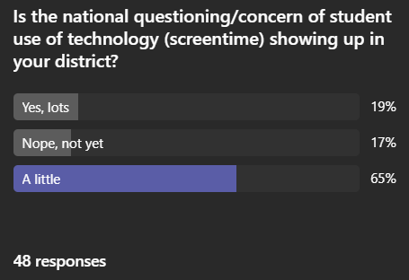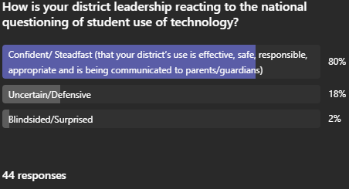

(31:06) Connected User Experience System (CUES) Implementation Progress: Chuck Austin provided an update on the CUES initiative, outlining progress on Rapid Identity, Infoblox IP services, and Active Directory decommissioning, and highlighted critical deadlines for endpoint protection, IP services, and Microsoft licensing.
- CUES Project Components: Chuck Austin explained that CUES consists of three main components: Rapid Identity for identity and access management, Infoblox for network services, and the decommissioning of on-premise Active Directory and all its related services.
- Critical Deadlines: Key deadlines include June 30 for retiring the state Trellix anti-virus/endpoint protection service, July 31 for completing Infoblox implementation, and August 31 for finishing Rapid Identity phase one and securing needed Microsoft licensing.

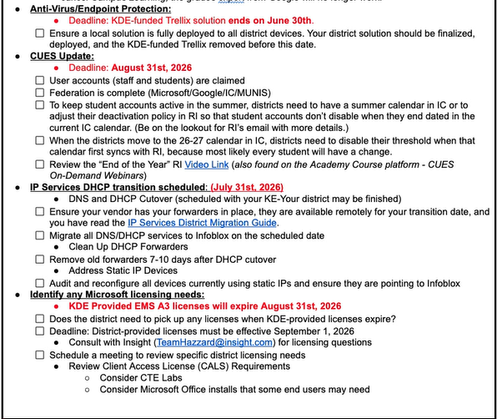

- Implementation Status: Over 100 districts have completed Infoblox implementation, and all districts are actively working on Rapid Identity, with support from enablement teams and project managers. Below are current implementation statistics on these initiatives:

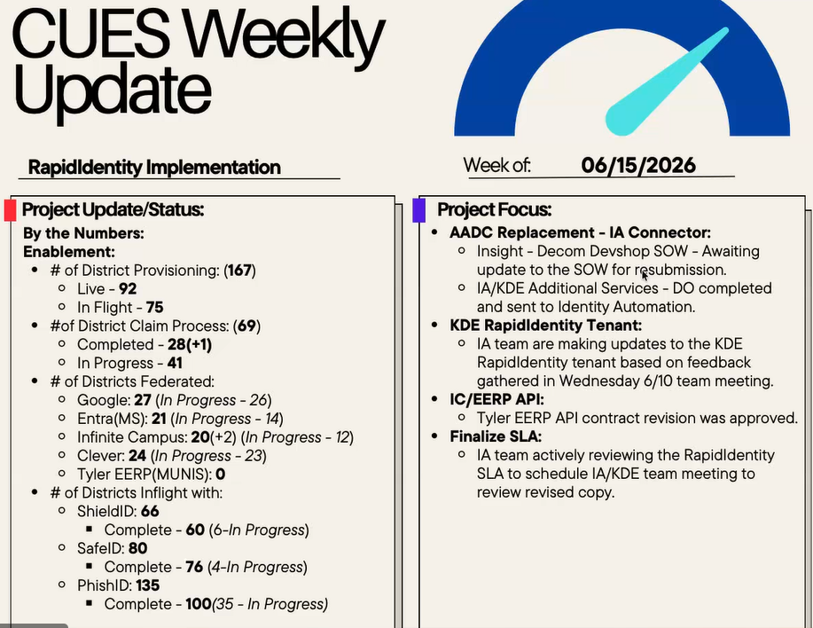
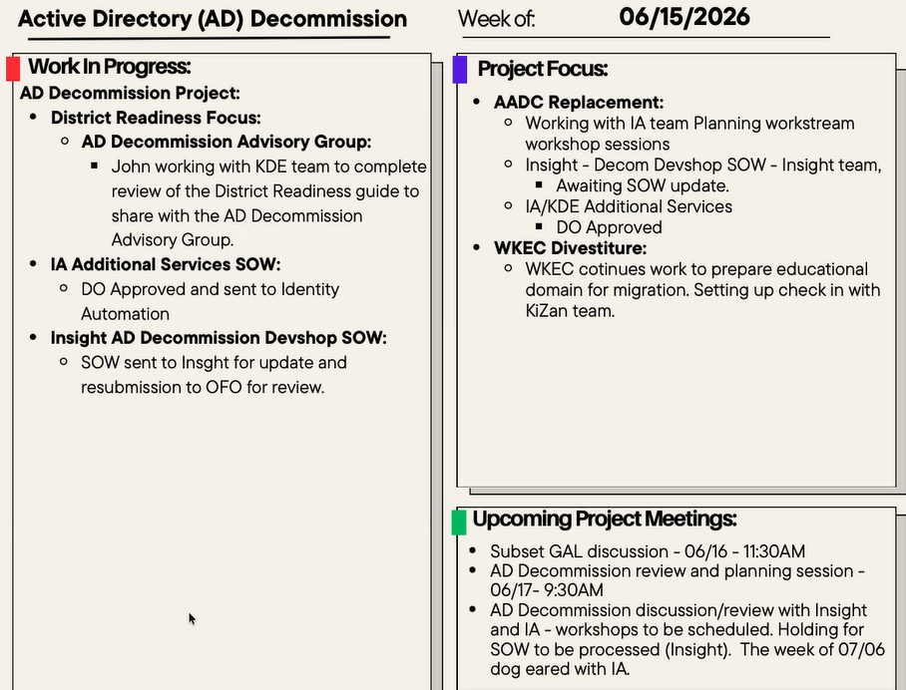

- Support and Communication: The team is coordinating with superintendents and providing readiness guides, with ongoing communication to ensure districts meet these upcoming deadlines and have the necessary support for endpoint protection and licensing.

(42:49) Data Security Initiatives: Social Security Number Removal and House Bill 307: Dede Conner reported on efforts to remove social security numbers from district systems, the release of new tools for data cleansing, and the implementation of House Bill 307, which requires new data sharing protocols with post-secondary institutions.
- Social Security Number Removal: Dede Conner noted that 46 districts have taken steps to remove social security numbers from their systems, and a new tool has been released to help districts remove these numbers from databases, with additional training planned during the beginning-of-year training sessions.
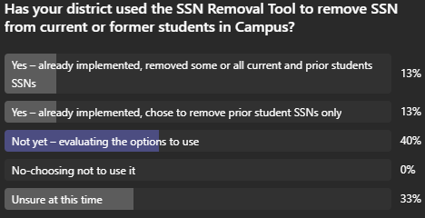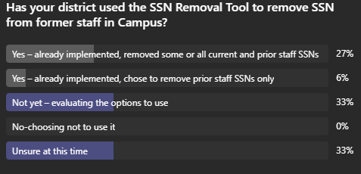

- House Bill 307 Data Sharing: Proactive Postsecondary Admissions or House Bill 307 mandates KDE to release data directly to universities, requiring alignment with FERPA and new data collections (five in total) in Infinite Campus; documentation and training will be provided to districts.
- Records Retention Training: Plans are underway for records retention training in collaboration with the Kentucky Department of Libraries and Archives, with a survey to gauge district interest.
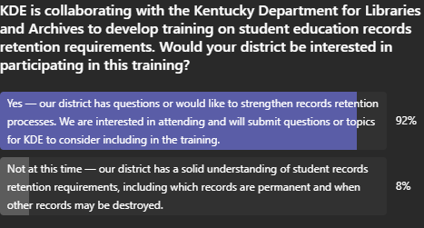
- IC Campus Learning & IC Online Registration: Dede Conner reminded districts that KDE will no longer pay for campus learning and online registration after July 1, and districts must ensure payment to maintain access.
- Additional Poll Question Regarding Annual Notices:

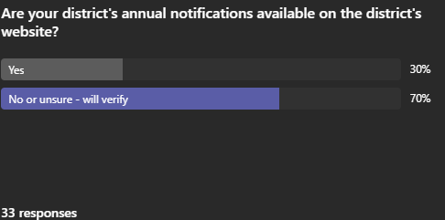

(49:09) Network Redundancy Success During Major Outage: Brian Spellman reported on a recent major internet outage caused by construction, highlighting that network redundancy allowed districts to avoid service disruptions, demonstrating the effectiveness of the new system.
- Outage Details and Response: A construction incident in Cincinnati severed a major fiber pathway, resulting in a 7–9 day outage, but our KY K-12 Internet network redundancy ensured uninterrupted service for Kentucky school districts, with all traffic rerouted seamlessly.
- Recognition of Partners: David Couch and Brian acknowledged the role of Zayo Education and its subcontractors in maintaining network resilience and credited the design and implementation teams for the successful outcome.

(52:59) Upcoming KETS Operational Budget and Cybersecurity Health Check: David Couch previewed the focus of the next webcast will be on the KETS operational budget for SY2026-2027 and reminded districts of the legal requirement to complete the required cybersecurity health check with their local boards.
- Budget Changes and Priorities: David Couch explained that costs, such as online registration, have shifted to districts due to budget changes, and emphasized the importance of keeping these items as funding priorities for future legislative sessions.
- Cybersecurity Health Check Requirement: Districts are required by law to conduct a cybersecurity health check with their superintendent and local board, and David Couch encouraged using this as an opportunity to educate leadership on technology risks and safeguards.

(55:19) Firewall Upgrades Notification: Brian announced that minor firewall upgrades will be performed in July, with schedules and details to be communicated to districts to ensure all firewalls are updated with the latest security patches.
- Upgrade Schedule and Communication: Brian stated that Zayo will coordinate firewall upgrades across districts, moving all devices to the latest software security patches, and that notifications will be sent out in advance.

We then had a closed session for just districts and OET staff on the following two topics:
- Update on progress of virus protection transition in KY K-12.
- It could happen to you but don’t let it. Recent cyberattack and old school scam targeting KY K-12 over the past 3 weeks that all districts need to be aware of and need to take precautions to keep from happening in their district.

