Summary of the April 2026 KY K-12 Education
Technology Leaders’ Virtual Meeting

In case you missed it or want a refresher, the following is what we talked about during the April 21, 2026, EdTech leaders’ virtual meeting. A copy of the video and audio can be found at: https://mediaportal.education.ky.gov/technology/2026/04/edtech-webcast-april-21-2026/ .

Public viewing of the archived webcasts and written summaries are also available on the KDE Media Portal at: https://mediaportal.education.ky.gov/technology/district-technology-leadership-webcast/ . Numbers in RED indicate the timestamp for that portion of the discussion so it can be easily located on the full digital recording.

This was a joint meeting with our OET staff and all the districts joining via Microsoft Teams and/or YouTube. We will continue to make these available from our KDE media portal so that you can watch the archived discussion and share with the appropriate people in your district. Poll questions were posed throughout the meeting and district EdTech leaders were asked to respond as it assists us in planning and getting a feel for how to best move forward. Your voice and your feedback are important and extremely helpful to us. Please remember that in addition to these webcasts being available on the KDE Media Portal, each month’s webcast is accompanied by these written summaries. We encourage you to share the link and all or any portion of these summary notes with staff throughout your district who may find the information beneficial to them in their position.

(00:36) KY K-12 Student Technology Leadership Program (STLP) State Championship on Friday, April 24th. STATE – STLP : Jeff Sebulsky and David Couch discussed the upcoming STLP State Championship event, providing detailed information on bus drop-off procedures, parking options, and the importance of communicating logistics to transportation divisions, with input/questions from Neil Arnett and Marty Park.

  - Bus Drop-Off Procedures: Jeff Sebulsky explained the new bus drop-off plan developed in collaboration with the Lexington Police Department, outlining two options: buses staying for the day should enter via High Street and park at Gate 1, while buses unloading and leaving should use the loading dock accessed from Manchester Street via Oliver Lewis Way.
  - Parking and Fees: Personal vehicles must pay for parking upon exit, while buses staying for the day have reserved parking with fees covered by the event; Jeff clarified that there will be no unloading on High Street to ensure student safety, and parents/volunteers parking in the lot will need to pay.
  - Communication to Districts: Marty Park and David Couch emphasized the need for ed tech leaders to proactively communicate bus logistics to their bus garages, noting that many bus drivers may be unfamiliar with Lexington and Rupp Arena, and that clear instructions are crucial to avoid confusion.
  - Event Information Access: Jeff directed participants to the STLP state info page for event schedules, award show live links, project table locations, and other details, optimized for mobile devices to facilitate easy access during the event.
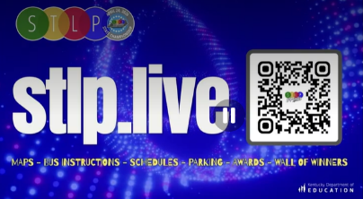
  - Recognition and Participation: Jeff thanked all those involved in preparing students for the event, highlighting that STLP activities support technology standards and encouraging districts without STLP groups to attend and observe.
(11:07) Legislative Session Outcomes and EdTech Impacts: David Couch and Lisa Moore reviewed the outcomes of the recent legislative session that ended April 15, detailing funding changes, removal of outdated regulations, impacts on student social security data, and consequences for district technology budgets, with contributions from Dede and other participants. A more comprehensive message will be coming out from the Commissioner’s office regarding legislation passed during the session and legislative guidance is also being drafted that will be available in late May.
- Funding Changes: SEEK funding for districts increased, but technology-specific funding was not set aside, requiring CIOs and tech leaders to advocate for a portion of that increased SEEK funding for technology with their superintendents, CFOs, and local boards.
- Statutory Updates: Outdated references to the Council for Education Technology and the statute on an outdated teacher computer purchase statute were removed/repealed. That statute was very short in length and was routinely used as a mule bill as we got toward the end of session and this was just a point of frustration. Moving forward, this will reduce confusion and administrative burden for future technology planning. This is a big win for us!
- Student Social Security Data: Legislation now significantly reduces the requirement for KDE the agency to provide full student social security numbers to state agencies. This greatly enhances student data privacy and safety.
- Artificial Intelligence Legislation: Despite expectations, no significant laws or funding for artificial intelligence professional development were passed, leaving districts without state-supported resources for AI training.
- Budget Request Consequences: This was our third attempt to get an additional budget request (ABR) passed, but very few across the department or other KY state agencies had their ABR addressed/funded in any way. We were pleased that the KY Board of Education (KBE) and the Commissioner were very supportive and championed this ABR effort for OET. We gave it a really good “at bat”. The Department is divided into two bureaus – BOSS and LARS – BOSS will get a 4% cut in FY2027 and a 7% cut in FY2028; we are in discussions to hold KETS and KEN funds harmless from these cuts. The failure to secure additional budget requests (ABR) means services like virus protection, Infinite Campus online registration and Infinite Campus’ campus learning service will shift costs to districts, resulting in higher expenses due to loss of bulk purchasing discounts at the OET level. There are consequences of not receiving the ABR.
  - IC Online Registration – Cost will transfer to school districts on 7/1 if they choose to continue this service for their district.

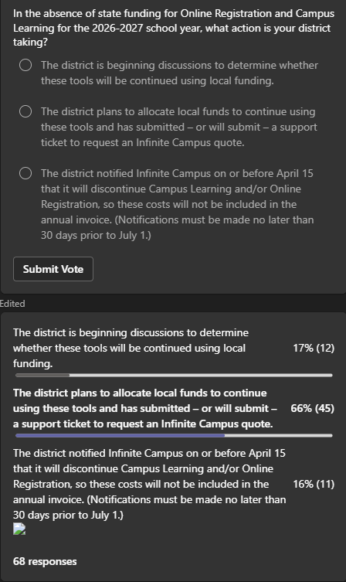
- IC Campus Learning – Another service that will not be paid for on behalf of school districts moving forward unless it’s continued/purchased by the district.
- Removal of Virus Protection and shifting to Identity Automation service.
  - IT Academy – Pays for certification exams and Computer Science AP exams. The IT Academy will be limited to current funding, requiring districts to use local funds for certifications and AP exams once the allotment is exhausted.
  - MUNIS – This Tyler financial management system faces annual cost of living increases without additional state support. We will be looking for assistance in absorbing the annual COLA increases.
- SB197/KDE Salary Language: There was a piece of legislation finalized on the final day of session that included some crucial language left out of the Executive Branch Budget that allowed for the KBE to recruit and retain some positions within the department. It was inadvertently removed just prior to the final version of the budget and then passed without it. (It was added back in after the webcast).
- HB727/Kentucky Educator Placement System (KEPS) - System Replacement: This provided a funding source for this work. Keep in mind that this will take time, but the work may begin with the identification and approval of a funding source.
- HB257/Assessment and Accountability Legislation: This was the KBE and the KDE’s top priority for this legislative session. The final language did not include 100% of what was wanted but it’s a great start. From OET’s perspective, we will look closely at the impact to online testing and the SRC dashboard. There were also some new data elements added that will also have to be reviewed and included.
- HB314/Kentucky Communications Network Authority (KCNA): This bill has the potential to help us get all of our KDE Internet Hub connections operating in a consistent way. The bill passed with an emergency clause and went into effect on 3/10. Passage of this language names David Couch (KDE’s CIO) as Chair of the KCNA board. An initial board meeting was held on 4/17 and work continues.
- SB318/K-5 EdTech Shot Clock: This bill was discussed extensively during the last webcast, and, while this language did not progress, OET will be working over the legislative interim to educate and share with legislators.
- HB307/Higher Education Marketing Legislation and FERPA Implications: Dede and David Couch discussed new legislation requiring districts to promote proactive post-secondary admissions, manage directory information, and establish opt-in/out processes for data sharing, highlighting FERPA compliance challenges and annual reporting requirements. The final language will be evaluated with internal discussions to determine where this new/additional work falls within KDE.
  - Proactive Admissions Promotion: With the passage of this legislation, districts will now be required to promote proactive post-secondary admissions, including automatic qualification based on GPA, and must decide locally how to implement these promotions.
  - Directory Information Management: KDE hasn’t historically submitted this information on behalf of school districts and this law will now require us to be much more involved in school directory information. Districts must track and report their directory information definitions, with KDE being required to release specified data elements to Kentucky public universities, depending on district policies.
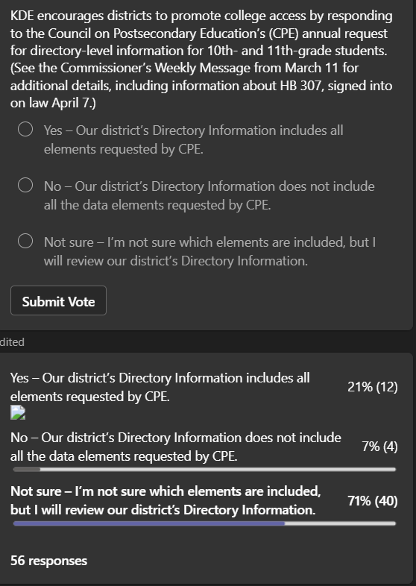
  - Opt-In/Opt-Out Processes: Preferred communication type, email address and an Opt-in/out process are items that districts may not have in place. Districts must establish opt-in processes for families to share additional data with universities, and KDE will need to track opt-outs, potentially using Infinite Campus FERPA tabs and online registration.
  - Annual Reporting Requirements: Districts must report annually on participation, effectiveness, and barriers to the proactive admissions process. There will be a compiling legislative reports based on district submissions.
  - Email Communication Limitations: David Couch noted that mass emails to students are often blocked or sent to junk folders, suggesting that Infinite Campus portals may be more effective for communication.

(46:11) GoGuardian Implementation and Exception Districts Update: David Couch and Matt Jury provided a final comprehensive update on the GoGuardian implementation, noting a successful statewide adoption, update cycles, and plans for exception districts, with Chuck and other participants contributing to the discussion. GoGuardian has been a dedicated partner to make this transition/implementation successful this past year and as we move forward.
- Statewide Implementation Status: 160 Kentucky K-12 organizations are using GoGuardian filtering service, with no districts switching away after adoption, indicating a successful transition and positive vendor partnership.
- Update Cycle Recommendations: Districts are advised to update to GoGuardian version 1.23.0 or higher, ideally after assessment windows and before the end of school, to enable auto-update features and reduce fall workload. The latest version available for Kentucky school districts is 1.26.2.1.
- Exception Districts Communication: After the 4/3 deadline, 14 districts are intending to use alternative products (i.e.,11 with Lightspeed, 2 with iBoss and 1 with Aristotle) for Internet filtering for the next school year. KDE will send customized communications to superintendents, CFOs, and CIOs, outlining potential cost savings and reasons for exceptions.
- Financial Incentives and Product Options: Districts that are part of this 14, who are in financial distress and/or using optional products from GoGuardian (e.g., Teacher, Beacon) are great candidates to transition to GoGuardian. Some 14 of these districts may want to continue with alternative filtering products because they use and like other products provided by that vendor.
- Ongoing Support and Resource Access: GoGuardian will provide ongoing updates via the Kentucky Resource Room and quarterly strategic webinars, ensuring districts remain informed about product developments.
(59:17) CUES/KETS Identity Management Transition & Funding Challenges: Chuck and David Couch discussed the transition from Microsoft Active Directory to Rapid Identity, highlighting funding constraints, implementation timelines, and district responsibilities, with updates on cohort progress and advisory committee activities.
- Funding Constraints: ESSER funds supported initial implementation of identity management and cybersecurity solutions, but these funds are now exhausted. With no additional budget requests approved, this may create financial pressure for completion.
- Transition Timelines: Statewide funding for EMSA 3 ends August 30, 2026, and duplicative costs for Active Directory and Rapid Identity will cease by June 30, 2028, requiring districts to complete implementation and decommissioning by these dates.
- Cohort Progress and District Support: Cohort 4 is well underway, Cohort 5 is starting, and all districts are urged to work closely with their KETS Engineer and enablement leads to ensure timely implementation and federation before the new school year.
- Advisory Committee and Readiness Guide: An advisory committee is actively supporting the transition, and a readiness guide for Active Directory decommissioning will be released soon, providing districts with actionable steps and information.
- IP Services Transition: DNS transitions are complete statewide, DHCP transitions are progressing, and districts should coordinate with KETS engineers to finalize these changes in preparation for Active Directory decommissioning.
(1:07) KY K-12 Data Systems Update: Dede provided updates on Kentucky K-12 data systems, including the annual front door project for geographic data accuracy.
- Front Door Project: As part of Earth Day on April 22nd, districts are asked to update school and office geographic coordinates as part of the annual Front Door project, supporting state mapping systems and ensuring data accuracy. We would like to have this done by 4/30 but let us know if you need a little more time to get these changes made. We provide this data to the Commonwealth Office of Technology (COT).
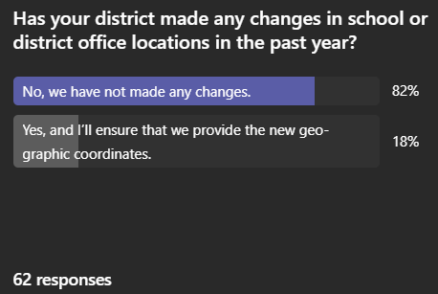
(1:08:39) KY K-12 Network Components RFP Status: We are very close to having this RFP finalized and ready to submit. This work has been a focus of OET staff, and the goal is to have those established by the January 2027 E-rate filing window.

(1:10:13) District Technology Plans Update: Amy Young provided an update on the required district technology plan submissions, with David Couch noting the importance of these plans for master plan development.
- Technology Plan Submission: Districts' technology plans were due April 15th, with 33 districts outstanding; these plans inform master plan development and E-rate filings. KETS regional engineers will be reaching out to assist outstanding districts in completing submissions.
- From current submissions, 129 plans have E-rate implications, 98 involve leases, and 70 involve student voice.
(1:12:04) AI in KY K-12 classrooms on Kentucky Educational Television (KET). Education Matters | AI in the Classroom: Education Matters | Season 16 | Episode 6 | PBS: Marty Park did a great job representing KDE and OET on this topic as a panel member that included district edtech staff along with a higher education representative. The episode focused on artificial intelligence, highlighting student perspectives, district practices, and the absence of new AI legislation.
- Panel Discussion Highlights: The panel featured KDE representatives, district CIOs, digital learning coaches, and STLP students, offering insights into responsible and secure AI use in Kentucky classrooms.
- Legislative Context: Despite the lack of new AI legislation during session, Kentucky has proactive guidance and practices in place, positioning the state as a leader in responsible AI integration.
(1:15:10) SAT Online Testing Implementation: Paul Shoemaker and Dede reported on the successful implementation of SAT online testing with a new vendor, noting high completion rates and minimal support calls, and provided updates on score loading and ACT score availability.
- SAT Testing Results: 46,036 SAT tests were completed with a 97% completion rate, and only two technology-related support calls were received, indicating a smooth transition to the new vendor, College Board.
- Score Loading and ACT Updates: SAT scores will be loaded into Infinite Campus, while ACT scores are no longer provided by the state and must be loaded locally by districts.
(1:17:07) KDE Website Revamp and Survey - Homepage - Kentucky Department of Education: David Couch announced ongoing improvements to the KDE website, including a new search engine and efforts to remove outdated data, and encouraged staff and districts to provide input via surveys for further enhancements.
- Search Engine Improvements: The KDE website's search engine has been upgraded to improve usability, addressing previous issues with finding relevant information.
- Data Cleanup Efforts: A major effort is underway to remove outdated documents and data from the website, with OET already completing its portion and other offices following suit.
- Survey for Feedback: Staff and district offices received a survey to provide input on desired website features and landing page organization, supporting ongoing enhancements.
(1:18:32) KDE Service Survey and District Awareness: David Couch discussed the recent KDE service survey sent to districts, emphasizing the importance of superintendent awareness of KDE staff visits and encouraging participation to improve agency responsiveness.
- Survey Participation: KDE sends out a service survey to districts, including superintendents, to gather feedback on agency support and interactions, with results reviewed at all KDE and Board of Education meetings.
- Superintendent Awareness: Field staff have been asked to ensure superintendents are aware of their presence in districts, addressing past issues where district leaders were unaware of KDE support activities.
