Summary of the February 2026 KY K-12 Education
Technology Leaders’ Virtual Meeting

In case you missed it or want a refresher, the following is what we talked about during the February 17, 2026, EdTech leaders’ virtual meeting. A copy of the video and audio can be found at: https://mediaportal.education.ky.gov/technology/2026/02/edtech-webcast-february-17-2026/.

Public viewing of the archived webcasts and written summaries are also available on the KDE Media Portal at: https://mediaportal.education.ky.gov/technology/district-technology-leadership-webcast/ . Numbers in RED indicate the timestamp for that portion of the discussion so it can be easily located on the full digital recording.

This was a joint meeting with our OET staff and all the districts joining via Microsoft Teams and/or YouTube. We will continue to make these available from our KDE media portal so that you can watch the archived discussion and share with the appropriate people in your district. Poll questions were posed throughout the meeting and district EdTech leaders were asked to respond as it assists us in planning and getting a feel for how to best move forward. Your voice and your feedback are important and extremely helpful to us. Please remember that in addition to these webcasts being available on the KDE Media Portal, each month’s webcast is accompanied by these written summaries. We encourage you to share the link and all or any portion of these summary notes with staff throughout your district who may find the information beneficial to them in their position.

(00:47) K-12 EdTech Funding/Policy and Legislative Updates: David Couch and Lisa Moore provided a comprehensive update on Kentucky K-12 education technology legislative activity, including budget requests for Infinite Campus, cybersecurity, IT Academy, and artificial intelligence, as well as tracking key bills affecting internet service, student privacy, and educator placement systems.
- Budget Request Overview: David Couch outlined the current ABR (Additional Budget Request) for KETS, which includes funding for Infinite Campus online registration, cybersecurity defense, increasing KETS offers assistance to districts, address KY K-12 student IT Academy growth, cost of living increase to MUNIS and a new proposal for artificial intelligence. The IT Academy, which provides student certifications, had previously received budget cuts, and the new request aims to restore the full funds due to increase in demand by KY K-12 students.
- Artificial Intelligence Professional Development: David and Marty described the proposal for a statewide professional learning network focused on artificial intelligence, leveraging existing content area networks and a coaching model. This includes a new course, 'AI Empowered Teacher,' launching soon on the Kentucky Learning Hub, intended as a foundational entry point for teachers to engage with AI in a safe, secure, and responsible manner.
- Legislative Bill Tracking: David highlighted several bills being tracked and emphasized that the team is actively educating legislators about existing programs and systems to avoid duplicative efforts.
- HB500 – The budget process normally goes right up to the end of session to get finalized. The House did not approve any ABRs in this year’s proposed budget. We will keep using every opportunity to bring our needs before them and we ask that you and your district leadership do the same.
- HB314 – This bill has the potential to help us get all of our KDE Internet Hub connections operating in a consistent way. This passed the House and has high odds of passing the Senate.
- HB307 – This is a pre-admission bill that includes KHEAA, CPE, and KySTATS. We already do a lot of data collection of our students, and it is our priority to continue to prioritize student privacy and not build duplicative systems.
- HB463 – This is a new edtech data reporting bill regarding inventory and repair of district technology. We met with the state representative and had a good meeting that identified how this need is already being done with effective quality.
- HB727 – This bill identifies funding for the replacement of the KEPS system; this is the Kentucky Educator Replacement System.
- SB121 – As part of the cleanup bill, we are requesting repeal of an outdated statute and removal of references to the Council for Education Technology.
- HB44 – Robotics Competition Grant bill; we don’t believe this one is going to progress.
- Assessment and Accountability Legislation (HB257): David noted that assessment and accountability legislation, particularly regarding summative testing, is likely to pass in some form, with ongoing debates about its content. The team is monitoring these developments closely due to their significant impact on K-12 education.
- Interstate Collaboration: David emphasized the value of relationships with counterparts in other states, which allows for direct comparison and clarification of legislative actions, benefiting Kentucky’s advocacy and policy alignment.

(11:30) KY K-12 Data Systems Update: Dede and David discussed the impending end of state funding for Infinite Campus Learning and Campus Online Registration tools, urging districts to budget for these services and explaining the financial implications and the review of poll questions to gather district feedback.
- End of State Funding: Dede informed participants that KDE’s funding for IC’s Campus Learning and Campus Online Registration tools will end this year (i.e., 30 June 2026) unless the ABR is approved, which currently appears unlikely. Districts are advised to budget for these tools independently moving forward.
- Cost Implications for Districts: David and Dede explained that purchasing these tools individually will cost districts significantly more—potentially 40-60% higher—due to the loss of statewide bulk purchasing discounts. Dede clarified that the pricing is not simply sticker price but includes minimum and maximum thresholds.
- Poll Questions and Feedback: Poll questions were launched to assess district intentions regarding continued use of Campus Learning and Campus Online Registration, and whether decisions are budget-related. The feedback will inform KDE’s understanding and advocacy efforts.

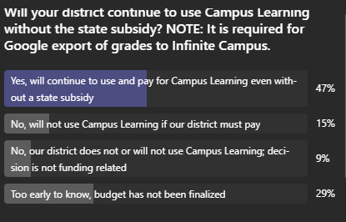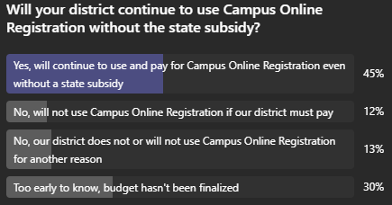
(34 responses) (69 responses)
- Upcoming Trainings and Website Modernization: Dede announced upcoming Infinite Campus user group trainings happening the week of April 13 along with end-of-year training sessions. There are also some federal training opportunities and those details are available on the KSIS Training page on the KDE website. She also mentioned the current KDE website modernization effort, inviting feedback from frequent users to improve the site.

(18:03) 2026 CIO Summit and KAST Conference Planning: Lisa and David provided details on the upcoming Kentucky K-12 CIO Summit at the KAST conference, including registration status, session logistics, table assignments, and the importance of district feedback for shaping EdTech priorities.
- Summit Registration and Logistics: Lisa reported that registration for the CIO Summit session remains open but closes soon. Close to 140 districts will have representation. The session will be held in Ballroom D of the Kentucky International Convention Center (KICC). The room will be open early for access to the KAST-provided lunch. The summit time is noon until 2:20 with lunch available at 11:30. As we normally do, table assignments have been made to encourage networking with school districts.
- Session Structure and Topics: David outlined that the summit will focus on three main topics, each with two poll questions, and will prioritize issues relevant for the next 6-12 months. We are still fine tuning these; however, topics may include the student and teacher side, artificial intelligence (AI), academic standards, and internet content management regulation. The AI topic has been part of the summit for the past three years and the feedback has been invaluable. While this has been a topic over multiple years, AI is fast paced and ever changing. We have three academic standards coming up for updating and they will go through the renewal process and culminate by going before the KBE. Other possible topics being evaluated are Simplify and Subtract and what is the best and most important thing you are working on and how is it moving the needle. Other valid topics may either be addressed through sessions already scheduled at the KAST conference or through upcoming special webcasts or bonus time after a regularly-scheduled webcast.
- Feedback and Action: David emphasized the importance of district feedback in shaping KDE actions and policies, noting that input from past summits directly influenced statewide initiatives. The summit aims to capture actionable insights and best practices from districts.
- Networking and Relationship Building: The summit is designed to foster relationships among EdTech leaders from different regions, enabling ongoing collaboration and sharing of strategies, which has led to significant improvements in district technology operations.

(36:21) KY K-12 CUES Initiative and Technology Modernization Update: Chuck Austin provided an update on the CUES initiative, including the rollout of Rapid Identity, transition from Active Directory to Infoblox, and the importance of community and vendor partnerships in supporting statewide technology modernization.
- Rapid Identity Implementation: Cohort 4 of Rapid Identity is launching, with pre-enablement activities led by KEs. The process has been streamlined, and a pilot for federation from Tyler to Rapid Identity is starting, alongside testing of Tyler’s API for improved data exchange.
- Transition to Infoblox: Zach Dean in Carroll County is piloting the transition from Active Directory to Infoblox, with documentation and consulting support for other districts. The KAST event will feature the unveiling of a readiness guide for this transition.
- Vendor and Community Engagement: Identity Automation and other vendors will have a presence at KAST, and regional events are being held for districts to share experiences moving away from on-premise Active Directory. Community and vendor support are highlighted as critical to the initiative’s success.
- API Integration and Cost Savings: The new Tyler API, provided at no cost, enables more secure and granular cloud-to-cloud data exchange, supporting future phases of the CUES initiative and reducing previous significant costs.

(44:40) GoGuardian Implementation and Exception Process Update: Matt Jury, David Couch, and Mike Leadingham discussed the GoGuardian implementation status. April 3rd is the deadline for districts to confirm participation or exceptions. They also shared details around the annual process for exception renewals, including required district leadership sign-off.
- Participation Deadline and Process: Districts with exceptions to GoGuardian must confirm their plans for the next fiscal year by April 3rd. Those not responding will be assumed to continue their exception but must sign a new exception form to acknowledge this decision.
- Financial and Logistical Considerations: The process ensures accurate billing and funding allocation for GoGuardian, with the understanding that exceptions are reviewed annually and districts can change their participation status each year.
- Product Updates and DNS Filtering: GoGuardian made a change to their version naming convention as of 2/1, and they have released a new version (26.1.1.200) that addresses Windows sign-on and registry issues. Precision DNS filtering is being finalized with eight districts, with broader rollout expected by the end of February.

(51:19) Technology Infrastructure Updates: SMTP Relay, Copper Phone Systems, and Endpoint Protection: Chuck, Matt, and Mike provided updates on the transition to a new SMTP relay service, the retirement of copper-based phone systems, and recommendations for endpoint protection solutions as districts move away from on-premise Active Directory.
- Copper Phone System Retirement: Districts are urged to contact their telephony providers to determine timelines for retiring copper facilities and to plan for upgrades to avoid service disruptions, especially for non-voice lines like elevators and security systems.

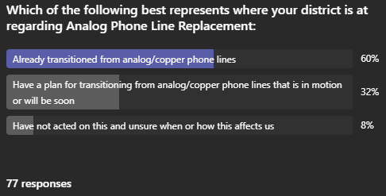
- SMTP Relay Service Migration: The IP addresses for the SMTP relay service are being updated, with the old system remaining online until April 28th. Districts are advised to report any issues to the service desk and ensure their systems are configured for the new service.
- Endpoint Protection Recommendations: Districts are encouraged to consider cloud-based endpoint protection solutions and avoid integrating with on-premise Active Directory, which is being decommissioned. Trellix hosted a statewide event to present their offerings, and districts are advised to avoid technical debt from legacy systems.

(1:00:01) Online Testing Readiness for SAT and Other Assessments: Paul Shoemaker briefed districts on preparing for the upcoming SAT and other assessments, highlighting the new College Board vendor, available support resources (both email and toll-free number), and the importance of maintaining communication with DACs (District Assessment Coordinators) for timely updates.
- Assessment Preparation and Support: Districts should ensure student devices are ready for the new Blue Book test delivery system from College Board, with Kentucky-specific support contacts available. DACs will receive the latest updates from the Office of Assessment and Accountability, and districts should keep communication lines open for any changes.

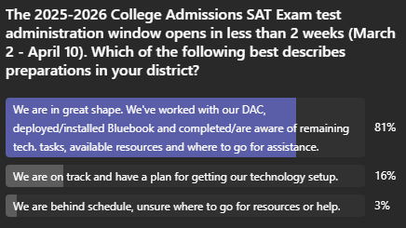
(62 responses)

(1:02:59) Cybersecurity Training and District Practices: Robert Hackworth introduced a poll to assess the prevalence of comprehensive cybersecurity training in districts, aiming to gather information on current practices and identify opportunities for sharing effective strategies.
- Training Assessment and Information Sharing: The poll seeks to determine how many districts have comprehensive cybersecurity training beyond phishing awareness, including password management and other best practices. The goal is to learn from districts with established programs and share effective approaches, though no statewide funding is currently available.

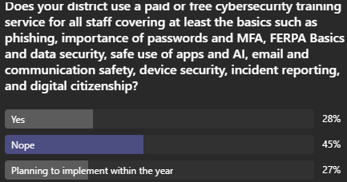
(67 responses)

(1:06:07) Other Items to Note:
- On 24 March 2026, Kentucky Educational Television’s Education Matters will focus on AI in KY K-12 classrooms. Dr. Marty Park will be sitting on that panel representing KDE and we will update you with the other panel members soon. This will be led by Kelsey Starks who is a huge advocate of STLP!
- Standards Revision and Feedback: Marty Park and David discussed the ongoing revision of Kentucky Academic Standards for Technology, which now includes over 80 references to artificial intelligence. The team, led by Laura Raganas, is revising the technology standards to integrate artificial intelligence across grade levels. Stakeholders are encouraged to provide feedback via a survey, with opportunities to do so before and during the KAST conference.
- Creative Digital Arts Judging Results: Distribution of creative digital arts judging results should be sent to participants within the week after ensuring all student products have been judged.
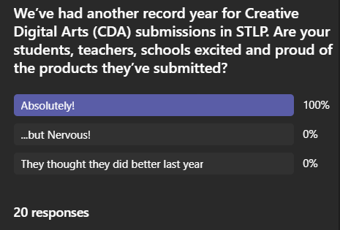
- Recognition of Tom Shelton’s Contributions: David Couch closed the meeting by honoring Tom Shelton’s legacy and his significant contributions to Kentucky K-12 public education, particularly in supporting standardized financial management systems. Tom Shelton was recognized for his roles as CFO, Superintendent, and Executive Director of the Kentucky Association of School Supts (KASS), as well as his support for the implementation of standardized financial systems in Kentucky schools. His advocacy and leadership were acknowledged as a significant loss to the education community.

