Summary of the January 2026 KY K-12 Education
Technology Leaders’ Virtual Meeting

In case you missed it or want a refresher, the following is what we talked about during the January 20, 2026, EdTech leaders’ virtual meeting. A copy of the video and audio can be found at: https://mediaportal.education.ky.gov/technology/2026/01/edtech-webcast-january-20-2026/.

Public viewing of the archived webcasts and written summaries are also available on the KDE Media Portal at: https://mediaportal.education.ky.gov/technology/district-technology-leadership-webcast/ . Numbers in RED indicate the timestamp for that portion of the discussion so it can be easily located on the full digital recording.

This was a joint meeting with our OET staff and all the districts joining via Microsoft Teams and/or YouTube. We will continue to make these available from our KDE media portal so that you can watch the archived discussion and share with the appropriate people in your district. Poll questions were posed throughout the meeting and district EdTech leaders were asked to respond as it assists us in planning and getting a feel for how to best move forward. Your voice and your feedback are important and extremely helpful to us. Please remember that in addition to these webcasts being available on the KDE Media Portal, each month’s webcast is accompanied by these written summaries. We encourage you to share the link and all or any portion of these summary notes with staff throughout your district who may find the information beneficial to them in their position.

(1:31) Digital Readiness Infographic and Statewide Technology Trends: David Couch and Marty Park presented the newly published Digital Readiness Infographic which is Appendix B within our KETS Master Plan for Education Technology. They highlighted statewide technology trends, device ratios, digital citizenship, and the integration of artificial intelligence in Kentucky K12 schools with input from district feedback and legislative presentations.
- Infographic Overview and Access: Marty Park explained how to access the Digital Readiness Infographic via the KETS Master Plan, specifically in Appendix B, and described its role in summarizing survey results and technology initiatives across the state. This is an excellent tool to educate yourself on education technology from a statewide perspective. It’s very useful to show not only what we are buying but how we are implementing it as well as the impact. Cybersecurity is still a big category, and the device footprint is very important to sustainability and refresh cycles.

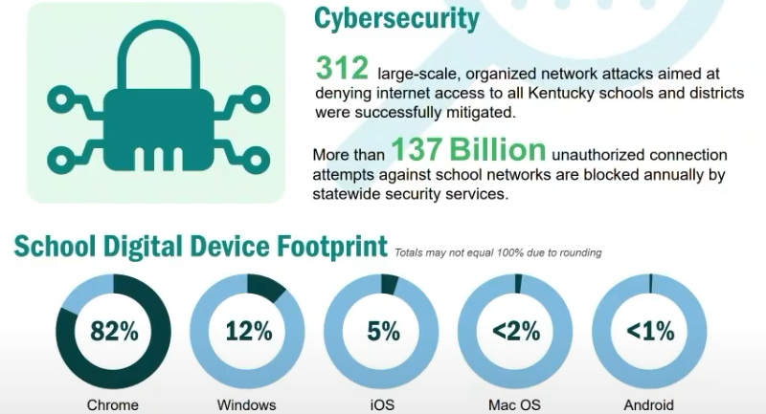

- Key Data Points and Legislative Use: David Couch emphasized the infographic's use in legislative presentations, noting its value in demonstrating device ratios, internet usage, and the impact of technology on teaching and learning, as well as its role in public and legislative education.
- Student and Teacher Feedback Integration: Marty Park detailed how the infographic incorporates direct feedback from students and teachers, focusing on digital learning collaboration, the role of digital learning coaches, and the importance of student voice in technology planning.
- Artificial Intelligence Adoption Metrics: Marty Park highlighted data showing 69% of school administrators and 78% of teachers are using or comfortable with AI, while only 28% of 6th-12th graders report using AI for schoolwork, indicating a gap in student AI fluency. This year there is a special callout to AI with emphasis on the safe, secure, and responsible use of artificial intelligence in the K-12 environment.

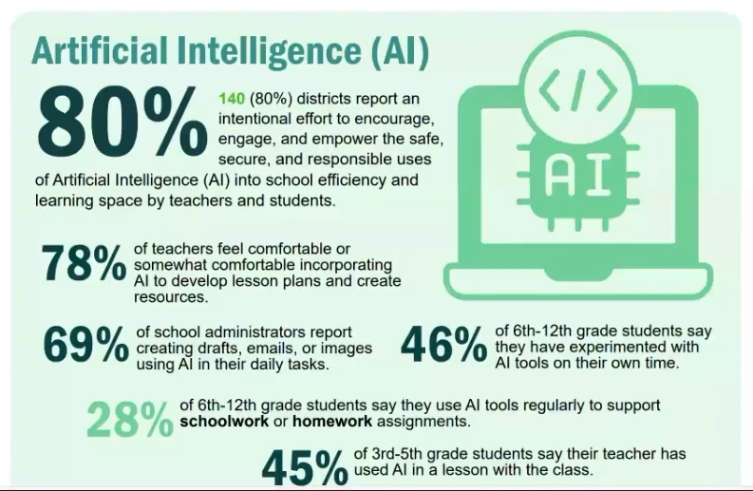
- Device Trends and Sustainability: The team discussed the ongoing shift from desktop to laptop devices, the importance of device sustainability, and the use of the infographic to compare district-level technology readiness and implementation.

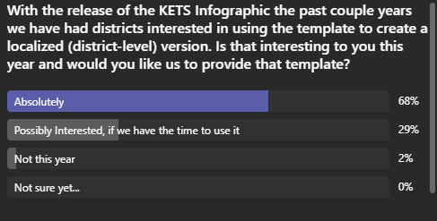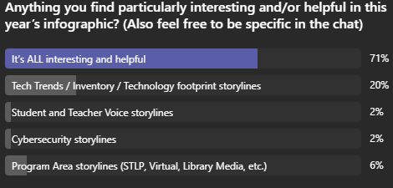
41 responses 65 responses

(17:19) Network Contracts and Offers of Assistance Updates: Mike Leadingham provided updates on the upcoming expiration and renewal process for KETS and E-rate network contracts and reminded districts about the schedule and amounts for the offers of assistance funding.

- Network Contract Renewal Timeline: Mike Leadingham outlined that current network products and services contracts are ending, with new KETS and E-rate eligible contracts to be in place by July 2027, with purchasing mechanisms available before the January 2027 E-rate filing window.
- District Input on Contracts: Districts were encouraged to communicate any needs or concerns regarding network contracts to their KETS regional engineers, who will relay this information to ensure district requirements are considered in the procurement process.
- Offers of Assistance Funding: Mike reminded districts that the first round of offers of assistance ($12 per ADA) should be received, with a second round ($9 per ADA) to follow, totaling $21 per ADA for the year.

(20:22) KY K-12 Data Systems Update: Dede provided an update on the successful Infinite Campus upgrade and data center migration, clarified changes in ACT score reporting due to contract expiration, and discussed ongoing school report card planning and data privacy training resources.
- Infinite Campus Upgrade Completion: Dede reported that Infinite Campus was upgraded from SQL 20 to SQL 22 and a server migration to a new data center over the holiday break, with only minor delays in KDE reporting processes. Appreciate all the efforts of our district and OET staff in making that successful!
- ACT Score Reporting Changes: Due to the end of the ACT contract in June, KDE no longer receives ACT scores at the state level; districts can optionally upload ACT scores for transcripts, which is helpful for students during scholarship season. The state no longer has access to those ACT scores; this is a change that is still being communicated.
- School Report Card Planning: Dede noted that while this is a downtime period for school report card submissions, KDE is planning for 2026 and welcomes district feedback on desired changes or clarifications. There is also some legislation on assessment and accountability that could impact the SRC suite of applications.
- Data Privacy and Retention Training: New federal resource videos are available on data privacy and retention, and districts are advised to avoid retaining data beyond required timeframes.

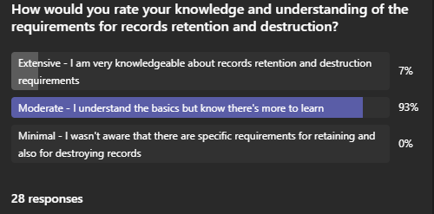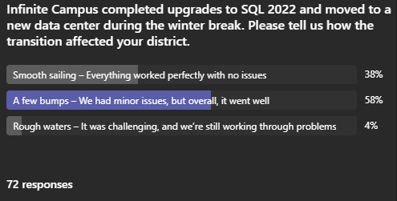

(27:44) GoGuardian Implementation and Auto-Update Release: Matt Jury updated the group on GoGuardian deployment status, announced the approval of version 1.23.0 with auto-update functionality, and described improvements in device version tracking for districts.
- Current Deployment Status: Matt Jury reported that 66 districts still have devices running a version prior to 1.19.2 GoGuardian versions, and 43 of those districts have more than 20 such devices; outreach to waiver districts is ongoing.
- Auto-Update Feature Introduction: Version 1.23.0 of GoGuardian, which introduces auto-update capabilities, has passed QA testing and will be released to org. management, allowing for more efficient updates and version control. Auto-update will still allow for QA testing before release.
- Improved Device Reporting: The new version will enable precise reporting of device versions by operating system, eliminating the need for indirect tracking methods and improving district-level oversight.

(30:49) KETS Additional Budget Request and Legislative Advocacy: David Couch summarized the recent legislative presentation on the KETS additional budget request, highlighting the selection of the KETS ABR as one of three Department of Education priorities, the rationale for the funding increase, and the legislative response. If you’d like to watch the presentation, you may access it here: House BR Subcommittee on Primary and Secondary Education - January 13, 2026. David encouraged everyone to watch the presentation and then discussed the points he covered during the presentation. A big point is that if we have to shift costs for state shared services that KDE currently buys, it will raise the per district cost by 40 to 60%.
- Legislative Presentation Highlights: David Couch, Marty Park, Lisa Moore, and Mike Leadingham were in attendance for this presentation to the legislature, emphasizing KETS's history of effective stewardship, the need to restore previous funding cuts, and the importance of maintaining statewide purchasing power. As part of his introduction, David shared the statement put forth by the recent APA Audit of the Kentucky Department of Education.
- Budget Request Details: The request seeks to raise the KETS baseline from $15.4 million to $30 million, primarily to recover past cuts and address inflation, with specific allocations for:
  - Computer Science & IT Academy,
  - Cybersecurity Defense,
  - Infinite Campus Online Registration/Infinite Campus Learning,
  - Infinite Campus ongoing costs,
  - COLA increases for MUNIS, internet content management system, School Report Card dashboard, eTranscripts, and the virtual library,
  - KETS Offers of Assistance to support device replacement and AI integration through professional development.
- Legislative Reception and Next Steps: Legislators were receptive, with questions focusing on the requested amount and its justification. David encouraged everyone to keep their superintendents and finance officers informed to maintain support.

(42:49) Legislative and Policy Updates Affecting Education Technology: David Couch and Lisa Moore reviewed current and proposed legislation impacting education technology, including Kentucky Wired, KCNA, data collection proposals, robotics funding, and efforts to remove outdated statutes.
- Kentucky Wired and KCNA Developments: Recent news articles and legislative presentations addressed potential changes in KCNA leadership and the cancellation of a recent RFP on 1/17, with KDE monitoring legislative actions affecting K12 internet services. Here are links to these resources for more detail: : 26RS SB 64, 26RS HB 314, KentuckyWired Lexington Herald Leader, https://www.youtube.com/live/Jc0C6JcqKhw?si=cNj5TF2fnJ30mcv8.
- Proposed Data Collection Legislation: A legislator is considering introduction of a bill to require school-level technology data collection, but KDE recommends against this due to increased reporting burden and the sufficiency of current district-level data we already collect/report on. A meeting is being scheduled with this sponsor to discuss the language, especially the request for data down to the school level.
- Other Legislative Initiatives: Additional bills include a robotics funding act, funding for the replacement of KEPS, efforts to remove an obsolete statute and references to the Council for Education Technology, and revisions to the traceable communications legislation passed last session. Presentations and proposals are being given/prepared related to assessment and accountability, SEEK, and pre-K data systems.

(53:32) Artificial Intelligence Guidance and District Support: David Couch and Marty Park discussed KDE's AI resources, recent presentations to superintendents, the AI in Action guide, and the role of the Digital Learning Coach Network in supporting responsible AI adoption in districts. This is a team effort that includes the Office of Education Technology (OET), the Office of Teaching and Learning (OTL), the Office of Career and Technical Education (OCTE), and the Commissioner’s Office.
- AI Resource Overview: KDE maintains a comprehensive AI resource section on its website, including guidance, standards, and readiness materials, which have been highlighted in recent superintendent and legislative presentations.
  - Superintendents’ Webcast – January 13, 2026 | KDE MEDIA PORTAL,
  - AI information and resources for KY K-12 schools at AI in Kentucky K-12 - Kentucky Department of Education,
  - and a new resource AI in Action Across Kentucky v1

- AI in Action Guide: Marty Park presented the AI in Action guide, which summarizes KDE's strategies for AI implementation across six key areas: Guidance, Standards & Readiness, Professional Learning, Student & Teacher Supports, AI Fluency & Digital Citizenship and Emerging Innovations.
- Digital Learning Coach Network Role: The Digital Learning Coach Network, led by Laura Raganas, regularly addresses AI implementation and professional learning, with ongoing efforts to expand support in collaboration with educational cooperatives and content area networks.

(1:03:21) CUES Initiative Progress and Active Directory Decommissioning: Chuck provided a comprehensive update on the CUES initiative, covering rapid identity implementation, IP services transition, and the decommissioning of on-premise Active Directory, with significant progress and community involvement. He thanked everyone for all their hard work over the past year and spent the holiday break reviewing half-time “game film” and the annual district feedback. This has been and continues to be hard work. We have made some resource adjustments to ensure we have the right number of technical resources available to you.
- Rapid Identity Implementation Status: 106 districts are in various stages of Rapid Identity deployment, with half live and the other half in process. Key cybersecurity components like Shield ID (17), Safe ID (55), and Phish ID (134) are being rolled out. Completion target is August 2026.
- IP Services Transition: A readiness guide for transitioning DNS and DHCP to Infoblox is being finalized for deployment to pilot districts. 127 of 171 districts have completed the necessary hardware setup.
- Active Directory Decommissioning: Community-led events and advisory groups are supporting the transition away from on-premise Active Directory, with readiness guides and best practices being developed for statewide adoption. Lots of great work is going on and there will be sessions at the Spring KAST event as well.

(1:11:49) February Kentucky Board of Education Meeting/Computer Science Education & Reporting: Marty Park and Sean Jackson previewed the upcoming Kentucky Board of Education presentation on computer science, which will highlight annual growth in student participation and teacher credentials, as well as its connection to budget requests.
- Annual Computer Science Report: The report will detail student participation, demographic breakdowns, and teacher credentialing in computer science, fulfilling legislative requirements and supporting ongoing budget advocacy.

(1:13:14) Top Five Feedback Collection and Confidentiality: David Couch explained the process for collecting and using top five feedback from districts, KDE offices, and OET staff, emphasizing confidentiality and its role in shaping summit topics and vendor discussions.
- Feedback Utilization and Anonymity: District feedback is used to inform summit topics and vendor communications, with strict measures to anonymize responses and protect district identities unless explicit permission is granted.

