Summary of the December 2025 KY K-12 Education
Technology Leaders’ Virtual Meeting

In case you missed it or want a refresher, the following is what we talked about during the December 16, 2025, EdTech leaders’ virtual meeting. A copy of the video and audio can be found at: https://mediaportal.education.ky.gov/technology/2025/12/edtech-webcast-december-16-2025/.

Public viewing of the archived webcasts and written summaries are also available on the KDE Media Portal at: https://mediaportal.education.ky.gov/technology/district-technology-leadership-webcast/ . Numbers in RED indicate the timestamp for that portion of the discussion so it can be easily located on the full digital recording.

This was a joint meeting with our OET staff and all the districts joining via Microsoft Teams and/or YouTube. We will continue to make these available from our KDE media portal so that you can watch the archived discussion and share with the appropriate people in your district. Poll questions were posed throughout the meeting and district EdTech leaders were asked to respond as it assists us in planning and getting a feel for how to best move forward. Your voice and your feedback are important and extremely helpful to us. Please remember that in addition to these webcasts being available on the KDE Media Portal, each month’s webcast is accompanied by these written summaries. We encourage you to share the link and all or any portion of these summary notes with staff throughout your district who may find the information beneficial to them in their position.

(1:24) KY K-12 Data Systems Update:
- School Report Card Suite: Data collection tool is now closed; accountability data is now under review until late January. Districts reminded of posting requirements (local newspaper and website).
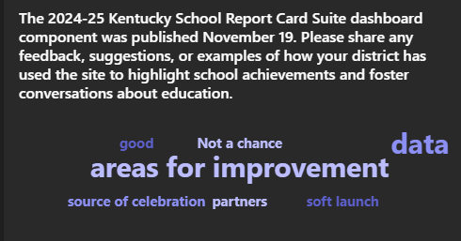
- Infinite Campus Server Migration: Scheduled Dec 19–21; impacts student/staff locator and records transfer. Q&A and training resources are available; Infinite Campus is the primary support contact. This migration does require tasks on the part of the district, and we ask that tickets be opened with Infinite Campus. ATC changes will be happening as well.
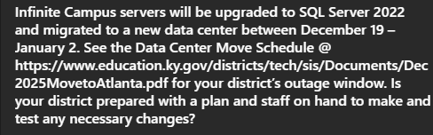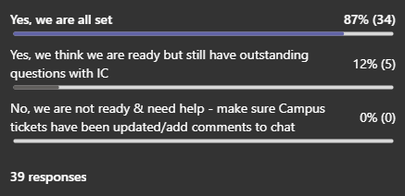
- Access Account Audit: Please check with the district KSIS point of contact to see if this information was reviewed. Districts must review system access and remove unnecessary vendor accounts.
- Interchange was a great event and over 135 districts were represented. If you were unable to attend or want to share the information, all of the KDE sessions and PowerPoints have been posted to the Campus community site.
- Training: There are some upcoming training courses around data privacy/other topics; please check out the KSIS Training page for details.
- Social Security Numbers: 22 districts have begun cleanup using the SSN Removal Tool. We encourage all districts to have these conversations locally and consider removing some staff and/or student SSNs to reduce your exposure and risk to cyberattacks. David also discussed a New York Times article giving the background of a stolen SSN. An SSN of a young person can be maliciously used for several years before it’s detected.

(12:17) KETS Additional Budget Request/Anticipated 2026 Legislative Topics: A bit of great news is that KASBO participants, during their recent conference, ranked KETS a #4 legislative priority as well. We greatly appreciate you taking time to discuss this ABR with your Superintendent and district leadership. Please continue helping us to champion for the increase in our KETS funding

Expected Legislative Topics:
- KETS ABR/2026-2028 Biennial Budget
- Kentucky Wired - We anticipate some legislation regarding Kentucky Wired/KCNA.
- Replacement of KEPS (teacher placement system) with cloud-based solution – There is a high probability that funding to replace KEPS for an off-the-shelf, cloud-based system will be discussed. There is an identified funding source.
- Pre-K Data System - Funding Pre-K for all students has been discussed for several years and there is now also discussion originating from the Governor’s office around creating a data system that provides some comprehensive data.
- Cleanup of outdated statutory language around a teacher computer purchase program statute and references in statute (5) to the Council for Education Technology or CET. Neither of these have been relevant for decades.
- Assessment & Accountability/Testing changes (standardized interim tests) – Any changes to the assessment and accountability program will impact online testing and the KY K-12 School Report Card dashboard.
- Modifications to the traceable electronic communications bill passed last session (SB181); as passed, the bill had some unintended consequences.
- AI-related legislation – This will be one of the HOT topics for 2026 with an emphasis on the protection of minors. David sent out the AI Task Force recommendations from SREB via email.
- Computer Science – There is interest by legislators/organizations to pursue computer science as a graduation requirement. Points from our 2025 Computer Science Annual Report:
  - Kentucky exceeds national averages in CS course offerings.
  - Middle school CS enrollment is highest in state (4,888 students).
  - Challenges: Female and minority participation remains low.
  - Strategies: Teacher certification pathways and district support emphasized.
- Data sharing initiatives.
Please note that this is not a comprehensive list and things change rapidly as session begins and continues through April 15, 2026.
(23:31) Updated AI information and resources for KY K-12 schools can be found at following link: AI in Kentucky K-12, December 2025 - Kentucky Department of Education. This expansive list of resources and informational points has been updated and includes the SREB AI Task Force recommendations. Districts are encouraged to explore free AI courses for K-12 students and teachers.

(25:44) 2025-2026 KY K-12 Digital Readiness Report available at the following links:

  - https://applications.education.ky.gov/trs_reports/,
  - https://docs.google.com/presentation/d/1fCFayrIHNP4YBlkAgUYa-AVEVTQUJN1J7-Upa1Oqfog/edit?usp=sharing

We went over the report extensively in our November webcast and David explained what information is available at the links above. A few items available in the reports were pointed out specifically:

- Updated statewide and district-level data available for technology planning,
- Includes trends and comparisons by region and district size, and
- Recommended as a starting point for upcoming tech planning cycles.
(28:42) KY K-12 Network Components Request for Proposal (RFP): The process has begun to establish an RFP for our network components; this will establish our purchasing mechanisms and support our KETS product standards. The current contracts expire June 30, 2027, and we have six contract holders with multiple resellers. We work backwards from this date to ensure we have contracts in place to meet procurement requirements of the Commonwealth and to also meet the requirements of E-rate eligible contract requirements at the federal level.

Mike shared the chart below showing the current level of purchasing with existing contract holders, with 70 to 80% of the total spend being E-rate eligible:

Current spending analysis
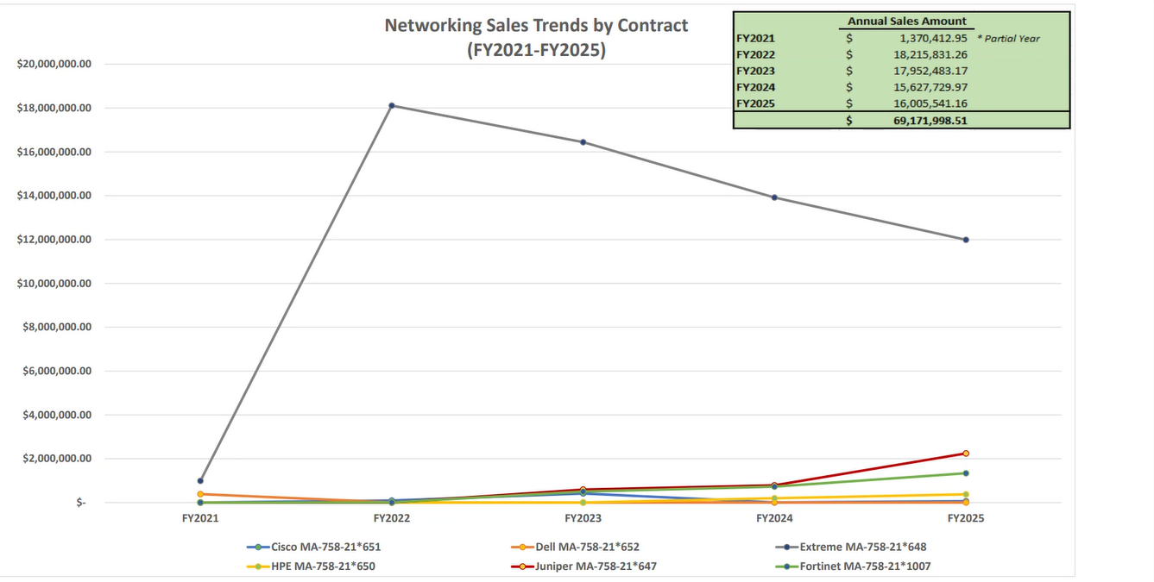

- KY K-12 CUES Identity Management System project update. Chuck Austin
(34:03) CUES (Connected User Experience System) Update: QUES (Connected User Experience System): Chuck shared details around the current status of the overall CUES implementation. He equated our current status to half time of a basketball game. We are winning but there are needed adjustments to win well. Appreciation was shared regarding all of the feedback we’ve received to help make our work internally and with our vendor partner even better. Each region has a representative that is on an advisory group, and this has been extremely beneficial.
- Multi-year, three prong program: identity management (Rapid Identity), IP services migration, and decommissioning legacy Active Directory.
- Current Progress: 95 districts engaged; 56 live with provisioning; focus on federation and cybersecurity features. We are beginning to go back and add-in some of the cybersecurity components.
- Needs: Resource adjustments in time and quantity with Identity Automation; more deliberate with pacing of cohort districts,
- Phase 2 is the IP Services move, and this is a non-service impacting activity but does require a MUNIS VPN swap.
- Pilots for transition of DNS and DHCP are in discussion; a schedule and readiness guide is forthcoming. Pilots will be testing the guide and the process so it can be extremely smooth for districts.
- On January 9 and 12, Region 1 and 2 respectively will be talking about transitioning from these legacy services.
- Goal: Complete AD decommissioning by June 30, 2027. The main goal is to do it right and do it well, but finances and resources play a part in our final date of completion.
- Testimonials of districts who are on the back side this are extremely positive. Efforts at the local level have been awesome!

(47:49) GoGuardian Implementation Update: Matt Jury and David Couch spoke about the number of districts that are on an old/unstable version, have completed a waiver, and are getting to a stable version (1.19.2) or later. KDE made the jump to 1.22.1 within KDE and we have seen some additional performance improvements. Paul Shoemaker confirmed that 1.22.1 is the newest approved version that is currently available.

GoGuardian Implementation Points:
- Transition from Lightspeed; monitoring version adoption.
- Critical threshold: districts should be on version 1.19.2 or later. This is the version where we saw considerable performance improvements.
- Ongoing work on reporting and waiver site tracking. We had 13 districts who originally requested a waiver, but it’s important that we continue to circle back to these districts with discussions about the financial impact and support/maintenance considerations.
(55:43) 2025 KY K-12 Computer Science (CS) Report: Sean Jackson shared the annual Computer Science Report as submitted to the legislature. The purpose of this report is to name and claim our students as we fulfill this legislative requirement. The full report can be accessed at https://www.education.ky.gov/districts/tech/Documents/2025CSReport.pdf:

Points from our 2025 Computer Science Annual Report:
- Kentucky exceeds national averages in CS course offerings.
- Middle school CS enrollment is highest in state (4,888 students).
- Challenges: Female and minority participation remains low.
- Strategies: Teacher certification pathways and district support emphasized.

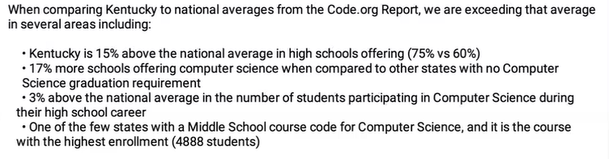

(1:01:11) December KY Board of Education (KBE) Meeting Update: The KBE met on December 3rd and 4th and OET had two items on the agenda:
- Certification of 704 KAR 8:010, Kentucky academic standards for computer science elective. This was recertified for an additional seven years with the understanding that we will be revising and modernizing them in the coming months.
- We Lead Computer Science Update that included Sean Jackson was shifted to February 2026 due to the illness of one of the panel of presenters.

(1:03:28) Cybersecurity Follow-Up/Poll Questions: Bob Hackworth discussed his reasoning behind the following poll questions posed to participants as a follow-up to last month’s discussion:

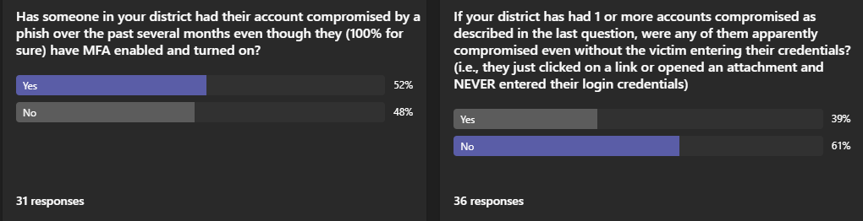
- Increased phishing attacks targeting credentials.
- Two main types:
  - Credential entry via form.
  - Compromise without credential entry (clicking links or opening attachments).
- Emphasis on user training as the most effective defense.

