Summary of the October 2025 KY K-12 Education
Technology Leaders’ Virtual Meeting

In case you missed it or want a refresher, the following is what we talked about during the October 24, 2025, EdTech leaders’ virtual meeting. A copy of the video and audio can be found at: https://mediaportal.education.ky.gov/technology/2025/10/edtech-october-2025/.

Public viewing of the archived webcasts and written summaries are also available on the KDE Media Portal at: https://mediaportal.education.ky.gov/technology/district-technology-leadership-webcast/ . Numbers in RED indicate the timestamp for that portion of the discussion so it can be easily located on the full digital recording.

This abbreviated Web”KAST” was broadcast from the Kentucky School Association of Technology (KAST) Fall Event being held at the Central Bank Center at Rupp Arena. We had a large group in the room and 100+ attending virtually. We will continue to make these available from our KDE media portal so that you can watch the archived discussion and share with the appropriate people in your district. Please remember that in addition to these webcasts being available on the KDE Media Portal, each month’s webcast is accompanied by these written summaries. We encourage you to share the link and all or any portion of these summary notes with staff throughout your district who may find the information beneficial to them in their position.

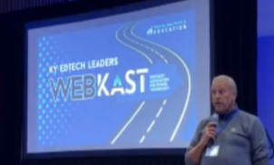

(00:38) KETS Funding Advocacy and Legislative Efforts: David led a discussion emphasizing the urgent need for increased Kentucky Education Technology System (KETS) funding, urging participants to advocate with their superintendents, chief financial officers, and legislators, and highlighting the financial consequences of inaction as well as the positive findings from the Auditor of Public Accounts. Please do your part to help get this funding request across the finish line.
- Additional KY K-12 EdTech funding needed going forward: David explained that KETS funding has not received a cost-of-living increase since 1992, and that the program is at a critical point due to increased demands and budget cuts, especially following the pandemic, making additional funding critical to maintain services.
- Advocacy Actions for Districts: Participants were encouraged to consistently communicate the importance of KETS funding to their superintendents, chief financial officers, and legislators, as district-level advocacy is seen as the most effective way to influence legislative outcomes.
- Financial Impact of Inaction: David detailed that without increased funding, districts would face a reduction through the KETS Offers of Assistance program as well as a potential 50-60% increase in costs for services currently provided by the state, as the state would no longer be able to absorb these expenses, directly impacting district budgets.
- Auditor’s Positive Findings: David referenced the Auditor of Public Accounts' extensive investigation, which identified KETS as a 'shining star' in Kentucky state government, and encouraged participants to use this recognition as leverage in their advocacy efforts.
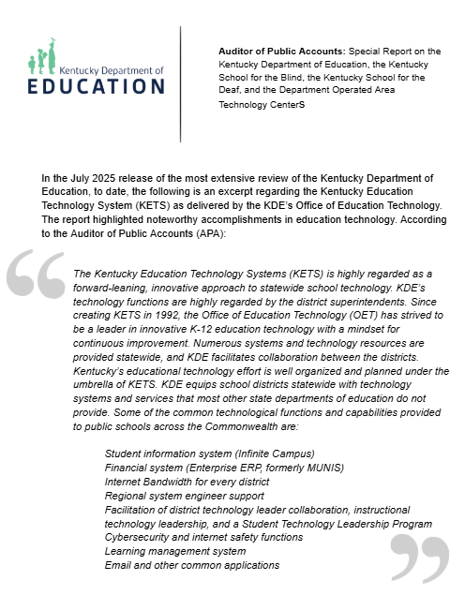

(5:30) Digital Readiness Feedback and Project Tomorrow Participation: Marty and David discussed the annual digital readiness feedback process, the high quality of current responses, and the importance of district participation in Project Tomorrow’s Speak Up initiative to incorporate student voice into technology planning.
- Annual Digital Readiness Survey: David described the process of collecting digital readiness feedback from all school districts in Kentucky, noting that the data is gathered in three ways—financial, inventory, and personnel—and is used to inform legislative advocacy and operational planning.
- Quality of Current Responses: Marty highlighted that the current year’s digital readiness responses are of the highest quality ever received, attributing this to the significant investment of time and effort by district leaders.
- Project Tomorrow and Student Voice: Districts were encouraged to participate in Project Tomorrow’s Speak Up initiative, which gathers student perspectives on technology use; about 20 districts are already involved, and Ben Maynard is leading this effort to ensure student input informs technology decisions.

(8:53) Connected User Experience (CUES) System Implementation Update: David provided an update on the statewide rollout of the Connected User Experience (CUES) system, noting the complexity of the initiative, the progress of early adopter districts, and the importance of collaboration and learning from those already live. A year ago, at this event we were launching into the design and implementation of the CUES initiative and now we have 36 districts who have transitioned. Districts in Cohort 2 are beginning this work. While creating a foundation for the future, this is hard work and change can be uncomfortable and difficult.
- Scope and Significance: David described the CUES system as the most complex and meaningful initiative since the inception of KETS, aiming to unify multiple systems for improved security and efficiency for students, teachers, and staff.
- Progress and Early Adopters: Thirty-six districts are currently live with the CUES system and serving as resources for other districts in the next cohort. Marty encouraged those beginning implementation to connect with these early adopters for guidance.
- Technical Challenges and Failover Testing: A recent AWS issue provided an unplanned test of the CUES system’s failover capabilities, with positive results in authentication and provisioning flows, demonstrating the system’s resilience even when other services experienced disruptions.
- Change Management and Collaboration: David acknowledged the challenges of organizational change, especially for HR and technical staff, and stressed the importance of collective effort to ensure the long-term success and sustainability of the CUES system.

(15:16) Modernization of Academic Standards and AI Integration: Artificial intelligence (AI) is an area with lots of attention right now and our legislature has been active in educating themselves and putting together an AI Task Force. We will see AI legislation in this upcoming session and feel sure we’ll be asked to come and present to them moving forward. Marty and David discussed ongoing efforts to revise Kentucky’s academic standards for technology, computer science, and library media, with a focus on integrating AI and inviting participants to join the revision teams.
- AI in Academic Standards: The team is reviewing and updating academic standards to include AI components, recognizing that AI will impact all subject areas, not just technology, and that both creation and usage of AI need to be addressed in the standards.
- Revision Process and Participation: Participants were invited to provide feedback on the current standards and to apply to join the revision/writing teams for technology, computer science, and library media, with Laura Raganas, Sean Jackson, and James Allen leading the respective efforts.
- Legislative and Community Engagement: The standards revision process is legislatively mandated and follows established procedures similar to other academic standards subject areas; feedback from districts and events like the CIO Summit is used to inform the process and legislative presentations.

(21:19) Student Technology Leadership Program (STLP) Updates: Jeff Sebulsky provided updates on the Student Technology Leadership Program (STLP), including upcoming registration deadlines, regional and state events, and a call for support from participants to help facilitate student opportunities.
- Registration and Event Deadlines: The deadline for STLP project registration is October 29, with regional events scheduled for November and the state championship set for Friday, April 24, at the Central Bank Center at Rupp Arena in Lexington. Before the state championship there will also be the Digital Art competitions, and we’d love to have you help us judge these events.
- Call for Volunteer Support: Participants were encouraged to assist with student presentations and provide feedback during regional and state events, helping to ensure students have the resources and opportunities to showcase their work.

