Summary of the August 2025 KY K-12 Education
Technology Leaders’ Virtual Meeting

In case you missed it or want a refresher, the following is what we talked about during the August 19, 2025, EdTech leaders’ virtual meeting. A copy of the video and audio can be found at: https://mediaportal.education.ky.gov/technology/2025/08/edtech-august-19-2025/.

Public viewing of the archived webcasts and written summaries are also available on the KDE Media Portal at: https://mediaportal.education.ky.gov/technology/district-technology-leadership-webcast/ . Numbers in RED indicate the timestamp for that portion of the discussion so it can be easily located on the full digital recording.

This was a joint meeting with our OET staff and all the districts joining via Microsoft Teams and/or YouTube. We will continue to make these available from our KDE media portal so that you can watch the archived discussion and share with the appropriate people in your district. Poll questions were posed throughout the meeting and district EdTech leaders were asked to respond as it assists us in planning and getting a feel for how to best move forward. Your voice and your feedback are important and extremely helpful to us. Please remember that in addition to these webcasts being available on the KDE Media Portal, each month’s webcast is accompanied by these written summaries. We encourage you to share the link and all or any portion of these summary notes with staff throughout your district who may find the information beneficial to them in their position.

It is the beginning of the 2025-2026 school year! A high percentage of school districts have started school and we hope everyone is having a good start. It takes a lot of time and energy to prepare for the beginning of the school year; we applaud you all for what you do and the dedication you have. There are a few additional school districts that will begin in the next few weeks.

(2:04) KBE, KET, KHSAA and Legislative Meetings Updates: There have been several impactful meetings in July and August as they relate to technology enabled systems:
- (2:34) Kentucky Board of Education and Legislative Updates: David Couch provided an overview of recent Kentucky Board of Education meeting held on August 7th, highlighting the reaffirmation of KETS funding as a top 4 budget priority, the push for increased funding, and legislative efforts related to the Kentucky Education Placement System (KEPS). Here is the clip of OET’s presentation to the KBE: https://youtu.be/uzu8h4DySr8.
  - KETS Funding Prioritization: David Couch explained that the Kentucky Board of Education reaffirmed KETS (Kentucky Education Technology System) as the #4 budget priority, following SEEK funding, transportation, and preschool. He encouraged participants to advocate for KETS funding with their superintendents and legislators, emphasizing the importance of raising the KETS budget by $14.6 million annually to maintain and expand services.
  - Legislative Advocacy for KEPS: David discussed the legislative push to secure funding for the Kentucky Educator Placement Service (KEPS), which would cover initial and ongoing costs for this system. The funding source exists, but legislative approval is required, and a concerted effort is underway to obtain this approval.
  - Auditor of Public Accounts Review: David referenced the Auditor of Public Accounts' (APA) extensive review of the Kentucky Department of Education, noting that the report highlighted noteworthy accomplishments in education technology. According to that recently released report in August 2025 by APA it states
    - “The Kentucky Education Technology Systems (KETS) is highly regarded as a forward-leaning, innovative approach to statewide school technology. KDE’s technology functions are highly regarded by the district superintendents. Since creating KETS in 1992, the Office of Education Technology (OET) has strived to be a leader in innovative K-12 education technology with a mindset for continuous improvement. Numerous systems and technology resources are provided statewide, and KDE facilitates collaboration between the districts. Kentucky’s educational technology effort is well organized and planned under the umbrella of KETS. KDE equips school districts statewide with technology systems and services that most other state departments of education do not provide. Some of the common technological functions and capabilities provided to public schools across the Commonwealth are:

- Student information system (Infinite Campus)
- Financial system (Enterprise ERP, formerly MUNIS)
- Internet Bandwidth for every district
- Regional system engineer support
- Facilitation of district technology leader collaboration, instructional technology leadership, and a Student Technology Leadership Program
- Cybersecurity and internet safety functions
- Learning management system
- Email and other common applications”
- (5:54) KET Funding Crisis and Emergency Broadcasting Role: David Couch serves on the KET board and reported on the recent Kentucky Educational Television (KET) board meeting, detailing the impact of federal funding cuts on KET's operations, its critical role in emergency broadcasting, and ongoing efforts to secure interim and long-term funding. David shared a PowerPoint via email with the agenda for you to reference.
  - Federal Funding Cuts to KET: David described how the Corporation for Public Broadcasting's funding, which supports 25% of KET staff and 75% of programming, was eliminated by Congress after 55 years. KET is now seeking interim funding through fundraising and preparing additional budget requests to the KY legislature to restore lost federal funds with state funds.
  - KET's Emergency Services: KET's 16 transmitters provide not only educational content but also critical emergency broadcasting services in partnership with agencies such as the FBI, the Kentucky Division of Emergency Management, the Forestry Service, the Early Warning System, the National Guard, the Transportation Cabinet, the National Weather Service, the Secret Service, and the State Police. Despite recent severe weather events, KET has remained operational with uninterrupted service.
  - Board Actions and Future Planning: The KET board, including David as the finance committee chair, is assessing the impact of the funding loss on schools and public services. They plan to put more emphasis on their fund raising as well as preparing additional budget requests for this upcoming KT legislative session. Currently, they are identifying which services may be reduced or eliminated and will provide further updates as the situation evolves.
- (9:58) Kentucky High School Athletic Association (KHSAA) Update: KHSAA holds an annual summer meeting and Marty Park represented KDE at this most recent meeting. During this year’s meeting, they discussed the revision to the data metrics around the classification system for football. Technology enabled services are embedded in the work of KHSAA and they are making the transition to use shared, cloud-based services. Within the eSports discussion, the question went out about whether to make any scheduling changes—they will continue with a Fall season and a Spring season with most of the competition titles remaining the same.
- (14:59) Presentation of KDE Performance Review by the Auditor of Public Accounts (APA): The APA office presented the special examination of KDE to the Interim Joint Committee on Education on August 18.

(16:41) Technology-enabled RFPs Underway that you may not be aware of:
- Telehealth RFP for KY K12 Schools: David Couch informed participants about a new telehealth RFP for K12 schools, emphasizing the need for technology compatibility and the agency's involvement in the evaluation process. We only became aware when KDE was asked to submit a name to be part of the RFP review/evaluation committee.
  - Telehealth RFP Details: A new telehealth RFP, managed by an external agency, is open for K12 schools. David noted the importance of ensuring selected solutions are compatible with school technology environments and that the agency will have representation on the evaluation committee to advocate for these needs.
  - Cost and Participation: David clarified that while the service may be offered at no cost to districts, there could be costs at the state level. Districts interested in telehealth services should be aware of this opportunity and potential implications.

(18:26) GoGuardian and Firewall Performance Improvements: David Couch and Matt Jury detailed significant performance improvements in the GoGuardian environment and state firewall services, including the rollout of version 19.6, the importance of client installation for compliance, and lessons learned from recent network changes.
  - GoGuardian Client Rollout and Performance: David explained that the 19.6 version of the GoGuardian client for Windows and Mac OS, released in early August, has led to substantial performance improvements. The majority of Chromebooks, primarily used by students, did not experience issues, but Windows and Mac OS devices, mainly used by adults, benefited from the update. Polls showed that 52% of those who installed the update reported better performance. We will continue to monitor and work with our vendor partner on these performance issues.

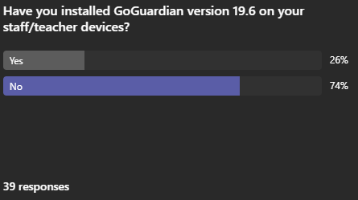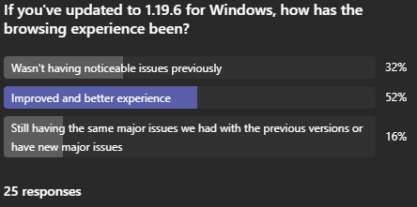
  - Compliance and Tracking Requirements: David emphasized the legal requirement for districts to have both filtering and tracking on all school-issued devices, including those taken off campus. He cautioned against removing the GoGuardian client from Windows and Mac OS devices, as this would result in non-compliance with state and federal laws and loss of tracking capability.
  - Firewall Filter Adjustment: A filter added to the state firewall in May, intended to prevent circumvention of content management systems, inadvertently degraded network performance. The filter was quickly removed after the issue was identified, resulting in immediate improvement. David and Matt stressed the need for careful change management and avoiding major changes at the start of the school year.
  - Network Outage and Change Management: Matt recounted a network outage caused by a vendor error during a circuit test, which led to multiple outages totaling about an hour. Protocols have been implemented to prevent recurrence, and all non-essential network changes are postponed until mid-September to ensure stability during the school year start.

(38:38) Last Thursday Network Outages/Lessons Learned: Matt Jury shared that through a recent circuit cleanup effort this past Thursday, we experienced a string of short outages that impacted the majority of our school districts. The intentions were good but it was very poor timing and resulted in some unintended consequences.

This is similar to our previous topic where we really need to emphasize and follow our change management process and only put in those emergency/unavoidable changes to correct a critical outage or situation. Another very important consideration is that you have communicated any change to all parties that would/could be impacted. The beginning of the school year is absolutely the worst time to make any changes within our enterprise network configuration. We will continue to work with our vendor partners and other offices to educate and emphasize this practice.

(43:21) KY K-12 Data Systems Update: Dede Connor and Robert Hackworth provided updates on the school report card portal, Social Security number removal tool, Infinite Campus training, cybersecurity health checks, and MFA adoption, with David Couch and Chuck contributing to related discussions. School Report Card and Data Review: Dede announced the opening of the school report card portal for data review and data entry, with specific domains open for five weeks and a partial public release scheduled for early October. She reminded districts of the requirement to post the School Profile Report by October 1.
  - Social Security Number Removal Tool: Dede and David discussed the launch of a tool to remove old Social Security numbers from district systems, highlighting its importance for cybersecurity. The state recently removed 3.6 million Social Security numbers dating back to 2007, and districts are encouraged to use the tool to reduce risk.
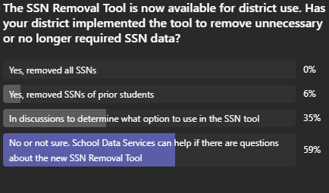
34 Responses
  - Cybersecurity Health Checks and MFA: Bob Hackworth polled districts on the status of their cybersecurity health checks and the adoption of multi-factor authentication (MFA). He noted increased attacks on MFA and sought feedback on staff reluctance to use authenticator apps, clarifying that such use does not expose personal phones to open records requests.
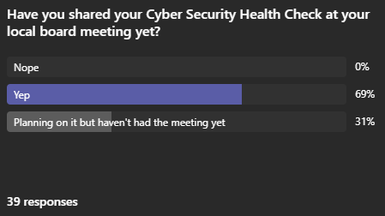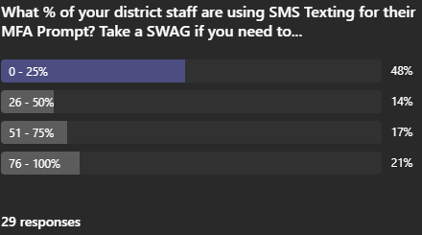
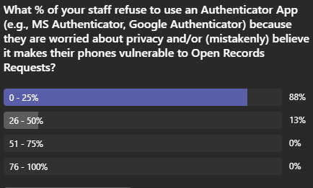
48 Responses
  - Infinite Campus Training and Access Management: Dede reminded districts about upcoming Infinite Campus user group training, the importance of updating access roles as staff change, and the use of the people role manager application to ensure correct permissions and accurate communications. For details on the following training opportunities, go to the KSIS Training webpage.

Other Items:
- eTranscripts – 2025 graduates have until Aug. 31 to order eTranscripts at no cost.
- Additional Poll Question:
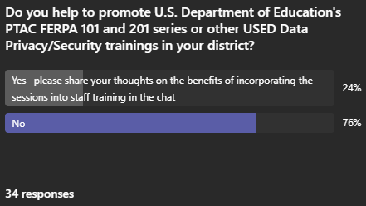

(50:43) Operational and Beginning-of-Year Reminders: Chuck and David provided a comprehensive list of operational reminders for districts and staff; the CIO agenda David referenced while speaking quickly to these topics will be sent out to everyone as regional meetings are held.
- Top Reminders:
  - 1) One of the most important operational reminders is to notify the KETS Service Desk if there is a planned power outage; this is very similar to us trying to emphasize change management.
  - 2) We also need a lot of advance notice if you plan to remove your district hub site.
  - Annual Infinite Campus Invoices were due Aug. 15
  - CUES Cohorts Update: We’ve extended the number of cohorts from 4 to 5 with the Cohort #2 beginning in October 2025
  - Antivirus Funding and Recommendations: David reiterated that state funding for third-party antivirus on Windows devices is ending, and districts should evaluate whether Microsoft Defender is sufficient or use local funds for alternatives. Recommendations have been provided to assist with this transition.
- IP Services and Infoblox Deployment: As part of the Cues initiative, districts are transitioning from Active Directory to Volta/Infoblox for IP services, with planning underway to ensure compatibility with existing DNS configurations.
  - Operational To-Do List: Chuck and David reviewed key beginning-of-year tasks, such as notifying the KETS service desk of planned power outages, updating Internet hub site relocation plans, ensuring correct state and regional distribution lists, and reviewing technology plans and commodity codes with CFOs.
- E-Rate and Technology Activity: Districts were reminded to set up E-rate EPC portal accounts, review PIA requests, and use the streamlined technology activity report, which now uses 14 commodity codes. The info is required by law and informs board presentations and funding calculations. This gives us the best grasp of the education technology funds spent by a district. It is used extensively and incorporated into a variety of things.

Chuck summed up this portion by sharing that over the years, he has grown to embrace what he calls “Blessed Chaos”. Our edtech community has been in this season for the last three years. We have had a LOT going on and it is a challenge to keep it all moving and balanced. It’s been a super busy summer and the beginning of school is now here.

(58:19) Digital Readiness and Student/Teacher Voice Initiatives: David Couch and Marty discussed the importance of the Digital Readiness Survey, the launch of the Speak Up Cohort for 2025-26, and efforts to incorporate student and teacher voice into technology planning, with support from Ben Maynard. If you’d like to participate this year, please work with your KETS Engineer and we’ll get you lined up with Ben Maynard who leads this effort.
  - Digital Readiness Survey: David highlighted the annual Digital Readiness Survey, open until September 15, as a critical tool for legislative advocacy, board reporting, and statewide technology planning. The survey data is used extensively in reports and presentations.
  - Speak Up Cohort Launch: Marty announced the 2025-26 Speak Up cohort, aiming for 25-30 participating districts. The survey, free to districts, collects student, teacher, and family perspectives on technology use and is aligned with Kentucky's digital readiness and edtech planning.
  - Survey Customization and Analysis: This year's Speak Up survey features a Kentucky-customized survey with a shorter format. It is developed with Project Tomorrow and supported by grant funding. Results will be analyzed to inform statewide and district-level technology strategies.

Other Items to Note:
- USDOE announces release of $87M in previously approved but held up Title funds to KY K-12. This impacts funding for KY K-12 Digital Learning Coaches, STLP coach stipends and school technology coordinator stipends.
- Additional Program and Technology Updates: David, Dede, and other staff shared updates on school library media access, digital learning events, and upcoming KAST events, with reminders about software updates and new opportunities for students.
  - Network Nomenclature Update: David announced the transition from the 'Kentucky Education Network (KEN)' to 'Next Generation Kentucky Internet (NGKI)' in all communications and status reports, urging staff to update their terminology accordingly.
  - School Library Media and Digital Learning: Laura encouraged participation in digital learning events and the use of the Digital Learning calendar.
  - KAST and Other Events: The Kentucky Association for School Technology (KAST) fall event is scheduled for October 24, 2025, in Lexington at the Central Bank Center, with the main event on March 2026 in Louisville.
- David received the latest copy of The Kentucky School Advocate and they have some good information about traceable communications. If you get a chance, please review: https://www.ksba.org/protected/ArticleView.aspx?iid=6Y03332&dasi=1B
- The final 2025 Bill Stilwell award was presented to Robin Wolfe Morley at the August OET Team Huddle. This is the most prestigious award we present. Robin led the MUNIS deployment effort along with several other high-level initiatives as well as serving in KDE three separate times.

