**Summary of the March 2025 KY K-12 Education**

**Technology Leaders’ Virtual Meeting**

In case you missed it or want a refresher, the following is what we talked about during the March 18, 2025, EdTech leaders’ virtual meeting. A copy of the video and audio can be found at:

<https://mediaportal.education.ky.gov/technology/2025/03/edtech-march-2025/>.

Public viewing of the archived webcasts and written summaries are also available on the KDE Media Portal at: <https://mediaportal.education.ky.gov/technology/district-technology-leadership-webcast/> . Numbers in **RED** indicate the timestamp for that portion of the discussion so it can be easily located on the full digital recording.

This was a joint meeting with our OET staff and all the districts joining via Microsoft Teams and/or YouTube. We will continue to make these available from our KDE media portal so that you can watch the archived discussion and share with the appropriate people in your district. Please remember that in addition to these webcasts being available on the KDE Media Portal, each month’s webcast is accompanied by these written summaries. We encourage you to share the link and all or any portion of these summary notes with staff throughout your district who may find the information beneficial to them in their position.

**KySTE 2025 Feedback –** William Pierce provided a few comments in the Teams chat and they are included here: *“KySTE '25 was a fantastic experience! I want to extend my heartfelt gratitude to everyone for making KySTE '25 a success! A special thank you to the Board for their tireless efforts in organizing this fantastic event. Your dedication and hard work truly shone through.*

*To all our attendees, thank you for your enthusiastic participation and commitment to connecting minds and igniting imagination. Your presence and engagement were key to the conference's success.*

*As we look to the future, we are excited to announce the transition from KySTE to the Kentucky Association for School Technology (KAST). This change reflects our desire to expand our offerings to members, focusing on continued learning, development, and achievement. We look forward to growing together and achieving even greater heights.”*

**(1:08)** [**STLP State Championship**](https://stlp.education.ky.gov/state) **–** We always shift gears to this event as our next BIG thing after the completion of the KySTE CIO Summit with a special shoutout to the STLP Engineers for their great work at the KySTE Conference. We are deep in the planning process and we have about a month to make this the best championship ever. We’ll have almost 20,000 folks on site and we are very excited for a great day. Jeff provided details about the upcoming STLP State Championship on April 23, 2025, at Rupp Arena in Lexington, KY, emphasizing the importance of the event in showcasing students' use of technology and the preparations being made for logistics, food, and volunteer judges.

* **Student Participation:** Jeff emphasized the event's role in celebrating students' use of technology, showcasing their skills, and the support provided by digital learning coaches and teachers.
* **Logistics:** Jeff discussed the logistical preparations, including managing traffic with the Lexington Police Department, ensuring efficient bus drop-offs, and addressing construction around the venue.
* **Food Arrangements:** Jeff mentioned the availability of pre-ordered lunches, the option for districts to bring school-prepared lunches, and the efforts to have multiple food kiosks open to accommodate the large number of attendees.
* **Volunteer Judges:** Jeff called for volunteer judges, particularly Level 3 judges, to help evaluate state championship projects, emphasizing the importance of having knowledgeable and experienced judges for the event.

**(13:39) CIO Summit Feedback -** We had each presenter review their topic using the full “One Big Idea” Document. We have provided some overall comments for each topic, but discussion was specific to the full feedback document. Following along on the audio while accessing the document might be helpful. See Part 1 of the attached Word document.

**Topic 1 – Artificial Intelligence in K-12**

AI hit the scene a little over 2 years ago and, overall, we are finding that it is “getting baked into everything” and does need to be included in our responsible use policies. Our KETS Master Plan was the cornerstone for our questions and also what our table comments were pushing on!

*Our KETS Master Plan includes an Area of Emphasis calling for us to encourage, engage, and empower the safe, secure, and responsible uses of AI into school efficiency and the learning space by teachers and students, ensuring humans remain in the loop with strong AI implementations. This area of emphasis was constructed from YOUR feedback from the two previous years’ CIO summit. Today we know that AI will definitely impact our work, sooner rather than later, in major ways.*

*The Southern Regional Education Board (SREB) has sponsored a commission on AI in education.  Kentucky has a leadership seat in the commission. The Commission’s* [*first seven recommendations*](https://nam11.safelinks.protection.outlook.com/?url=https%3A%2F%2Fwww.sreb.org%2Fai-commission-recommendations&data=05%7C02%7Clisa.moore%40education.ky.gov%7C30fea096ec6141fd70c108dd79388466%7C9360c11f90e64706ad0025fcdc9e2ed1%7C0%7C0%7C638800006303737096%7CUnknown%7CTWFpbGZsb3d8eyJFbXB0eU1hcGkiOnRydWUsIlYiOiIwLjAuMDAwMCIsIlAiOiJXaW4zMiIsIkFOIjoiTWFpbCIsIldUIjoyfQ%3D%3D%7C0%7C%7C%7C&sdata=rpR54hCKAt4zx%2B2FNOFHEQ5gSGVuxQDtRPI5bwbksVE%3D&reserved=0) *are designed to help states move forward, assisting schools and postsecondary institutions with efforts to adopt AI.*

**Guiding Questions:**

1. Regarding AI in K-12 education, has there been a major noticeable or unnoticeable difference thus far, operationally, educationally and/or administratively in your district?   Yes/No
2. If there is a major noticeable difference, what are those differences?
3. Do you know or anticipate any noticeable differences of AI, operationally, educationally and/or administratively in your district over the next 12-24 months?  Yes/No
4. If yes, what are they?
5. While AI can greatly benefit education, what are your biggest concerns and apprehensions related to AI in education and beyond education that need boundaries.
6. Over the past 2 years, we have shared with districts and KDE organizations, guidance, policy recommendations, research, studies, legislative presentations, uses in the classroom, and skills required in the workforce. Is there anything else that has a sense of urgency, that is related to AI, that districts would like KDE or some other organization to help provide to districts?

* **CIO Summit Feedback on AI:** David Couch shared the feedback from the CIO summit regarding the noticeable difference AI has made in districts over the past two years, with 60% of participants acknowledging its impact on instructional, administrative, and operational aspects.
  + **Specific Uses:** David detailed various uses of AI, including streamlining teacher processes, translating documents, analyzing staff performance, creating lesson plans, and teaching students responsible AI use.
  + **Challenges:** David mentioned challenges such as the stigma of AI being associated with cheating, the need for responsible use policies, and the importance of AI training for staff to address privacy concerns and ethical use.
* **Future Impact of AI:** David Couch discussed the anticipated noticeable difference AI will make in the next 12 to 24 months, with 98% of participants expecting significant changes in various areas, including instructional tools, administrative processes, and technical support.
  + **Examples:** David provided examples of anticipated AI uses, such as AI-driven instructional tools, administrative efficiency improvements, and enhanced technical support for networking and data analysis.
  + **Training and Ethics:** David emphasized the need for ongoing AI training for staff and the importance of addressing ethical concerns and responsible use to maximize the benefits of AI in education.

**Topic 2 – Additional Budget Request for KETS**

*Since 1992 multiple factors have taken a toll on funding for the KETS Program, from cuts and absorbing cost increases to multiple unsuccessful attempts to raise the KETS Funding appropriation from $15.4M to $30M.*

*The consequences of not receiving a raise in KETS funding in the 2026-2028 Biennial Budget involve several tough decisions with some services no longer being provided unless an alternate funding source from a different area is identified at a higher cost, as well as the greatly reduced usability of some mission critical systems/resources.*

*Time is running out to bring KETS Program Funding to the forefront as a Legislative priority for action during the 2026 Session by leveraging available and new channels to inform and engage Superintendents, other District Leadership, Local Legislators, and stakeholders. Participation by and feedback from districts on strategies to connect with decision makers is an absolute must for securing these additional education technology targeted funds and averting these consequences.*

**Guiding Questions:**

1. Have you shared the financial impact with your Supt and CFO of shifting certain state service costs to the district where the district will pay 50-100% more for that same shared service?
2. If yes, what was the reaction?
3. If no, why not?
4. What is your known or gut feeling of your district’s Supt and CFO being very supportive of the KETS ABR in relationship to SEEK?
5. What are your suggestions as it relates to lobbying the legislature for the KETS ABR given KDE is not permitted to hire lobbyists and districts can’t afford them?

* **Financial Impact of KETS Funding:** Mike Leadingham and Amy Young discussed the financial impact of KETS funding on districts, emphasizing the importance of understanding the magnitude of the situation and the need for detailed information to share with district leadership. The overwhelming majority of our districts have had conversations with their Superintendents and Chief Financial Officers (CFOs) about the need to lobby for additional KETS funding. We need to keep in mind the matching and purchasing power of a KETS dollar and it sometime appears we are in competition with the SEEK funding. We shared the one-pager prepared to accompany our KETS Additional Budget Request (ABR) and that can be shared electronically--the specifics of those dollar amounts have also been shared in our summary notes.
  + **Detailed Information:** They emphasized the importance of providing detailed information to superintendents and CFOs to ensure they are aware of the financial implications and the need for careful planning and prioritization.
  + **Purchasing Power:** Amy explained that KETS funding provides greater purchasing power compared to SEEK funding, due to state-level discounts and matching components, making it more cost-effective for districts.
* **Superintendent and CFO Support:** Mike Leadingham highlighted the importance of district superintendents and CFOs being supportive of the KETS annual budget request, noting the need for clear communication and understanding of the impact on/sustainability of technology programs.
  + **Clear Communication:** He emphasized the need for clear communication with district leadership to ensure they understand the impact of KETS funding on technology programs and the potential consequences of reduced funding.
  + **Competing Priorities:** Mike acknowledged the challenge of competing priorities within districts, highlighting the need for technology leaders to effectively advocate for the importance of KETS funding in the context of overall district needs.
* **Lobbying for KETS Funding:** Many don’t realize that KDE, as a state government agency, is not allowed to have or employ lobbyists. Mike Leadingham discussed suggestions for lobbying the legislature for KETS funding, including leveraging vendor partners, working through co-ops, and organizing informative events to educate legislators and other stakeholders about the importance of KETS funding.
  + **Community Involvement:** He suggested involving community stakeholders, teachers, and parents in advocacy efforts to create a united front and emphasize the importance of KETS funding for educational technology.
  + **Legislative Engagement:** Mike recommended face-to-face meetings between superintendents and legislators, as well as inviting legislators to events like KySTE and STLP to demonstrate the impact of KETS funding on student success.

**Topic 3 – Maximizing Cybersecurity Opportunities in K-12**

*Keeping in mind there’s no pile of money to purchase new services to shrink the cybersecurity gap, there are still features, functions and services that can increase security. KETS has required a number of statewide security upgrades over the past several years to increase our security posture and set a more modern security baseline given the onslaught of cyberattacks. Items such as MFA, SSPR, SSO have been a part of our baseline for a while, but we’d like to add a few more things, many of which your district may already be doing. We want to standardize the stuff that matters across the state/in every district.*

**Guiding Questions:**

1. Please rank the following cybersecurity options and settings that you’d like to see become part of the statewide security baseline. Keep in mind that funding is a challenge for new and even continuation of some current services. By and large, these are SETTINGS and not ACTIONS. An ACTION would be like training users about phishing while a SETTING is more like turning on email caution banners. While Training is an ACTION, it’s important enough to add to this list.

* EXAMPLE ONLY - CISA’s External Network Scanning Service (already requiring)
* EXAMPLE ONLY - Antivirus/Endpoint Protection (already requiring)

**RANKING GROUP 1**

1. Ongoing end-user security awareness and training (will need team to develop/find and approve)
2. Deploy Microsoft’s Local Administrator Password Solution (LAPS) even if Local Admin Permissions are removed
3. Remove/reduce Local Admin Permissions from as many Windows device users as possible. Could also separate the regular user account from Local Admin Account on device.
4. Student Password Strengthening (no more patterns/use of SSID/etc.)
5. Geo-block all authentication to KETS cloud accounts from outside the USA
6. Implement Rapid Identity’s PhishID

**RANKING GROUP 2**

1. Implement Caution Banners for email (from unknown/untrusted senders AND could include certain common phisher keywords like “kindly,” “invoice,” or “action”)
2. Disable SMTP Authentication for email (Complete for Google Workspace districts already)
3. Add Suspicious Inbox Manipulation rule in Defender
4. Restrict student email inbound/outbound to specific domains or lists
5. Finalize DMARC/DKIM settings
6. Cybersecurity is demanding more and more attention. Let’s discuss one way KDE might be able to help.
7. Why are you not able to keep up?  (recent feedback from districts frequently states that districts struggle with keeping up with Cybersecurity)
8. Do you want KDE to do a bid for a service **that districts use their local funds to obtain** to help you keep up and be more proactive with Cybersecurity? Think: Security monitoring, threat detection and response; essentially Security Operations Center as a Service (SOCaaS) **Yes/No**
9. Would you ACTUALLY pursue this AND do you have funding?  (Partner with a service provider) **Yes/No**

* **Cybersecurity Priorities:** Bob Hackworth presented the ranking of cybersecurity priorities, with geo-blocking authentication to KETS cloud services and ongoing end-user security awareness training being the top priorities identified by participants. Ranking Group 1 responses are below:

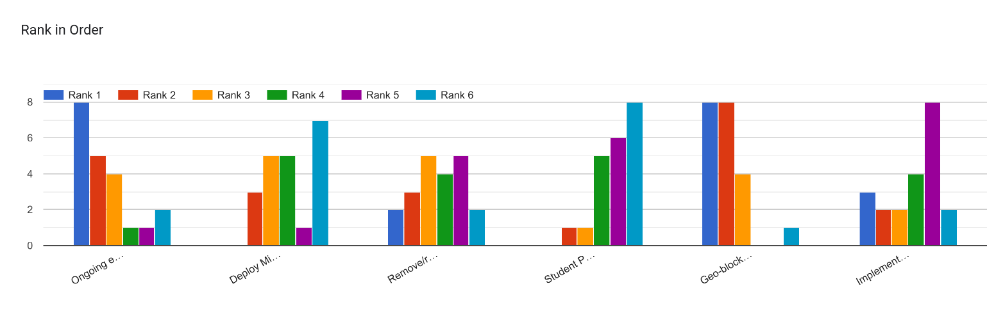

* + **Additional Measures:** Other important measures included implementing PhishID from Rapid Identity, removing local admin permissions, deploying Microsoft LAPS, and strengthening student passwords.
  + **Email Security:** Bob highlighted the importance of finalizing DMARC/DKIM settings, implementing caution banners for emails, and restricting student email to specific domains to enhance email security. Ranking Group 2 responses are below:

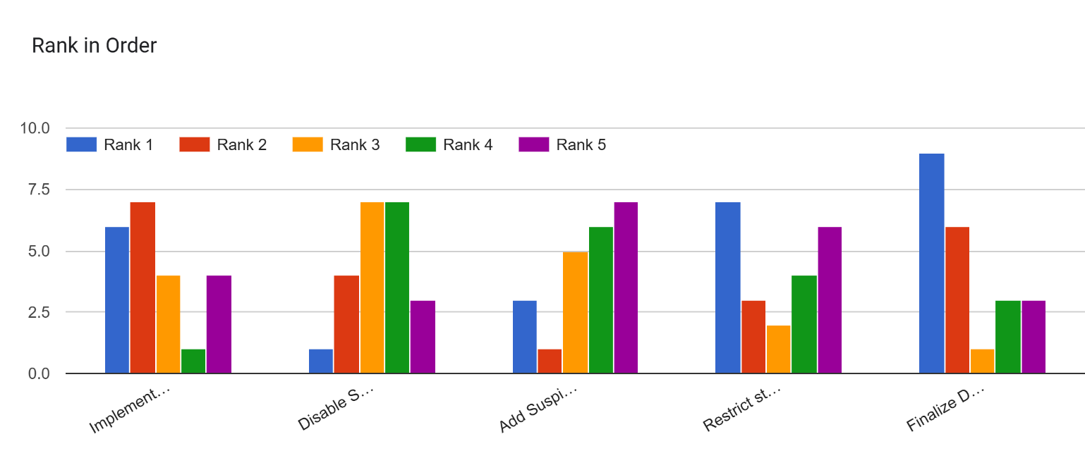

* **Challenges in Cybersecurity:** Bob Hackworth discussed the challenges districts face in keeping up with cybersecurity demands, including limited resources, the need for external support and training, and the importance of proactive communication and alerting.

Topics 4 and 5, along with the remaining questions on Cybersecurity, were shifted to the agenda for the April district edtech leaders’ webcast. Also, as a reminder, there will be upcoming special webcasts/discussions on Active Directory (AD) and Trellix’ Endpoint Security.