**Summary of the January 2025 KY K-12 Education**

**Technology Leaders’ Virtual Meeting**

In case you missed it or want a refresher, the following is what we talked about during the January 21, 2025, EdTech leaders’ virtual meeting. A copy of the video and audio can be found at:

<https://mediaportal.education.ky.gov/technology/2025/01/edtech-january-2025/> .

Public viewing of the archived webcasts and written summaries are also available on the KDE Media Portal at: <https://mediaportal.education.ky.gov/technology/district-technology-leadership-webcast/> . Numbers in **RED** indicate the timestamp for that portion of the discussion so it can be easily located on the full digital recording.

This was a joint meeting with our OET staff and all the districts joining via Microsoft Teams and/or YouTube. We will continue to make these available from our KDE media portal so that you can watch the archived discussion and share with the appropriate people in your district. Poll questions were posed throughout the meeting and district EdTech leaders were asked to respond as it assists us in planning and getting a feel for how to best move forward. Your voice and your feedback are important and extremely helpful to us. Please remember that in addition to these webcasts being available on the KDE Media Portal, each month’s webcast is accompanied by these written summaries. We encourage you to share the link and all or any portion of these summary notes with staff throughout your district who may find the information beneficial to them in their position.

**(2:30) KY K-12 Internet Content Management System in KY K-12 Districts & KDE Organizations:**

**Internet Content Management System Implementation:** David Couch discussed the implementation of the Internet content management system, emphasizing the importance of the July 2025 deadline. He provided historical context, mentioning the 1998 law and the evolution of content management systems and associated applications/platforms. This1998 bill and associated regulation have stood the test of time and remain relevant today.

* **Implementation Deadline:** David Couch emphasized the importance of implementing the Internet content management system by July 2025, highlighting the urgency and necessity of meeting this deadline.
* **Historical Context:** David Couch mentioned the 1998 law (SB230) that required Internet content management and the evolution of these systems from 1995 to the present. Acceptable use/Responsible use policies are the fundamental principles behind this discussion.
* **System Requirements:** David Couch explained the requirements for the new system, including the ability to filter, block, track, and inspect Internet usage, and the importance of adhering to existing laws and regulations.
* **District Responsibilities:** David Couch clarified that districts have the responsibility to decide what content to block or allow, and that the state agency does not block any content directly.
* **Transition to GoGuardian:** David Couch mentioned the transition from Lightspeed to GoGuardian as the new Internet content management system, with the state covering the cost for the GoGuardian Admin product statewide. By law, we must provide this service at no cost to the district; however, this is one product standard where a district may request a waiver and use an alternate product that is purchased using their 100% district funds.

**(13:02) GoGuardian Introduction:** David Couch introduced the internal, OET GoGuardian team who will play a significant role in the implementation of the Internet content management system. The team includes Jody Rose as the product manager and Jennifer Devine as the project manager. Jody provided some background and details on the contract award and asked for everyone’s patience. Once it gets going, this will move quickly. After the next few weeks, we will have a much better plan and idea of how to proceed while ensuring a successful implementation. This is considered a white-glove service. We discussed the poll questions included below and talked about the feedback form that all districts will be asked to complete very soon. There were multiple questions fielded via the chat and this will serve as a basis for developing a feedback process. David Couch clarified the roles of the GoGuardian team members, emphasizing their responsibilities in ensuring the successful implementation of the new system as well as the partnership with GoGuardian and the collaborative efforts required to meet the implementation goals.

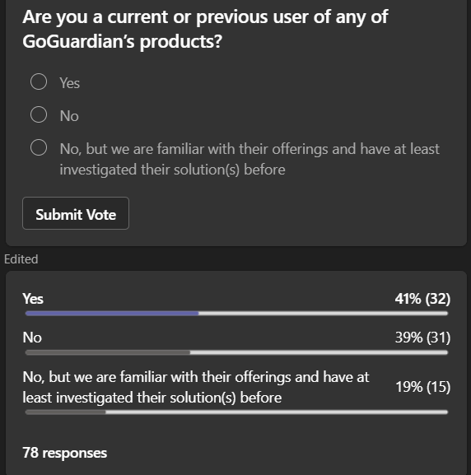

**(26:45) GoGuardian:** John Buchanan began the GoGuardian presentation and expressed how excited they are to be the chosen vendor. Below is the team GoGuardian has assembled to work with us on this transition/implementation:

**GoGuardian Admin Product Overview:**

John Buchanan provided a quick overview of the company and then Brian Larkin focused on the GoGuardian Admin product. He emphasized the product's ease of use, reliability, and superior support. A few of the slides from the presentation have been included below:

* **Product Features:** Brian Larkin highlighted key features of the GoGuardian admin product, including dynamic content detection, YouTube controls, and the parent app for parental control over Internet access at home.

* **Ease of Use:** Brian Larkin emphasized the product's ease of use, with a user-friendly interface and intuitive workflow designed to help administrators manage Internet content effectively.

* **Reliability:** Brian Larkin assured participants of the product's reliability, with high uptimes and consistent performance to ensure continuous protection for students.

* **Superior Support:** Brian Larkin highlighted the superior support provided by GoGuardian, with a dedicated support team available to assist users and ensure smooth operation of the product.

**(40:37)** **Implementation and Training Plan:** Nieshe Washington outlined the implementation and training plan, which includes gathering information from districts, scheduling implementation calls, and providing professional services and customer education. The goal is to ensure a smooth transition and long-term success.

* **Information Gathering:** Nieshe explained that the first step in the implementation plan is to gather information from districts about their device landscape and other relevant details to tailor the implementation process. She shared the following timeline:

* **Implementation Calls:** Nieshe mentioned that implementation calls will be scheduled with districts to discuss specific needs and ensure a smooth deployment of the GoGuardian admin product.
* **Professional Services:** Nieshe highlighted the availability of professional services to support districts during the implementation process, including technical onboarding, product training, and ongoing consultation.
* **Customer Education:** Nieshe emphasized the importance of customer education, with modular training courses, webinars, and continuous learning opportunities to ensure users are well-equipped to use the product effectively.

**Device Support:** Steven Hardwood confirmed that GoGuardian admin supports Windows, Mac OS, and iOS devices through the GoGuardian app. The team will work closely with districts to ensure successful deployment and testing.

**Filtering Beyond School Campus:** Brian Larkin explained that GoGuardian admin offers at-home mode, allowing differentiated filtering for school and non-school hours. The parent app also enables parents to control Internet access on school-issued devices at home.

**Continuous Learning:** David Couch emphasized the importance of continuous learning for both KDE and school districts. The GoGuardian team will provide ongoing training and support to ensure effective use of the product.

**Closing Remarks:** David Couch concluded the open session, thanking the GoGuardian team and participants. There was a Q & A section and David pointed out that we will learn a lot with KDE being the initial implementation. He also mentioned that the current regulation is going through the recertification process internally and we anticipate modernizing terminology and language of that regulation in the very near future. Jody said we will do our best to respond to all of the questions. Please give us a few weeks to create a feedback process.

If interested, we recently did a GoGuardian demo with interested KY K-12 school districts and OET staff members. This is the link to the demo of the GoGuardian Admin product that will be implemented in and used by everyone in KDE organizations and in all KY K-12 districts ([link](https://nam11.safelinks.protection.outlook.com/?url=https%3A%2F%2Fdrive.google.com%2Ffile%2Fd%2F1GFdc0Y-kJwPWigWXbgd2l3yW3ECwp6Tj%2Fview&data=05%7C02%7Clisa.moore%40education.ky.gov%7C0702c145b3134ac4825f08dd4f9e44f3%7C9360c11f90e64706ad0025fcdc9e2ed1%7C0%7C0%7C638754263515202983%7CUnknown%7CTWFpbGZsb3d8eyJFbXB0eU1hcGkiOnRydWUsIlYiOiIwLjAuMDAwMCIsIlAiOiJXaW4zMiIsIkFOIjoiTWFpbCIsIldUIjoyfQ%3D%3D%7C0%7C%7C%7C&sdata=ySvuOyEFVfyFWue9M203PaBdzfDUKL9BaAkD%2FyfAgl0%3D&reserved=0)). You’ll need to fast forward to the 9-10 minute mark, because the demo started the recording before the session truly began.

After this GoGuardian presentation concluded, we transitioned into a closed session to discuss recent cybersecurity happenings with just districts and OET staff.