Summary of the July 2024 KY K-12 Education
Technology Leaders’ Virtual Meeting

In case you missed it or want a refresher, the following is what we talked about during the July 16, 2024, EdTech leaders’ virtual meeting. A copy of the video and audio can be found at:
hhttps://mediaportal.education.ky.gov/technology/2024/07/edtech-july-2024/.

Public viewing of the archived webcasts and written summaries are also available on the KDE Media Portal at: http://mediaportal.education.ky.gov/. Numbers in RED indicate the timestamp for that portion of the discussion so it can be easily located on the full digital recording.

This was a joint meeting with our OET staff and all the districts joining via Microsoft Teams and/or YouTube. We will continue to make these available from our KDE media portal so that you can watch the archived discussion and share with the appropriate people in your district. Several GoSoapBox poll questions were posed throughout the meeting and district EdTech leaders were asked to respond to all the questions as it assists us in planning and getting a feel for how to best move forward. Your voice and your feedback are important and extremely helpful to us. Please remember that in addition to these webcasts being available on the KDE Media Portal, each month’s webcast is accompanied by these written summaries. We encourage you to share the link and all or any portion of these summary notes with staff throughout your district who may find the information beneficial to them in their position.

(01:13) Annual Presentation/Approval of the KETS Operating Budget - The Office of Education Technology is required by law to go before the Kentucky Board of Education (KBE) annually to present and gain approval for the Kentucky Education Technology System (KETS) operational budget for the upcoming school year. This annual presentation gives us approval to disburse the $15.4M allocation. In addition, we take this time to educate our board members on the KETS program, to share all the funding sources that districts may use to put toward education technology purchases, and to share our most recent KETS Timeline and KETS Infographic. This year’s presentation will be on August 8th. We use the data collection information submitted by our CIOs throughout the year to assist and help in the preparation of these materials.

This is an in-depth discussion and it is recommended that you follow this portion of the presentation via the full audio at https://mediaportal.education.ky.gov/technology/2024/07/edtech-july-2024/ as we walk through the materials submitted for the August KBE meeting.

(3:13) Staff Note: The staff note contains the “ask” of the board members and provides a detailed background on the topic by covering the laws and regulations involved, the budgetary impact of the request, the summary of the issue, and what groups have been consulted. Our ask of the board is the approval for disbursement of the $15.4M KETS funds; however, there is $427.7M in additional federal, state and local district funds and KDE organizational funds that could be available for technology enabled services.

We are beginning to realize the funding cliff decline and our additional budget requests have not been addressed by the legislature. We will take this opportunity to include and share our budgetary needs with the board members to continue to advocate for this to be a KBE legislative priority. Our request has been and will be to restore the previous cuts and increase this allocation from the current $15.4M to a minimum of $30M per fiscal year.

Once the “ask” for the $15.4M is approved, this will also be presented to the School Facilities Construction Commission before the Office of Education Technology can move forward with the disbursement of any funds through the KETS Offers of Assistance Program. The discussion covered the process and statutes that govern the program.

(20:00) KETS Infographic – We use this for a variety of reasons--to tell our story and show all of our current data and statistics in a visual way. David scrolled through this and spoke to the differing sections and how the infographic is continually being modernized while showing the success of the program from several different perspectives. The KETS Infographic is an integral part of our KETS Master Plan and is currently Appendix B of our latest, approved KETS Master Plan for Education Technology 2024-2030. This document was shared with our KBE members as part of the overall package prepared for the upcoming board meeting.

(24:03) KETS Timeline – The KETS Timeline is another integral part of our KETS Master Plan and is currently Appendix G of our latest, approved KETS Master Plan for Education Technology 2024-2030. This document was also shared with our KBE members as part of the overall package prepared for the upcoming board meeting. This is shared all throughout the year and David regularly points to this document to show how Kentucky is a national leader and pioneer in most aspects of education technology.

David reviewed the following new entries made to the KETS Timeline:

Transition to Next Generation K-12 Internet Service
All 171 K-12 Public School Districts, Kentucky School for the Blind (KSB), Kentucky School for the Deaf (KSD), and KDE have transitioned from a long-term provider of the network to the Next Generation K-12 Internet services provided by Education Networks of America (ENA). The transition to the ENA provided network was implemented within 9.5 months (October 2023 – July 2024). This new network provides associated network services meeting current requirements, allows for high performance and reliability including at least 1 Mbps per student of bandwidth for every district, provides modern and high levels of security and reporting, ensures robust and scalable internet services will be capable for the next 10 years maximizing state and federal funding opportunities, and gives both districts and KDE staff at-a-glance visibility into the health status of the network.

The Nation’s Largest and Most Successful K-12 Online, High-Stakes Assessment Reaches New Heights
KY continues its success with student online testing venues for the 5th consecutive year. The Kentucky Summative Assessments (KSA), at 1,587,831 successfully completed tests, exceeded the largest testing windows from the past 4 years. KSA results, which measure proficiency and progress on the state content standards, were returned exceptionally fast to teachers and school leaders. 1,685,025 total tests were completed during 2023-2024 school year testing windows by students in 3rd through 11th grades across all 171 KY school districts with near zero issues. This total includes additional online testing sessions from Career and Technical Education with the E-SESS online system for END-OF-PROGRAM assessments and Tech Ready Apprentices for Careers in Kentucky (TRACK) Pre-Apprenticeship Assessments, Fall and Spring ACT testing on the online platform measuring college readiness levels in core academic content areas, and Kentucky’s participation in the National Assessment of Educational Progress (NAEP) Device Study Testing and NAEP Annual Operational Testing. No other state has come close to experiencing this level of sustained success with deploying online testing for their K-12 students at this scale.

Artificial Intelligence (AI) Guidance for KY K-12
As an Area of Emphasis in our KETS Master Plan 2024-2030, emerging technologies like AI are often met with a mix of excitement and apprehension, especially in K-12 education. KDE became one of the first states in the country to publish guidance for the safe, secure and responsible uses of artificial intelligence for K-12. This guidance brief (and study) provides a foundation for implementations in Kentucky K-12 public schools.

KY K-12 Student Technology Leadership Program (STLP) 30 Year Anniversary
The Student Technology Leadership Program (STLP) surpasses a major milestone in celebrating the 30th anniversary of the statewide student targeted program. In this 30th year celebration, the program continues to reach new heights with the largest ever and continued growth of student and teacher participation.

(27:20) KETS Operational Plan – This is the final piece of the KETS staff note package for the board meeting and it is included in its entirety for your review below. This document has a more specific breakdown of how funds are used and the funding available from a variety of sources. The initial breakdown on this is for the KETS Trust Fund Allocation of $15.4M that the board is required to approve with the remaining information outlining other local, state and federal funding resources that may be used to address the KETS unmet need along with additional programmatic resources. The Grand Total for all funding sources available to school districts for SY 2024-2025 is $443.1M.

Kentucky Education Technology System (KETS)
2024-2025 Operational Plan

The State Shared Discounted Services categories and the estimated expenditure amounts associated with each in the 2024-2025 KETS Operational Plan are:

Instructional/Administrative Software Maintenance Licenses that are for or go directly to School Districts  Financial Management System (MUNIS), Virus Protection, Student/Teacher Technology Usage Analytics, Microsoft Network Licensing | $2.0M
Instructional/Administrative Systems Operations and Maintenance Services that Students, Teachers and Staff Depend on Daily  Help Desk Service (Levels 1-3, KDE and Vendor Partners), Customer Relationship and Resource Management (e.g., KETS Field Staff), Student Technology Leadership, Digital Learning Coach Services | $6.6M
Administrative Systems Operations and Maintenance that are regularly used by Teachers, Staff or School District Leadership  School Report Card Suite, Kentucky Educator Placement Service, District Digital Readiness Survey, Student Voice, Open House | $2.1M
KETS Leadership, Planning, Management, Research and Evaluation  KETS Engineering, KETS Vendor Management, KETS Planning,  KETS Product Testing and Evaluation, KETS Project Management | $1.8M
SY 2024-2025 Funds for KETS State Shared Discounted Services (subtotal of above lines) | $12.5M
SY 2024-2025 Funds for Offers of Assistance for all districts projected as | $2.9M
Grand Total SY 2024-2025 KETS Trust Fund Allocation from the Legislature | $15.4M

In addition to the KETS Trust Fund Allocation, the SY 2024-2025 Operational Plan includes other local, state and federal funding resources that can address the KETS unmet need:

Kentucky K-12 Computer Science and IT Academy prepares educators and students for industry-recognized certifications. This is projected as $750K.

Possible federal E-rate rebates for KDE-provided Internet services through the Next Generation K-12 Internet (NGKI) contract to all school districts that are projected as $9.0M. These funds will be used for the following:

- KETS Offers of Assistance to school districts projected to be $6.5M.
- KDE technology infrastructure updates projected as $0.7M.
- Student Information System State Portion projected as $1.6M.
- E-rate Management and Administration projected as $0.2M.

Contingency available in the KETS Trust Fund. This is projected as $1.0M.

Interest gained on the KETS Trust Fund and Escrow account. This is projected as $650K.

Local district funds that are used to equally match KETS Offers of Assistance funds. This is projected as $10.1M.

Education Technology targeted Elementary and Secondary School Emergency Relief (ESSER) aim to help K-12 schools “rethink the way students access education.” Federal funding intends to make learning more accessible to students with disabilities, at-risk populations, language needs, and other challenges through September 2024. KDE is seeking a liquidation extension for these funds, which if approved for SY2024-2025, is projected to be $7.1M.

Education Technology targeted Elementary and Secondary School Emergency Relief (ESSER) 10% State Shared Services Funds through various COVID-19 related federal funding that are used for LightSpeed Modernization, Professional Learning for Digital Learning and Digital Learning Coaches, Online/Virtual Schools Network, Infinite Campus Learning, Infinite Campus On-Line Registration, Internet Bandwidth Growth, Expand Data Visualization/Campus Tools, Statewide Student eBook Library/Kentucky Virtual Library Membership and Simplify and Improve Secure Student and Teacher Access to all local and online K-12 resources. KDE is seeking a liquidation extension for these funds, which if approved for SY2024-2025, is projected to be $4.6M.

Federal E-rate that districts apply for themselves that are sent directly to districts. This is projected as $12.5M.

Kentucky K-12 Internet Resources: The state legislature appropriated $17.3M in annual operational resources to support the continued growth of the high-speed K-12 Internet network used by KDE and all Kentucky school districts.

- In 1995, Kentucky became the first state in the nation to provide high speed Internet services to every school district. KDE provides equity of Internet access speed, price, and service to every one of the 171 school districts through a highly available and high-quality fiber network. Based on previous surveys of all 171 Kentucky school district education technology leaders, the reliability and speed of the Kentucky Education Network (KEN) continues to exceed expectations in support of instructional practices. This high level of satisfaction is important as it allows students, teachers and staff reliable Internet access to resources/content, on-line testing sites, and cloud-based systems such as the student information system, email/communication tools, and financial management system. Additionally, many school districts utilize cloud-based management of security, facilities and school safety technologies, which need reliable Internet access to facilitate these critical systems. The 2024- 2025 school year will be the 2nd year of the 10-year Next Generation K-12 Internet (NGKI) contract that continues to provide a minimum access of 1 Mbps per student statewide.
- To provide a safe and secure infrastructure for all K-12 students, teachers and staff, Kentucky K-12 Internet is fortified by firewalls, a variety of Internet defense/protection services and an Internet Content Management System on the school campus and beyond the school campus. This also meets Senate Bill 230, 701 KAR 5:120 and Federal Children’s Internet Protection Act (CIPA) regulations that are required for (a) KDE to meet state Internet safety/security requirements for K-12 students/adults and (b) for K-12 t to receive up to an estimated $21.5M in federal E-rate rebate (KDE-$9.0M, school districts-$12.5M).

State School Facility Construction Resources for new construction or renovations that can go toward: (1) internal wiring of voice, video and data lines within the school, (2) phone systems (including phone handsets), and (3) electronic projectors/boards or televisions. This is approximately $15M per year.

KDE Program Area Resources: The following are used to directly support instructional and administrative systems for K-12 customers; Office of Education Technology (OET) Operational Resources, Child Nutrition Information Payment Systems (CNIPS), P20 Data System (KYSTATS), School and Community Nutrition (SCN) Point of Sale, Technology Education Database System (TEDS), Ky Summative Assessments (KSA), School Report Card Dashboard, Continuous Improvement Platform (eProve), Grant Management System, eTranscripts, Student Data Review & Roster (SDRR), Kentucky Facility Inventory and Classification System (KFICS), Kentucky Educator Certification and Ethics System (KECS), Kentucky School for The Deaf and Kentucky School for the Blind Technology, Area Technology Centers Technology, Professional Learning Management System, Support Education Excellence in Kentucky (SEEK), KDE Managed Print Services, EMARS and KHRIS. This is approximately $16.7M per year.

The total for all resources (KETS Trust Fund and other local, state and federal) listed above is $110.2M.

Additional resources available as reported by school districts that can go toward technology services for students estimated at $332.9M:

Other resources that may be available to go towards technology services would include Special Education Funds, SEEK Funds, Corporate Donations, Local District General/Tax Funds, other Federal Funds (not technology specific) and Local Fund Raisers.

The Grand Total for all funding sources available to school districts is $443.1M.

(38:14) Annual Cybersecurity Healthcheck Reminder – School districts and KDE are required to provide an annual cybersecurity healthcheck report to their local board. This is provided by district CIOs to their Supt & local school board. The Office of Education Technology provides the same type of report to the Commissioner and the KBE. This is an excellent way to get before the board and advocate for technology and security needs of your schools and districts.

This serves as your second reminder that this deadline is August 31. This is a great opportunity for you to not only review your systems and what you have at the school and district levels that require protection, but it also serves as an avenue to discuss and educate on the how and the why. We recommend that you NOT present this information in an open forum in its entirety; many CIOs do this through an executive (closed) session. If you do need to cover this in a public forum, use a summary of the data that is more “public safe” and doesn’t provide all the specifics. If you have further questions, please reach out to Bob Hackworth.

(43:18) Importance of Being Cyber-Savvy – Bob Hackworth shared a few slides that included below that depict the importance of being cyber-savvy in our overall KETS environment. What happens across the nation has the ability and potential to impact the health of the KETS network. There have been numerous data breaches in 2024 with large exposure to data records and each one may allow the cyberattackers to gain more knowledge about you; using your KETS account to sign up for accounts/services will increase this possibility even more. Bob discussed several of the large breaches.

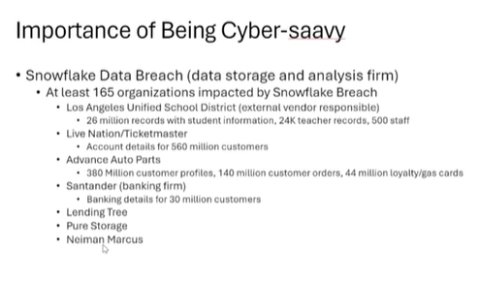
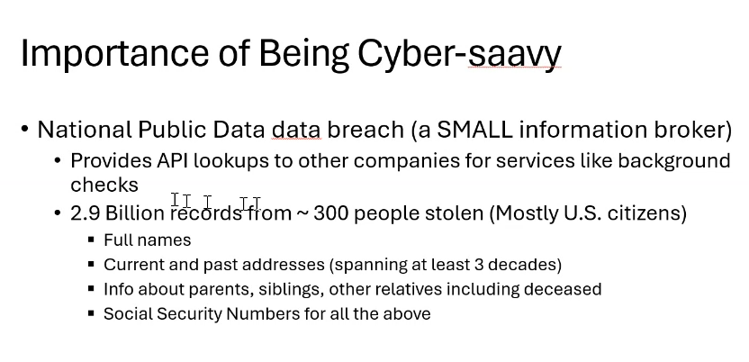
Note: should be 300M people

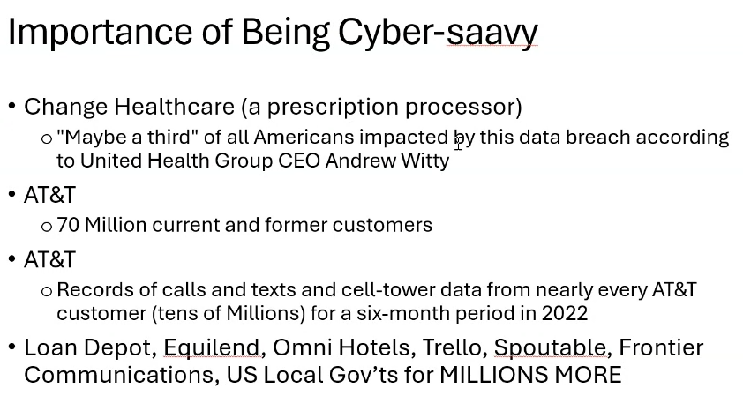
This is why we have increased the levels of security across the enterprise and taken steps to up our game! When you sign up for services, ask them or check into what security services they have to keep your data secure. This is for your personal use but it also applies to accounts/services that staff create and use at the school and district level.

(53:55) KDE Regulation Amendment Update – KDE is currently amending 704 KAR 3:535 that covers full-time enrolled online, virtual and remote learning programs. This regulation originally went into effect on March 7, 2023. OET has been part of presentation to the School Curriculum, Assessment and Accountability Council (SCAAC), along with several other KDE offices, supporting these revisions. Next steps will going before the Local Superintendent Advisory Council (LSAC) and the KBE to discuss and seek approval for the modifications. The main revision centers around how schools flag students for accountability purposes; there is also one clarification and one point of emphasis along with some technical modifications. This regulation is going with the companion regulation being brought forward by the Office of Assessment and Accountability.

(55:21) KY K-12 Data Systems Update -
Data
- School Report Card Suite (SRCS): We are making others aware of how they can verify data early before it is released in the dashboard view.
  - URL/domain change pending final decision on the proposed name insights.kyschools.us or reportcard.kyschools.us.
  - Preliminary major district timeline dates:
    - 09/16 – Collector/approval tool opens to districts (including download option for School Profile Report)
    - 10/28 – Districts begin review of assessment/accountability data in collector tool.
    - 11/15 – Early access to dashboard and datasets for districts and media outlets.
    - 11/20 – Public release of dashboard and datasets.
    - Spring 2025 – Public release of 2023-2024 Financial Transparency data
- 2023-2024 Civil Rights Data Collection – Tentatively scheduled to open December 9 and close March 7
- SSN Data Diet/Minimization Progress:
  - New option allows districts to exclude students’ SSNs from the food services files sent to Mosaic
  - SSN removed from data synchronization from Infinite Campus District Edition to State Edition, effective 9/11

Kentucky Student Information System (KSIS)
- Renewal reminder – Infinite Campus renewal payments are due by August 15. Contact Infinite Campus for questions about your invoice. If you need a copy of the invoice, send a request to KDE Data Services.
- Published updated KSIS Data Standards July 1 – changes are noted; please help us communicate these updates

- User security review and maintenance – As you prepare for the new school year, review employee access and permissions assignments in Infinite Campus. See the KSIS Infinite Campus News Summer Edition (coming July 18) for tips and tools.

Training Opportunities
For details on the following training opportunities, go to the KSIS Training webpage.
Date | Title | Training Provider | Location
July 18 | KSIS Infinite Campus Beginning of Year | KDE | KDE Media Portal
July 31 | Cyber Summer School: Top Tips for Teachers | US Dept. of Ed. PTAC | Online
Aug. 14 | FERPA 101 and Data Security Best Practices | US Dept. of Ed. PTAC | Online
Aug. 21 | FERPA 201 and Transparency | US Dept. of Ed. PTAC | Online
Aug. 28 | Incident Response and Vetting Educational Technology | US Dept. of Ed. PTAC | Online
Dec. 5-6 | Infinite Campus WinterChange | Infinite Campus | Omni Louisville Hotel

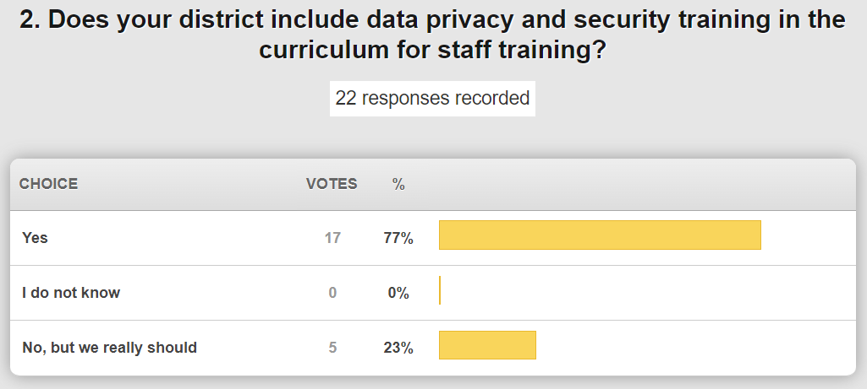

(1:06:34) Annual KY K-12 District Digital Readiness Survey Demo - This years’ digital readiness survey collection launched on July 15 and will remain open through September 16th. When you go to the collection tool, there is a planning sheet and a document that has question additions, revisions and notes by section to help you better prepare for and understand this year’s survey. Marty walked through this document and noted some of the changes/revisions/deletions made section by section. Once you launch this year’s collection, some of the data is pre-filled in for you; this is something that’s been asked for and we were able to make that happen for this year’s collection.

(1:12:11) Status of KY K-12 EdTech RFPs, Contracts and Implementations – Mike reported that all of these are at some point in the procurement process and are all progressing.

The following items are currently in some stage of procurement process and moving forward:
- Internet Content Management
- Professional Learning Mgt System (PLMS) -This is for all adults that need professional learning that would be published or hosted by the Kentucky Department of Education.
- Grant Management Application Planning (GMAP)
- Kentucky Educator Credentialling System (KECS) – This is ongoing work with a few more phases of that project still to be implemented.
- Insight – The new contract holder as the Microsoft channel partner; this was effective in April 2024. Discussions are occurring around the offerings and how the licensing is provisioned; we hope to provide some greater detail and make improvements on this very soon.
- School Report Card Suite (SRC) –This is ongoing work as well and the suite is expected to roll out mid-September with a public release in mid to late November. We are very optimistic in our work with AnLar and being able to meet all the expectations. See the Data Systems Update given earlier for a full list of anticipated release dates, etc.
- Next Generation KY K-12 Internet (NGKI) – We’ve completed the transition of all districts, KSB and KSD last week. KDE will transition on July 17 and that will have us all moved over to the NGKI solution through ENA. There is still much work to be done that will occur over the next several months in the areas of new functionality, enhancements in reporting, etc. We have a 10-year contractual opportunity with this current contract and we are looking forward to it. AT&T has been a great partner and they continued to shine throughout this transition. We are piloting some network analytics, called KENTIK, with ten school districts—it provides real-time data and analytics. There will be a dashboard view that will be a tile on your My ENA portal.
- KY K-12 Connected User Experience System (CUES) – on June 20, a contract was awarded to Identity Automation. This award will create a new KETS standard for identity and directory service as a statewide shared service and we are anxious to share details. There was a kickoff meeting on July 9 and we are now organizing teams and work streams. There are already events scheduled and being planned to provide much more information and details around this upcoming implementation—KASBO Conference, KySTE Fall Conference, Kentucky Interchange, possible special webcasts, and regional meetings. We are looking at a two-year implementation cycle but there is nothing that needs to change or be completed before the start of the school year. Get ready for an exciting journey!
- SEEK – This contract has been awarded to G2O and is now an ongoing implementation.

(1:27:45) Annual KY K-12 District Technology Activity Report (TAR) Update - Districts will get information within the next week for this annual data collection. This will be disseminated out through the KETS field staff. This is a component/requirement of the KETS Offers of Assistance program and it’s also very important to the overall reporting of the KETS program.

(1:29:05) KETS Offers of Assistance Update – Information regarding the KETS offers is being verified and then we will be able to move forward. We are projecting a $21 total offer and we will do that in two different offers – late September/early October offer of $12/ADA and a second offer in the March/April timeframe of $9/ADA.

(1:30:51) Annual Vendor Partner Meeting Recap – The annual vendor partner meeting was held July 10th. We had 39 companies represented and it was a successful meeting. This allowed us to have a meeting specifically for our vendors where we shared a lot of the same information as we’d share in our monthly webcasts; however, this venue allowed them to ask questions and participate fully.

(1:33:25) Other Items to Note:
- AI Presentation to the KY Legislature – This happened earlier in July and David sent out an email containing a summary of the presentations provided during that meeting along with the associated PowerPoints. Both presenters were outstanding.
- District Leases Information – The District Lease webpage has been updated and reflects the new regulation that went into effect of March 5, 2024 and reflects that the attorney form is now a requirement.
- HB6 – With the passage of this legislation, there is now a requirement to have specific information related to test scores posted on the district’s website landing page. Information either has or will be sent to the District Assessment Coordinators (DAC) from the Office of Assessment and Accountability (OAA).

