Summary of the January 2023 KY K-12 Education
Technology Leaders’ Virtual Meeting

In case you missed it or want a refresher, the following is what we talked about during the January 17, 2023, EdTech leaders’ virtual meeting. A copy of the video and audio can be found at: https://mediaportal.education.ky.gov/technology/2023/01/edtech-january-2023/.

Public viewing of the archived webcasts and written summaries are also available on the KDE Media Portal at: http://mediaportal.education.ky.gov/. Numbers in RED indicate the timestamp for that portion of the discussion so it can be easily located on the full digital recording.

This was a virtual meeting with our OET staff and all the districts joining via Microsoft Teams and/or YouTube. We will continue to make these available from our KDE media portal so that you can watch the archived discussion and share with the appropriate people in your district. There are no GoSoapBox poll or discussion questions today; however, we do have GoSoapBox available for the social question and answer section.

Please remember that in addition to these webcasts being available on the KDE Media Portal, each month’s webcast is accompanied by these written summaries. We encourage you to share the link and all or any portion of these summary notes with staff throughout your district who may find the information beneficial to them in their position.

(1:03) 2023 Legislative Session Update - Legislators came to Frankfort the first week of January to begin the short session. They met for one week, recessed and will reconvene the first week of February. At this time, the only bill from an education technology perspective that we are watching is SB20—this bill bans the use of the social media platform TikTok on state-owned devices across state government. Currently, 19 other states have passed similar legislation and the federal government has also taken action against the use of this social media platform. As the bill reads right now, this doesn’t impact KY K-12. We do anticipate additional education-related bills to be filed when they reconvene and will have a more detailed update in next month’s update. With this being a short session, the majority of budget and funding related matters won’t be addressed until the 2024 legislative/budget session.

(2:02) Upcoming Ky Board of Education (KBE) Meeting Update - The next meeting of the KBE is February 7 and 8. During the morning of February 8, OET will be presenting our additional budget request for EdTech for the 2024-2026 biennial budget. We’ve presented this request several times to both restore and increase the KETS funding; it is our hope that it is made a legislative priority in the upcoming biennial budget submission for KDE. This information was presented during the August KBE retreat and we shared our latest KETS Infographic with the board at that time. Our request is for $30M and this is a $14.6M increase annually that covers three areas:
- Increased KETS Allocation
- Restore previous budgetary cuts to our baseline funding
- Fund rapid increase and workstation replacement with upcoming funding cliff in late 2024
- Fund Infinite Campus costs with a sustainable funding source rather than taking funds from E-rate rebates
- Restore Funding for Computer Science and IT Academy
- Address the many needs of the People Side of KY K-12 Education Technology

(5:44) KY K-12 CIO/EdTech Leaders’ Summit – Registration is now open for the annual CIO Summit that will be occurring the morning of March 15th at the Kentucky Society for Technology in Education (KySTE) Conference in Louisville. The registration form will be available shortly after today’s webcast and will be sent to you through your KETS field staff. We haven’t yet nailed down the topics for the 2023 CIO Summit, but planning is underway and we rely heavily on your year-end feedback to help us prioritize and develop topics.

(6:11) Federal E-Rate Program Due Dates/Training Dates -
- 2023 USAC filing window will open at noon on Wed, Jan 18 and close at 11:59 pm on Mar 28, 2023.
- Discount Data/Form 479 (CIPA compliance) are due back to OET no later than Jan 20, 2023.
- Form 471 in person trainings offered by KDE for districts. Invitations have been delivered to CIOs via the field staff:
  - Region 1 – Jan 30, 9 am (Central) at WKEC Conference Center in Eddyville
  - Region 2 – Jan 31, 9 am (Central) at GRECC in Bowling Green
  - Region 4 – Jan 23, 10 am at the Carroll Co Tech Office
  - Region 5 – Feb 3, 9 am at the Fayette Co Schools Warehouse
  - Region 6 – Jan 24, 10 am at the Pulaski Co Boardroom
  - Region 7 – Jan 19, 10 am at KEDC
  - Region 8 – Jan 27, 11:30 am location to be determined

(6:47) New KY K-12 EdTech Infographic - The newly updated Infographic is now public in Surveys and Results as part of our 2018 – 2024 KETS Master Plan. This is Appendix B of our KETS Master Plan. The KETS program has a great story and our challenge is how to tell that story; the current infographic allows us to share that story in a visual way. This is the launch of the January 2023 version of the KETS Infographic completed in partnership with Google BrightBytes. This effort is led for us by Ben Maynard. With each update, we try to improve how we portray our story. If you haven’t had the opportunity to use the infographic to have a discussion, please do; it’s a great conversation starter and question generator.

KETS Infographic points of interest:
- School fiber internet total usage increased 247% over the past 24 months while maintaining uptime of 99.98%.
- 95% of students report internet access from home.
- 87% of students feel as though their school encourages technology use for learning.
- 85% of teachers rate the speed of Internet at their schools as average or above average.
- In terms of digital equity - 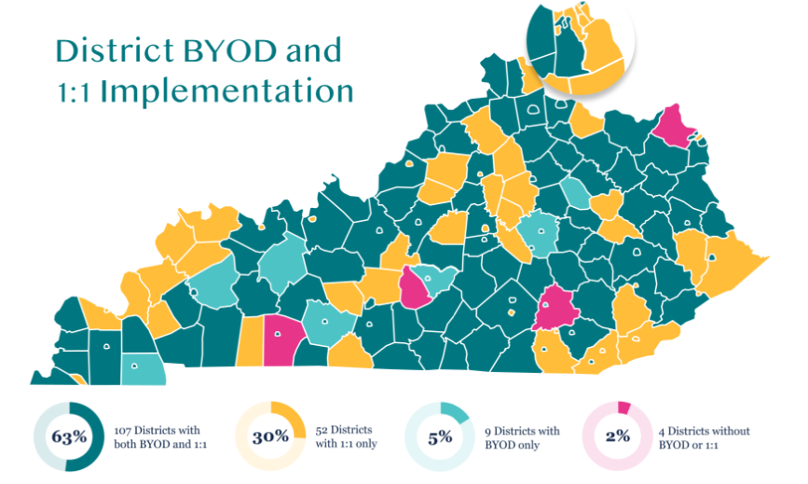
- 100% of schools provide Wi-Fi access to students, with 99% of schools having dense Wi-Fi networks capable of supporting BYOD or 1:1 initiatives.
- 87% of students say their teachers talk with them about how to act respectfully while online and 97% of districts report having a strategic plan for teaching digital citizenship skills.
- 71% of students say their classmates always or usually treat each other with respect when collaborating online, with less than 5.2% saying classmates never treat each other with respect – this is a targeted area of improvement.
- Infographic is constructed using the Academic Standards for Technology and has input from several data points. We take what students are saying and compare to what teachers are saying and see how they stack up.
- The methods for communicating with parents/students visual was discussed in depth:
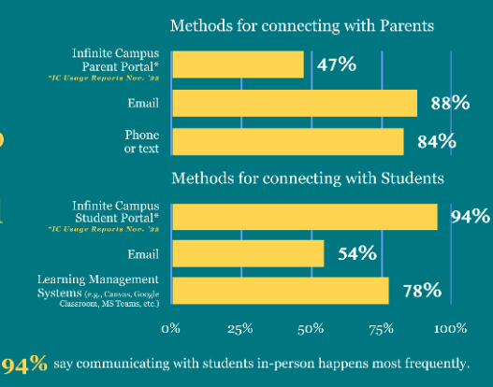

- 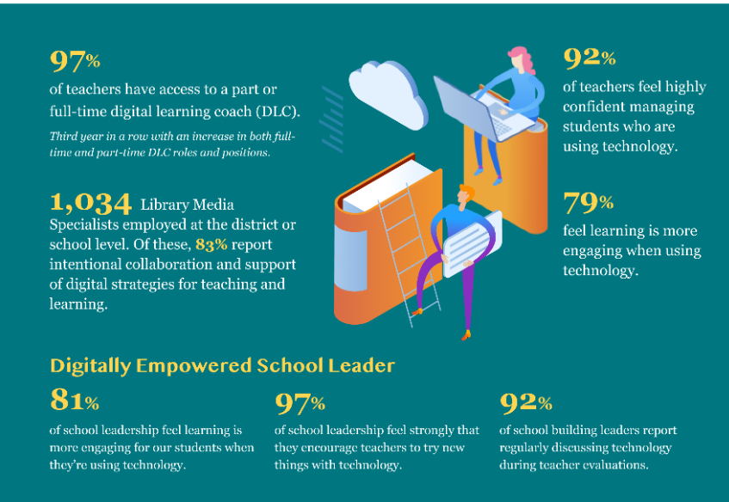
- At the end we have included several technology trends and how we are supporting certain initiatives. There is a strong trend towards mobility that we predicted 6 to 7 years ago.

(21:14) KY K-12 EdTech Contracts Status Update -
- KY K-12 RFP Update - We are in an active/open RFP procurement and this is progressing forward to establish a new contract for our K-12 Internet services.
- Connected User Experience – We are continuing work/planning on a procurement path for this project which will most likely be an RFP.
- SEEK – This is a multi-faceted program with many functions that oversees district funding. This is a large and intense program that will impact our districts as it progresses.
- The educator and teacher licensure system has been awarded and implementation continues.
- Other Areas of RFPs or procurement – We review our contracts and product standards on a regular basis and moving forward we may be discussing and seeking input on some upcoming work. This could be a renewal, an extension, etc.

