**Summary of the April 2022 for KY K-12 Education**

**Technology Leaders’ Virtual Meeting**

In case you missed it or want a refresher, the following is what we talked about during the April 20, 2022 EdTech leaders’ virtual meeting. A copy of the video and audio can be found at:

<https://mediaportal.education.ky.gov/technology/2022/05/edtech-webcast-april-2022/>.

Public viewing of the archived webcasts and written summaries are also available on the KDE Media Portal at: <http://mediaportal.education.ky.gov/>. Numbers in **RED** indicate the timestamp for that portion of the discussion so it can be easily located on the full digital recording.

This was a virtual meeting with our OET staff and all the districts joining via Microsoft Teams and/or YouTube. We will continue to make these available from our KDE media portal so that you can watch the archived discussion and share with the appropriate people in your district. Because we held an abbreviated webcast from the STLP State Championship at Rupp Arena, no GoSoapBox questions were posed today.

Please remember that in addition to these webcasts being available on the KDE Media Portal, each month’s webcast is accompanied by these written summaries. We encourage you to share the link and all or any portion of these summary notes with staff throughout your district who may find the information beneficial to them in their position.

**STLP State Championship--Rupp Arena on 4/20/22** – Today’s webcast was broadcast from the Rupp Arena floor today as one of many events happening at the STLP State Championship! Joining David today was a very special guest, Don Coffman. Don was an Associate Commissioner in the early years of KETS and comes from a family of educators; we were honored to have him join us. He was very proud to see that STLP continues and thrives and described his experience today as overwhelming. Don shared comments on the building and launching of the STLP program/KETS throughout today’s webcast.

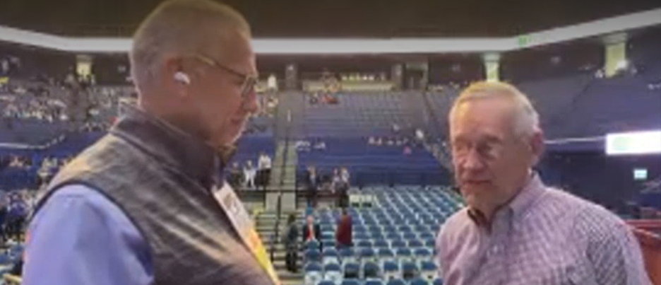

Students, parents, teachers, and volunteers all began arriving very early, but the event officially “opened” at 10:00 a.m. with over 400 schools and 100 school districts participating. It was exhilarating to stand outside and watch the buses rolling in since we hadn’t held in-person STLP activities since the regionals concluded in December 2019. The red carpet was rolled out for students to enter for today’s event.

We had some live looks at each of the new major areas within the Central Bank Center while STLP activities were occurring:

1. DeDe joined from Level 3 and showed students as they were participating in the Challenges and earning their ribbons. As students complete challenges, they earned ribbons corresponding to the technology standards.
2. Mike Leadingham and Laura Raganas joined us from different portions of the Robotics area. Laura was joined by several of the Digital Learning Coaches. They gave us a glimpse of the all the activities happening in this area.
3. Bruce Lindsey quickly jumped in as well and gave us a view from the projects area where judging was underway.

After all the events are complete and judging is finalized, it all comes down to the Terrific Twenty and then down to the Elite Eight and eventually the Final Four. The final award of the evening is the Dave Sigler Award; this was named after an OET staff member who has passed and had an enormous impact on the design and implementation of the KETS network. Our elementary, middle and high school champions will also be selected and recognized.

Here are some important facts and statistics about STLP and the STLP State Championship event:

* There are 60,000 KY K-12 students that are part of STLP. Nearly 10,000 students, educators, volunteers, community members and parents are expected to be in attendance. The State Championship is almost entirely run by volunteers from across Kentucky including dozens of students that comprise the STLP Student Service Corps.
* Today’s event was the largest event ever held in the newly renovated Lexington Central Bank Center and the first event to use every event space.
* This is the 28th year of STLP that began in 1994.
* This is the 15th STLP State Championship.
* Over 400 STLP Projects were on display in Central Bank Center’s Exhibit Hall; each striving to be selected as a Best in State winner.
* Over 600 Digital Product semi-finalists (narrowed down from thousands of entries) were scored to find the 1st and 2nd place winners for each of 23 different STEAM related categories.
* There were 18 on-site live Challenge competitions that challenge students to demonstrate specific technology skills on demand.
* The 5:00 PM STLP Award Show was broadcast live on KET’s Kentucky Channel; we’ll be able to share the archived awards show soon.
* For the very first time, the Kentucky Board of Education (KBE) and the Kentucky Valley Educational Cooperative (KVEC) held their board meetings at the STLP state championship and will observe the environment and competitions.

Thanks for joining us today and we’ll see you next month!