**Summary of the February 2022 for KY K-12 Education**

**Technology Leaders’ Virtual Meeting**

In case you missed it or want a refresher, the following is what we talked about during the February 15, 2022 EdTech leaders’ virtual meeting. A copy of the video and audio can be found at:

<https://mediaportal.education.ky.gov/technology/2022/02/edtech-webcast-february-2022/>.

Public viewing of the archived webcasts and written summaries are also available on the KDE Media Portal at: <http://mediaportal.education.ky.gov/>. Numbers in **RED** indicate the timestamp for that portion of the discussion so it can be easily located on the full digital recording.

This was a virtual meeting with our OET staff and all the districts joining via Microsoft Teams and/or YouTube. We will continue to make these available from our KDE media portal so that you can watch the archived discussion and share with the appropriate people in your district. Several GoSoapBox poll questions were posed throughout the meeting and district EdTech leaders were asked to respond to all the questions as it assists us in planning and getting a feel for how to best move forward. Your voice and your feedback are important and extremely helpful to us. Today’s webcast focused on the annual, state of the KY K-12 EdTech Commonwealth address--throughout the various topics discussed during this webcast, David shared feedback received in December from all school districts.

Please remember that in addition to these webcasts being available on the KDE Media Portal, each month’s webcast is accompanied by these written summaries. We encourage you to share the link and all or any portion of these summary notes with staff throughout your district who may find the information beneficial to them in their position.

**(4:27) Last Mile Wired/Wireless Internet Service Update –** As we shared with the Legislative Research Commission (LRC) and shared the Education SuperHighway report with them, one of the biggest barriers for last mile access is affordability. There are two federal funding sources that help low-income homeowners pay for last mile wired/wireless Internet service. Unfortunately a very low percentage of eligible low income home-owners are taking advantage of these programs. Our school districts are making parents aware of these two options, anything you all can do to make low-income households aware of these two funding options will be much appreciated:

* Lifeline @ [Lifeline Support for Affordable Communications | Federal Communications Commission (fcc.gov)](https://nam11.safelinks.protection.outlook.com/?url=https%3A%2F%2Fwww.fcc.gov%2Flifeline-consumers&data=04%7C01%7Clisa.moore%40education.ky.gov%7C2e1271ddbda145e9c0fb08da067fa736%7C9360c11f90e64706ad0025fcdc9e2ed1%7C0%7C0%7C637829442615763161%7CUnknown%7CTWFpbGZsb3d8eyJWIjoiMC4wLjAwMDAiLCJQIjoiV2luMzIiLCJBTiI6Ik1haWwiLCJXVCI6Mn0%3D%7C3000&sdata=tl6Vsn0VbJlEsKR37YPcZTA2Hxh%2B%2FVHWzxJCOH4kHNk%3D&reserved=0) and
* $3.2B in available Emergency Broadband Benefit funds @ [How to Apply - EBBP (getemergencybroadband.org)](https://nam11.safelinks.protection.outlook.com/?url=https%3A%2F%2Fgetemergencybroadband.org%2Fhow-to-apply%2F&data=04%7C01%7Clisa.moore%40education.ky.gov%7C2e1271ddbda145e9c0fb08da067fa736%7C9360c11f90e64706ad0025fcdc9e2ed1%7C0%7C0%7C637829442615763161%7CUnknown%7CTWFpbGZsb3d8eyJWIjoiMC4wLjAwMDAiLCJQIjoiV2luMzIiLCJBTiI6Ik1haWwiLCJXVCI6Mn0%3D%7C3000&sdata=DoovSp7rtutSMNdw44YfmSsuqJmRfNSQHGA658LZjIA%3D&reserved=0) is now called the Affordable Connectivity Program (ACP) as of 1 January 2022 @ [Home - ACP - Universal Service Administrative Company (acpbenefit.org)](https://nam11.safelinks.protection.outlook.com/?url=https%3A%2F%2Facpbenefit.org%2F&data=04%7C01%7Clisa.moore%40education.ky.gov%7C2e1271ddbda145e9c0fb08da067fa736%7C9360c11f90e64706ad0025fcdc9e2ed1%7C0%7C0%7C637829442615763161%7CUnknown%7CTWFpbGZsb3d8eyJWIjoiMC4wLjAwMDAiLCJQIjoiV2luMzIiLCJBTiI6Ik1haWwiLCJXVCI6Mn0%3D%7C3000&sdata=Ayud249%2B7GCUWiphKuggZX%2F8xiE%2BU%2FS4BoG1xnFtG5c%3D&reserved=0). ACP differs from the EBB in at least one significant way. EBB paid for $50 per month up to 31 Dec 2021. Beginning on 1 January 2022, ACP pays $30 per month. There is also an additional requirement of proof of student enrollment; the packet is 14 pages. If the parent/students are already part of a CEP district, it is not quite as stringent.

**Results/Themes of the Annual Feedback received in December –** This was sent out as an attachment to the meeting invite. We encourage you to listen to the audio and follow that document. In areas where we had more clarification or discussion, a ***Note:*** has been added to the bullet point or section.

**(8:57) The KY K-12 plans**

* The previous 2017-2022 KDE strategic plan is available at KSBA portal site.
* The 2022 to 2027 KDE strategic plan is in the creation stage: [Strategic Planning - Kentucky Department of Education](https://education.ky.gov/CommOfEd/CDU/Pages/Delivery_Home.aspx), United We Learn feedback ([United We Learn - Kentucky Department of Education](https://education.ky.gov/UnitedWeLearn/Pages/default.aspx)) and KDE Strategic Dashboard ([KDE Strategic Dashboard - Kentucky Department of Education](https://education.ky.gov/CommOfEd/Pages/KDE-Strategic-Dashboard.aspx)).
* The 2018-2024 KETS Master Plan (required by law). Its 36 Areas of Emphasis (Acceleration and Improvement): [KETS 2018 - 2024 Master Plan - Kentucky Department of Education](https://education.ky.gov/districts/tech/Pages/KETS-2018---2024-Master-Plan---Areas-of-Emphasis.aspx)

***Note:***  This will be an area that will need our CIOs to review and be familiar with for the upcoming CIO Summit.

* District Technology Plans (required by law). [2018-2019 Technology Plan Template.pdf (ky.gov)](https://education.ky.gov/districts/tech/Documents/2018-2019%20Technology%20Plan%20Template.pdf)

**(11:15) What is the annual Top 5 feedback from all 171 districts and all OET staff used for that we received in December of 2021?**

* To get each individual district CIO and OET staff member’s perspectives on the top 5 things that went well in calendar year 2021, top 5 things didn’t go well or we didn’t get to but should have in 2021 and what should be our top 5 goals for calendar year 2022.
* A chance for our OET leaders/managers and OET field staff to capture and address things we are doing well and can do better with each person individually and collectively.
* Helps us identify the collective bigger picture while at the same time understand the lens of the bigger picture to each district CIO/EdTech leader and OET staff member.
* Get a real time picture of consistent themes between as well as becoming aware of unique one-off comments that are just as important as a consistent theme to celebrate, that we need to fix, recognize and/or have as a goal.
* Used in small group and one on one discussions (e.g., meeting with a district(s), for a small group OET staff luncheon).
* Helps use become aware of and address something someone may be grinding on early, so it doesn’t fester.
* How much does or doesn’t OET staff feedback match or differ from the feedback of our districts, of KDE staff customers and of other OET staff?
* Makes me aware of things that I wasn’t aware of before… or is a good reminder of something I was previously made aware of earlier in the year.

**(13:30) Major strategic goals/targets, biggest payoffs/opportunities & most important initiatives for calendar year 2022. These are based upon (a) KDE Strategic Plan thus far, (b) 2018-2024 KETS Master Plan’s 36 Areas of Emphasis and (c) Top 5 feedback from all 171 districts and all OET staff.**

* Keep doing well, what we already have been doing well, that districts and KDE need us to keep doing well that include:

***Note:*** It’s important to identify the continuance of things you are currently doing well and letting people see that what they are doing well is still part of the plan.

* Ensuring basic and equitable anytime, anywhere, always-on access to instructional and administrative education technology (EdTech) services are provided to students, teachers, administrators, parents and the general public;
* Creating and maximizing partnerships (student technology leadership/skills, vendors, districts, agencies, universities), as well as building and maintaining productive customer relationships;
* Staying current and open to emerging technology and trends that may assist with meeting educational needs and managing/maximizing EdTech resource opportunities;
* Managing educational technology policies and legislation;
* Maximizing data use, continuing to improve data quality, and championing data security and data privacy best practices to all districts and KDE;
* 99.999% high quality and uptime of our KY K-12 technology enabled services;
* Be excellent stewards and manager of federal and state taxpayer dollars;
* Play an important role, through technology enabled products & service, in (a) providing all KY K-12 students a good educational experience so they have a good run and go for the next grade level and after graduation and (b) helping parents, teachers and staff do their best to help students be prepared for that next grade level and after graduation;
* Attracting and retaining high quality OET staff and district CIOs/EdTech staff;
* Staying in touch with KDE plans/goals and district plans/goals.
* etc.
* Legislative committee meetings & session… restore previous cuts/increase in funding for People side (OET staff and districts), Internet, technology replacement and post CARES funding. Increase awareness of significant downsides of restoring cuts that will occur with certainty in the near future.

***Note:*** We hope that a very high percentage of CIOs are reaching out to members of the legislature as we proceed through the budget process. If you are in a district with a member of the House and/or Senate in a leadership position, we really hope that you take advantage of this and get the message to them. We have reached out to several groups and entities, but we need each of you to do the same; it is truly a team effort. The most important voice they will hear is yours.

* KIH4 (Next Generation KY K-12 Internet Network) RFP for all 171 school districts, KSB, KSD and FFA camp. ***Note:*** This is purely a K-12 bid and are transitioning away from the use of the KIH name. This is anticipated to be released this summer and would span a 10 to 11 year period. This will be a topic at our upcoming CIO Summit.
* The next generation Active Directory project (aka, Connected user experience and identity management project).  Positions KY K-12 well for the next 10 years.
* Next steps of KY K-12 cybersecurity.
* Implement the teacher certification & license system.
* Continue KY K-12 data systems modernization and maximization.
* Champion district’s doing digital health checks. ***Note:*** We have completed a digital health check at KDE. Our schools have really good network partners but if it isn’t configured properly, especially the wireless network, you may not be using it as effectively as it can be. We have several partners available that can do this work. In July 2021, we posed two questions on this topic. We posed the same 2 questions below:

Current Responses:

July 2021 Responses:

* Implement Digital Learning Coaches (DLC) equivalent for techs (i.e., the Region 2 technician’s model at KySTE). We want to model the equivalent of this for our DLCs and
* Kentucky Higher Education Assistance Authority (KHEAA) and Council of Postsecondary Education (CPE) initiatives with KDE that maximize all three orgs resources to promote college going.
* Prepare districts and KDE for post federal CARES funding.

***Note:*** It is important for us to prepare for this and getting the $5.3M in KETS and KEN cuts restored is the very first step. Our previous and current additional budget request (ABR) is to restore and increase that funding according to anticipated needs as we move forward. Our goal is to avoid and deter a major drop in service when the federal funding expires.

* Maximize federal ESSER funds. Try to use a portion for data systems modernization.
* Examine next steps for KY K-12 phone systems that will use the KY K-12 Internet service.
* Ensure OET’s major goal/initiatives is considered as part of KDE’s new strategic plan. Ensure OET staff understand and support that new KDE strategic plan.
* Update and modernize the KY K-12 EdTech People Side of technology study and formula. [KY_The People Side of K12 EdTech_Full Version_Final 8.3.17.pdf](https://education.ky.gov/districts/tech/Documents/KY_The%20People%20Side%20of%20K12%20EdTech_Full%20Version_Final%208.3.17.pdf), [Copy of HumanCapital_District_Slides.pptx - Google Slides](https://nam11.safelinks.protection.outlook.com/?url=https%3A%2F%2Fdocs.google.com%2Fpresentation%2Fd%2F1hF3hBspjDnH5wcKbH4Z29lpLUq0ze9m_osNy3WHUCAU%2Fedit%23slide%3Did.g2651dd4ad0_0_27&data=04%7C01%7Clisa.moore%40education.ky.gov%7C2e1271ddbda145e9c0fb08da067fa736%7C9360c11f90e64706ad0025fcdc9e2ed1%7C0%7C0%7C637829442615763161%7CUnknown%7CTWFpbGZsb3d8eyJWIjoiMC4wLjAwMDAiLCJQIjoiV2luMzIiLCJBTiI6Ik1haWwiLCJXVCI6Mn0%3D%7C3000&sdata=wHFoIIIhbWNOrZUHUI7ajaUVkfbO%2FDG4xAC5%2FIwDalQ%3D&reserved=0), [Copy of Human Capital Model v2 - Google Sheets](https://nam11.safelinks.protection.outlook.com/?url=https%3A%2F%2Fdocs.google.com%2Fspreadsheets%2Fd%2F16r00zGPIK12VHnu6Jo0bt6iPPMDH6lIGdQ9UpMVUsYI%2Fedit%23gid%3D1921709767&data=04%7C01%7Clisa.moore%40education.ky.gov%7C2e1271ddbda145e9c0fb08da067fa736%7C9360c11f90e64706ad0025fcdc9e2ed1%7C0%7C0%7C637829442615763161%7CUnknown%7CTWFpbGZsb3d8eyJWIjoiMC4wLjAwMDAiLCJQIjoiV2luMzIiLCJBTiI6Ik1haWwiLCJXVCI6Mn0%3D%7C3000&sdata=F5BYgMfU%2Fy4c4FR9nrRpWhKbMFkNjltB7uwQ6NEpCGQ%3D&reserved=0)

**Final Draft: Big wins of calendar year 2021**

* Kept doing well what folks needed us to keep doing well.
* Our OET staff is greatly appreciated and valued by districts and KDE staff. Customer facing staff (e.g., KETS Engineers (KE), KETS Help Desk, Digital Learning Team, IC/MUNIS team, Cybersecurity team, e-rate team, etc.… and all those folks behind the scenes supporting them). Spartan 300 (i.e., having the success that normally would take 10 times the number of staff that we have).
* Supporting and providing both in-person and remote options at a high level of quality as they merged for districts, KDE staff and OET staff.
* Maximized existing funds & successfully obtained $133M in additional temporary federal funding at the district and KDE level for EdTech products and services. Funded Infinite Campus (IC) Learning & Registration software, Lightspeed Relay, KY Virtual Library, virtual learning, on school campus Internet, network components, computers and last mile Internet services beyond the school campus. ***Note:*** This was really a big win for us and KDE/districts had to work for approval to receive these funding sources.
* Our disaster recovery services for pandemic & tornado (e.g., payroll done in cloud) was awesome. Already had a great plan and approach in place, plus our fast and quality responsiveness and adjustments to those plans.  ***Note:*** Our work is a national model for how to handle these differing disasters.
* Communications. Keeping staff and districts informed. Caring about their health/welfare. Interactions & relationships between OET staff with each other, districts and KDE staff (monthly meetings with districts & staff, CIO summit, KySTE fall training, daily/weekly interactions, technology planning council, IC/KSIS newsletter, trainings). ***Note:*** For some this may seem like over communicating but we feel it’s important to reach you were you are and we go about our communications utilizing various methods.
* Planning, project management and successful implementation of technology enabled projects (e.g., components in the KY K-12 Internet (KEN) rack, Active Directory (AD), Lightspeed relay implementation)
* Upgrades/modernization/data & data visualization projects and interoperability initiatives… includes project mgt. (e.g., KEN racks, single sign-on, Equity dashboard, tying different systems together)
* Retention of our crucial folks in our KDE Office of Education Technology (OET). ***Note:*** We are proud of the retention of OET’s staff over time despite all the issues with recruitment, retention and budgeting/salary challenges.
* KY K-12 Digital Readiness Infographic. It’s the best one yet. Identifies past and present significant achievements of KETS. [2022JanuaryInfographicPrint.pdf (ky.gov)](https://education.ky.gov/districts/tech/Documents/2022JanuaryInfographicPrint.pdf)
* Major KY K-12 EdTech RFPs and awards (Network components, Teacher licensure, point of sale)
* On-line testing scale (e.g., K-PREP). Largest ever done in and done with high quality in comparison to other states.
* Recognizing/celebrating success as well as listening to and addressing things we need to get better at.
* KETS product and design standards. [KETS Technical Environment Information Document (ky.gov)](https://education.ky.gov/districts/tech/kpur/Documents/KETS%20Technical%20Environment%20Overview%20Public.pdf), [KETS Product and Technical Standards - Kentucky Department of Education](https://education.ky.gov/districts/tech/kpur/Pages/KETS%20Technology%20Standards%20and%20Purchasing.aspx)
* Continued emphasis on People Side of KY K-12 EdTech. Build people not systems.
* Training & PD opportunities for districts and OET staff. (IC, just in time, privacy & security).
* The quality of our KY K-12 cybersecurity defenses.
* Significant progress in 1 to 1 computers for students and Internet access on the school campus and beyond the school campus. Over 1M KY K-12 computers now. Internet bandwidth on the school campus was enough, reliable and stable.
* No other time has more progress and funding been available for Internet access beyond the school campus for KY K-12 students than the past 2 years. Similar progress with Wi-Fi in the buildings and other locations on the school campus (e.g., parking lots).
* Increases usage of Learning Management Systems (LMS) and web-based instruction.
* Successfully navigated a second one of a kind school year in a row. We not only survived but thrived.
* KY K-12 student technology leadership program (STLP). Making the most of 100% virtual situation for regionals and state for STLP for the 1st time. ***Note:*** Last year we navigated and had a very successful virtual year. This year we will be holding our STLP State Championship at Rupp Arena and we are trying for the 3rd time to have our April Kentucky Board of Education (KBE) meeting on-site. Third time is a charm. There will be some additional state K-12educational groups (e.g., Kentucky Valley Educational Cooperative) meeting at this event. This will be our first event in the newly renovated Central Bank Center at Rupp Arena and there will be something for everyone. It’s February so lots of things will be happening to enable the travel for staff and kids to be there. We are going to pack the place! Seeing our students in action reminds us all why we do what we do so plan to be there and participate and volunteer.
* KETS offers of financial assistance were at least the same amount as previous years. Can’t promise that going forward in the near future.
* Largest numbers ever numbers of districts pursued virtual learning waivers… next needs another 1-year waiver and reg.
* The 2nd Digital Learning Coaches (DLC) Summit for districts was a major success.
* The results of Office of Education Accountability (OEA) study about technology portions of NTI and legislative studies. Results of other EdTech audits.
* The most money ever (i.e., $356M) being available for KY K-12 EdTech… and the lowest gap ever (i.e., $10M) in the difference between KY K-12 unmet EdTech need (i.e., $366M) and funds available to address that need. ***Note:*** You can see the impact it has made in the Teachers Impact Survey with their answers to the technology-related questions.
* There was a proposed budget increase of $4.1M, to restore previous KETS cuts, in Governor’s Office biennial budget. ***Note:*** We need to go full court press to get this and more put into the House version.
* Equity dashboard. Took advantage of an existing product (IC) versus building a brand-new data system.

***Note:*** Big win for us; rather than building our own we were able to use an existing product. People/money to maintain is always a concern.

* Digital Driver’s License upgraded to cloud-based service.
* Infinite Campus (IC) contract extended to at least 2027.
* KDE staff password upgrade completed.
* Successfully prevented short-term & long-term issue and consequences of homes using the district’s KY K-12 Internet service.
* CV-19 vaccine available to KY K-12 with priority to teachers and elderly. CV-19 testing tents gone from KDE’s Sower parking lot. Reduction of possibility of getting CV-19 and its potentially serious health consequences. Thus, in turn reducing the stress on EdTech technology services of a 100% virtual environment 100% of the time. Some normalcy of in person EdTech options returned.
* 1st ever KY K-12 Computer Science (CS) plan created… and the KY K-12 CS report was good.
* KY K-12 technology academic standards updated for the first time in 10 years.
* 1st ever KY K-12 library academic standards established.
* Generate tool used for the 1st time for federal reporting (Ed Facts). Add to the next KETS historic Timeline.  [2021 KETS Timeline.pdf (ky.gov)](https://education.ky.gov/districts/tech/Documents/2021%20KETS%20Timeline.pdf)

**Final Draft: KY K-12 EdTech fixes on radar screen for 2022**

* Address firewall stability and timeframe of the restoration of services. ***Note:*** Phil meets each Monday with a core group and they have been working on improving the identification and resolution of issues. We drove these changes from AT&T processes with our service level agreements. This has been ongoing and we continue to work with them; our issues and asks have been very instrumental in AT&T making company-wide changes to how they handle these work processes.
* Address KY K-12 Internet Content Management system regarding IC’s power users, help desk response time and tech management info.  ***Note:*** We have also been working diligently with Lightspeed; we shared your feedback (both positive and negative) to the executive leadership of Lightspeed. They have developed some changes they want to implement and the IC issue is a prominent action item. They plan to send their top tier engineers to Kentucky to work directly with IC staff and some of the districts that have experienced issues and they will also have a booth at the upcoming KySTE conference so you can talk with them face to face.
* Kentucky High School Athletic Association (KHSAA) as it relates to using our KY K-12 field of play on the KY K-12 Internet service for eSports, state championship events and ticketing/video streaming.  ***Note:*** There is a meeting scheduled for Feb 16th to discuss several of these topics with KHSAA to ensure that our organizations are in sync on these topics.
* IC state & district sync… and IC custom reports.
* Address the stale accounts as people come and go in districts and KDE the agency. Stale accounts are a major cybersecurity risk. ***Note:*** These stale accounts are very attractive to cyber criminals. Based on the responses to the GoSoapBox questions, we know there is a challenge in some data systems that our edtech staff may not have access to in order to clean up and verify access permissions.

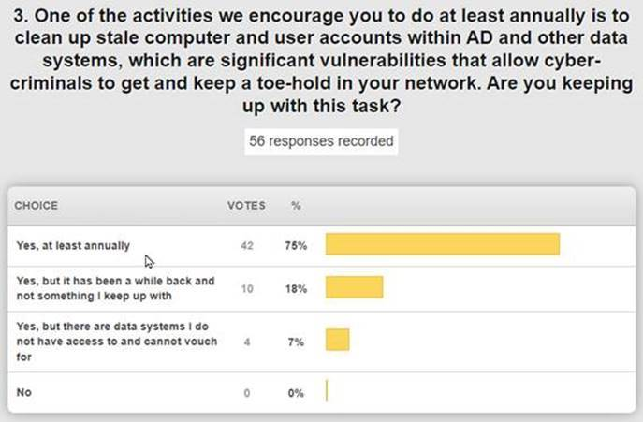

* Open House facelift.
* One more one-year waiver for virtual learning. Reg needs to be in place next.
* KY K-12 type of organizations on their own Office 365 tenant.

**Final Draft: Fell through the Cracks/Didn’t get to but should have in 2021. Need to get addressed in 2022.**

* Ray Baum/Kari law of emergency situations and phone systems.
* Get KDE the agency at Sower ready for hybrid meeting rooms & areas.
* Get the Area Technology Center (ATC) EdTech inventory.
* Facelift of OET portion of KDE website.
* Resuming regular inspection of how well we are meeting or not meeting the KETS Master Plan’s 36 areas of acceleration & improvement. [KETS 2018 - 2024 Master Plan - Kentucky Department of Education](https://education.ky.gov/districts/tech/Pages/KETS-2018---2024-Master-Plan---Areas-of-Emphasis.aspx)
* Resume password reset for districts and Multifactor Authentication (MFA) for KDE the agency. Take a strong look again at removing local admin rights for staff in KDE the agency computers.
* Next steps with Model Lab
* 170 of the 171 KY K-12 districts use the MUNIS Cloud. Circle back to the remaining on-premise MUNIS location.

**Draft: Other items of note that were mentioned:**

* OET’s portion of CARE’s funding the KY Virtual Library (KyVL) was much appreciated
* Appreciate the A3 Licensing being part of KY K-12 Active Directory (AD) Connected User Experience
* Recommend KY K-12 CFO type of calendar for KY K-12 CIOs/EdTech leaders
* Want more analytics available of Internet usage
* Appreciate OET leadership is accessible
* Success of School Report Card (SRC) Quality Assurance (QA) Tool
* Success of Civil Rights Data Collection (CRDC) rewrite
* Merging of OET’s messaging and security team
* Web uploading through Student Data Review and Roster (SDRR) tool
* Improved purchasing workflow
* Hyper V upgrade to systems that run applications that district use
* Upgrades to Oracle and Telerik software that run applications that districts us
* $400K saved in federal E-rate audit
* Produced a process/system catalog
* Holding tech vendors accountable
* OET Digital Learning Team continue to be aware of and champion Microsoft, IC and Google tools.

**(58:09) Proposed KY K-12 CIO/EdTech Summit Topics –** Our KY K-12 CIO/EdTech Summit is scheduled for Wednesday, March 9th from 10:30 a.m. to 1 p.m. at KySTE in Louisville. The CIO Summit is your time to provide us your ideas and recommendations on how we move forward with these crucial areas. The proposed topics are outlined below and were sent out as an attachment to today’s virtual meeting invitation; please continue to provide David your feedback as we finalize and refine these topics to make the best use of our time together. OET leadership and staff are excited to be joining you for this event; it was March 2020 during this event that Covid-19 began having an impact in a big way.

1. Which of the 36 Areas of Emphasis in the 2018-2024 KETS Master Plan have we already reached and/or done really well in, which haven’t reached yet but need to keep going, which ones do we need to drop/adjust as a goal to achieve NLT 2024 and what should we add as an area of emphasis for this KETS Master Plan or the next one (i.e., 2025-2030)?
2. Major technology enabled initiatives for 2022 that we need your input on that have significant long term impacts to KETS:

* Next Generation KY K-12 Internet RFP scheduled for summer of 2022 release
* Connected User Experience status and possible next steps during 2022
* District Digital Health Checks during 2022
* Our best adoption metrics for students using the stuff – internet bandwidth usage, growth, and projections

1. The People Side of KY K-12 EdTech

* An upgrade to portions of the study and our modernized, suggested EdTech staffing formulas in 2022
* Establishing a DLC network equivalent for technicians in 2022

**(1:01:57)** **Commissioner Jason Glass’ OP/ED and Working Conditions Survey** - David brought up the Summary of the Teacher Impact Survey for discussion and recommended everyone take a few minutes to ready the Op-Ed written by Commissioner Glass on [Seeing teachers thrive](https://nam11.safelinks.protection.outlook.com/?url=https%3A%2F%2Fwww.kentuckyteacher.org%2Fleadership%2Fcommissioners-comments%2F2022%2F02%2Fseeing-teachers-thrive%2F&data=04%7C01%7Clisa.moore%40education.ky.gov%7C2e1271ddbda145e9c0fb08da067fa736%7C9360c11f90e64706ad0025fcdc9e2ed1%7C0%7C0%7C637829442615763161%7CUnknown%7CTWFpbGZsb3d8eyJWIjoiMC4wLjAwMDAiLCJQIjoiV2luMzIiLCJBTiI6Ik1haWwiLCJXVCI6Mn0%3D%7C3000&sdata=vWOCl%2FQuQGeicse%2BN%2FpGj4l5SJ975asZNLgL8ZAmb5s%3D&reserved=0) .

The [Working Conditions Survey - Kentucky Department of Education](https://education.ky.gov/teachers/PGES/prinpges/Pages/PPGES-Working-Conditions-Goal.aspx), conducted in the November/December timeframe, was presented at a high level. Please get with the staff in your district that have the login and can assist you in drilling down and viewing your school/district responses to specific questions. There are several areas where the change from previous surveys was significant and this is in line with Commissioner Glass’s Op-Ed. The Emotional Well-Being and Belonging section of the survey received some concerning scores; this definitely deserves some time and discussion to see how your folks responded. There are two edtech-related questions included in this study and this one received one of the highest jumps from the last survey: Chart

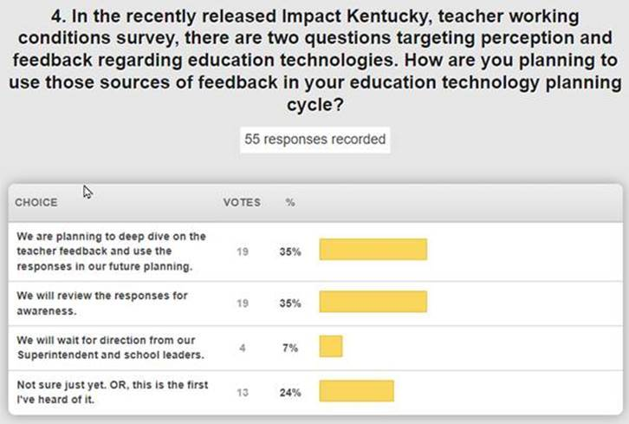

**(1:15:30) GoSoapBox Review –** We discussed a few of the poll questions throughout the meeting and then conducted a full review of them during this time.  The one’s not discussed at other points during the meeting are included below:

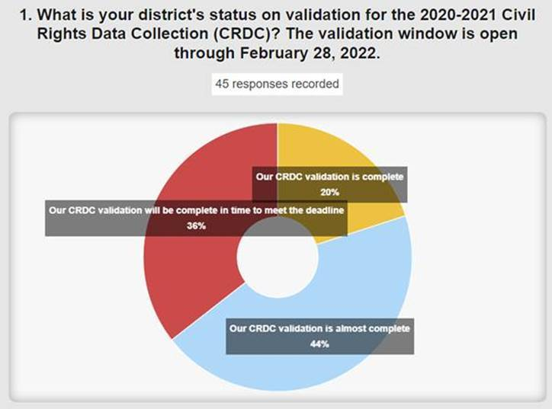

**(1:22:06) From the KETS Corner by Mike Leadingham –** Mike asked everyone to review his latest email message detailing several items for our EdTech leaders. Below you can find excerpts of that email along with items that have been highlighted or were discussed in more detail due to them having a sense of urgency.

Below you will find a few reminders and awareness items that I feel it is important to ensure we have a consistent understanding of.  As always, many of these topics you likely have already had some discussion with your KETS Engineer and we will also touch base on during the upcoming District EdTech Webcast on Tuesday, Feb. 15th.   Be sure to contact your KETS Engineer for any follow-up, additional clarification, or assistance as needed.

Be sure to also review my previous KETS Corner communication for additional detail on many of these topics.

Erate Application Window remains scheduled to close on Tuesday, March 22nd.

Mini-bids and 470’s need to be in process to ensure you are prepared to complete your Erate Application prior to March 22nd.   I remind everyone of the Erate requirement to conduct an open and fair competitive process for mini-bids and 470’s.  This includes ensuring that a mini-bid or 470 does not eliminate or exclude any potential respondent and has not been influenced by a vendor/provider. I ask that each of you ensure you are keeping these Erate requirements in mind. Failure to do so can put your district at risk, the KETS contracts as risk, and ultimately bring question to the KETS program and our relationship with the Erate program.  I’m sharing similar points with our KETS Product Vendor Partners, which includes awareness that their obvious influence or participation in the creation of a district mini-bid or 470 can put their KETS contract in jeopardy. Your KE can certainly direct you to answers or assistance as you continue to work through this Erate filing period.  We are completing the state application for Internet services on behalf of all districts.  Our state Erate application will continue to provide adjustments and improvements beneficial for all districts.

Erate Sessions for KY K-12 districts are coming up.  District leaders are encouraged to take advantage of the following Erate offerings as an additional resource for assistance with questions related to the Erate program:

* 2022 Spring KySTE Conference – (2) E-rate Sessions provided by Scott Kane & Caprice Gay: 1) Wed, Mar 9 @ 3:30 in the Willow Room - will cover last-minute concerns about filing Forms 471. 2) Thu, Mar 10 @ 9:30 in the Willow Room - will look at common E-rate mistakes and pitfalls and how to address and avoid them.
* 2022 E-rate Office Hours sessions will be offered to allow districts to address more specific scenario type questions on Feb 24, 2022 from 10am-12 pm EST

Technology Leases over $100,000, associated to your Erate application, have a due date for submission of Tuesday, March 1st.

The Erate Notice of Proposed Rule Making, to address “Promoting Fair and Open Competitive Bidding in the E-Rate Program”, continues to be available for public comment.  Due dates have been updated to March 28th for initial comments, and April 27th for reply comments.

District Technology Planning continues with a completion due date of Friday, April 15th.   Both the Digital Learning Team and KETS Engineers will continue to work with you on this important work.

A 2nd KETS Offers of Assistance is scheduled to begin mid-March.  The 2nd KETS Offers will be $12/ADA, to complete a total Offer of $21.00/ADA for FY22.  Based on feedback from districts and the changes in how the Offers are being managed between KDE & SFCC, there will not be a separate 3rd Offer this year.  **Going forward we will plan two KETS Offers of Assistance each year.  This will not negatively impact the total amount made available for the year.**

Look for your KE to advise you with more detail and provide additional guidance or assistance as needed.

Thanks.

mL

Thanks for joining us today and we hope to see you at the upcoming KY K-12 CIO/EdTech Leaders’ Summit at KySTE!  We’ll be sending out more details as they become available.  See you next month.