**Summary of the January 2021 for KY K-12 Education**

**Technology Leaders’ Virtual Meeting**

In case you missed it or want a refresher, the following is what we talked about during the January 19, 2021 edtech leaders’ virtual meeting. A copy of the video and audio can be found at

<https://mediaportal.education.ky.gov/featured/2021/01/edtech-webcast-january-2021/>.

Public viewing of the archived webcasts and written summaries are also available on the KDE Media Portal at: <http://mediaportal.education.ky.gov/>. Numbers in **RED** indicate the timestamp for that portion of the discussion so it can be easily located on the full digital recording.

This was a virtual meeting with our OET staff and all the districts joining via Microsoft Teams and/or YouTube. We will continue to make these available from our KDE media portal so that you can watch the archived discussion and share with the appropriate people in your district. Several GoSoapBox poll questions were posed throughout the meeting and district edtech leaders were asked to respond to all the questions as it assists us in planning and getting a feel for how to best move forward. Your voice and your feedback are important and extremely helpful to us.

**(1:45) Heartbeat from the Field** –As we did in December, a few districts joined us virtually to share their experiences with technology and connectivity while navigating the challenges with Covid-19 and the virtual learning experience.

* **(2:07) Pikeville Independent (with Supt. David Trimble, CIO Neil Arnett & CTO Brandon Blackburn):** Superintendent David Trimble joined us this morning along with Neil Arnett and Brandon Blackburn. Neil and Brandon serve as co-CIOs and they have held many district and state leadership positions and represent Pikeville Independent very well. Pikeville is a small but successful district with 1,160 students. Supt. Trimble has been in his current position since last July. They have a long history of success with a team and community members who are very passionate about education. Their focus has not been a 1:1 implementation even though they are very close to having it. Rather, it has been a focus on getting the students/teachers the right resources and ensuring teachers are trained and are able to maximize the use of the technologies. He hates paper! Processes are being transitioned to eliminate need for paper processes (digital efficiency).

Brandon is so proud of their district, KY K12 education, and the emphasis on computer science. He is seeing gains in the computer science pathways--they have added two new computer science classes and a new engineering pathway as well. The lab has been expanded to support all that is coming next. Digital opening day has been very successful and provides professional development opportunities for staff. The district has recently paid for all teachers to work towards their Google certifications. eSports is expanding and Pikeville has partnered with KHSAA and participated virtually and seen success.

Neil commended the passage of the technology and computer science standards and STEM being a focus. It is fully integrated into every topic area. At the elementary school, they are part of a $1.2M partnership with the National Science Foundation. They are working in conjunction with some other schools/organizations to build a STEM lending library. One of the main goals is to create a K-8 model for rural school districts to use and replicate.

**Pikeville Independent Feedback/Discussion:** Communication, support and funding levels during the pandemic were noted as top things done well. Pikeville Ind. noted appreciation of the 10% funds used toward shared services (Campus learning and Campus Online Registration). They shared concern about having an ongoing funding source for some of the initiatives.

**How does life look different for Pikeville Ind. after the vaccine?** Vaccinations just began in Pikeville and the schools are currently at about 80% in-person instruction. The online virtual academy has been successful and they don’t see things changing through the end of the school year. David commented that some students are excelling in the virtual learning environment and sees this continuing to be an option.

* **(22:32) Shelby County (COO Jill Tingle & CIO Chad Hebner):**  Today is Shelby County’s first day back for in-person learning and they have 80% of their students in person & 20% virtual (80/20). The technology team is led by Chad Hebner.  Jill Tingle, Shelby County Schools’ Chief Operating Officer, stated that most decisions are based on the Strategic Leadership Plan and they have been a 1:1 district for about six years. The pandemic forced them to ask how to support their students and staff from home. They started a virtual technology helpline right away and they also have an on-site repair system set up to ensure social distancing, etc. Kids have devices. But in a district with 7,000 students and 1,200 staff, Internet access within rural communities has been an issue:
  + Two years ago, they joined the Sprint program (now under T-Mobile and named the 10 Million Project) to receive free hotspots; this has been very helpful during the pandemic. Shelby County has distributed 100’s (150 have been sent out and 250 to still place) of hotspots through this program and they are tracking this free service to the child. It has been a slow process and they have a waiting list. It is not a foolproof solution, but not wanting the service has not been an issue; some have returned the hotspot if they are in a geographic area that cannot obtain any service at all.
  + They also recently worked on a project that involved community, industry (AT&T, LGE & KU), school and state staff, etc. to gain pole access and install equipment to bring Internet access to a portion of their students. It has taken a village to complete and now 500+ kids in the US60 corridor will have Internet access away from the school campus. No public announcements have been made yet, but it is on schedule! David commented that a recent white paper by the [Pegasus Institute](https://nam11.safelinks.protection.outlook.com/?url=https%3A%2F%2Fwww.pegasuskentucky.org%2F&data=04%7C01%7Clisa.moore%40education.ky.gov%7C5952c044b1684570a15308d8cf96f457%7C9360c11f90e64706ad0025fcdc9e2ed1%7C0%7C0%7C637487594764981929%7CUnknown%7CTWFpbGZsb3d8eyJWIjoiMC4wLjAwMDAiLCJQIjoiV2luMzIiLCJBTiI6Ik1haWwiLCJXVCI6Mn0%3D%7C1000&sdata=LUv9ccevB8qWOpVEurDXTGDBb488CTcSA%2FG1mC7v2E4%3D&reserved=0) in KY has some recommendations on removing barriers as described by the COO.

**How does life look different for Shelby County after the vaccine?** Until restrictions (masks/social distancing/quarantining) are lifted, they see it remaining at the current 80/20 percentages for in-person instruction. Their issue has been with adult staffing more so than with students. Mental health issues are also raising to the top.

**(39:43)** [**Commissioner’s Keep. Stop. Start. Survey**](https://nam11.safelinks.protection.outlook.com/?url=https%3A%2F%2Fkcews.ky.gov%2FReports%2FTableau%2F2021_EFS&data=04%7C01%7Clisa.moore%40education.ky.gov%7C5952c044b1684570a15308d8cf96f457%7C9360c11f90e64706ad0025fcdc9e2ed1%7C0%7C0%7C637487594764991924%7CUnknown%7CTWFpbGZsb3d8eyJWIjoiMC4wLjAwMDAiLCJQIjoiV2luMzIiLCJBTiI6Ik1haWwiLCJXVCI6Mn0%3D%7C1000&sdata=qfq5RoFmrxxpUVTZI62%2BUkJSaobWH22nKpElgWTkJU0%3D&reserved=0) **(Note: This link wasn’t shared during the webcast but became public after the Feb 3rd KBE meeting.) –** The commissioner released a survey on October 5th that remained open until November 20th. The survey asks what KDE, districts, partners and educators should:

* **KEEP Doing:** Things we value, that bring us meaning and pride, the “right” work.
* **STOP Doing:** Things that are not of value, that don’t have meaning or purpose, or are antithetical to our values as a Commonwealth.
* **START Doing:** Things we should aspire toward, work to put in place, build capacity around.

The results of this survey were presented to the Kentucky Board of Education on Feb 3rd. Below are a few of the combined responses. You are encouraged to check out the full report and view the entire responses from different perspectives (i.e., teachers, parents, etc.).

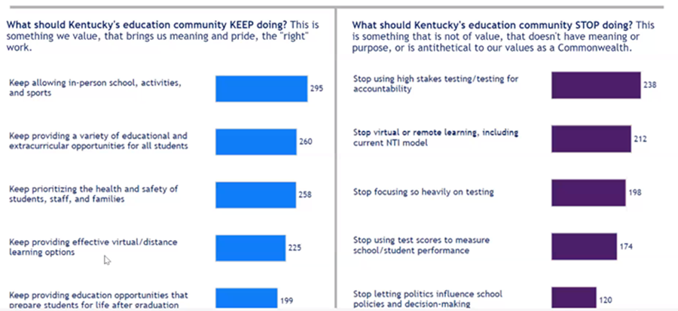

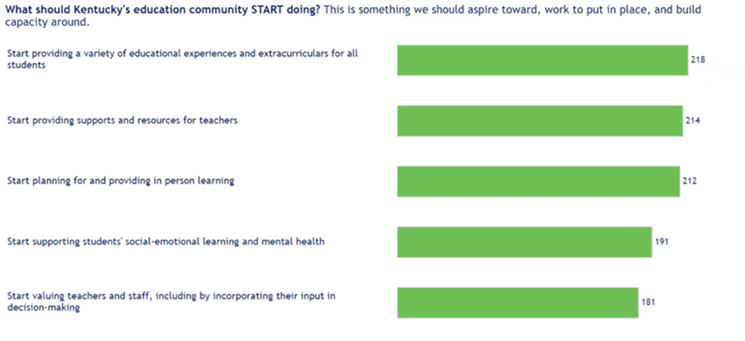

**(48:43) EdTech Funding Update –**

* **Legislative session** – This is not normally a budget year, but due to the pandemic the legislature only approved a one-year spending plan during last year’s session not knowing what might happen and how it could affect Kentucky’s economy. The overall financial situation is significantly better than we anticipated and the Governor’s initial budget proposal and state of the commonwealth address speak to that. Of course, the House and Senate each bring forward their versions of the budget bill and it ultimately goes into a conference committee to hash out the final version that will go before the Governor for signature.
* **LMI 1.0 Update** – The $8M Last Mile to the Internet (LMI) initiative deadline was extended beyond the end of December 2020. If your district was approved for a certain amount and didn’t expend the full amount, you now have more time to do so using the end of the school year as a target date. We have received reimbursement requests for close to $1.5M of the $5.7M allocated LMI funds and the reimbursement request deadline has also been extended. Even though the date was extended, there will not be any additional allocations.
* **Kentucky Educational Television (KET) Datacasting Initiative for school districts** – We are continuing to move forward with planning and pilots in school districts using a portion of the unallocated LMI dollars toward this initiative. This will provide a service to students who do not have Internet beyond the school campus and may be in a geographic area where they cannot receive a last mile wired or wireless connection for some time. They’ll be able to get their school assignments from their home by using KET’s wireless television signal to their home. This will help prevent teachers from creating paper packets and thumb drives with digital assignments on them that parents and/or students must have to drive to the school to pick up if the student is out sick or during extended/normal NTI type of days.
* **ESSER 2.0/GEER 2.0 Federal Funding Update** - The most recent Superintendent webcast covered many items regarding the new federal funding package that is close to $1B. We are terming this ESSER 2.0 and GEER 2.0 funds, but it is also referred to as CRSSA.
  + We expect the **ESSER** funds to be close to five times the last funding cycle and it can be used on a wide variety of items at the district level. This second round of ESSER funding expires in September 2023 so it gives districts time to plan and use those funds. Take some time to think about items that would benefit the education technology goals of your district.
  + The **GEER** funds also expire September 2023; however, the focus/uses of GEER 2.0 funds have not been identified.
  + There is also a separate federal funding source of $3.2B (**LMI 2.0**) for last mile access beyond the school campus. This fund will provide $50 monthly for Internet service and $100 for an end device.
  + In the allocation for Kentucky, there will still be an up to **10% allocation at the state education agency** level (i.e., KDE) and we would like to hear your thoughts on EdTech priorities for possible uses of those funds with an emphasis on state-shared services or one-time expenditures. Based upon the feedback that we received from all 171 districts in December, you were very complimentary of what we did with our portion of the CARES 1.0 funds to provide technology enabled services to your districts.
* **E-rate/KETS Offer of Assistance** – We are moving forward with the second KETS Offer of Assistance this month at $7/ADA. The third offer in the April timeframe will true up the annual offer amount. The E-rate filing window is now open and training sessions and guidance sessions are now available through OET staff.

**The following are the results from our GoSoapBox poll questions from you during our virtual Microsoft TEAMS meeting with all districts and OET staff.**

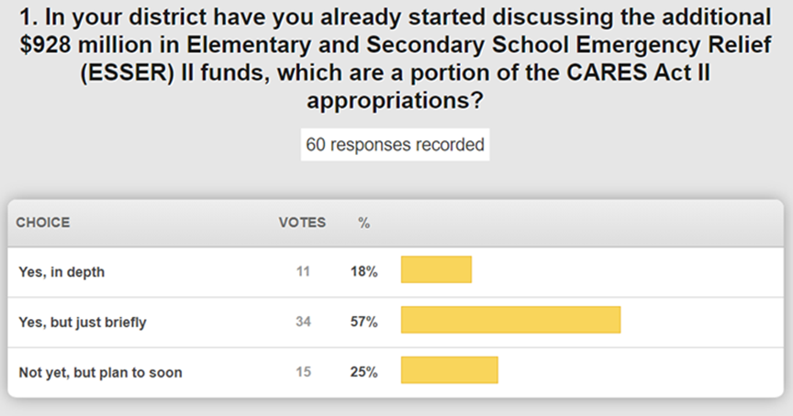

Be prepared for the onslaught of vendors who are trying to get a portion of these funds. In talking and planning with district leadership, be sure to address the need for ongoing funding to sustain any technology or services being purchased.

**Note:** The KDE guidance documents that will cover the eligible uses of these funds will be available by 2nd week of February and presented on the February 9th Superintendent webcast. This webcast will be available/archived on the KDE Media Portal.

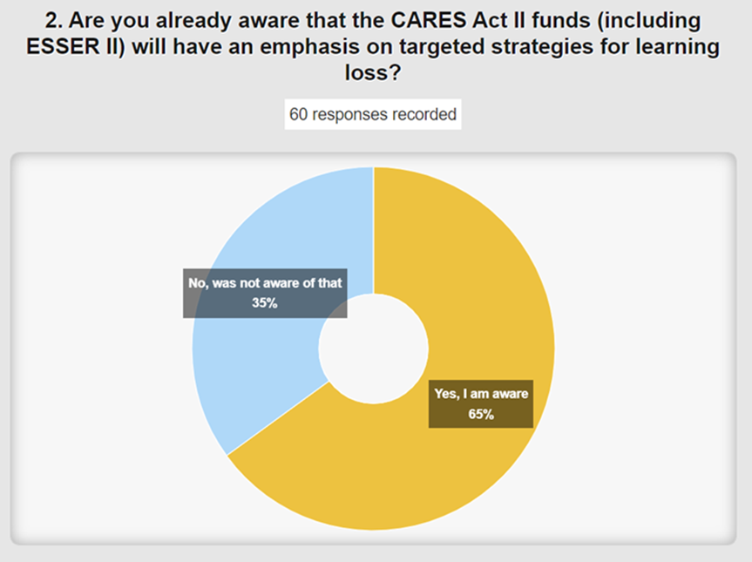

Be sure to target your discussions on tools, applications, digital resources, etc.

* [**Speed Test**](https://nam11.safelinks.protection.outlook.com/?url=https%3A%2F%2Feducationcabinet.ky.gov%2FInitiatives%2FPages%2FKBI.aspx&data=04%7C01%7Clisa.moore%40education.ky.gov%7C5952c044b1684570a15308d8cf96f457%7C9360c11f90e64706ad0025fcdc9e2ed1%7C0%7C0%7C637487594764991924%7CUnknown%7CTWFpbGZsb3d8eyJWIjoiMC4wLjAwMDAiLCJQIjoiV2luMzIiLCJBTiI6Ik1haWwiLCJXVCI6Mn0%3D%7C1000&sdata=%2B4VJ%2BOsY81tNrGMyEOew1%2Bn6uFQXllcI3w4au2OPD2Q%3D&reserved=0) - There will be an Internet speed test conducted across the state and the focus is the speed to the home to see where the areas of need are across the Commonwealth. This is being done as a portion of the Kentucky broadband initiative and focuses on speeds to the home.

**(1:09:31) Senate Bill 230 Refresher -** In 1998, this legislation was passed to ensure the Internet safety of our KY K-12 students and adults and there has been a renewed focus on Internet safety in our current situation. Because we accomplished this so long ago, we like to periodically go back and remind folks that we have had this in place for over two decades. There is a requirement in this legislation that KDE provide an Internet content management tool to our districts and we use Lightspeed. We do have a handful of districts that use something different but soon that will down to only 1 or 2 districts. Beyond that, we also have the Digital Citizenship program. OET staff are not the Internet police but the Lightspeed product does have logging and filtering capabilities.

**(1:13:52) Lightspeed Relay Update -** Phase I of the Relay project is to get the relay agent on every district device; since March 2020 we have implemented this on almost 500,000 KY K-12 computers on all platforms in districts. We are still working to complete Phase I while planning Phase 2. Phase 2 is putting the relay service in the best supportable framework/ease of use for your district. Right now, most districts must make policy changes in 2 places and we are working to make it so you only have to make policy revisions in 1 place with all devices using the cloud service. Phase 2 will be in a pilot phase later this month and we are working closely with Lightspeed to ensure we make this as simple as possible. After the pilot phase is complete, the project is projected to be complete by the end of summer.

**(1:18:37) Ray Baum’s Act/Kari’s Law -** We are learning more about the interpretation of the Ray Baum Act and Kari’s Law but wanted to know your current level of knowledge and understanding of these federal law and guidelines. As we have more information, we will continue to share any specific guidance or requirements from our phone and voice service providers.

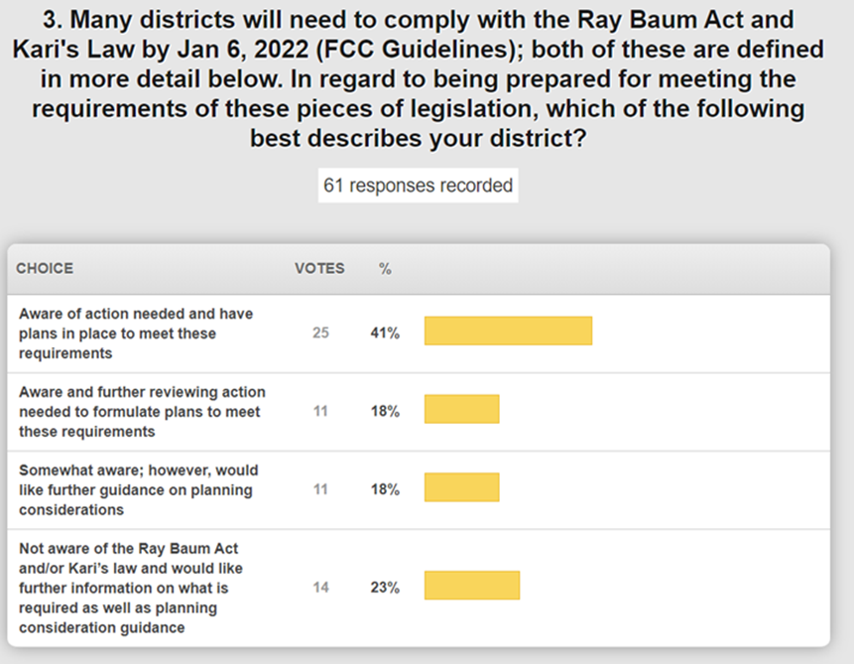

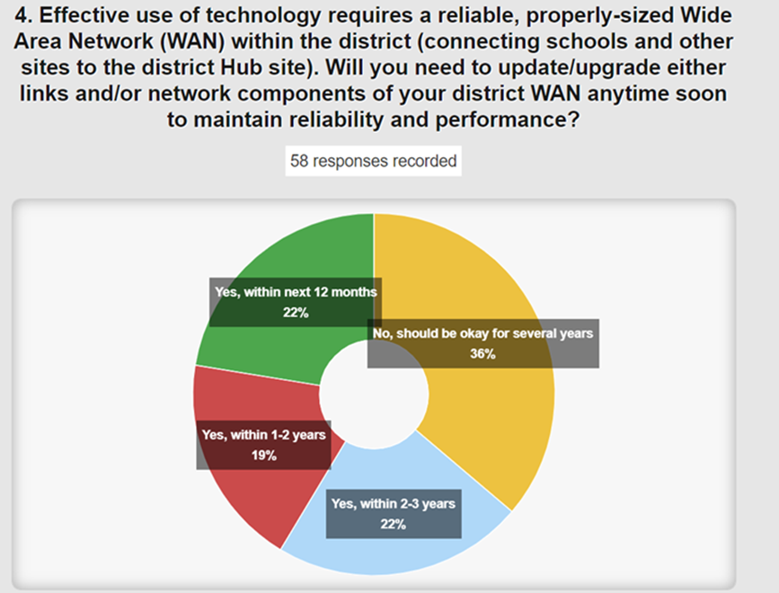

Make sure that we are aware of any potential access needs or issues within your district. We want to be very proactive and continually evaluate the needs of the individual districts. Since the pandemic began, bandwidth and network upgrades have continued.

**(1:24:20) Update on KY K-12 EdTech and Technology-enabled RFPs –**

* Point of Sale (POS) System – This is an active proposal and it is entering the negotiation phase.
* Educator Licensure System – This is also an active proposal in the negotiation phase.
* Network Components Contract – An offer was given to current vendors on this contract to extend the current contracts through the end of June. HP and Extreme did extend those contracts and Dell chose NOT to extend their contract expiration date. We do have an active RFP open at this time that closes on 1/19/2021 and that will allow the opportunity for up to six contracts to be awarded. Each contract awarded can have up to five named agents/resellers. We are on a tight E-rate application window that expires on March 25, so be prepared to move quickly for filing purposes through the next fiscal year.

**(1:28:59) Top 5 KY K-12 EdTech Accomplishments/Improvements for 2020 and 2021 Goals -** We normally work these into our monthly webcast but we want to set up a special webcast this year to spend some dedicated time on this topic. We may ask a few districts to join us as we have in the last few months. Appreciate the Top 5 feedback that every one of our 171 districts provided and every OET staff provided us in December.