**Summary of the November 2020 for KY K-12 Education**

**Technology Leaders’ Virtual Meeting**

In case you missed it or want a refresher, the following is what we talked about during the November 17, 2020 EdTech leaders’ virtual meeting. A copy of the video and audio can be found at

[https://mediaportal.education.ky.gov/technology/2020/11/edtech-webcast-november-2020/](https://mediaportal.education.ky.gov/technology/2020/11/edtech-webcast-november-2020/%20)

Public viewing of the archived webcasts and written summaries are also available on the KDE Media Portal at: <http://mediaportal.education.ky.gov/>. Numbers in **RED** indicate the timestamp for that portion of the discussion so it can be easily located on the full digital recording.

This was a virtual meeting with our OET staff and all the districts joining via Microsoft Teams and/or YouTube. We will continue to make these available from our KDE media portal so that you can watch the archived discussion and share with the appropriate people in your district. Several GoSoapBox poll questions were posed throughout the meeting and district EdTech leaders were asked to respond to all the questions as it assists us in planning and getting a feel for how to best move forward. Your voice and your feedback are important and extremely helpful to us.

**(3:20) SY 2020-2021 Budget Update -** The proposed 8% budget cut to the Kentucky Department of Education will not be implemented. The revenues were better than expected and while we may still have to take some portion of that 8%, it won’t be the full 8%. We plan to take any needed cut from the KETS Offer of Assistance program. The first offer was already reduced to $7.50/ADA in anticipation of this; the 2nd and 3rd offers will be adjusted and we hope to be able to get back to our original offer projections for the school year.

**(5:09) Heartbeat from the Field** – Visiting school districts is one of our favorite activities. The personal visit, learning about the area and school, and highlighting the school/district is such a great experience. Today, we have a few districts joining us virtually to share their current experiences with technology and connectivity while navigating the challenges with Covid-19 and the virtual learning experience. We will also review some of the “heartbeat” information that we are collecting and updating/comparing monthly in regarding to Internet access outside of the school campus.

* **(8:14) Covington Independent** **(with Supt. Alvin Garrison, CIO Jamarcus White, and Assistant Supt. Scott Alter):** Supt. Alvin Garrison introduced the district staff and passed it on to Jamarcus White to speak to Covington Independent’s experiences. Covington Independent is the most northern school district in the state and a big challenge has been a delay in receiving ordered laptops. The City of Covington and community partners are stepping up and doing their part to assist through a Covington Partnership Initiative for Internet accessibility and hot spots. They also have partnerships with T-Mobile and the United Way/ Cincinnati Bell partnership. It is exciting work and these infrastructure initiatives will stay in place even after Covid.  Scott Alter, Asst. Supt., discussed their learning challenges. They began with a lot of paper packets, especially for the K-6th grade students, and quickly began planning for a blended learning environment. The 6th-8th grades were not at a full 1:1, but the 9th-12th grades were at a 1:1 implementation. They began training for Edgenuity and they chose Odysseyware for their elementary schools. There have been some bumps in the road and teachers are working hard to complete the needed training and become proficient. They are working hard to limit the number of programs parents are asked to use and be familiar with while learning remotely. Lexia software tools are being used throughout the district and they are also piloting FEB tutoring software. Covington has purchased 40 blended units—cameras & audio combined into one system that have been placed in classrooms throughout the district to assist with instruction delivery. Coming out of this crisis, all the planning and relationships will continue to provide positive steps forward.
* **(27:13) Jefferson County (with CIO Kermit Belcher):** Jefferson County was not a 1:1 district and the pandemic has really accelerated the implementation of this endeavor. They have deployed over 65,000 instructional devices to students since March. Having cloud-based systems has been very helpful to the district. Closing the digital divide has been challenging and they have deployed 11,500 hot spots to their students to assist with the “last mile” connectivity; this has been a huge undertaking. Kermit went through all the steps they took from a security and instructional perspective. The Lightspeed Relay for their student devices has gone very well and the analytics/analyzation of the data is proving to be very helpful and allowing data driven decision making. Kermit stated that the infrastructure and supports that have been put in place at the state level has been a big part of their success. All districts are being challenged for long-term, sustainable models for home Internet access solutions along with the Career and Technical programs support. Repairs and break/fix is also challenging with both students and staff being remote.
* **(42:09) “Heartbeat” Update (with Chuck Austin):** The Digital Readiness Report is complete; however, there are a few data elements we are having to check on monthly outside of the digital readiness data that is a snapshot in time. This survey helps us establish the unmet need component (inventory), it allows districts to perform comparative analysis, and it helps us identify and react to trends. The pandemic and pivot to remote learning options is requiring a more frequent snapshot of a few of the data elements captured in the survey; these “heartbeat” questions will help us see the month to month data regarding Internet access away from the school campus and the data around instructional devices. We will continue capturing these data elements monthly for at least the next six months. It will also provide more accurate/needed data to lobby for continued and increased support with our legislators and “K” groups. We are currently relaying that we have 3% of students who do not have Internet access beyond the school campus to do schoolwork and 2% of students who do not have an instructional device available to them to complete their schoolwork remotely.

We hope that instructional devices currently ordered or on backorder get delivered in the next few months. We have received 30,000+ devices since June and close to 60,000 devices are still due for delivery. We will have close to 1,000,000 instructional devices when all these are put into service!!! To put this in perspective, this number is 10 times larger than all the devices in state and local government agencies. Increasing the number, deployment and support for all these devices is heroic—THANK YOU.

**(56:54) Kentucky Education Technology System (KETS) RFPs Update -**

* Kentucky Educator & Licensure System – This is an active/ongoing RFP and we can’t speak to it in much detail while this in process. This is a large, multi-scale system.
* School and Community Nutrition Point of Sale System (POS) – This is also ongoing and we are working with our partners in School and Community Nutrition to pursue a solution.
* Infrastructure as a Service RFP Initiative – We are also actively working on this request for proposal.
* Networking Products & Services Contracts – This RFP is upcoming with the current contracts expiring in February of 2021. It is likely that we will request an extension to this expiration and that will also allow the contract expiration to coincide with the fiscal year and E-rate filing dates.
* The Last Mile Internet contracts (8 in total) are still active and available.
* File Service and Storage have recently been awarded.
* Instructional Device Contracts were also recently awarded.

**(1:00:19) KY K-12 Data Systems Update -** The School Report Card (SRC) is out and there is a new compare feature available; it will be expanded to provide ability to see trends and perform comparisons on multiple subgroups simultaneously. The additional functionality will be live in the next few weeks but it will still be limited because the data is limited.

Infinite Campus (IC) training week has started and it is the replacement for the Interchange Conference; this is an online, national training week. It is an excellent value at $499 for the entire week with the training resources available to all district staff.

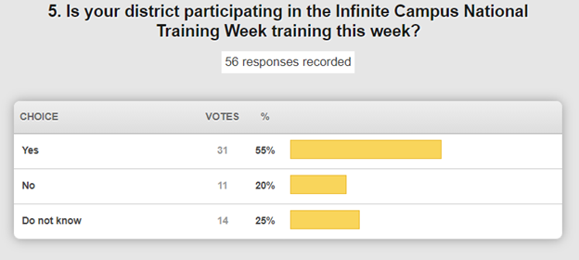

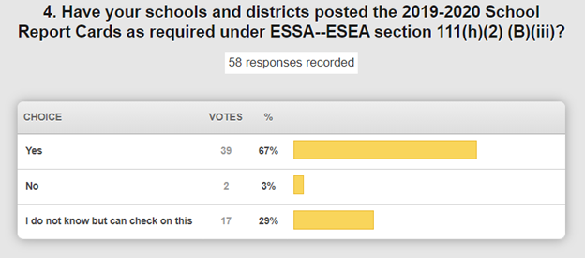

This is a good number! At some point, we will be checking district websites to ensure that these are posted as required under law and reaching out to follow-up with districts that have not already completed this requirement.

IC sent out a message over the weekend (4 p.m. Sunday) describing a phishing email situation where IC credentials were being collected and suggesting several features that could heighten the security of your district IC accounts. It is not impacting any of the Kentucky school districts at this time, but it could have. Bob Hackworth described the details of the issue and encouraged everyone to be on their “phishing game” along with having a multi-layered approach to security by enabling login alert notifications, auditing IC account permissions and considering enabling for multi-factored authentication. The yellow caution banner is also effective in letting you know an email may have come from an outside source. None of the approaches is 100% on its own, but with the layers, it will greatly increase the overall security. If you have any questions, please reach out to IC with your questions.

**Other Items:**

1. We do have opportunities for SRC feedback through BrightBytes.
2. IC extended the training timeline for Online Registration and Campus Learning. These are free to districts and you are encouraged to take advantage of this while it is available.
3. High school feedback reports are out and now available through the KySTATS website.

**(1:09:54) CARES Funding Updates -**

* Lightspeed Relay – This effort began before the pandemic and we continue with this effort. We have 470,000 relay-aware devices. Phase 2, the analytics portion, are coming on and there are some upcoming trainings available. Phase 3 will be the out of band mode and we had a question concerning this since it will require work by both OET and district technical staff. Pilots are being planned for January and then a schedule will be formulated for implementation across the state.

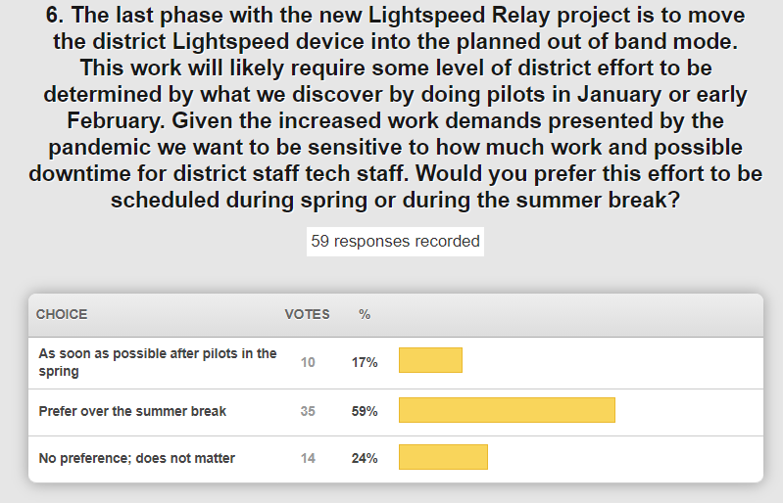

* Last Mile Internet funding – We had $212M to use toward a large variety of things along with the $8M Last Mile Internet Program. The last mile program is a funding source that expires at the end of December 2020 and we have made a lot of progress in a very short period of time. The updated numbers are below and we’ll continue conversations with the state budget office to maximize the funds.

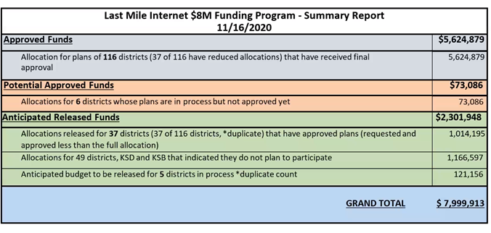

**(1:18:36) June Survey Update –** The link and results of the June Family/Caregiver survey have been shared several times, but today we spent a few minutes on some specific questions related to the Access to Technology section of the survey results. These have been used within the last mile to the student as discussion points. Keep in mind that this was completed in June and we are looking monthly now at these same data elements.

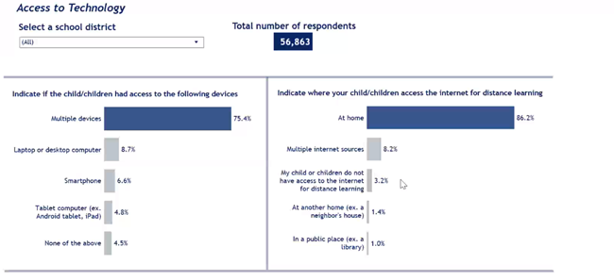

In conjunction with this, we are reviewing/updating our heartbeat items on a monthly basis and continuing to look at other ways we can reach these last students who do not access to the Internet outside of the classroom.  One of the ways being explored is in a partnership with KET using ATSC 1.0 and ATSC 3.0 technologies. Below is a depiction of the current coverage of Kentucky Educational Television (KET) using 16 transmitters that reach about 90% of homes the state.

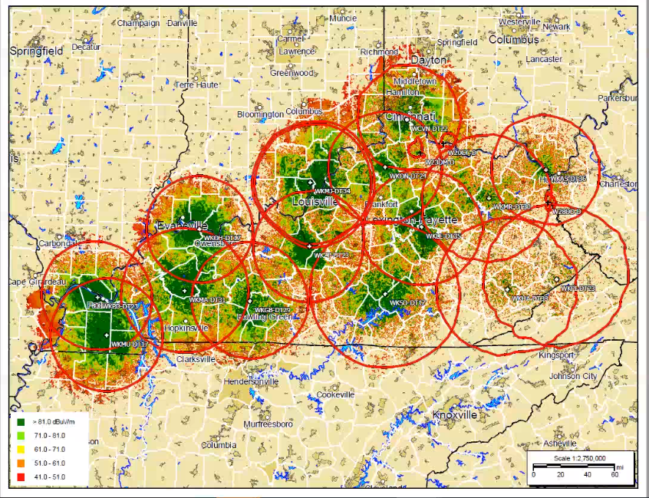Using the ATSC technology could be a possible solution for NTI or a homebound student going forward. Kentucky Education Television (KET), with its wireless digital signal, is working to provide another tool for asynchronous learning. It is capable of providing content to the student without them having to drive to the school, sync a thumb drive or get a paper packet. It is not a 100% solution but we are planning a pilot with these devices and will be documenting all the pros and cons as well as the impact of the ATSC 1.0 & 3.0 technologies.

We reviewed the poll questions that are related to the Internet and KET’s ATSC 1.0 & 3.0 discussions:

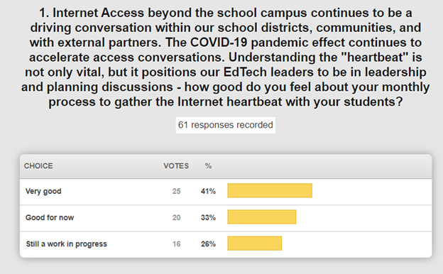

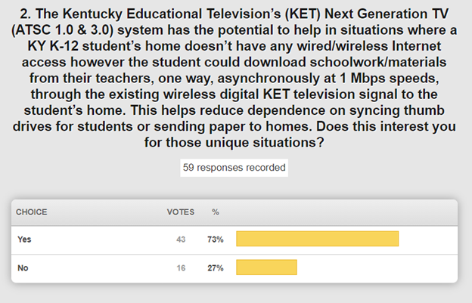

If you are interested in being a pilot for this, please reach out to your KETS Engineer.

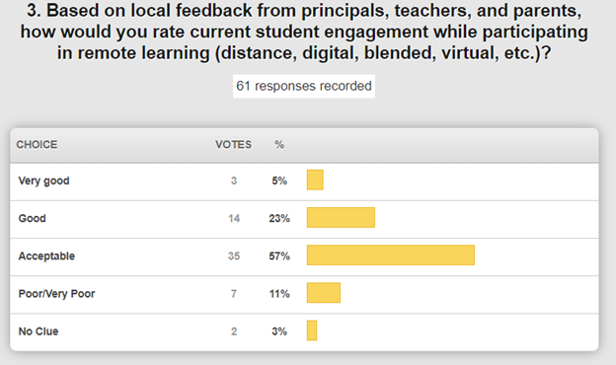

**(1:30:29) Kentucky Society for Technology in Education (KySTE) update –** Greta Casto of Russell Independent schools and KySTE/ISTE liaison joined us today and noted that this year is definitely the year to recognize the outstanding work of our teachers and sending in nominations for the Impact Awards. On the KySTE site, there is a drop-down menu for the awards—Impact Leader, Impact Teacher, Impact Technical Support, and Making IT Happen. Nominations close on January 29th, so please take a few moments to submit nominations using the simple Google form. STLP scholarship forms are also up and open! Please pass this information along to your counselors. KySTE is still happening in the Spring, but we are anticipating it will be a virtual event. More information will be coming soon.

**(1:34:05) Annual Feedback Update –** We are collecting feedback comments from all 171 district CIOs and OET staff. In order to provide ample time, the due date is shifting from the 1st of December to the 15th.  This feedback is so valuable to us and we hope you take a few minutes to provide some thoughtful responses. We’ll discuss the collective responses in the January timeframe.

Let’s look at November as a month of thanks! We won’t be able to celebrate in all the traditional ways and it won’t be ideal, but please be safe and well.