**Summary of the October 2020 for KY K-12 Education**

**Technology Leaders’ Virtual Meeting**

In case you missed it or want a refresher, the following is what we talked about during the October 20, 2020 edtech leaders’ virtual meeting. A copy of the video and audio can be found at

<https://mediaportal.education.ky.gov/featured/2020/10/edtech-webcast-october-2020/>

Public viewing of the archived webcasts and written summaries are also available on the KDE Media Portal at: <http://mediaportal.education.ky.gov/>. Numbers in **RED** indicate the timestamp for that portion of the discussion so it can be easily located on the full digital recording.

This was a virtual meeting with our OET staff and all the districts joining via Microsoft Teams and/or YouTube. We will continue to make these available from our KDE media portal so that you can watch the archived discussion and share with the appropriate people in your district. Several GoSoapBox poll questions were posed throughout the meeting and district edtech leaders were asked to respond to all the questions as it assists us in planning and getting a feel for how to best move forward. Your voice and your feedback are important and extremely helpful to us.

**(3:40) KY K-12 Digital Readiness Report for School Year 2020-2021-** This annual report is based upon all 171 districts providing the data that populates both the district and cumulative information. This was a very in-depth conversation and we are sharing some key discussion points in this summary; however, we do encourage you to listen to this portion in its entirety.

The snapshot is done as of June 30, 2020. All 171 districts have responded, and we appreciate your time and efforts in completing this survey. This year has been an exception in many ways. Currently, the Covid-19 cases are increasing in Kentucky and many other states. We must continue to be agile in our instruction and certain data elements (i.e., Internet access beyond the school campus) will need to have a more real-time, “heartbeat” update.

**Highlighted Points:**

* Digital readiness is broken into 2 pieces – technology inventory and programmatic/district strategy questions.
* Public report will be ready very soon.
* Student to Computer Ratio went from .90:1 to .78:1; the original goal was 6:1 and then 1:1 in our last KETS Master Plan. We have to keep in mind that the original goal of 1:1 wasn’t an individually assigned 1:1 device (mobile). The move toward a mobile 1:1 will be very important in our current remote learning environment.
* We have 901,866 devices and this data element will be one of the “heartbeat” data elements that we will collect frequently. Sixty-four percent (64%) of our current digital footprint is Chrome devices and will have to do more of a deep dive into the Mac data to see what percentage of those devices are MacBook Airs, MacBook Pros and Mac desktop workstations.

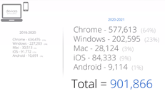

* 193,601 new devices were purchased this past year while 80,609 devices were surplussed.
* Statewide Online Testing – While we are unsure what form testing will take this year, we had a significant increase in devices that are accessible for online testing.
* Wi-Fi inside of schools (dense Wi-Fi) – 99%; We have more and faster connections than we had last year.
* FTE positions have increased to 946; we have an increase in the Digital Learning Coach position while we have lost a few technicians (7) and we have fewer STLP Student Help Desks (87 currently). CIO contract days are up and we have an increase in our district level data quality.
* We will be asking for updates to the snapshot in time via the monthly “heartbeat” survey through the field staff. The CARES funds and community involvement is causing this to constantly change. Also, some districts have things in motion but are waiting on equipment and vendor/community engagement so these numbers could change dramatically month to month. It is important to note that Internet access alone does not equate to having sufficient broadband to complete assignments remotely. This is especially true for homes with multiple students in the home and parents who are working remotely as well.
* We now have 165 school districts that have Learning Management Systems.
* 140 districts using Google Meet, 70 districts using Teams, and 60 districts using Zoom.
* Individual Learning Plan (ILP) – Districts have found a way to continue this even though funding was ceased.
* 166 districts are utilizing the Digital Driver License program; we will be circling back to the 5 districts who aren’t taking advantage of this program.
* We will be populating the district by district view of this data for your comparison as well as updating our annual KETS Infographic. We always strive to have this updated and available as we go into the legislative session. You can also use this for discussions with your Superintendent, your local board, and other organizations.
* SpeakUp and BrightBytes windows will be opening soon as well with 15 to 20 districts being part of each of those.

**(38:01) KY K-12 EdTech RFPs/Awards Update –** We have several items active right now that affect our school districts and below is a short summary of all the recent activity surrounding those:

**Upcoming Activity:**

* Networking Products and Services – This contract is coming to an end and we’ll be working on this to have eligible contracts in place
* KIH-3 Contract – This is our Internet services contract and we will be ramping up activity on this as well.  It is a way off, but it will be here before we know it.

**Open/Ongoing Activity:**

* School and Community Nutrition POS System – This is the Point of Sale system that we are working on with Office of Finance and Operations within KDE.
* Education Licensure System – This is also an open RFP and of interest to our school districts.
* Last Mile to the Student RFP – This is still open at this time and is termed an optional-use contract. Appalachian Wireless met the intent of this contract in their bid response and we wanted to point out that they really came to the table on this one. We will also look at national pricing for these services.
* Infrastructure as a Service – This is still an open RFP currently.

**Recently Closed/Awarded Contracts:**

* Server and Storage Contract – HP, Lenovo, Cisco and DELL received these awards.
* Instructional Device Contract – Dell, HP, Lenovo and Microsoft were awarded to this contract. Bytespeed & Apple were two previous contract holders who did not receive awards on the new contract. We are having conversations to discuss how districts work through not being able to purchase Apple MacOS enterprise desktops and MacOS enterprise laptops (i.e., MacBook Pro) devices any longer. Districts can continue to buy iOS consumer devices like the iPad. A waiver will be required for the Apple MacBook Airs for student, teacher and staff use from their classrooms, offices and beyond the school campus. A waiver will also need to be submitted for Apple products that are required by the district staff to manage their district’s MacBook Airs and iPads. There will be a waiver option for this school year for those districts that have plans in motion for Apple purchases and then we will review/update our guidance so applicable districts may develop their transition plans. Apple did not meet the conditions to receive consideration for a contract with the Commonwealth (12 of 19 mandatory requirements were not met).

**(59:07) Current Status/Next Steps Regarding the Last Mile Internet for KY K-12 students –** The chart below depicts the current status of this initiative and the portion of the $8M that have been approved and/or released to school districts. Keep in mind that this $8M is above and beyond the $212M in CARES funding sources that have been made available for districts and some districts may elect not to take advantage of this or do not have a need to utilize these funds.

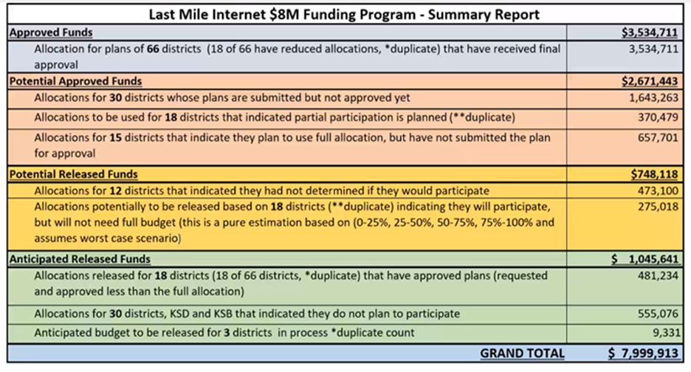

We still have a wide range of uncertainty and the deadline for a district to submit a plan was extended to October 30th. Once approved, districts have until December 30th to spend these dollars and a February 1st deadline to request reimbursement. Districts have had CARES funds (ESSER and GEER funds) available to them prior to this Last Mile Internet $8M Funding Program. The intent of the last mile program is for those free and reduced lunch students who do not have Internet access available at the home. The big limitations are the 30 December 2020 cutoff and what it can/cannot be spent on. The other CARES funds are available until September 2022. We’ll keep a close eye on the unallocated dollars and make every effort to look at ways to either reallocate or redirect those funds to maximize the funding available through this program.

**(1:12:25) KETS Offers of Assistance Update -** We are going to move forward with a 1st Offer of Assistance of $7.50/ADA; this is lower than our originally projected offer of $9.00/ADA due to the budgetary forecast and anticipated budget cuts. We will have the opportunity to adjust the 2nd and 3rd offers based on the outcome of the budget discussions and eventual actions.

**(1:13:30) E-rate Filing Update –** E-rate filing windows will be coming up soon. There are many discussions happening right now regarding the E-rate program. We have not received the letter of agency from a few of our school districts; this is necessary for statewide eligibility requirements.

**(1:14:51) KY K-12 School Report Card (SRC) Update -** The new SRC was released on Wednesday and is a valuable tool for students, parents, school staff, community members, and media/researchers. The School Report Card really has three components:

1. BrightBytes – This portion is valuable to parents who are looking to move or relocate.
2. Infinite Campus Parent and Student Portal – This is most valuable to parents and students currently in the school system and is near real-time information.
3. Open House – This section of the SRC is valuable for the media and researchers.

We appreciate all the work at the district level to contribute to the success of this work. The financial piece of the SRC will come out in the April timeframe.

**(1:17: 53) STLP Update –**Regionals are still a go and moving full steam ahead. Many people/volunteers across the state are engaged and ready to begin! In trying to be respectful of our students/teachers with all that is going on, it will be 100% virtual with regionals going into mid-December and having a very simplified approach. After December, we will begin work on Level 2 projects. Digital online judging has been pushed back to February this year as well. One of the silver linings is that you and your students may have more opportunities to participate; hop onto the STLP site and check it out. No travel, no substitutes needed, and we have increased Digital Learning Coaches across the state that can help you connect and highlight student work. STLP lends itself to this virtual format and we look forward to seeing all the ways we can make this AWESOME while showcasing the work of our students.

**(1:25:29) GoSoapBox Review -**

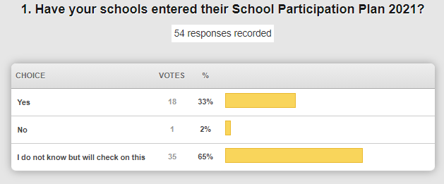

This information will be shared, and it is important to update this information periodically to show the current and/or changing status at our schools.

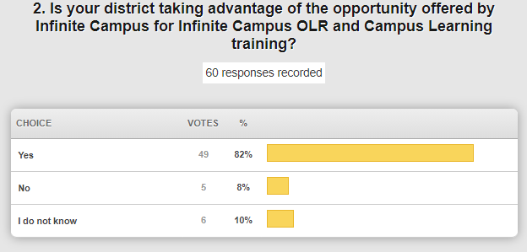

Please don’t miss these training opportunities that are available for a very limited time!  Check out the KSIS Training page on the KDE website for more information.

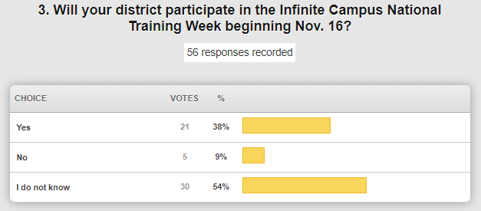

This is a $499/district training cost and a great, cost-effective opportunity for multiple members of a school or district to receive training.

**(1:30:13) “Heartbeat” Collection Update -** There are some key data elements (i.e., Internet access beyond the school campus) that we will be reaching out to you and updating on a monthly basis for the next few months. To prepare for this we’ll be tweaking some of the previous survey questions and doing all that we can at the state level to assist in shoring up some of the issues. We are so impressed with how you have been working and hope that you are doing well; you ARE making a huge difference and impact.

We are working on how we can still showcase what a district is doing since we cannot make our usual district visits. Thanks for joining us today and thank you for what you do for our school leaders, teachers, and students.

We’ll see you next month.