**Summary of the September 2020 for KY K-12 Education**

**Technology Leaders’ Virtual Meeting**

In case you missed it or want a refresher, the following is what we talked about during the September 15, 2020 EdTech leaders’ virtual meeting. A copy of the video and audio can be found at

<https://mediaportal.education.ky.gov/technology/district-technology-leadership-webcast/2020/09/edtech-webcast-september-2020/>

Public viewing of the archived webcasts and written summaries are also available on the KDE Media Portal at: <http://mediaportal.education.ky.gov/>. Numbers in **RED** indicate the timestamp for that portion of the discussion so it can be easily located on the full digital recording.

This was a virtual meeting with all our OET staff and all the districts joining via Microsoft Teams and/or YouTube. We will continue to make these available from our KDE media portal so that you can watch the archived discussion and share with the appropriate people in your district. Several GoSoapBox poll questions were posed throughout the meeting and district EdTech leaders were asked to respond to all the questions as it assists us in planning and getting a feel for how to best move forward. Your voice and your feedback are important and extremely helpful to us.

**(2:10) Farewell to Interim Commissioner Kevin Brown/Welcome to New Commissioner Dr. Jason Glass –** We bid farewell to Kevin Brown who will be returning to his position at Jefferson County Public Schools. When he was asked to take on the Interim Commissioner role last year, none of us had any idea of the work he would undertake in the interim capacity. He did an outstanding job under very trying circumstances.

Dr. Jason Glass came on board September 14th and taped an episode of Kentucky Tonight on his first official day as Commissioner; you can view this at[https://www.ket.org/program/kentucky-tonight/challenges-and-benefits-of-remote-learning-in-kentucky/](https://nam11.safelinks.protection.outlook.com/?url=https%3A%2F%2Fwww.ket.org%2Fprogram%2Fkentucky-tonight%2Fchallenges-and-benefits-of-remote-learning-in-kentucky%2F&data=04%7C01%7Clisa.moore%40education.ky.gov%7C2753656a7b4e474c667808d87497b4fe%7C9360c11f90e64706ad0025fcdc9e2ed1%7C0%7C0%7C637387542334268375%7CUnknown%7CTWFpbGZsb3d8eyJWIjoiMC4wLjAwMDAiLCJQIjoiV2luMzIiLCJBTiI6Ik1haWwiLCJXVCI6Mn0%3D%7C1000&sdata=r0YnlNk1Zm3%2FqiZB0njWu8TqaNZSrGJdT%2BO2mlMNNHU%3D&reserved=0) . Much of this interview covered technology aspects so we recommend that you view/listen to it. He has been engaged in meetings for the last several weeks, so he has hit the ground running and has an excellent background for this position. He grew up in Kentucky but has been working/living in other parts of the country; he is glad to be back and has moved into the Lexington area.

**(5:06) Recent 8% Budget Cut for KY State Government General Funds –** We were notified of this last week. Since 2008 KDE has absorbed substantial cuts to the department and tried to do so with the least amount of impact to the funds and services that go directly to our school districts. This 8% cut has the potential to impact KY K-12 EdTech Funds (e.g., Kentucky Education Technology System (KETS) Funds, Kentucky Educational Network (KEN) and Office of Education Technology (OET) Funds). Due to this 8% cut along with no restoration or increase to our KETS and KEN allocations, we will have to look at a reduction to our KETS Offers of Assistance. We are doing our best to work through this with no or minimum impact to our services and the funds that flow to your districts to meet the technology needs for staff and students. The first KETS Offer could be impacted by as much as $1M (from $9 per student to $7.50 per student) and we will be reviewing all possible alternative courses of action.

**(11:11) Status of the CARES Funding for KY K-12 EdTech Initiatives -** The CARES funding is a temporary funding source available until September 2022, but it is a plus for us all in our current situation. Districts have been using a very high percentage of these funds ($174M ESSER funds and $30M GEER funds) to purchase devices for students to use at home. We had a 1:1 computer ratio before this situation, but this was not collected based on a mobile solution where the students took the device home. Our current budget situation could be a temporary one, but it still validates why we need to continue working to restore and/or increase our education technology funding (KEN and KETS). In today’s webcast, we addressed some of the specific items that the CARES funding could be used toward:

* **Professional Development for teachers on distance teaching and learning –** A portion of the CARES funding can be used toward PD and we took a multi-tiered approach

1. We launched the **Digital Learning Design Labs** and that work continues to grow through our educational cooperatives.
2. Another angle is the **Digital Learning Coach Stipend Program** and we are using CARES funds to help move this work forward and extend a full fledge program.  Our field staff will be sending out the information/details regarding this program to you and Superintendents. This is one-time funding and dedicated to the digital learning coach work. Marty Park spent a few minutes to review the details of the program.

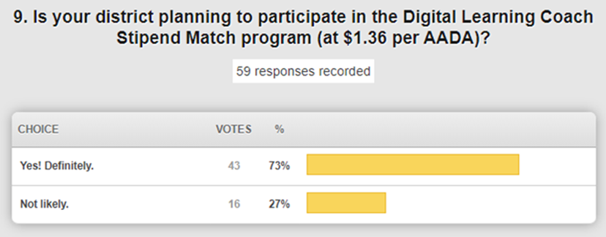

* **Lightspeed Internet Content Management Service and Lightspeed Analytics –** We currently have 352,000 devices installed with the relay client and hope to have all devices loaded with the relay client by the end of the calendar year. The purchase of the Lightspeed Analytics is almost complete, and we’ll be turning on that service for our school districts in the near future; it does rely upon every client having the relay service. We are excited about the implementation of the analytics and there will be some upcoming training opportunities. Lightspeed is also offering the districts a basic CIPA filtering service to use with hotspots they are deploying, but it is important to note that while it is CIPA-compliant, it will not provide any reporting capabilities.
* **Infinite Campus (IC) Services –** IC has two CARES related offerings. The Campus On-Line Registration was offered to all districts and 111 districts are currently using that service. If you decided not to implement, it is not too late if you'd still like to take advantage of it in January or next school year; just initiate this request through a support ticket. The Campus Learning has been opted in by 125 school districts.  Of those 125 districts, 85 districts have opted in for the Google Classroom integration. If you haven’t decided yet, it is time to make your final decision prior to October 1, 2020. There will be some additional training opportunities for both offerings, and we recommend you take advantage of these training dollars/hours while they are available to us.
* **Next Generation of Virtual Schools –** We don’t have a firm date on this yet, but this is full time virtual enrolled students who do not have assigned classroom teachers. It is a moving target and we have 15 schools who have implemented a virtual academy on some scale.

**(33:29) Department of Public Health (DPH)/Governor’s Press Conference Announcement –**This announcement introduced a technology enabled initiative at the school/district level for collecting information regarding Covid-19. This was already being done as part of existing policy in reporting infectious diseases, but this collection tool is specific to known information regarding Covid-19. The tool doesn’t collect specific student information, but rather numbers of students. We want to emphasize that this is a tool developed and supported solely by the Department of Public Health.

Parents and guardians are required to notify local public health agencies and schools about students who have tested positive for COVID-19. Schools are then required to report those numbers to the state’s Department of Public Health (DPH), and how many people are in quarantine, on a public dashboard through this tool. The DPH dashboard, updated each weekday, is intended to help parents, teachers and administrators make real-time decisions based on a color-coded grid. The Governor has said that he doesn’t intend to make any further recommendations regarding virtual vs. in-person classed. Input into the DPH dashboard system begins on September 28th. There is a report in IC that already collects three of the numbers being requested in the DPH tool for students and this is an optional only resource for your schools to use to complete the daily data entry into the DPH tool. Staff information is not collected within IC. Data quality will be an issue and we reviewed the components of data elements/data quality.

**(48:50) Status of RFP & Funding for “Going the Last Mile for KY K-12 students” and KET’s Kentucky Tonight Program –**During this portion we reviewed the GoSoapBox poll questions while providing updates in relation to the Request for Proposal (RFP) for the Going the Last Mile to the student as well as commenting on topics covered during the Kentucky Tonight program hosted by Renee Shaw that included Dr. Jason Glass and several other guests to discuss remote learning in KY K-12.  If you’d like to watch the September 14th program, please do so at [https://www.ket.org/program/kentucky-tonight/challenges-and-benefits-of-remote-learning-in-kentucky/](https://nam11.safelinks.protection.outlook.com/?url=https%3A%2F%2Fwww.ket.org%2Fprogram%2Fkentucky-tonight%2Fchallenges-and-benefits-of-remote-learning-in-kentucky%2F&data=04%7C01%7Clisa.moore%40education.ky.gov%7C2753656a7b4e474c667808d87497b4fe%7C9360c11f90e64706ad0025fcdc9e2ed1%7C0%7C0%7C637387542334278371%7CUnknown%7CTWFpbGZsb3d8eyJWIjoiMC4wLjAwMDAiLCJQIjoiV2luMzIiLCJBTiI6Ik1haWwiLCJXVCI6Mn0%3D%7C1000&sdata=1ByokM1GII3IoluZ%2BHsFRQmUEFewc3R2Rq3pvuV56F0%3D&reserved=0). Dr. Glass focused on having the right infrastructure in place to allow for remote instruction. Students are learning a full skill set of flexibility and being able to thrive and learn in our current situation.

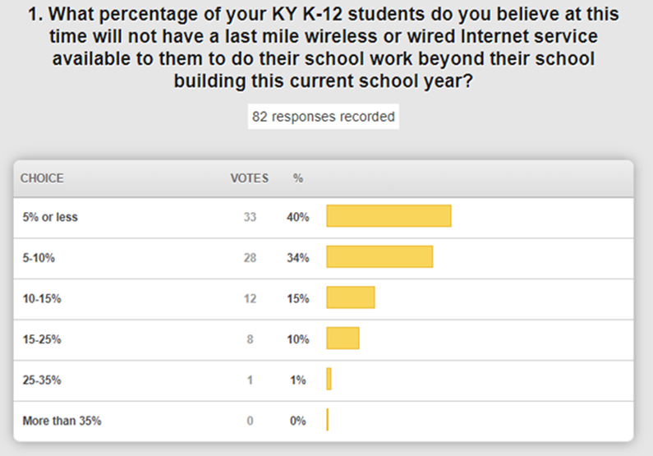

The Common Sense Media only reported the wired connection to the home and reported that 36% of Kentucky students don’t have any type of Internet access at the home. Our data collection has shown something very different and these responses are in line with our data. We will have further verification with the completion of our Digital Readiness Collection data.

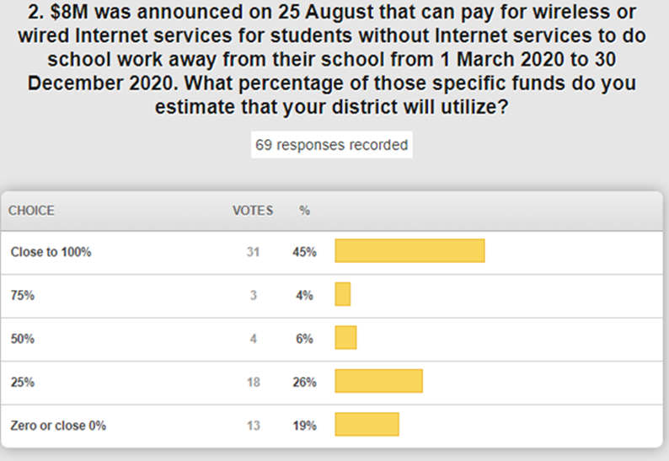

We want to ensure that we maximize these funds that have a December 31 expiration date and can’t pay for any Internet services beyond that date. We will be identifying those districts that will not be taking advantage of this to see if we can reallocate or repurpose those funds.

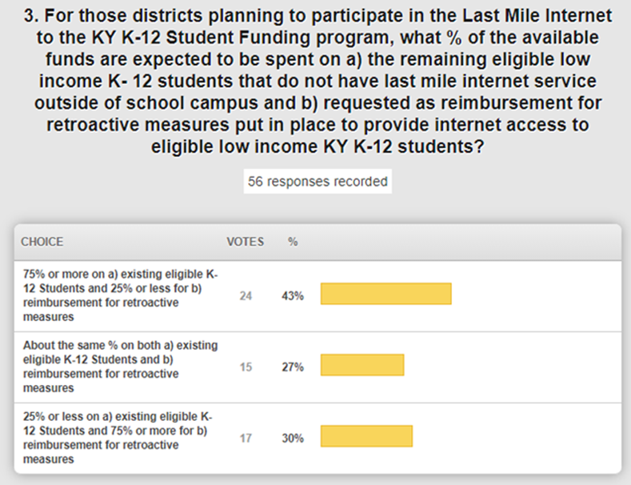

We wanted to see what the use of these funds might look like and this gives us a very good idea.  It is being allocated via the income eligible student data based on the free and reduced lunch calculation; this will be available in the GMAP data system and the information about accessing this information also went to the Superintendents in their Monday Message email. The deadline to submit a district plan is September 30th (now 30 Oct) and then we’ll have more information about the dollars that could possibly be redistributed or reallocated.

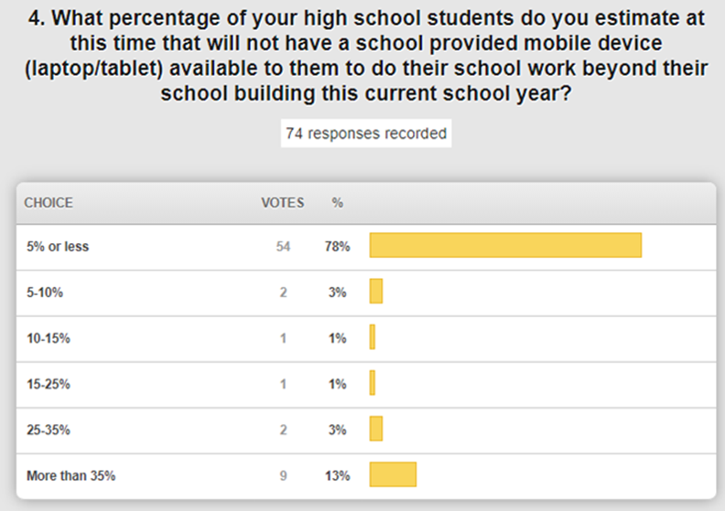

This is consistent with what we expected and seen through our annual data collection. Most of our past 1:1 ratio was historically at the high school level and we expect to see this trend change with future data reviews.

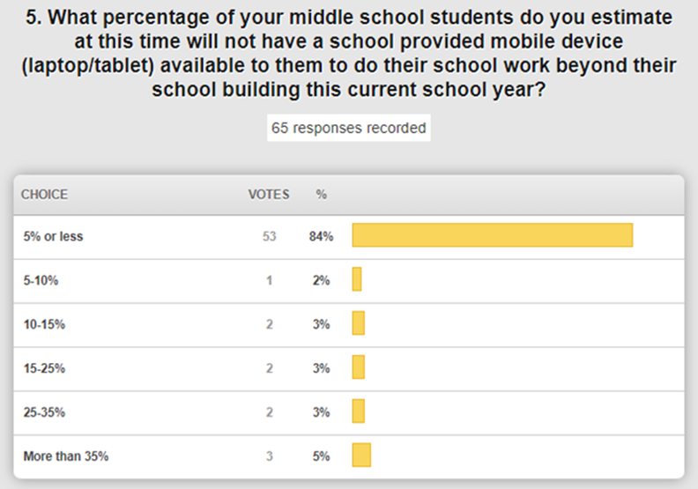

This is similar to the high school data. We do know that many schools are using a hybrid approach to going back to school and some Superintendents spoke very well to their school/district situations during the Kentucky Tonight broadcast.

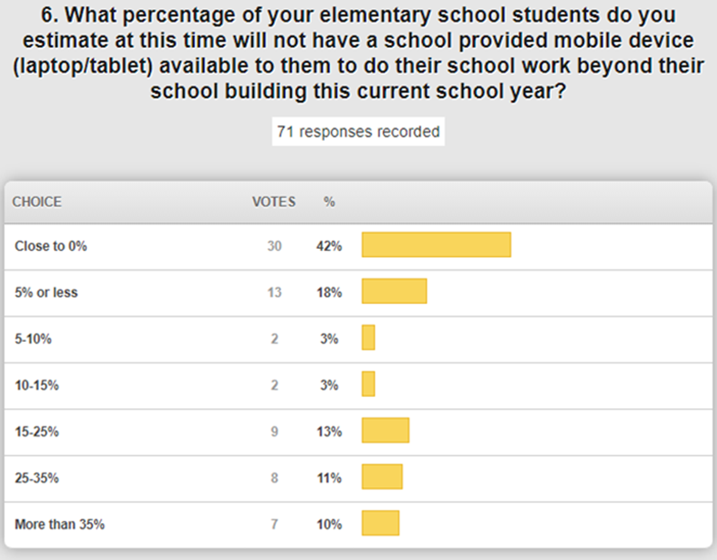

The responses here are not surprising as the 1:1 implementation was lowest at the elementary level. It would also be interesting to know what percentage of this is due to not having the funds and what percentage is that they have been ordered but the district is waiting on equipment to arrive.

The RFP for Last Mile Internet for the KY K-12 Student was announced on August 25th and the first wave of bid responses have been received. They should be available and posted for you very soon.  Our goal is to get all the major wireless and satellite providers as well as last-mile wired providers to respond and provide very competitive options. Vendors can submit bid responses until early December. It is intended for student use only and not seen as a whole household solution; there are more decision points for a district when you have a home with multiple students.

This is not a KETS Master Plan line item and there are no KETS product standards involved; therefore, districts have the choice to use this state contract or other contract sources/purchasing vehicles as available.

**(1:21:34) School Report Card Update –** We are in the middle of the review period and it has been extended to September 25th with about 33% of our districts having completed their review. At the time of the webcast, approximately half of the districts had entered their technology-related data.

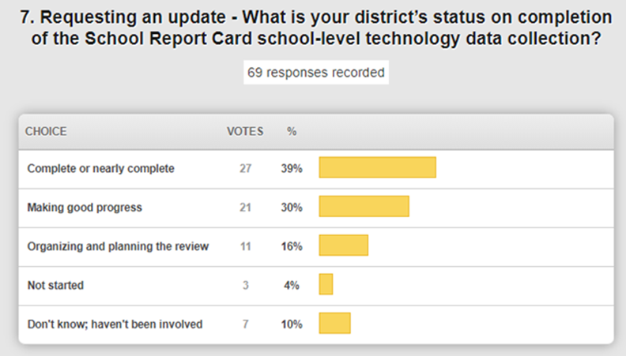

CIOs are encouraged to be involved in this so that this data closely aligns with the digital readiness collection efforts. Two of the best practices cited are to (1) provide those numbers for the data entry or to (2) enter the numbers for the school-level technology data collection.

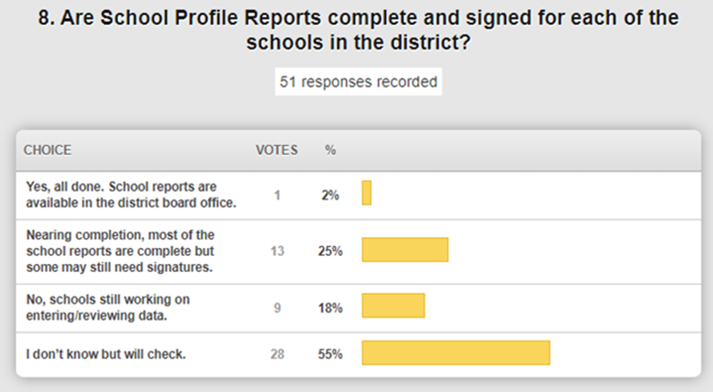

This is just one component of the School Report Card. School Profile Reports are due by October 1, by statute, and it does get released along with the School Report Card.

Public release is still scheduled for mid-October and having a September 25th deadline at the district level helps us complete all the internal reviews and preparation to meet all the additional deadlines as well as state and federally mandated release dates. We appreciate your continued feedback and input!

DeDe also provided a brief update of other Covid-19 Assistance & Upcoming Training Opportunities:

* New Infinite Campus custom tab for tracking school participation
* Attendance Groups for tracking Covid-19 quarantine due to positive test or exposure – new report released 9/10.
* Attendance Code for NCVP – No COVID virtual participation (Blended learning should be turned on)
* New statewide flag that can be used by school personnel to identify students who have a mask waiver on file. New Ad hoc report available.
* Published ad hoc filters to assist districts in tracking students diagnosed and/or quarantined due to COVID
  + Students with a positive temperature screening (over 100.5)
* Early Warning functionality has been updated to support the calculation and display of GRAD and Category Scores for Kindergarten through 12th grade students.
* For details on KSIS training opportunities, go to the [KSIS Training webpage](https://education.ky.gov/districts/tech/sis/Pages/KSIS-Training.aspx).
  + Sept. 15 and Oct. 13 – Parchment eTranscript back-to-school webinar.

**(1:30:15) KY K-12 Internet Service Update –** Never in the history of KETS has the health and reliability of the KETS network been more important that it is today. We continue to make the network our highest priority. We are working during school hours as well as after school hours and actively monitoring all our network services. There are 10 to 12 school districts that have needed improvements to the middle mile network and that work has been ongoing for these districts as well as our continued bandwidth upgrades and project related upgrades for all school districts. We have entered a new era with Covid-19 and pandemic-related change; our services need to up and operational 24 x 7 for both academics as well as extracurricular activities.

**(1:36:14) KY K-12 Digital Learning Guidelines Update –** We have brand new, updated digital learning guidelines. We’ll ensure these are posted and available for you and recall that they are included as part of the Superintendent Assurances.

**(1:38:12) Other Items:**

* STLP Regionals are still ON; be looking for more information via email from Jeff Sebulsky and our field staff! Some of that work will look and feel different but we are very excited about moving forward.
* K – 12 Computer Science Plan will launch soon so be looking for that.
* Libraries and library leaders are in full swing and help teachers and leadership in new and exciting ways.
* SY2020-2021 KY K-12 Digital Readiness Survey/Report – These are due very soon and being reviewed by field staff; we have 100 submitted at this time and completeness and accuracy is more important than ever.
* We have several bids and contracts in process:
  + Instructional Device Contract – should be available and posted any day
  + Server and Storage Contract – awarded and announced
  + Point of Sale System – Working with OFO
  + Education Licensure System – Working with OELE
  + RFP for Last Mile Internet to the KY K-12 Student – mentioned earlier; available soon
  + New Networking Products and Services Contract – will be in place for upcoming E-rate filing window

Thanks for joining us today and thank you for all your efforts. Take care and we’ll see you next month.