**Summary of the July 2020 for KY K-12 Education**

**Technology Leaders’ Virtual Meeting**

In case you missed it or want a refresher, the following is what we talked about during the July 21, 2020 EdTech leaders’ virtual meeting. A copy of the video and audio can be found at <https://mediaportal.education.ky.gov/technology/2020/07/edtech-webcast-july-2020/>.

Public viewing of the archived webcasts and written summaries are also available on the KDE Media Portal at: <http://mediaportal.education.ky.gov/>. Numbers in **RED** indicate the timestamp for that portion of the discussion so it can be easily located on the full digital recording.

This was a virtual meeting with all our OET staff and all the districts joining via Microsoft Teams and/or YouTube. We will continue to make these available from our KDE media portal so that you can watch the archived discussion and share with the appropriate people in your district. Several GoSoapBox poll questions were posed throughout the meeting and district EdTech leaders were asked to respond with their best swag to all the questions as it assists us in planning and getting a feel for how to best move forward. Your voice and your feedback are important and extremely helpful to us. June and July webcasts, historically, have the lowest viewing percentages, but due to our current circumstances, this may not be the case.

**(1:03)** **Kentucky Society of Technology in Education** **(KySTE) Remarks –** Mary Ann Rankin joined us this morning to provide a KySTE update on the following items:

* As we all know, the conference was cut short back in March, but planning is still happening for next year with the theme “Soaring to New Heights”.
* Outreach grants are opening up for applications.
* Fall conference is underway and will have some different formats.
* Awards windows will open in the fall and there will be some changes to follow the lead of the International Society of Technology in Education (ISTE). The awards will now be called Impact awards.
* The “Making IT Happen” award will not change and has had over 700 recipients since 1995. KySTE recognized the 2020 winner today. She truly models the student-first mindset and knows how to get students engaged and has impacted Microsoft’s IT Academy, Girls That Code, etc.  Congratulations Laura Raganas!!!! This is very well deserved. Laura accepted the award on behalf of ALL the digital learning coaches. David is very proud of our strong relationship and work with KySTE over the years.

**(6:34)** **Kevin Brown, Interim KDE Commissioner**, joined us this morning to give a few opening remarks. He has had the opportunity to work with OET both within KDE and at the district level and he congratulated Laura on receiving her recognition and applauded the work she has done and expertise she has shared. He loves to talk about OET and how we have laid all the groundwork in place to quickly pivot to non-traditional instruction (NTI) and a full telecommute work structure. Laura’s work ethic is a perfect example of the work ethic alive and well within the Office of Education Technology.

**(11:39) KY Board of Education (KBE) on August 6th –** OET has three items coming before the KY Board of Education (KBE) at their next meeting and below is short summary of each of these items and how it impacts education technology:

1. Kentucky Education Technology System (KETS) Operational Needs – We will be presenting the $366M in statewide KY K-12 EdTech needs in school year 2020-2021 and identifying approximately $330M in funds that can help address those needs. The discussion will include anticipated KETS Offers of Financial Assistance to districts for next school year. For those who are new in the EdTech leader role, our KETS Master Plan outlines the unmet need and how it is calculated. We go before the board each year to remind them of this need $366M and we have identified $330M to address that need. This coming year it is a smaller gap than it has been in a very long time and that is primarily due to the CARES funding going to districts, increased E-rate rebates and discounts, and some CARES funding at the state education agency level. As part of educating the board, we take this opportunity to give them a KETS update and educate them about our programs by sharing the KETS Infographic and the KETS Timeline. Please let us know if we are missing any achievements that you feel should be included in our historic timeline.

The KETS Operational Plan was shared in detail and we discussed the funding and why we continue to need to request increased/restored KETS funding in future legislative sessions. ***Please refer to the audio for the full presentation of this upcoming board item.*** Your feedback from last month for some of the funding estimates was used for the CARES funding items. Robin Kinney will soon have information to share with us regarding each district’s plan for the use of these funds so we’ll have a better idea about the accuracy of our estimates. E-rate projections are higher, and we continue to do everything we can to protect these funds.

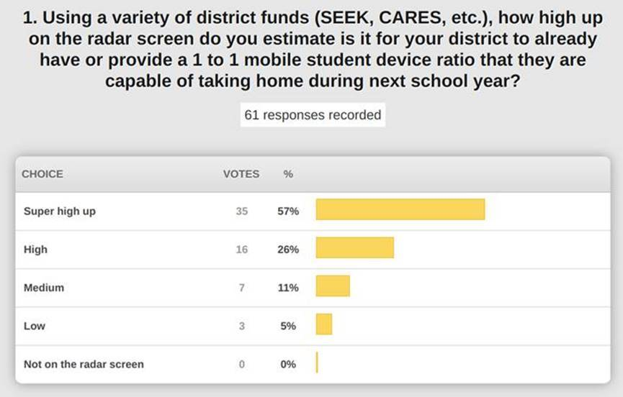

Responses are consistent with what we have seen over the last few months and we are still seeing schools that had a 1 to 1 ratio replacing or expanding that program to other grade bands. Marty Park spent some time speaking to the Superintendent Advisory Council discussing school re-entry options and the work being done to offer KY Virtual Network opportunities. This is especially important as we have seen the recent increase in Covid-19 cases rather than the decrease we were hoping to see. Digital access has three components—digital device, home Internet access, and access to digital content.

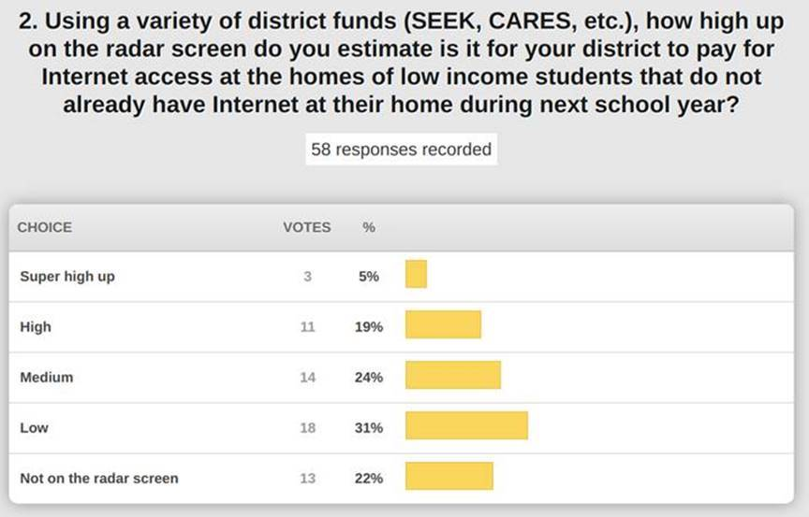

This, again, is fairly consistent with the data we collected before. The Internet access document sent out last week covers the data we have collected and shared. In that document, we highlighted and encouraged our telco providers and charities to provide discounted services or free services to our low-income students over the next year. The document should be helpful in providing talking points for you at the district level and allow for districts to develop common strategies and recognized different levels of access. This is a hot topic and should be seen as a “whole household” issue and not just a K-12 issue. If you need assistance from OET in talking with a local provider, please reach out to us through your field staff.

Your previous responses to this question helped us develop our estimates in the KETS Operational Plan.

Percentages are higher and this makes sense because the scope for the usage of these funds is much narrower.

1. The second reading of the Kentucky K-12 Academic (KAS) Standards for Technology – This regulation will go for second reading and approval at the August meeting of the Kentucky Board of Education. There were minor edits to the document to be incorporated by reference since the first reading in June and these standards will be part of their own regulation moving forward. This is a refresh because we had technology standards, but they have been modernized. This is foundational work for being able to demonstrate competency in technology and there is no assessment even though it is a graduation requirement.  If approved, the regulation will move on to go through the legislative approval process and that will allow us time to ramp up the implementation prior to next school year.
2. The first ever reading of the KAS for Library Media - These standards are in parallel to our computer science and technology standards and they are listed as elective standards. Please take a look at this and we’ll continue to keep you updated about this exciting work.

**(57:15) CARES Funding for KY K-12 EdTech District Initiatives Update -** We are moving forward with the **Lightspeed relay service**. The analytics part, we hope, will be a great decision-making tool for you at the district level. Lightspeed is working very aggressively to get the relay service up and running prior to school opening and they are conducting virtual training and orientation sessions. This will play a big part in virtual learning from the home and this is a big improvement. It’s exciting to think about having more informed decisions about what our kids are using and what impact it is having…we’ll be there soon.

Do you see yourself spending more on **distance and virtual learning PD**? The people side of K-12 has always been lower in importance while we have always seen the value in our digital coaches and the maximization of education technology. We are launching, in collaboration with our educational cooperatives, digital learning design labs using some of the 10% CARES funds at the state level. This professional development will be led by our cooperatives using regional-based talent. We will also be launching a **digital learning coach stipend match** to help you develop the district digital learning coach role. You may already have that role in place or you may need to develop that role as you onboard teachers for the fall. This is just to help support that role and is not intended to fully fund the digital learning coach role.

Be thinking about if your school is looking to establish a full-time, enrolled virtual school. Inquiries and strategies are coming in daily. We are working to build and review strategies in creating our **K-12 KY and Virtual Schools Network**.

We are starting to see some shifts in this as we near the start of the school year and recent increase in cases.  This will be a moving target. Some schools in other states have announced six-week virtual school starts.

This is a new feature set and it is very important to make sure you set up structures that are not performance-based because it is hard to gauge participation.

We worked for a long time to get this included and it is a major value add; it makes the Kentucky Academic Standards actionable, interactive components for use by staff. It will be a great tool for our teachers. Please share this information with district staff.

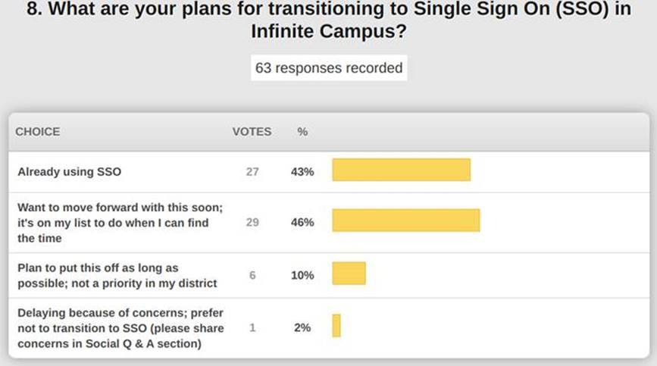

We didn’t push on this due to Covid-19, but it is still a good thing and it’s not a heavy lift.  We realize you have a lot of high priority issues and the June 30th deadline was lifted. Infinite Campus is ready to assist when you have time to move forward. Please keep this on your radar and plan to complete by June 2021.

This is a repeat question. We are estimating 111 districts have begun the process and training. KDE is working on some new documentation and guidance. It is a lot for one person in your district to make happen; it is more of a team effort.

This is also a repeat question. You had to opt-in for this service and it allows for more depth in the core products in Infinite Campus. About half of our districts are moving forward with this; KSIS points of contact and CIOs are receiving these communications.

**(1:22:26) KY K-12 Cybersecurity Health Check Update –** This is a reminder that the cybersecurity health check by each district and KDE the agency is due by the end of August.  This is required by law.

We had a vendor partner who recently had a security incident. In talking with the CIO, the advice they gave to our districts was:

1. Use multi-factor authentication (MFA) on everything!
2. If you have single sign-on (SSO), please be cognizant of phishing attacks.
3. Lock down all privileged accounts and administrator accounts and review who has access to these accounts.
4. They also use advanced end protection, and this is what clued them into their recent security attack.

KDE has moved forward with several security initiatives this summer and tried to make things more secure as well as a better experience for our KDE staff (i.e., email banners, advanced threat protection, disc encryption, password upgrade). Telework and telecommuting has added a few layers of concern. We will share our lessons learned with the field staff so it can be shared with our CIOs as you work to implement these things in your schools and district.

Thanks for joining us today and thank you for all your efforts; we have a heck of a school year ahead of us!