**Summary of the June 2020 for KY K-12 Education**

**Technology Leaders’ Virtual Meeting**

In case you missed it or want a refresher, the following is what we talked about during the June 16, 2020 edtech leaders’ virtual meeting. A copy of the video and audio can be found at <https://mediaportal.education.ky.gov/technology/district-technology-leadership-webcast/2020/06/edtech-webcast-june-2020/>

Public viewing of the archived webcasts and written summaries are also available on the KDE Media Portal at: <http://mediaportal.education.ky.gov/>. Numbers in **RED** indicate the timestamp for that portion of the discussion so it can be easily located on the full digital recording.

This was a virtual meeting with all our OET staff and all the districts joining via Microsoft Teams and/or YouTube. We will continue to make these available from our KDE media portal so that you can watch the archived discussion and share with the appropriate people in your district. Several GoSoapBox poll questions and a discussion question were posed throughout the meeting and district edtech leaders were asked to respond with their best swag to all the questions as it assists us in planning and getting a feel for how to best move forward. Your voice and your feedback are important and extremely helpful to us. June and July webcasts, historically, have the lowest viewing percentages, but due to our current circumstances, this may not be the case.

Today we had our OET leadership share on the status of a variety of topics and discussing the questions that were posed.

**(4:00)** **Lexington Herald Leader Article –** The Herald recently published an article that can be accessed at:

[https://www.kentucky.com/news/local/education/article243346776.html](https://nam11.safelinks.protection.outlook.com/?url=https%3A%2F%2Fwww.kentucky.com%2Fnews%2Flocal%2Feducation%2Farticle243346776.html&data=02%7C01%7Clisa.moore%40education.ky.gov%7C6040b61065c6429634bc08d82ccdbd5c%7C9360c11f90e64706ad0025fcdc9e2ed1%7C0%7C0%7C637308609481116161&sdata=IGk0ejYfS4JUBOspZkGy73Y6%2BUMjW%2FH19g28utTBs%2Bo%3D&reserved=0). We encourage you to read and share this article pertaining to declining NTI participation as we neared the end of the school year. One view of this that wasn’t discussed is that participation for in-school classes normally sees a decrease in participation as you get closer to the last days of school. It is a fair and well written article and these discussions will continue as we begin looking at what reopening schools in the fall might look like. As part of that, there is a very intent focus of the **Education Continuation Task Force** regarding the restart of the school year. The task force was expanded recently to include certain legislators and leaders of what we term the “K” groups.  Transportation/buses is a major point of discussion right now. This task force and several other groups are meeting frequently to discuss public health concerns and areas specific to our K-12 education and health concerns as well facilities and transportation. The wearing of masks has become a big point of concern and divisiveness. The recorded meetings can be viewed here: <https://education.ky.gov/CommOfEd/adv/Pages/Continuing-Education-Task-Force.aspx>.

**(9:00) Commissioner’s Search Update –** The Kentucky Board of Education and the agency conducting the commissioner’s search have narrowed the field of candidates down to six individuals. These six have not been named and this work is still conducted in closed session. It could be as early as mid-July or as late as the first of September before a successful candidate is announced and in place.

**(9:31) Telework/Telecommuting at KDE Update –** KDE was the first state agency to move to a 100% telecommute work environment. We were very well positioned and more prepared to quickly pivot to telework and it has worked very well. As for telecommuting for state offices, we feel like it will continue to be this way for some time and will also continue in some form for many of our parents or caregivers next school year. Some parents may also be apprehensive for their child to return to the traditional classroom and there are still many unknowns about how back to school will look and function. This is also a time where cyber attacks are on the increase rather than decreasing and we’ll be discussing some of that work as well as covering some of the new features that Microsoft and Google are putting in place to meet the needs of our education community.

**(15:02) Chief Technology Officer Update –**

* We completed the 200 Gbps upgrade
* We are almost finished with the district switch upgrades
* We are in the beginning stages of the UPS upgrade; with this upgrade, our vendor partner is also installing the new VPN device for MUNIS.

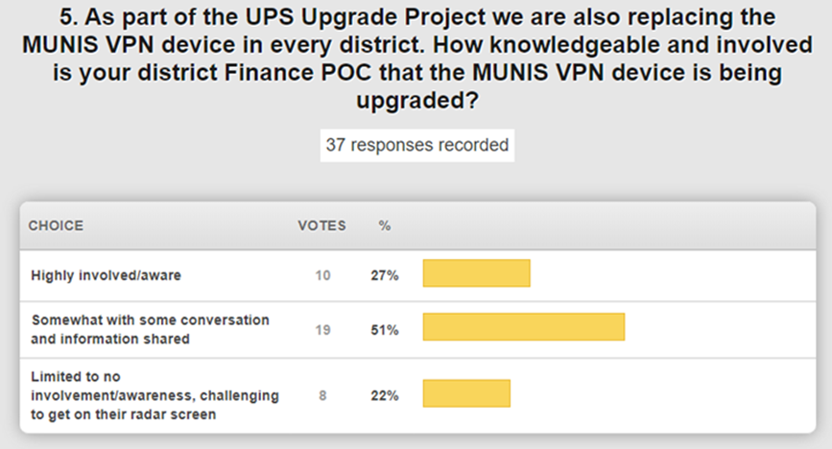

* The timeline for some of the things we had on our radar for completion at KDE has been moved up. We have completed the implementation of banners for e-mail and we were also able to implement SafeLinks and Safe Attachments to increase our threat protection. We are currently implementing hard disk encryption. Ideally, a user would not have significant PII on their laptop, but almost everyone has their personal employee information, and this would prevent them risking exposure.

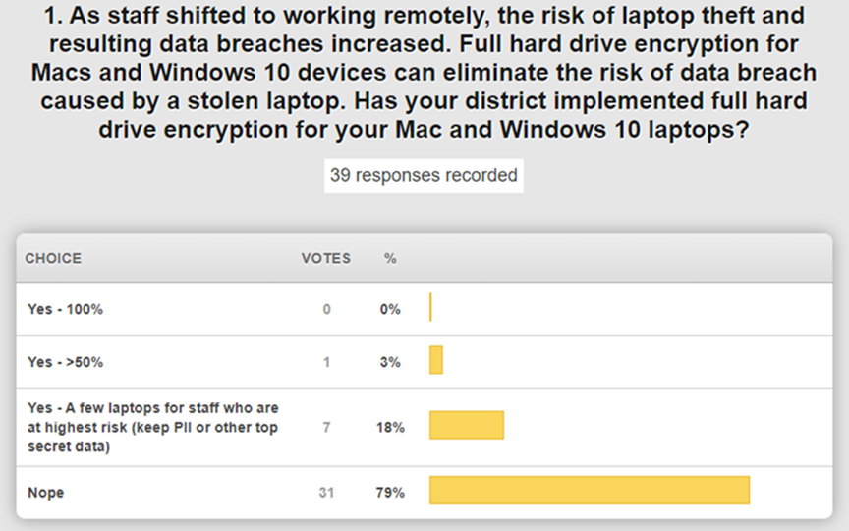

* KDE is in the third week of implementing a new password policy and moving office by office. A communication was put out to KDE staff and we tried to make the steps very simple and easy to understand. The multi-factor authentication is always an option that is still to be considered, especially for those who use certain applications and systems.

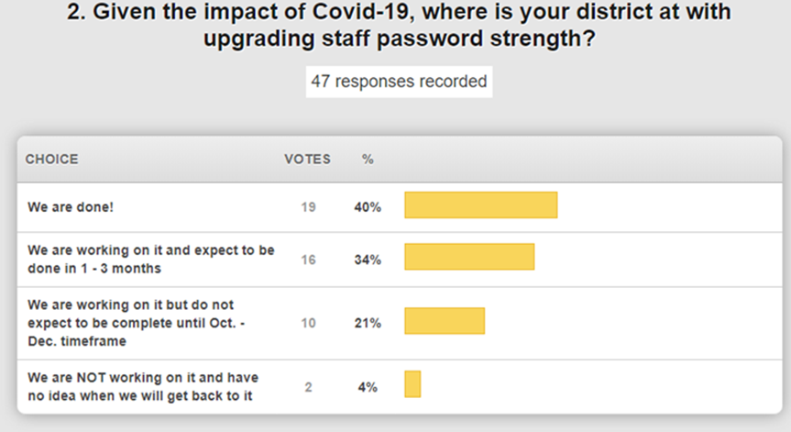

**1. What are the biggest obstacles to your schools/district completing your staff password upgrade?**

* Completing this task off-prem and maintaining passwords in synch.
* Were done, but the next expiration cycle is going to be fun..... educating users (and hoping they remember) about what/when/how things will sync when they are off-prem can be challenging for many.
  + Agree....especially in a Mac environment in which devices are not bound to AD.
* Not having a user password link for them to use means we must create a secure communication path to manually change their passwords for them. We are A1 license with Macbooks (not bound) and PC and chromebooks.
  + I’m in a very similar situation in my district.
* Running a script nightly to email reminders about password expiration works really well when everyone is telecommuting. I send an email at 7, 3, and 1 day prior to the expiration.
* Remote technical support is a challenge due to the COVID situation.
* Final communications and scheduling is all that remains. We had the backend setup in place prior to the COVID-19 issues. Once we ramped up NTI, we delayed the enforcement of this.
* Passwords were all changed to 15 complex 180 in January. Completing 2nd change now as they expire.
* Having staff in district to facilitate password change. We were ready to go for April but then NTI happened and was no longer a priority.
* The Lightspeed Relay implementation is moving forward and some districts are anxious to get this completed. The contractual work is complete, and this has been purchased for every district in the state. Work will ramp up after July 1st with the goal of having this available to every district by the end of the year.

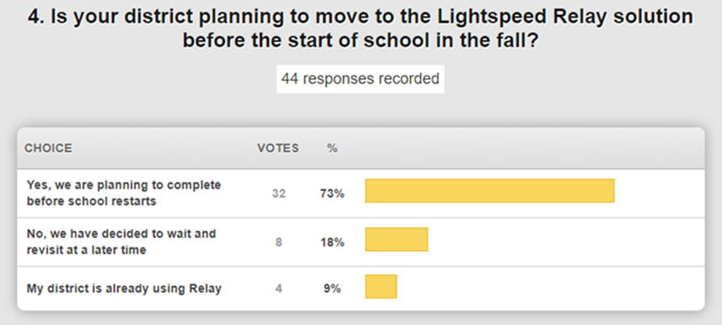

Internet access to the home is becoming a very hot topic and we are continuing to discuss and prepare guidance for you and your districts for school-issued devices (both students and adults). This is an opportunity for us to leverage our cloud services. When using CARES funds to do something like this, remember these funds are temporary and will expire. We have identified on ongoing funding source after that time for this relay to be a long-term, state-shared service. The Lightspeed analytics will be able to give you a good picture of what is being used and what is not being used; this will allow you to be an even better steward of taxpayer dollars. We will evaluate the value of the analytics component after this two-year period.

The federal and state law is clear that if the parent is paying for the Internet access from the home for a school issued device, the district does NOT have to filter.  If the school district becomes the Internet service provider to a home, then this would likely be a different answer.

It is a very busy summer for you and your school districts and we want to be there to assist you so that our schools and districts will be as prepared as possible from a network and security perspective for the restart of school in the fall regardless of what that may look like.

**(43:01) Chief Data Officer Update –**

* Infinite Campus/SAML Integration Update - This has not been forgotten and that work is ongoing.  Reach out to Infinite Campus and open a ticket to begin this work whenever this is convenient for you and the transition date will be extended.
* School Report Card Update – The financial transparency tab was published at the end of May. Staff are looking at district and school websites to ensure they are linking to the new SRC and messages are being sent out to update or create these links. This is a requirement of ESSA as well as a state requirement. We are working on the SY 2019- 202020 SRC and that data will roll out at the end of September 2020. Details of the Covid-19 impact and what will/will not be included is on the SRC page under [Details of Covid-19 impact](https://education.ky.gov/districts/tech/sis/Documents/2020SRCReportingImpactChanges.pdf).
* Campus Learning Offering Update- The upcoming overview session is June 17th for Campus Learning. This service will be paid for on behalf of the school districts for the next two years using CARES funds. KDE will pay Infinite Campus directly for the districts that are using it; this is not a “thou shalt”. There is some increased interoperability with Google and academic standards that districts might find beneficial; this is a big milestone for us. Campus Learning is also working on some increased functionality for a more robust product. If your district hasn’t decided on this yet, there is still time and actual trainings will ramp up in the August timeframe. We do not have a firm cutoff for a district to decide to implement Campus Learning. We were hoping that the percentage of districts who were unsure was smaller.

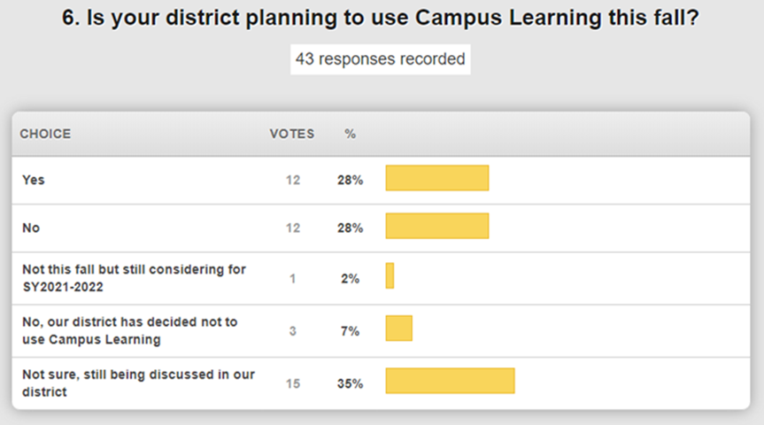

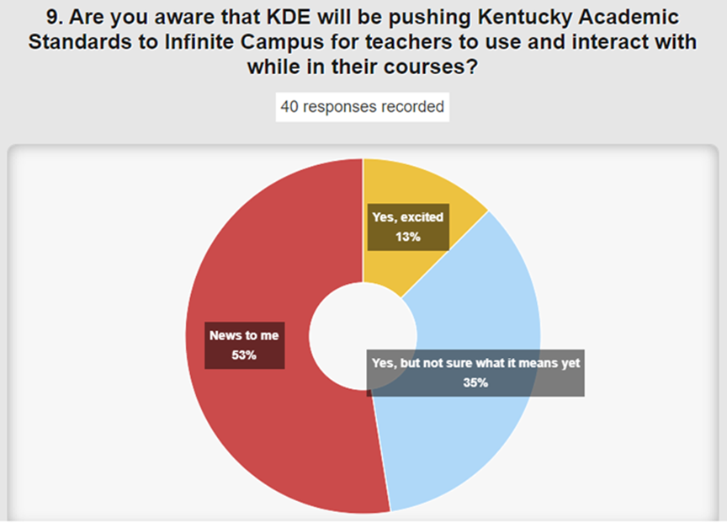

Based on the responses, over half of our respondents were not aware of this new functionality, so please have those conversations with your district staff about these interactive capabilities. This has been a long time coming and we need your help getting this on the radar screen.

* Campus On-Line Registration Offering Update - Training has occurred the last two Mondays and the next round of training will be regional trainings that begin the week of June 23rd. We do now have a majority of districts planning to use this for this fall and this is paid for all districts. The percentage of districts that are not sure is much lower than last month and that is what we were hoping to see. There is a 30-day rollout for the core product; however, if you implement after the start of school year it will still be beneficial for transfer students, etc.

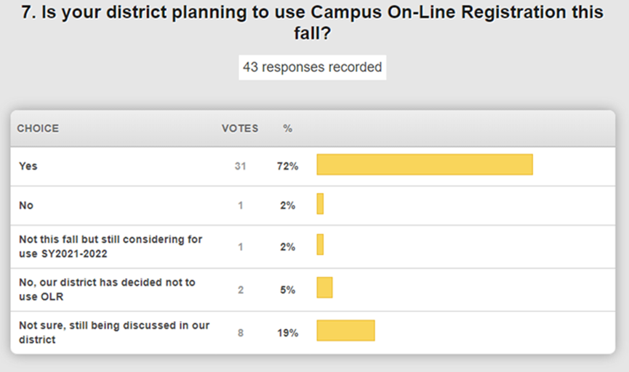]

* Working with Campus on a solution to allow electronic signature on Household Income Form (HIF).
* Annual Infinite Campus invoices were sent out in April; payments are due no later than August 15. If you need a copy of the invoice, send a request to the [School Data Services mailbox](mailto:kdedatarequest@education.ky.gov).
* P-EBT Program Update – Open and receiving applications. Partnership between Cabinet for Health and Family Services and KDE to provide financial assistance, up to $313.50 per student, to families with students who lost access to free or reduced-price meals due to COVID-19. See the table below for the status of students approved as of COB June 10.

|  |  |  |
| --- | --- | --- |
| **Description** | **Students Approved** | **Expected for PEBT application** |
| Group 1 - Enrolled students receiving Medicaid or KTAP benefits automatically receive P-EBT card by mail– | 359,330 |  |
| Group 2 - All other eligible public school students who must apply to receive the benefits. | 120,875 | 141,516 |

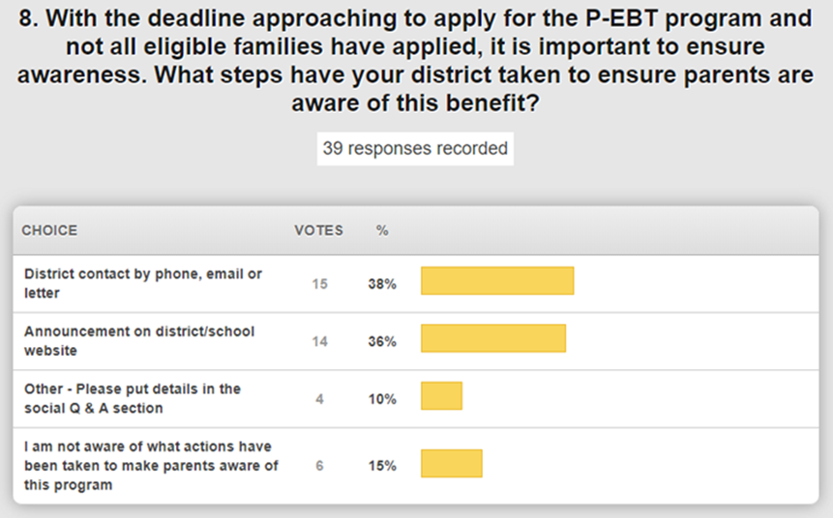

* For details on the following training opportunities, go to the [KSIS Training webpage](https://education.ky.gov/districts/tech/sis/Pages/KSIS-Training.aspx).
  + July 15-16 – KSIS Infinite Campus 2020-2021 beginning of year training
  + June 15-26 – Infinite Campus Kentucky specific Mastering Campus online training. **SESSION IS FULL**. Lisa Rhoton working to schedule another Kentucky-specific training.

**(1:03:13) Chief Technology Officer Update -**

* We have fourteen projects and initiatives showing as active right now that require interaction with schools and district over the next six months. That is in addition to our normal operational efforts and we just wanted to speak to that because work is continuing and, in some cases, has been moved up.
* We have several open bids and procurement activities ongoing. Instructional devices and server storage contracts may not be in place before these current contracts expire at the end of June. If that is the case, we may be able to obtain a 90-day extension. Updates will be sent out through your field staff.
* We are in the annual budget planning process and it is looking like the KETS Offer will be similar to this past year and we feel comfortable with a $21/ADA estimate for our KETS offers at this time.  Budget cuts could impact this, but we will keep you apprised.

**(1:07:41) Chief Security Officer Update -** It is the time of year to remind you that by August 31st every district is required to update their local board on the district’s cyber security readiness. There is a packet of information to help guide you through this and that will be sent out through the field staff by the end of this week.

**(1:09:27) Chief Digital Officer Update –**

* August KBE meeting will have the second reading of the KAS for Technology
* August KBE meeting will have the first reading for our brand new Library Media Elective standards
* This summer is the summer of professional development. There are many opportunities happening throughout the remainder of the summer, and we encourage you to connect and share all the great things you are doing!

There was one question we did not discuss as we heard from our various OET Leadership members:

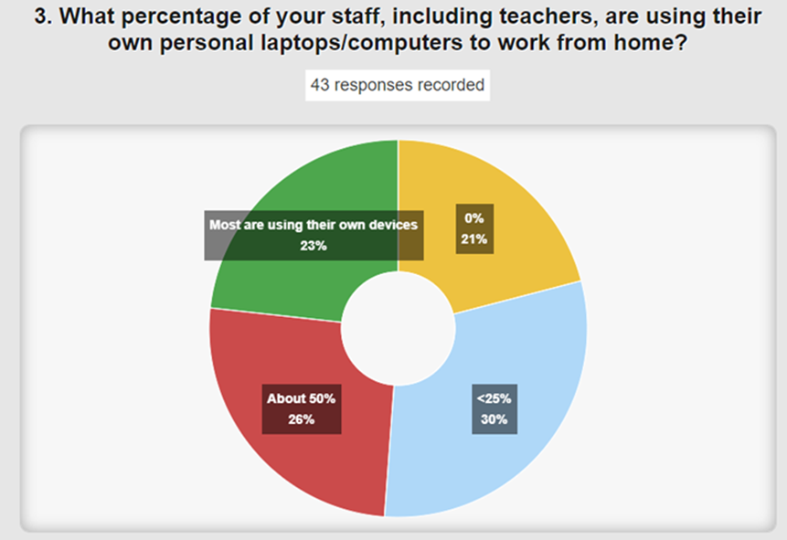

It has been a very busy few months and we hope you have some time to take off, relax and recharge.