**Summary of the May 2020 for KY K-12 Education**

**Technology Leaders’ Virtual Meeting**

In case you missed it or want a refresher, the following is what we talked about during the May 19, 2020 edtech leaders’ virtual meeting. A copy of the video and audio can be found at <https://mediaportal.education.ky.gov/technology/district-technology-leadership-webcast/2020/05/edtech-webcast-may-2020/>

Public viewing of the archived webcasts and written summaries are also available on the KDE Media Portal at: <http://mediaportal.education.ky.gov/>. Numbers in **RED** indicate the timestamp for that portion of the discussion so it can be easily located on the full digital recording.

We held a virtual meeting with all our OET staff and all the districts joining via Microsoft Teams and/or YouTube. We will continue to make these available from our KDE media portal so that you can watch the archived discussion and share with the appropriate people in your district. Several GoSoapBox poll questions and discussion questions were posed throughout the meeting and district edtech leaders were asked to respond with their best swag to all the questions as it assists us in planning and getting a feel for how to best move forward. All the questions and responses are included throughout the summary.

**(1:40)** This is an intense time and things are happening very quickly. We opened today’s meeting with a tweet/video shared by Rex Chapman. At least 2-3 times a day, most of us in the KY K-12 EdTech field are the guy pushing that cart.  [https://twitter.com/RexChapman/status/1226979163992662016](https://nam11.safelinks.protection.outlook.com/?url=https%3A%2F%2Ftwitter.com%2FRexChapman%2Fstatus%2F1226979163992662016&data=02%7C01%7Clisa.moore%40education.ky.gov%7Cb9ab0971a6e642c91e7708d81164f553%7C9360c11f90e64706ad0025fcdc9e2ed1%7C0%7C0%7C637278472773018990&sdata=LIACUoCCekaMwPFVHfBwgDXJjPtoHi5hAjHO7EICUNo%3D&reserved=0)

Besides being really funny, this guy is going about his business and then something just comes up and tries to shock him! Keep your composure, pick yourself up, and keep on going.  We sometimes don’t get included in some edtech-related discussions until it comes up and gets us just like in this video, but be like this guy and pick yourself up and keep going!

**(4:15) CARES Funds Update** – The CARES funding was covered in detail in a recent Superintendent webcast and the presentation is at: <https://education.ky.gov/CommOfEd/web/Documents/OFO%20KDE%20CARES%20ACT%20Supers%2042320.pdf> .

The Elementary and Secondary School Emergency Relief Fund (ESSER) and the Governor’s Emergency Education Relief Fund (GEER) funds are both being distributed using the Title 1-A funding formula. ESSER funds may go towards a wider variety of products and services. The people side of things can be addressed as well, but keep in mind that these funds are limited and should not be used for long-term positions that must be sustained after the ESSER funds expire. GEER funds are to be used for technology as it relates to remote/distance learning and school feeding. From the total ESSER funds of $194M, KDE may retain up to 10% or $19M. Regional meetings have given some indication of what you may be planning, but responses to today’s questions will give us a better feel for how the districts are planning to utilize these funds.

In discussing the types of technology that can be purchased, we have always encouraged mobile devices versus desktops to allow for mobility. We think professional development will be very high up on the radar screen to increase and maximize skills for teaching virtually or a combination of traditional classroom and virtual. Another area getting much discussion nationally as well as here in Kentucky is trying to solve the Internet access to the home issue—especially a last mile, wired connection. More immediate is addressing the wireless connectivity options. Other areas we see as possible areas for district technology purchases are digital curriculum and learning management systems.

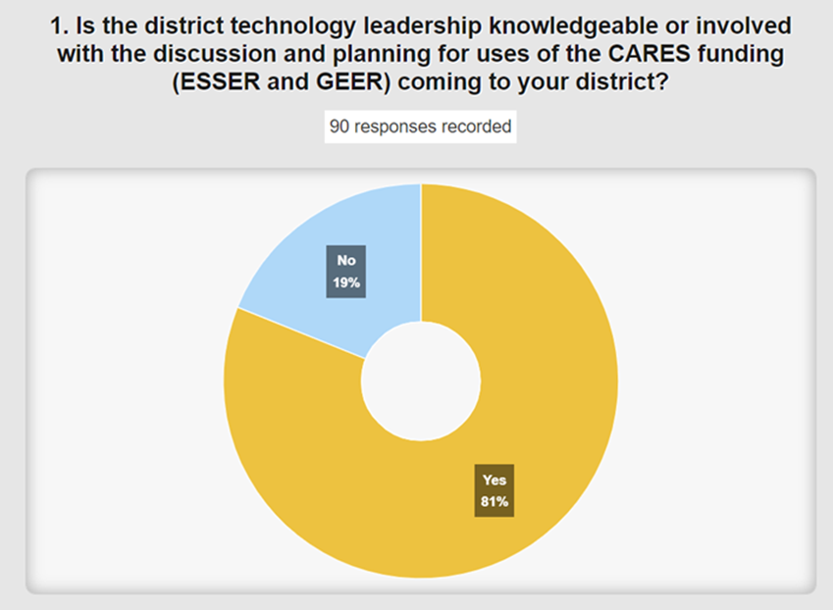

A large percentage of our technology staff are knowledgeable of the ESSER and GEER funds coming to the district. We highly encourage you to get involved and push for the use of these funds for your district technology needs.

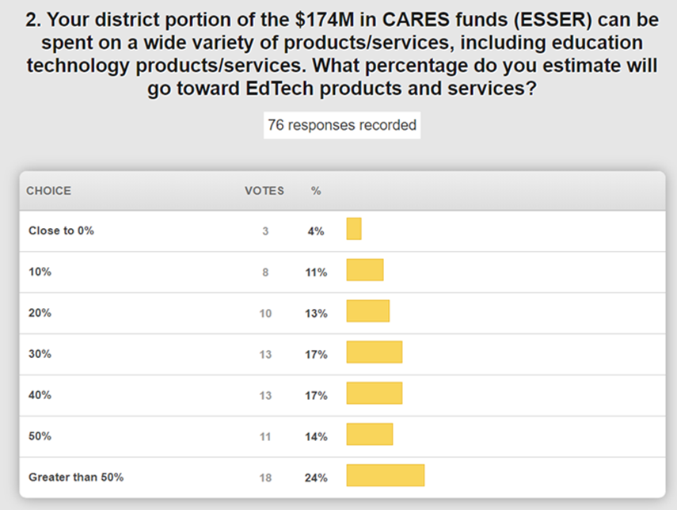

ESSER funds can used on a variety of things. The responses are not surprising, but go to bat for these monies! Most districts are going for 30% or greater of these funds.

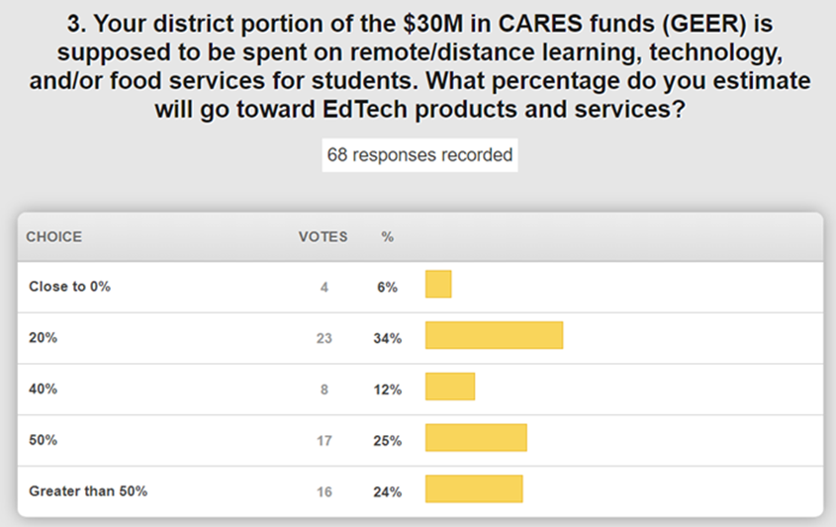

GEER funds are much more limited and focus on two topics. If you are one in the lower end of this, let us know and we’ll try to help steer the discussion on your behalf.

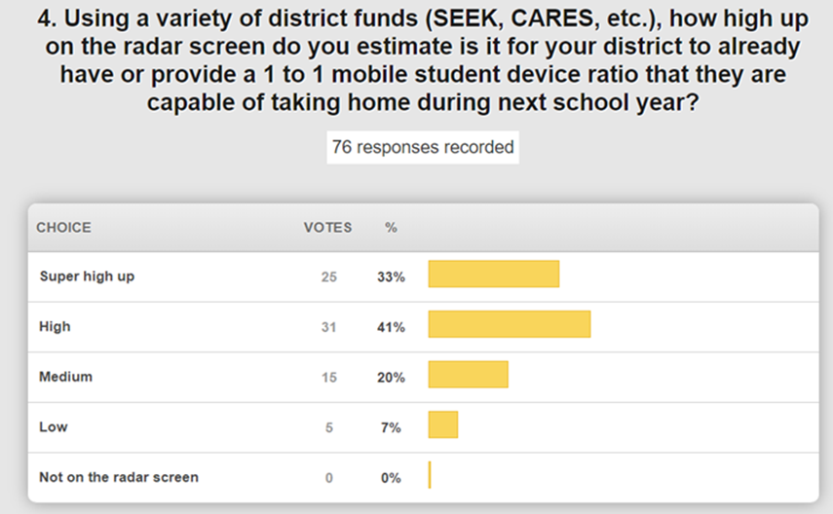

1 to 1 mobile student device ratio that allows the student to take the device home is high up on the radar screen. While some districts were already at a 1 to 1 ratio, this is also a good time to expand to other grade levels or update devices. It is also important to note that the people side of additional technology should be addressed when considering adding/upgrading devices and other technologies.

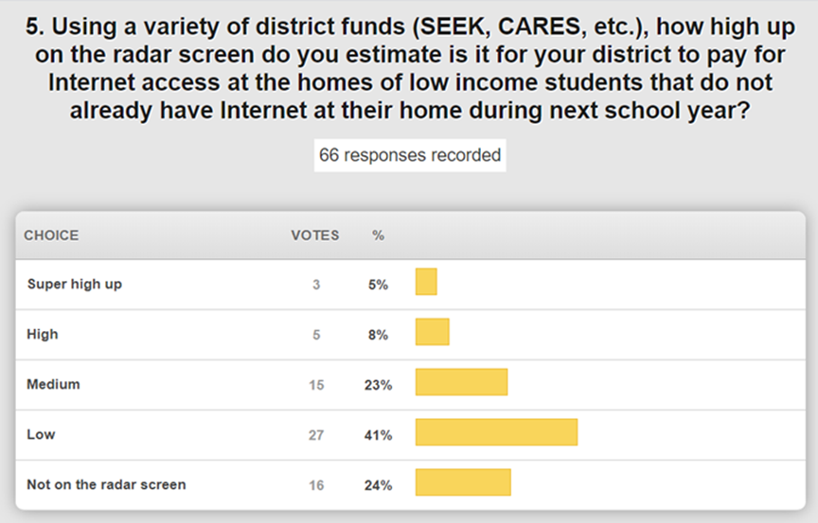

Internet access at home—we have historically provided resources for parents but now the focus is on providing access to the home. Poverty is very high right now and on a sliding scale.  Some districts are getting a lot of pressure to provide access to their low-income students.

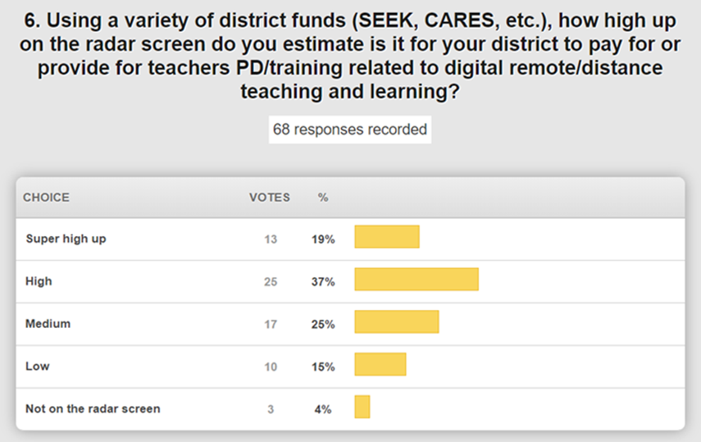

Professional development and training for digital remote/distance teaching and learning is also high on the radar screen. Our next step is how to beef up our digital learning team and increase capacity to deliver professional development and training. This includes library media leaders as well.

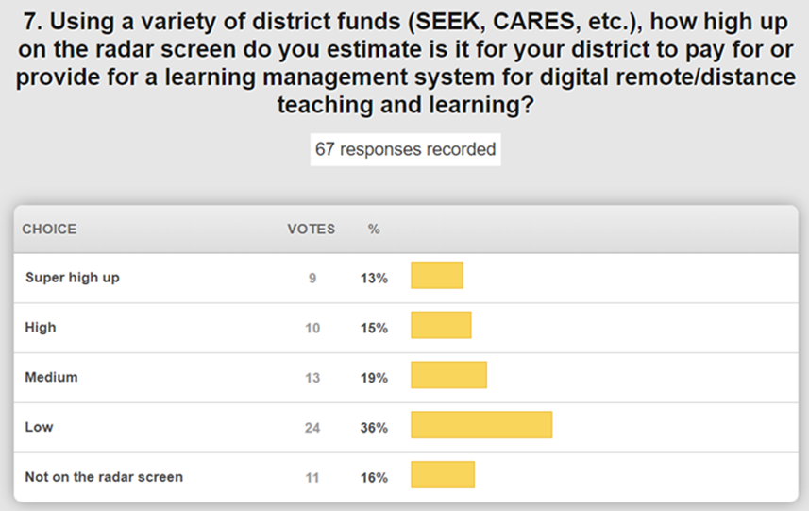

This one received a lower level of being on the radar screen. Some tools are freely available, and it is not surprising that this is lower than other items we have covered.

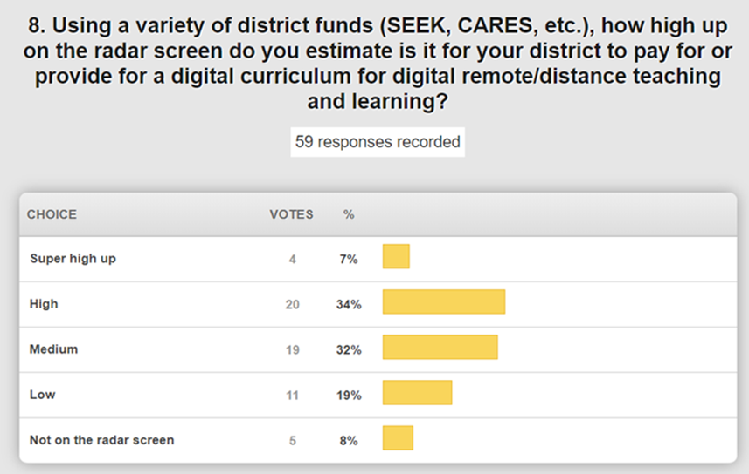

Digital curriculum has already been on the rise and this one is equal between being medium and high on the radar screen.

We are expecting a response very soon regarding our requests for the $19M of the ESSER funds that may be retained by KDE. We have identified some priorities for the use of those funds:

1. Professional Development

2. Lightspeed Relay and Analytics

3. Next Generation of the Kentucky Virtual High School – this is really an expansion of the BAVEL.

4. KSB and KSD – KDE has direct responsibility for these schools, and we have addressed their technology needs.

5. ATCs – This one has some vagueness. We struggle with the concept of the student not being able to use their device at the high school and then taking it with them to the ATC. Thirteen of the ATCs only serve one school district while 40 of them have multiple schools attending. Would cloud-based applications for things like AutoCAD make this more feasible?

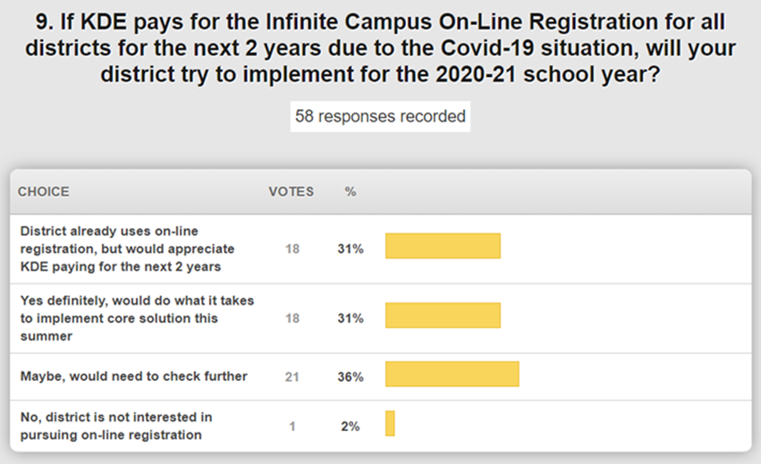

Online registration is already used by 27% of our districts responding, but it was reported that the majority of the remaining would be willing to do what it takes or check further with their leaders. This is the full version, which is customizable, but the core version would take about 4 weeks to stand up and the customization could happen later. We are able to drive down the cost by KDE purchasing as a state shared service.

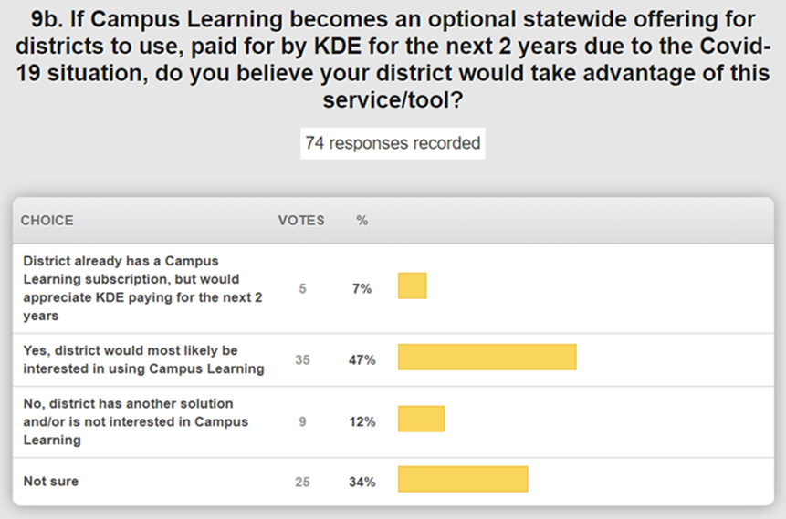

It may be of different value to different districts. As standards get pushed into Campus this year, you may see more value with that integration across the schools and districts. Campus offers a full range of services that are helpful regardless of whether your district has another learning management system. Several districts are not sure, and we suggest reaching out to your KSIS points of contact; this is going to be important to know as we move forward.

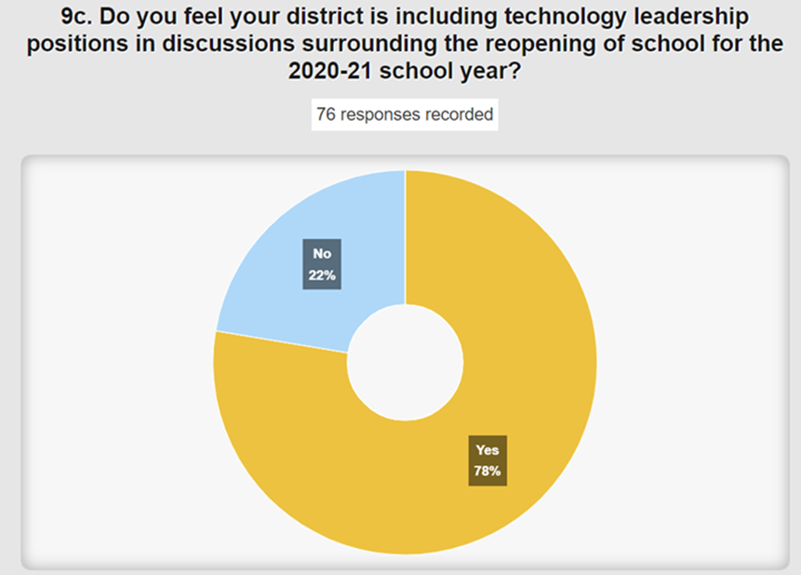

A very high percentage of our technology leadership are being included in the discussions regarding the reopening of school for the 2020-21 school year. You should definitely be part of those discussions. If you are in the no %, we hope that this is because those conversations haven’t ramped up yet. Guidance has been put together and sent out regarding the reopening of school for the next school year.

**1. What topic(s) cause you or your technology staff alarm or concern involving technology-related conversations about Covid-19?**

* One of the biggest fears is how do we sustain many of the initiatives we start now after CARES money is gone!
* Repairs of broken devices that have been in homes.
* Schools wanting to greatly expand summer programs, which now means “take-home" devices during the summer. Current staff contracts for support don’t account for this and now we lose a lot of our summer "breathing room" for major projects, regrouping, etc.
* Lack of technology staffing to support a 1:1 home initiative.
* Yes...supporting issues at home safely is a concern. We’ve done a really good job thus far, but sustaining that through summer and/or fall is a concern.
* Ensuring the CIA of data that could be on personal devices at peoples’ homes when they are operating remotely, as well as cyberattacks that could target home networks which may not be secure.
* Ensuring that any new equipment or services we provide are done so in a sustainable way. Additionally, ensuring the appropriate staffing is hired to keep from overwhelming existing district edtech staff.
* Same here. We have enough staffing to support in-person school and we did great when we went to all students at home. My fear is will we be able to adequately support a hybrid model. I think we will be stretched super thin.
* How the district can provide a device with internet access on a sustainable basis to those students that are in need. Definitely would like to see pressure put on the ISPs to provide affordable internet access to all K-12 students in KY. Internet access in home has also been a primary concern for us. Comments have been made by administration noting that it literally wouldn’t matter if we have devices or digital classrooms for students if they are unable to access at home.
* Our district is super great about allowing flexibility with the tech team and their hours/time. I’m also very lucky to have a tech team that doesn't mind being flexible with their time. We noticed most students start work sometime after noon and finish up in the late night hours. Some of this was because older siblings were babysitting younger siblings and had to wait for parents to get home to start (or help with) their work. Also, some work off of hot spots on parents or siblings’ phones and once again, they had to use it whenever available, which was not always normal business hours. We are working on ideas to make sure we meet the needs of every family, but it is far from "traditional". We also had a challenge with teachers who had small children at home, they were trying to be teacher, mom and NTI instructor for their own kids. Talk about superheroes! We are trying to work out ways to make sure they are taken care of.
* Wondering if/how our internet filtering can be applied easily to these 1:1 take-home devices... and if we as a district are legally still required to enforce the same type of filtering. Also, more devices means much more staff to manage them!
* GoGuardian has been great for us. We are still learning the in’s and out's of it, but it has been fantastic so far. It also allows screen sharing, so a teacher can share the screen on her Chromebook to teach and keep the kids from going other places if she wants them focused on her screen. Same with taking quizzes/tests; the teacher can make sure they are only on the URL for the quiz and not using other tabs to search the answers as they go.

**2. Based on what you are hearing so far, what sort of EdTech and non-EdTech expenses or initiatives do you feel will be funded with district ESSER and GEER (CARES Act) funding?**

* devices for students and teachers/staff, if they are available, Hosted Communications Platform (using IP based phones) to allow for voice/video/etc. to be available from anywhere, possible technology infrastructure project (top of rack switches) that will better prepare our internal network to support all future Wi-Fi upgrades that will begin with the new funding cycle of E-rate and be necessary as to provide better Wi-Fi in outside campus locations for drive up service if necessary.
* Devices for students
* 1-1 device upgrades, better devices for staff
* May pay part of our 1:1 lease, definitely add some things for remote learning to our G-Suite (district license for screencastify, for example).
* 1-1 devices for students but leadership wanting to squirrel away funds for the possibility of cuts
* This is very unusual for our district, but no one has talked to me at all about these funds. Maybe it’s because I'm retiring?? But I'm not retiring until August 1 so I think I should still be consulted. The only question I've been asked is how much we're paying for the hotspots we bought to support families without Internet.
* Discussions are centered around the following: - 1:1 device and staffing initiative - Wi-Fi buses to provide hot-spots in the largest low-income areas
* The only thing my super wants to use it for is replacement devices if the ones we sent home come back broken.
* We are 1:1 and have implemented Google Meet for Face to Face instruction; Google Classroom for assignments/discussions/creativity; and GoGuardian for screen sharing and activity control. We will use these funds to support this plan and build upon it. That will include broken device replacement/repair, Wi-Fi to homes of students that can’t afford it, PD for teachers and support staff to help them understand the best ways to "work from home" within their positions.
* I suspect that we will probably end up using some of the money to replace textbooks and other resources that have been lost due to the pandemic.

**3. As you have been discussing and planning for the upcoming school year, have you identified new training needs that we can help with in the 2020-21 beginning of year KSIS Infinite Campus Training?**

**If the answer is yes, please take a moment and describe those for us in your response.**

* I plan to do a better job of training teachers how to email students using the IC tools. Very good resource for teachers if they need to communicate.
* We are already OLR, but if the whole state goes with it, some retraining/rethinking of how we do currently use it would be greatly appreciated. Maybe some in-depth sessions on the scheduling tools/using the portal for requests, etc. would be nice too. Not sure what the impact is going to be on calendars, schedules, etc. Previously much of this was a “set it and forget it" that I could do for/with my schools then get on with DTC duties, but if it changes a lot, we need to build more staff expertise to lighten that load.
* Ad Hoc reporting training so that we can pull the information people need from what was entered in OLR. For example, transportation needs a report that prints students’ name, students’ grade, pick up, drop off, etc. If I create a “Pleat", as IC calls it, and map it back into the Infinite Campus SIS side, how can my transportation coordinator easily pull that info for every student to enter it into her transportation software to create routes and make sure buses aren’t over crowded?

**(52:15)** [**Alternative Learning Design Strategies**](https://education.ky.gov/comm/Documents/Reopening%20-Alternative%20Learning%20Design%20Strategies%20FINAL%206-8-20.pdf)**and Digital Strategies to be NTI Awesome!–** If you navigate to KDE’s Covid-19 page, you will see all the guidance documents that have been prepared—including the school reopening guidance. We have received a lot of national attention for this work. In that guidance, we provided four potential models/strategies along with a timeline. The guidance focuses on a traditional start, an early start, and a delayed start. Our field staff is prepared to discuss these options with you as needed.

All these options and models have their own unique challenges in all areas. Model 2, Synchronous Opt-In, is looking like a good option. Model 3 is a hybrid approach and has received some favorable consideration. Model 4 has been discussed quite a bit and is a regional approach that maximizes the online and virtual approach; this work will be accelerated, and we know this is going to be needed with a target for the 6th – 12th grades. Home school and homebound will be a long-term need as well. The draft document continues to be updated and is in a rapid design/revision mode. Please continue to check the Covid-19 resources pages to ensure you have the most up-to-date resources.

The Kentucky Academic Standards (KAS) for Technology go to the Kentucky Board of Education (KBE) in June for first reading and we encourage you to review the standards document at [oet.news/KASforTech](https://nam11.safelinks.protection.outlook.com/?url=http%3A%2F%2Fwww.oet.news%2FKASforTech&data=02%7C01%7Clisa.moore%40education.ky.gov%7Cb9ab0971a6e642c91e7708d81164f553%7C9360c11f90e64706ad0025fcdc9e2ed1%7C0%7C0%7C637278472773028981&sdata=%2B1U3M2jO4nHKprM1j83mR6vDx8xrw39ERDvglD37X0k%3D&reserved=0). This work was driven by Laura Raganas and the technology standards are competency-based standards and does not provide for an assessment. We are providing the new technology standards along with best practices. Students can thrive in an environment with these blended engagements.

**4 Digital Strategies to be NTI Awesome:**

1. Access @ Home
2. LMS Consistency
3. People (Supports)
4. Digital Learning Experiences

**(1:13:00) Bandwidth Upgrade –** Working with our KIH3 provider, we were able to successfully upgrade from 80G to 200G. We are also continuing to upgrade our districts’ bandwidth and continuing with the UPS upgrades. We want schools to be as prepared as possible to address blended learning models and emphasize the upload speeds. We will be testing the district KIH3 connections and the school/district full duplex. Home Internet access is our unknown and a new part for us to consider and include. We spent some time discussing resolutions and options being discussed.

**(1:23:00) 2020 Legislative Session Update -** We are not always aware of proposed legislation until after it is drafted and submitted. That puts us in a reactive mode and requires us to quickly respond and look into the magnitude of change/negative consequences that would result if the legislation is enacted into law. We look at every bill that comes to KDE from an education technology perspective. Most of the bills enacted into law will go into effect July 15th.  Some of the bills that we need to bring to your attention:

* [SB 63](https://nam11.safelinks.protection.outlook.com/?url=https%3A%2F%2Fapps.legislature.ky.gov%2Frecord%2F20rs%2Fsb63.html&data=02%7C01%7Clisa.moore%40education.ky.gov%7Cb9ab0971a6e642c91e7708d81164f553%7C9360c11f90e64706ad0025fcdc9e2ed1%7C0%7C0%7C637278472773038977&sdata=o0Xa14FJbLLU2soaltF%2FWU4T9ci5u8TzquTylp%2BG1l4%3D&reserved=0) – Virtual High School completion for those who have dropped out and are at least 21 years of age.
* [SB193](https://nam11.safelinks.protection.outlook.com/?url=https%3A%2F%2Fapps.legislature.ky.gov%2Frecord%2F20rs%2Fsb193.html&data=02%7C01%7Clisa.moore%40education.ky.gov%7Cb9ab0971a6e642c91e7708d81164f553%7C9360c11f90e64706ad0025fcdc9e2ed1%7C0%7C0%7C637278472773038977&sdata=MNvso1xOhxT8DdEWe2X3uZanPrffsPEDenGsSzjtuXw%3D&reserved=0) – Increasing participation in computer science course in underrepresented groups and requires an annual report.
* [HB312](https://nam11.safelinks.protection.outlook.com/?url=https%3A%2F%2Fapps.legislature.ky.gov%2Frecord%2F20rs%2Fhb312.html&data=02%7C01%7Clisa.moore%40education.ky.gov%7Cb9ab0971a6e642c91e7708d81164f553%7C9360c11f90e64706ad0025fcdc9e2ed1%7C0%7C0%7C637278472773048968&sdata=OPkPsXr4%2BqrHYEBd0BEa9AjPnY4T7sggetDCDcQBRIs%3D&reserved=0) – Foster care bill; requires the KDE to develop protocols for student records within the student information system to promote expeditious enrollment and placement of students in foster care who are transferring to a new school or district. It could have some unintended consequences if the transfer doesn’t start correctly and we are trying to ensure that doesn’t happen. The time clock starts for both the sending and receiving school so ensuring you have the right student is really important. The law also requires the KDE to report to the IJCE by December 1, 2020 on possible system improvements in the transmission of records.
* [HB352](https://nam11.safelinks.protection.outlook.com/?url=https%3A%2F%2Fapps.legislature.ky.gov%2Frecord%2F20rs%2Fhb352.html&data=02%7C01%7Clisa.moore%40education.ky.gov%7Cb9ab0971a6e642c91e7708d81164f553%7C9360c11f90e64706ad0025fcdc9e2ed1%7C0%7C0%7C637278472773048968&sdata=bU8LYCCNE%2FndVmgL9%2ByBl1EHrXvWjQqnUZpHcXJSa%2BU%3D&reserved=0) – This is the budget bill that is a one-year spending plan due to our current pandemic situation. It does include an option for an ATC to become locally controlled – only 4 ATCs have chosen to do that so far.
* [HB366](https://nam11.safelinks.protection.outlook.com/?url=https%3A%2F%2Fapps.legislature.ky.gov%2Frecord%2F20rs%2Fhb366.html&data=02%7C01%7Clisa.moore%40education.ky.gov%7Cb9ab0971a6e642c91e7708d81164f553%7C9360c11f90e64706ad0025fcdc9e2ed1%7C0%7C0%7C637278472773058962&sdata=5UASSAsvipWYkHz6FXcat5aBYMBwHTNKc7WMc3XWGws%3D&reserved=0) – Legislation regarding the Model Lab at EKU
* [SB177](https://nam11.safelinks.protection.outlook.com/?url=https%3A%2F%2Fapps.legislature.ky.gov%2Frecord%2F20rs%2Fsb177.html&data=02%7C01%7Clisa.moore%40education.ky.gov%7Cb9ab0971a6e642c91e7708d81164f553%7C9360c11f90e64706ad0025fcdc9e2ed1%7C0%7C0%7C637278472773058962&sdata=Kz3ihgomLB9tUszcttq4MPcsTQ%2F%2FqxAmoo2SZtrxirs%3D&reserved=0) – Covid-19 Legislation that provides for additional NTI days, approves waivers for testing, and has other process and procedural changes in light of the pandemic.

**(1:36:00) Other Items:**

* STLP Update – We are preparing a communication that will go to every KBE member regarding the STLP virtual event and the awards show. Please share this with your legislator(s) and your school/district leadership; it will be better and more meaningful coming from you. Thanks to all of you who stepped up behind the scenes to help the students quickly pivot and shift to this virtual environment. The kids were completely comfortable. We are working to tie the STLP rubrics to the new technology standards.
* KY K-12 School Report Card (SRC) Update – Release next week with the financial transparency data.  No assessment or accountability data this year.
* Update Infinite Campus (IC) services
* Upcoming IC training –The [KSIS training page](https://education.ky.gov/districts/tech/sis/Pages/KSIS-Training.aspx) is updated and some class costs have been reduced.  The Beginning of Year (BOY) training is in July.  There is also some new Campus functionality training and some IC Forums are available as well.
* Infinite Campus Bill – Not actually due until August 15th but the bills have been sent out.
* 3rd Kentucky Education Technology System (KETS) offers of financial assistance to all school districts – districts should have received offer notification. SFCC sent all notifications out so get with your KETS Engineer if you haven’t received your notification letter.
* KETS Contracts Update - We have the instructional devices RFP and are working on the RFP for networking components that expires in the February timeframe. Several other RFPs and contracts are ongoing.  Since these are “active”, we are limited in what can be shared. Some of these may have a gap between the expiration and awarding of the new contract. Your field staff will be having those conversations with you.
* Passwords – We are continuing this for KDE the agency; we realize this is more complicated for those telecommuting and not connected to the network. If you have decided to wait, work on strengthening passwords, implementing banners…all those basic security initiatives.
* Communication translation products/services that teachers can use to communicate to their parents and students – During a regional discussion, this came up.  What service do we have where a teacher writes the communication once and then a service that will send it out across a variety of methods? We have identified some sources that provide this type of service and can provide that to you if you reach out to us through your field staff. We are not endorsing any particular resource but wanted to make the resources we found available if needed.