**Summary of the February Webcast for KY K-12 Education**

**Technology Leaders from Spencer County Schools**

**In case you missed it or want a refresher, the following is what we talked about during the February 18, 2020 webcast from Spencer County.**

Access the digital video and audio copy for this webcast through our webpage at: [https://mediaportal.education.ky.gov/featured/2020/02/edtech-webcast-february-2020/](https://nam03.safelinks.protection.outlook.com/?url=https%3A%2F%2Fmediaportal.education.ky.gov%2Ffeatured%2F2020%2F02%2Fedtech-webcast-february-2020%2F&data=02%7C01%7Clisa.moore%40education.ky.gov%7Cc45e94b252db4b114c5608d7ca728e94%7C9360c11f90e64706ad0025fcdc9e2ed1%7C0%7C0%7C637200465734818881&sdata=EQ0UTJLdilBzR%2Fmf8jseCMPz9h6EGPSbW%2FfppQJLl84%3D&reserved=0)

Public viewing of the archived webcasts and written summaries are also available on the KDE Media Portal at: [http://mediaportal.education.ky.gov/](https://nam03.safelinks.protection.outlook.com/?url=http%3A%2F%2Fmediaportal.education.ky.gov%2F&data=02%7C01%7Clisa.moore%40education.ky.gov%7Cc45e94b252db4b114c5608d7ca728e94%7C9360c11f90e64706ad0025fcdc9e2ed1%7C0%7C0%7C637200465734828873&sdata=nc7b71vXQDOKFuQt7sif3xq3POLw3hOPnHFP2d5XWnA%3D&reserved=0). Numbers in **RED** indicate the timestamp for that portion of the discussion so it can be easily located on the full digital recording.

In attendance from KDE’s Office of Education Technology were David Couch, Mike Leadingham, Marty Park and Phil Coleman. Charlotte Chowning, KETS field staff member for this region was also in attendance. We also had DeDe Conner, Robert Hackworth and Chuck Austin joining in from our Frankfort office. There were several GoSoapBox poll questions posed during today’s webcast along with a few discussion questions.

**(6:49) Spencer County Schools Update/Comments -** Today’s webcast began with a presentation by Spencer County’s robotics team who have won multiple regional and state championships. They described the processes used, the life skills learned, and the value of teamwork! Chuck Adams is one of the longest tenured superintendents in Kentucky and has several staff members with longevity and wisdom.  Chuck Abell, Assistant Superintendent, and Eric Cecil, Chief Information Officer, were in attendance and recognized for their length of service and their value to the Spencer County team. Spencer County is rural district southeast of Louisville and they value relationships, provide a culture nurturing success and have a very supportive board of education. They use a layered approach and the teacher and support staff all understand the philosophy of relationships and hard work to continue the success in the learning environment.

They are very proud of the progress made in the area of technology and they believe all students deserve a personalized learning approach. From the technical perspective, they have tried to make all platforms available for instruction and the autonomy to choose what they want to use in their classroom. The district student growth has increased dramatically, and they have worked diligently to grow and scale their services. We were also joined today by the district’s state representative.

**(15:04) KY K-12 CIO Summit Update –** We will be hosting our seventh annual CIO Summit at the upcoming KySTE conference on March 11, 2020; we are the only state in the nation that holds this type of forum for our edtech professionals. This is our opportunity to present some strategic topics where we really need your district feedback and we listen; these are not informational updates. One example is interoperability—this topic was submitted by many of you through the annual feedback process as being a need/goal for 2020 and has touchpoints with many of our current programs and services.

This year’s event is in the same location as last year and it is Wednesday, March 11th, from 11:15 a.m. to 1:45 p.m.  Registration is now open, and we are finalizing the topics. There is a question today and we’d appreciate your final suggestions and comments.  This is the only CIO forum of its kind and we intentionally place districts of different sizes together to discuss and share these topics. We will send out additional information regarding the CIO Summit by email and through the KETS field staff. A huge thanks to KySTE for working with OET Leadership to sponsor and support this event.

**(25:24) 2020 vision in 2020/Looking back on 30 years of KETS while at KySTE –** David Couch is the sole remaining member of the KERA Leadership team that was brought in directly after the passage and implementation of the Kentucky Education Reform Act. Technology is the strand that wasn’t expected to thrive over time, and it has surpassed all the original expectations. We hope to take some of the historical documents and have them available for review and discussion and sharing about what has made us so successful over time.  Would you be interested in participating in an after-hours function?  We will pursue or not pursue based on your feedback.

**(29:37) Legislative Session Update –** We wanted to take a few minutes to update you on legislation that impacts or has the ability to impact education technology:

* The Governor’s budget has been introduced and the budget approval process is a long one. The budget proposal does have an education focus and does not include any cuts. There is an increase in SEEK funding and $11M per year for instructional materials (they have textbooks, but it can be used on digital instructional materials). The additional budget request submitted and approved by our board was not included in the Governor’s/House budget proposals even though it was recognized as a priority by the Kentucky Board of Education. We will continue to educate on the need behind the request as the budget goes through the approval process.
* Computer Science – There is a piece of legislation introduced that promotes making computer science available broadly across the state.
* Sexually Explicit Information – This is an extension to a 1998 piece of legislation and requires informational materials be developed regarding the negative consequences of students having access to sexually explicit materials. This legislation was proposed last session as well and has not made any movement in this year’s session.
* A bill was introduced that could significantly impact speed of the transfer of school records for a student from one school district to another. Our biggest concern is the accuracy of the student data selected and the efficiency of that data transfer (i.e., we all want to ensure the right student is selected and if so that student’s information was sent to the right school). Superintendent Adams agreed that the analogy used by David with the children getting on the right school bus was very accurate. We are expecting some additional amendments to the bill.

**(44:55) E-rate Update –** The filing window closes on March 25th. If you need to complete a 470 form filing, that is due by February 24th. Our current network contract expires soon, and it looks like there will be a gap between the expiration and the awarding of the new contract. We are looking at options to fill that gap and we’ll keep you updated.

**(46:31) KY K-12 Student Technology Standards & Library Standards Update -** Laura Raganas was recognized for leading the effort for the Kentucky Academic Standards for Technology ([http://bit.ly/KASforTech](https://nam03.safelinks.protection.outlook.com/?url=http%3A%2F%2Fbit.ly%2FKASforTech&data=02%7C01%7Clisa.moore%40education.ky.gov%7Cc45e94b252db4b114c5608d7ca728e94%7C9360c11f90e64706ad0025fcdc9e2ed1%7C0%7C0%7C637200465734828873&sdata=TAXsWLa4FpDz4TUzccAEH1BSZ8VAozZv0DIJPYI6w2I%3D&reserved=0)). This will go to the KBE for the first reading in April and these are required standards. It works out very well because these will be presented at the same time as our state STLP Championship. The computer science standards were approved and implemented last year. The second reading of the technology standards will be in June.

We will also be moving forward with the library media standards with the first reading in June and the second reading in August. The library media standards are elective versus required standards.

**(53:31) Dede Conner’s KY K-12 Chief Data Officer Update –** We received good feedback on question #4 below. News media may have already helped a district meet some of these requirements! From the CIO perspective, you can get this on the school and district web site and have those available; these URLs are available for your school and district sites.

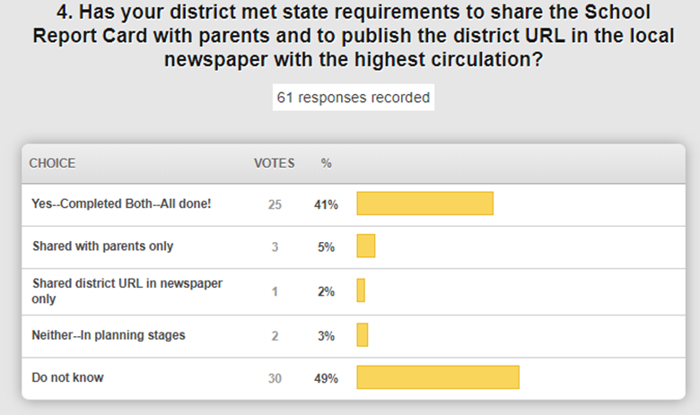

Other Items:

* One new thing is the school report card summary for A1 schools; it is a short 2-page summary that gives you a snapshot to use for community involvement and open up discussions, etc. The new school-level summary report is available to provide parents, guardians and other stakeholders an at-a-glance view of how their schools are doing and it can be used to start conversations within your community. Go to the [Ky. School Report Card site](https://nam03.safelinks.protection.outlook.com/?url=https%3A%2F%2Flnks.gd%2Fl%2FeyJhbGciOiJIUzI1NiJ9.eyJidWxsZXRpbl9saW5rX2lkIjoxMDAsInVyaSI6ImJwMjpjbGljayIsImJ1bGxldGluX2lkIjoiMjAyMDAyMTAuMTY5NDQ0NTEiLCJ1cmwiOiJodHRwczovL3d3dy5reXNjaG9vbHJlcG9ydGNhcmQuY29tL2hvbWU_eWVhcj0yMDE5In0.-PnxW0C0kPeOcQmkIwRkat_PGwS-WTCZlnY1xWLjDjg%2Fbr%2F74875863621-l&data=02%7C01%7Clisa.moore%40education.ky.gov%7Cc45e94b252db4b114c5608d7ca728e94%7C9360c11f90e64706ad0025fcdc9e2ed1%7C0%7C0%7C637200465734838872&sdata=N%2B9RSDubIDLztI0gFRDR%2BkaEmjJLNE8xo4eYm76WiSM%3D&reserved=0) and search for your school. A new Download Summary Report option is available to the left of the compare option.
* **Data Privacy/Security -** [New Privacy 101 video series](https://nam03.safelinks.protection.outlook.com/?url=https%3A%2F%2Ffpf.org%2F2020%2F02%2F11%2Fnew-privacy-101-video-series-helps-school-district-leaders-protect-student-data%2F&data=02%7C01%7Clisa.moore%40education.ky.gov%7Cc45e94b252db4b114c5608d7ca728e94%7C9360c11f90e64706ad0025fcdc9e2ed1%7C0%7C0%7C637200465734838872&sdata=qKREEv%2FWwloTOqcVmYL6bQHXa%2FYeb04nuEsMznGqZEU%3D&reserved=0), produced by the Future of Privacy Forum (FPF), provide an animated overview of best practices and tips on how schools can protect student privacy. We encourage you to use these resources. The series covers:
  + opportunities and challenges for collecting and safeguarding student data in the digital age
  + legal compliance about requirements of the Family Educational Rights and Privacy Act (FERPA)
  + how to avoid common privacy risks
  + transparency and how to engage and inform parents about a school’s data collection practices
* Upcoming Trainings – Spring user group trainings are scheduled for both eastern and western Kentucky. Please encourage folks to attend to get information directly from Infinite Campus and meet with your peers. End of year training is coming in April as well as some advanced IC training. For the full details regarding upcoming training opportunities, please visit the [KSIS Training webpage](https://nam03.safelinks.protection.outlook.com/?url=https%3A%2F%2Feducation.ky.gov%2Fdistricts%2Ftech%2Fsis%2FPages%2FKSIS-Training.aspx&data=02%7C01%7Clisa.moore%40education.ky.gov%7Cc45e94b252db4b114c5608d7ca728e94%7C9360c11f90e64706ad0025fcdc9e2ed1%7C0%7C0%7C637200465734848865&sdata=7XalJlskzNbCZtrQpaNvdqSfV4HEuQbNlmGcriG6h4I%3D&reserved=0).

**(1:00:06) Annual KY K-12 Supt Assurances Update --** There is an annual review activity of the KDE Superintendent Assurances and has an education technology section. We have made a few minor tweaks to these and the technology portion is made up of ten specific assurances. We will be distributing these through the field staff and appreciate your feedback. These are typically finalized and sent out to Superintendents at the beginning of the fiscal year.

**(1:02:08) Upcoming statewide KY K-12 Summative On-line Testing Update -** Everyone likes testing feedback as quickly as possible. There are three types of online testing—summative, MAP/PASS, and normative. This year we will be ramping up our online testing from 90,000 to over 400,000.  We have been working and testing to ensure we are prepared and the 1:1 implementation has allowed us to compress the testing window. There is both a technology piece and a people piece to the overall testing success.

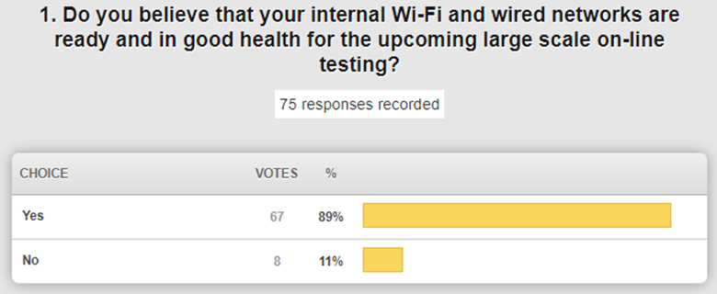

Most districts are comfortable that they are ready!

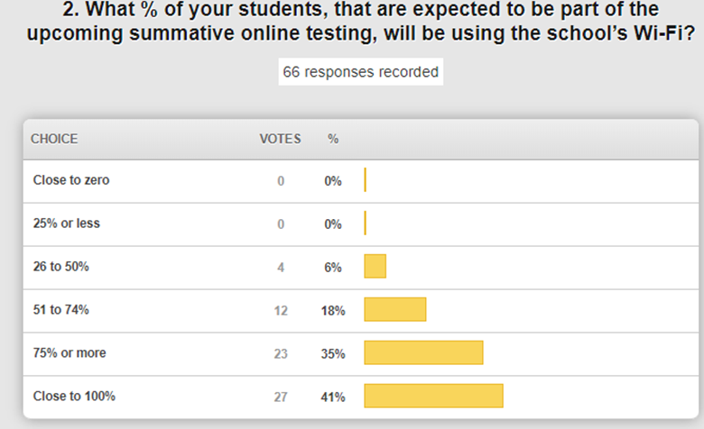

This is very insightful for us and shows the importance of having a healthy Wi-Fi network in order to successfully complete the online testing experience. We are currently using an 80GB pipe and we have been peaking in the 50GB range. We are working with our vendor partners to plan for an upgrade and discussing the need to go to a 200GB pipe in order to maximize the success of the online testing experience and avoid a perfect storm. We have 400,000 students testing within a two-week window and we are working on some strategies. We don’t want to complete the upgrade during this window and risk broken glass.

**(1:12:00) KY K-12 Edtech Projects Due Thru June 30, 2020 -** There are 25 or so technical projects/tasks that are ongoing and the field staff will be covering these in detail in their regional meetings. We highlighted a few:

* SAML conversion
* District Bandwidth Upgrades – These upgrades will pause during the testing window
* KEN Rack Switch Upgrades – These upgrades will also pause during the testing window
* UPS Replacement – These will begin directly after the testing window ends
* Minimum Password Standard – Targeting June 30 for completion
* SAML Integration – Targeting June 30 for completion

**(1:14:19) Items Brought to Us by Non-Edtech Staff -** The department is sometimes approached directly rather than the individual district. We like to loop you in and make you aware so that the chain of command and communication does not break. There is a region of CFOs that would like us to come talk with them regarding KETS initiatives; these are very basic questions and prompted us to ask the following question:

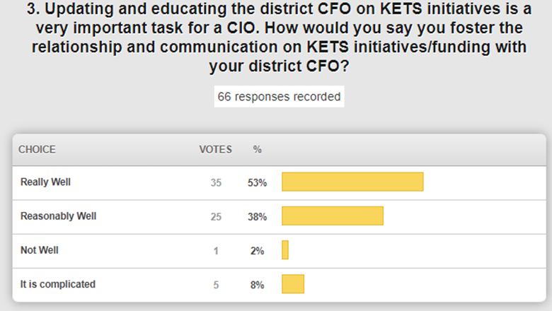

We have also received questions about the behavioral data of a student and how it is transferred when the student transfers. There was also a question regarding VOIP and moving to that in a school.  We were surprised by that question.

Other Items:

* eSports – Fortnite was named as an unacceptable game for the gaming portfolio. We have 30 to 35 districts that have eSports programs.
* Indemnity Clause – We are looking into this hold harmless clause from a legal perspective regarding the use of free instructional resources.
* Additional GoSoapBox poll questions:

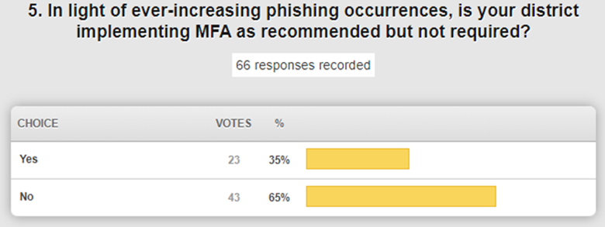

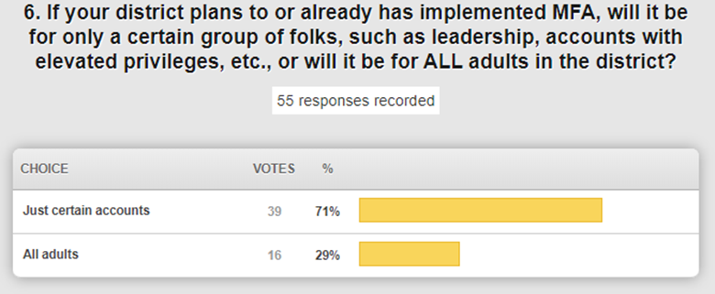

Thanks for joining us today from Spencer County and we’ll see you next month!