**Summary of the January Webcast for KY K-12 Education**

**Technology Leaders from Frankfort Independent Schools**

**In case you missed it or want a refresher, the following is what we talked about during the January 21, 2020 webcast from Second Street Elementary School in Franklin County.**

Access the digital video and audio copy for this webcast through our webpage at: [https://mediaportal.education.ky.gov/featured/2020/01/edtech-january-2020/](https://nam03.safelinks.protection.outlook.com/?url=https%3A%2F%2Fmediaportal.education.ky.gov%2Ffeatured%2F2020%2F01%2Fedtech-january-2020%2F&data=02%7C01%7Clisa.moore%40education.ky.gov%7Ccfc8ae6defd94bae96fd08d7b3f376e9%7C9360c11f90e64706ad0025fcdc9e2ed1%7C0%7C0%7C637175730595020063&sdata=%2F%2FDdRBpTRQGyrR8zKWVNMGkfo8t%2BdHc8YFWAEe67Eic%3D&reserved=0)

Public viewing of the archived webcasts and written summaries are also available on the KDE Media Portal at: [http://mediaportal.education.ky.gov/](https://nam03.safelinks.protection.outlook.com/?url=http%3A%2F%2Fmediaportal.education.ky.gov%2F&data=02%7C01%7Clisa.moore%40education.ky.gov%7Ccfc8ae6defd94bae96fd08d7b3f376e9%7C9360c11f90e64706ad0025fcdc9e2ed1%7C0%7C0%7C637175730595030051&sdata=nijw%2FsS0LzjmAHmKn64%2Fj4GnOtWu4mIBrIHG58PzLYQ%3D&reserved=0). Numbers in **RED** indicate the timestamp for that portion of the discussion so it can be easily located on the full digital recording.

In attendance from KDE’s Office of Education Technology were David Couch, Mike Leadingham, DeDe Conner and Marty Park. Damon Jackey, KETS field staff member for this region was also in attendance. We also had several additional Office of Education Technology staff members present along with several distinguished guests. There was one GoSoapBox poll question posed during today’s webcast along with a few discussion questions.

**(4:21) Frankfort Independent Schools (FIS) Update/Comments -** We began today’s edtech district webcast with a video produced by students on the rich history of education technology in the Frankfort Independent school district and how FIS is preparing students today for tomorrow’s world. Superintendent Houston Barber described how FIS is a very community driven district and uses a 3:1 approach to meet the needs of every student—social/emotional needs, academic/behavioral needs and access to opportunity. They have also been working toward the 1:1 implementation approach for some time. Today, FIS is focused on a world class education, a connected community school, enhanced human capital performance, and 21st century technology and facilities as well as efficient/effective operations and safe/secure facilities. Superintendent Barber was joined today by:

Jonathan Jones, CIO

Arlene Crabtree, Technology Integration Specialist

Jina Greathouse, Board Member

Tasha Jones, Board Member

Sam Sams, Principal

**(6:27) Interim KDE Commissioner Kevin Brown –** It is the 30th year of KERA and the 28th year for the Kentucky Education Technology System (KETS) program. Kevin pointed out that the first text message he received after being named Interim Commissioner was from David Couch asking him to join us today.  When the reform act was passed, Kevin was with his father who told him that this was going to change education; he did not realize at the time what an integral part of it he would become. David is the sole remaining member of the original KERA leadership team hired in after the 1990 education reform legislation was passed. Consistency has been a strong point in the Office of Education Technology and has enabled us to do more with less. Our best practices and work ethic are a national model.

**(10:06) Thank you for your service to our KY K-12 schools and state! -** David took a few moments to recognize the service of those that have helped make KY K-12 edtech very successful and special. We are like an old rock band who has been able to change and remain relevant over the decades. The success of KETS is a culmination of all our leadership, our commissioners, our boards, our vendor partners, our legislators, our educational cooperatives, our agency partners and our district edtech staff. We had several guests in the audience representing some of our educational and vendor partners.

Three groups of OET staff members were recognized—

* Those with less than 10 years of service in OET but overall more than 10 years when including their service to school districts and or other state agencies:

* Those with 10 to 14 years of service in OET:

* Those with 15 or more years of service in OET:

David shared a quote from Steve Jobs that he keeps in his office (see in picture below). We also recognized Bill Stilwell who created a list serve service in the early 1990’s. We now give an award annually in his honor known as the [Stilwell Award](https://nam03.safelinks.protection.outlook.com/?url=https%3A%2F%2Feducation.ky.gov%2Fdistricts%2Ftech%2FPages%2FThe-Stilwell-Award.aspx&data=02%7C01%7Clisa.moore%40education.ky.gov%7Ccfc8ae6defd94bae96fd08d7b3f376e9%7C9360c11f90e64706ad0025fcdc9e2ed1%7C0%7C0%7C637175730595030051&sdata=3qKRV89OYQrZ8MBayToouTSj0AQQThIHoStHrEGGmUA%3D&reserved=0) for those who go above and beyond the call of duty in the area of education technology. You can visit the link to read all about the award and our current/previous award winners. This year the Stilwell Award was awarded posthumously to Terry Orr. Terry Orr was the Project Manager for all major projects since 2002 and he was our MVP of Project Managers. Awards were also presented to Phil Coleman, Mike Leadingham, DeDe Conner, Robert Hackworth, John Logan and Lisa Moore. John Logan tops the list with 29+ years and worked hand in hand with Terry on many projects. Great team!

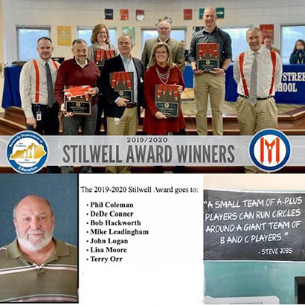

**(34:34) Transforming Lives Award –** This award was presented by Supt Barber and he referenced a [1993 AT&T commercial](https://nam03.safelinks.protection.outlook.com/?url=https%3A%2F%2Fwww.youtube.com%2Fwatch%3Fv%3DVyya-bSlAF4&data=02%7C01%7Clisa.moore%40education.ky.gov%7Ccfc8ae6defd94bae96fd08d7b3f376e9%7C9360c11f90e64706ad0025fcdc9e2ed1%7C0%7C0%7C637175730595040047&sdata=vxdXfbFOUuucdFs2DTWs248%2BHBWRsRHpL4p1btDQR5Q%3D&reserved=0) and [Short video](https://nam03.safelinks.protection.outlook.com/?url=https%3A%2F%2Fwww.youtube.com%2Fwatch%3Fv%3DyFWCoeZjx8A&data=02%7C01%7Clisa.moore%40education.ky.gov%7Ccfc8ae6defd94bae96fd08d7b3f376e9%7C9360c11f90e64706ad0025fcdc9e2ed1%7C0%7C0%7C637175730595040047&sdata=2N62nZCxpUV3NIIE00Djt9qAHmeH2PnjlLzuMhmXQlo%3D&reserved=0) about all the education technology described in our KETS Timeline that has helped transform their school district. The Frankfort Independent schools “Transforming Lives” coin was created to honor those who have had a great impact on their community and the schools. OET very much appreciates this award going to one of our OET staff members.

Supt. Barber described how FIS is one of the first districts in the state to partner with the city to provide home Internet access to all the kids in their school. He also shared several good news items and challenges for their district. They value technology and believe in it and appreciate OET’s support. He highlighted their involvement in a cutting edge program called Profile to a Graduate and you can view the full presentation at [https://www.frankfort.kyschools.us/pog.aspx](https://nam03.safelinks.protection.outlook.com/?url=https%3A%2F%2Fwww.frankfort.kyschools.us%2Fpog.aspx&data=02%7C01%7Clisa.moore%40education.ky.gov%7Ccfc8ae6defd94bae96fd08d7b3f376e9%7C9360c11f90e64706ad0025fcdc9e2ed1%7C0%7C0%7C637175730595050036&sdata=MQiz%2FQk9bego1j9H%2FDi0xcnBxmKqnunGBydnFmz%2Fleg%3D&reserved=0).

This year is the first year that the Second Street Elementary STLP qualified for the state competition. This is a very enthusiastic group! At the regional competition, their project was not working when they arrived and got set up. They went into troubleshooting mode and were able to fix the problem and continue the competition with their project that is called Dash.

**(43:47)** [**Rep. Joe Graviss**](https://nam03.safelinks.protection.outlook.com/?url=https%3A%2F%2Flegislature.ky.gov%2FLegislators%2FPages%2FLegislator-Profile.aspx%3FDistrictNumber%3D56&data=02%7C01%7Clisa.moore%40education.ky.gov%7Ccfc8ae6defd94bae96fd08d7b3f376e9%7C9360c11f90e64706ad0025fcdc9e2ed1%7C0%7C0%7C637175730595050036&sdata=Vad7ZVb8LG8NSRxHcwvLoqudXmNJur0%2BIbT%2Bavuxu9k%3D&reserved=0) joined us today and touched on some of the previous comments. Frankfort is the only city in Kentucky that hosts state government officials and we really need the state to do its part for education by looking at revenue disparities. One of the immediate requests is the KDE technology funding request OET submitted and how KY needs to prioritize our teachers and the tools we need for tomorrow! It’s a tight budget time and there are a lot of “asks” so don’t be shy in supporting and communicating with your elected officials on revenue measures. FIS works tirelessly to raise money and receive grants and other funding dollars.

**(50:53) 2019 Top 5 Feedback Process/Review –** This an annual exercise that we ask all our district edtech leaders and OET staff to complete. Receiving the feedback is only the first step and today we took a few moments to provide some of the items that, through our review, were seen as the central themes of the 2019 feedback as a whole.

**What we did well in calendar year 2019 in KY K-12 edtech:**

* Kept doing well what we had already been doing well that districts and KDE staff wanted us to keep doing well.
* Good stewards of taxpayer funds
* Championing the people side of KY K-12 edtech across the state. Saw some improvements of district edtech staffing.
* Additional budget request (ABR) approved and submitted for increase in KETS Funding to
* STLP is item that was overwhelmingly noted by districts
* Improved mitigation response time of DDoS attack
* Better awareness and savviness regarding cybersecurity
* Implementation of the KY K-12 CIO academy but can get better
* Made progress on our new KY K-12 password policy
* Overall appreciation of OET staff/relationships with district edtech staff
* KY K-12 technology enabled project management services
* KY K-12 technology planning template
* OET’s KY K-12 data services and governance
* OET’s field staff and digital learning team
* Deployment of the new KY K-12 School Report Card
* Staying on top of telehealth efforts
* KY K-12 Computer Science Standards established
* KY K-12 student technology academic standards in progress
* The annual KY K-12 CIO Summit
* KY K-12’s IT Academy. More “Girls Who Code” clubs than any other state
* Successful on-line formative testing. Especially in comparison to other states.
* School Safety/Anonymous Reporting Tool (2019 SB1 mandate)
* One of the most successful year of E-rate funding by districts.
* Protection of KIH3 E-rate funding
* RFI and RFP for Teacher Licensure System - automating and improving this experience
* Made changes, based upon district edtech leaders’ feedback, to our KY K-12 voice contracts approach & KY K-12 printer contracts approach
* eSports (Educating folks on what it is and what it isn’t; Requiring district leaders and parent’s acknowledgment of pluses and minuses.)
* Changes to commodity codes for edtech in Munis
* The 2018-2024 KETS Master Plan and Future Ready connection
* Office 365/IC integration

**Areas of improvement and some goals for 2020 for KY K-12 edtech:**

* Better awareness of the existing KETS services (e.g., all KY K-12 districts and schools are already connected to the Internet, etc.) for the leaders in each county (legislators, magistrates, etc.), parents & community members and those within the school system.
* More interoperability between major systems is a common theme across all comments received. Automated account creation and removal between these systems.
* Technology Academic Standards (Getting them across the finish line!)
* Continued work on Cybersecurity approaches
* More help on managing Microsoft Office365
* Google password reset
* Wi-Fi district health-check options
* The next KY K-12 network component RFP
* Expand the KY K-12 Internet pipe from 80GB to 200GB
* Awareness and comparison of Microsoft Teams, Google Hangouts and Zoom
* The 36 KETS Master Plan Areas of emphasis goals -tracking and measuring progress
* Data visualization (Replacing SWISS)
* Follow-up on Firewall upgrades
* Addressing unique situations that require basic Internet services to be addressed including backup.
* Kentucky library media standards
* Single Sign-on capability
* DMZ/Avocent replacement
* SAML for Infinite Campus
* Civil Rights Data Collection - Continuing work on behalf of school districts
* Larger scale KY K-12 summative online testing preparation/piloting
* Printing costs reductions
* Require digital Munis technology activity report (TAR) from each district
* Follow-up on virus protection/guidance
* Follow-up on Active Directory as a service
* Follow-up on Lightspeed reporting functionality and Relay.
* Follow-up on stale account management and automation
* Follow-up on OET portion of KDE website
* Follow-up on Multi-Factor Authentication (MFA)
* SHI contract improvement

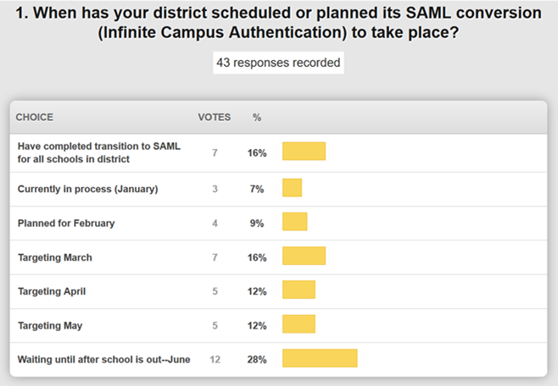

**Closing Comments by FIS -** Implementing and navigating the complexity of technology is hard and OET is there to assist. Efforts don’t go unnoticed and it is an honor to work with OET.

Thanks for joining us today and allowing us to take some time to recognize our Stilwell Award winners. We’ll see you next month from Spencer County.