**Summary of the December Webcast for KY K-12 Education**

**Technology Leaders from Lewis County Schools**

**In case you missed it or want a refresher, the following is what we talked about during the December 17, 2019 webcast from Central Elementary School in Lewis County.**

Access the digital video and audio copy for this webcast through our webpage at: <https://mediaportal.education.ky.gov/technology/district-technology-leadership-webcast/2019/12/edtech-webcast-december-2019/>

Public viewing of the archived webcasts and written summaries are also available on the KDE Media Portal at: <http://mediaportal.education.ky.gov/>. Numbers in **RED** indicate the timestamp for that portion of the discussion so it can be easily located on the full digital recording.

In attendance from KDE’s Office of Education Technology were David Couch, Mike Leadingham, and Marty Park. Jody Rose, KETS field staff engineer for this region, was in attendance along with Judith Evans. Phil Coleman, DeDe Conner and Robert Hackworth joined in via Skype from Frankfort. There were three GoSoapBox poll questions posed during today’s webcast along with several discussion questions.

**(2:03)** [**Lewis County Schools**](https://nam03.safelinks.protection.outlook.com/?url=https%3A%2F%2Fwww.kyschoolreportcard.com%2Forganization%2F5607%3Fyear%3D2019&data=02%7C01%7Clisa.moore%40education.ky.gov%7C3aa39af5bdef4c6e31b108d79e0e15ad%7C9360c11f90e64706ad0025fcdc9e2ed1%7C0%7C0%7C637151656209611583&sdata=Lo5IEybr64LTkBhuv37NJYSymQbGPO7Rqz1WYZiSPG0%3D&reserved=0) **Update -** School was called off today for Lewis County schools due to flooding in the region, but the webcast was able to continue. Jamie Weddington, Superintendent of Lewis County Schools, provided some background regarding Lewis County. It is the 13th largest county in the state with rolling hills, trees, and the northern part of the county fronts the Ohio River. There are six schools and a locally owned technology center and they have about 2,100 students in total. Central Elementary is a brand new building and replaced a school built in 1932; it has been an adjustment!

Other staff present from Lewis County:

* David Lucas, CIO
* Brenda Box, Instructional Supervisor

David Lucas is a member of the KySTE board and a huge supporter of the STLP program. STLP promotes team values and environment and that you can accomplishment more than you realize. Participation in STLP, with all the interactions and relationships, is something that students will carry with them throughout their lifetime. This is a very interesting district—what they have as far as devices has changed dramatically over the last five years. Brenda spoke about the use of the Google Chromebooks and how they use individualized instruction to supplement traditional teacher-led classroom instructional practices.

**(10:28) Transitions in Frankfort that impact KY K-12 Edtech –**

* Anytime we have a change in administration, we normally have a new cabinet secretary. Jacqueline Coleman is now our Lieutenant Governor and will serve a dual role as our Workforce Development and Education Cabinet Secretary.
* There have been new members identified for the  [Kentucky Board of Education](https://education.ky.gov/KBE/memb/Pages/default.aspx). We have education technology ties to three of those members: Lee Todd, Lu Young, and David Karem.
* Wayne Lewis resigned as our Commissioner of Education and Kevin Brown will serve as our Interim Commissioner while a national search is conducted to fill the Commissioner position. Wayne Lewis has since accepted a position as Inaugural Dean at the College of Education at Belmont University in Tennessee.
* The Commonwealth Office of Technology (COT) has new CIO as well—Ruth Day.

**(14:50) Annual KY K-12 Edtech Readiness Update** - Our annual data collections help us make informed decisions and see/capture trends in K-12 education technology. We use this information across a wide variety of audiences throughout the year and districts are able to use this data as well for comparison, education, and effective decision-making purposes. We have the KETS Big 4--EdTech Plan, 360 Feedback a/k/a/ “Top 5”, Digital Readiness Survey, and Technology Activity Report. We see this as growth cycle work developed through the KETS Master Plan to determine areas of success and improvement for the KETS Program.

Digital Readiness work has several components. It includes inventory type information and understanding what we do with the “stuff” information. We also focus on the people side of things for education technology. All this information helps feed our trends that assist in our decision making and planning and it is used to formulate our Infographic—our story of technology usage.  The new Infographic and data will be updated on the KDE website in the next few weeks and can be located in [Appendix B](https://education.ky.gov/districts/tech/Pages/KETS-2018---2024-Master-Plan---Appendix-B.aspx) of the KETS Master Plan at <https://education.ky.gov/districts/tech/Pages/KETS-2018---2024-Master-Plan---Appendix-B.aspx>. Marty Park highlighted several data points that were collected, and you are encouraged to listen to this section of the audio beginning at the **(23:00)** minute mark.

Continue to educate others about all the great things we have accomplished and that all our schools are connected. Had we known the attention that a recent outage would have brought to our connectivity, we would have done it long ago! While we aren’t perfect, we are a national leader in many areas of education technology and it’s important for others to know and realize that. This Infographic helps us show where we are doing very well and areas where we need improvement.

Lewis County Points of Interest to Digital Readiness Discussion:

* Computer carts are located in almost every classroom. Students don’t carry their device from room to room; they receive them in each room.
* As they move toward career ready, they move to additional/different operating systems that may work best with a specific career pathway.
* Smartphones are used in some classrooms that are not equipped with Chromebooks and the students use a tool called [Kahoot](https://nam03.safelinks.protection.outlook.com/?url=https%3A%2F%2Fkahoot.com%2F&data=02%7C01%7Clisa.moore%40education.ky.gov%7C3aa39af5bdef4c6e31b108d79e0e15ad%7C9360c11f90e64706ad0025fcdc9e2ed1%7C0%7C0%7C637151656209621573&sdata=aY3hAe%2Fh7UhHw4gneKYgk0svDirKpeCfF0gFAS8qL%2BA%3D&reserved=0).  Principals have mixed feelings about the use of personal cellphone devices for instructional purposes and access to the wireless network. Bandwidth when using the dense wireless in this manner can make it challenging to provide a good user experience.
* Superintendent Weddington described how almost any position in the district uses technology in some manner and that preparing students for workplace readiness is challenging as they could use various technology platforms/devices.
* Online assessment in Lewis County—they are prepared and have 1:1 Google Chromebooks ready for online assessments.

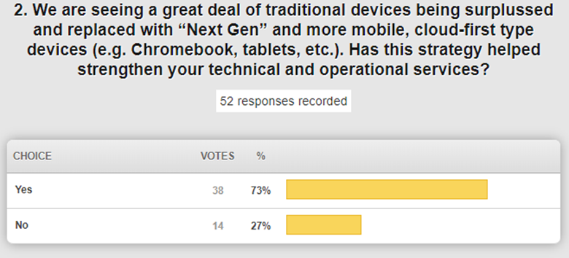

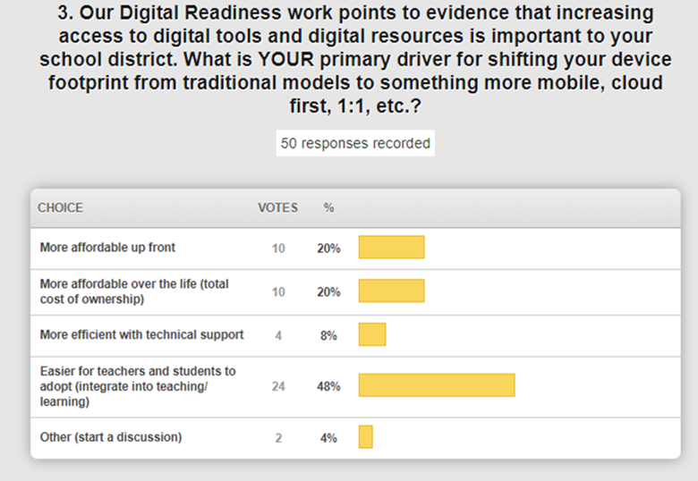

**(55:45) Annual “Top 5” Feedback Update -** Our January webcast from Frankfort Independent Schools will focus on the annual feedback. The collection closed on December 1st and we are currently evaluating that feedback. Our Digital Readiness Survey received feedback regarding the collection efforts. As of July 1, 2020, we are going to be doing things a little more efficiently and will be opening the collection window earlier.

**(1:00:16) E-rate Update -** A few months ago we discussed the proposed rulemaking changes by the FCC.  There has been a ruling released and we’ll be sending out a more detailed summary via the field staff.  The Category 2 funding will remain. They will have a transition year--you will have this year 6 funding (20%) to spend that and any remaining funds from the first 5-year budget cycle to spend. After that, there will be another 5-year budget cycle. This is good news for us, and the budget allocated (in this coming 5-year budget cycle) will be applied at the district level vs. the school level. This is huge news for districts that need to implement technology across the district vs. specific school level initiatives. Scott Kane and Caprice Gay are scheduling training sessions for the upcoming filing windows. Discount data is now available. Kentucky has always done well in maximizing this program and E-rate continues to be the lifeblood of our technology funding.

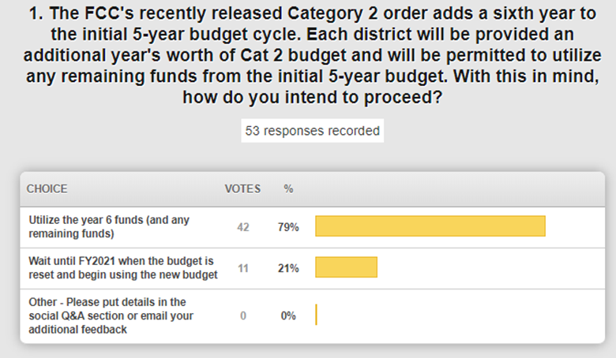

**(1:09:25) KETS Offers of Assistance Update -** 1st offer was $9/ADA – most districts have taken advantage of this and we are still on target to receive $21/ADA for the year.

**(1:10:36)** **DeDe Conner Updates/Items:**

* Annual Kentucky Infinite Campus (IC) Summit was last week in Louisville. We had a great turn out for Interchange and thanks to everyone who attended and presented. Infinite Campus makes this a priority and we learn from each other. There were 119 districts represented with 576 total participants and it continues to grow. We would like to see all districts have representation and have also considered putting on a conference dedicated to data. Data privacy information has been updated on the website.
* School Report Card (SRC) – One Page Summary Report was previewed and provides an overview that will be available within the next week for A1 schools.

**(1:18:22) Active Directory/Staff Update -** We always support staff who choose to move their careers forward, but we work diligently to fill those gaps with qualified staff. We have recently lost 2 positions on our AD team and we are working with Microsoft to temporarily fill those gaps as we work to backfill these positions.

**(1:21:44) People Side of Edtech/Health Check Assistance to Districts -** When we ask our teachers and students what their Internet experience is, we get mixed responses. How can we work with some of our vendor partners to assist districts in performing district health checks to ensure that districts have Lightspeed and network components configured properly and maximized? Is this a service you would utilize? We are requesting your feedback on how we can partner with some of our vendors to perform preventative health checks on the internal district edtech network.

**(1:24:35) STLP Update –** The final STLP Regional will be in Pikeville on Dec 18th. January 8th is the registration deadline for the online digital product; it cannot be extended this year. Pictures from regional STLP events were shared and discussed; special thanks to all our volunteers and judges because these events could not happen without you.

**(1:25:54) Auditor of Public Accounts (APA) Update –** The APA released a Phase 2 report today in regards to the KyWired initiative: [http://apps.auditor.ky.gov/Public/Audit_Reports/Archive/2019KyWiredPhase2Exam-PR.pdf](https://nam03.safelinks.protection.outlook.com/?url=http%3A%2F%2Fapps.auditor.ky.gov%2FPublic%2FAudit_Reports%2FArchive%2F2019KyWiredPhase2Exam-PR.pdf&data=02%7C01%7Clisa.moore%40education.ky.gov%7C3aa39af5bdef4c6e31b108d79e0e15ad%7C9360c11f90e64706ad0025fcdc9e2ed1%7C0%7C0%7C637151656209621573&sdata=TRwZ%2FhWf4IOuylA9%2BCMdokmBVBHjpyxZi%2B0zOyb93dU%3D&reserved=0) .

Superintendent Weddington closed with recommending that OET staff spend the rest of the day being “boots on the ground” at the host district!

Thanks for being with us today; we’ll see you next month from Frankfort Independent Schools.