**Summary of the November Webcast for KY K-12 Education**

**Technology Leaders from Trigg County Schools**

**In case you missed it or want a refresher, the following is what we talked about during the November 19, 2019 webcast from Trigg County Middle School.**

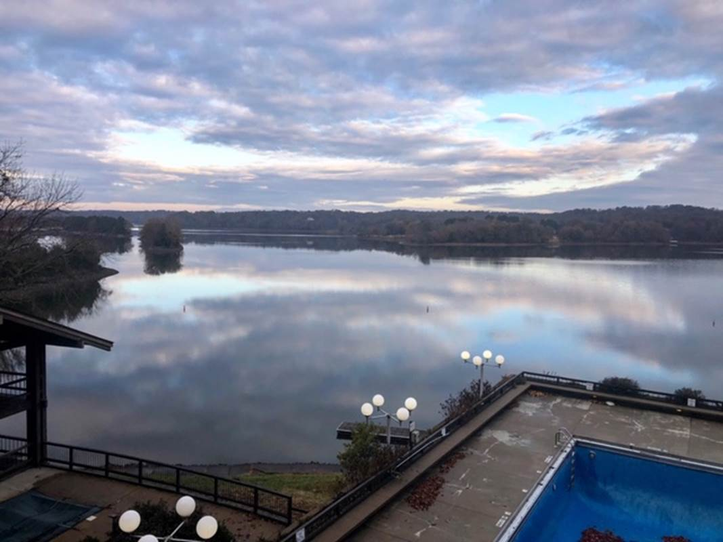 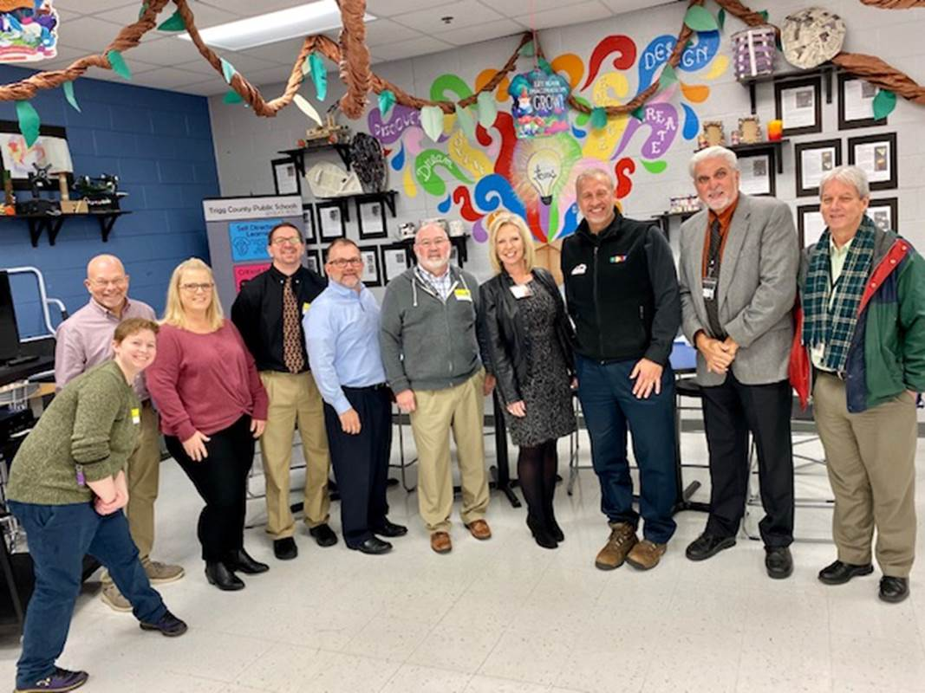

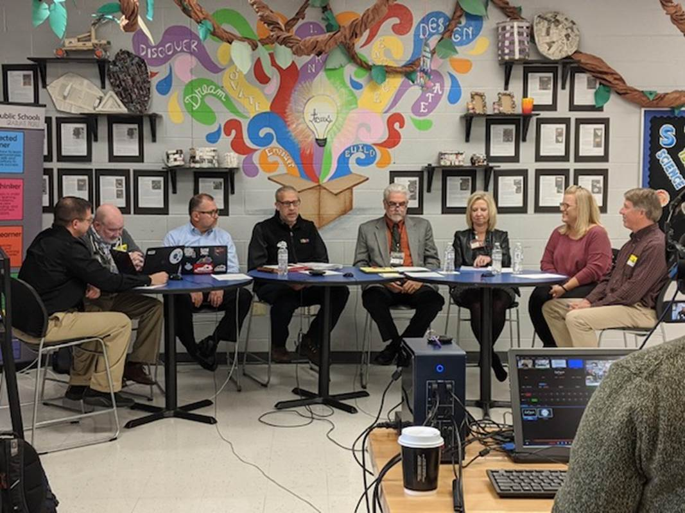

Access the digital video and audio copy for this webcast through our webpage at: <https://mediaportal.education.ky.gov/featured/2019/11/edtech-november-2019/>.

Public viewing of the archived webcasts and written summaries are also available on the KDE Media Portal at: <http://mediaportal.education.ky.gov/>. Numbers in **RED** indicate the timestamp for that portion of the discussion so it can be easily located on the full digital recording.

In attendance from KDE’s Office of Education Technology were David Couch, Mike Leadingham, and Chuck Austin. Jody Rose, KETS field staff engineer for this region, was also in attendance along with Judith Evans. Phil Coleman, DeDe Conner and Jeff Sebulsky joined in via Skype from Frankfort. There were two GoSoapBox poll questions posed during today’s webcast along with two discussion questions.

**(1:35) Trigg County Schools Update -** Welcome to Cadiz and Trigg County Schools! It is a great school district and Interim Superintendent Tim McGinnis believes they have the best kids in the world. All the students are on one campus and they are proud of the kids and the teachers. Other staff/guests in attendance for today’s webcast: [Representative Walker Thomas](https://legislature.ky.gov/Legislators/Pages/Legislator-Profile.aspx?DistrictNumber=8), Assistant Supt. Beth Sumner, CIO Rory Fundora, and James Mangels. Supt. McGinnis is proud of the administrative team at Trigg County Schools.

Rory has been a CIO for two different districts and has completed a 1:1 implementation at each district. She had some words of wisdom and lessons learned. Remember that is not a truly technical initiative—it’s an instructional initiative, curriculum focused and a tool. She described their current 1:1 implementation plan at Trigg and they have been working on this for seven years. Beth discussed the need for the instructional and technical staff to work collaboratively to maximize the investment. It is not just about having a device. Trigg County is trying to be more selective and very intentional about the tools being used and whether it fits in with state standards. They are currently completing a trial with some analytic software called [CatchOn](https://www.catchon.com/) that catalogs the sites/tools being used. It is a way to give them a good view of tools/software being used and where they need to focus on spending, training, security, etc.

Rep. Thomas spoke about the passage of the 2019 SB1, the school safety bill, and that its passage was a framework of a wish list. This year they will work to fund those mandates. He is drafting legislation to formulate some medical compacts and that could assist with the current telehealth initiative as well. Kentucky has seven border states and this would assist with some medical areas of expertise where Kentucky has shortages.

**(14:19) KETS Additional Budget Request Update –** The ABR for KY K-12 edtech was approved by KBE at their board meeting earlier this month. These additional funds would be utilized for increased KETS funds for the people side of edtech in districts, cybersecurity, online testing, end device replacement in districts, incremental Internet bandwidth needs, and to address cost of living increases since 1992 and budget cuts since 2007.

**(15:59) Annual “Top 5 Feedback” Update –** The annual feedback from each district is due on December 1. This feedback covers the following three areas:

1. What did we do well in 2019?
2. What we didn’t do well or didn’t get to that we should have done in 2019?
3. What should be the top goals of 2020?

We do read every one of these and use this feedback throughout the year.

**(16:53) Program Review and Investigations Committee Meeting Update –** This legislative committee will be meeting on Friday, November 22nd. David will be in attendance and has reviewed the draft report and KDE has provided a response.

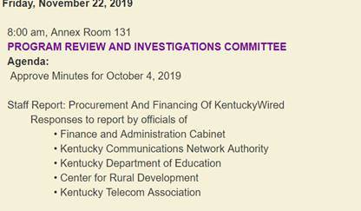

In our response to the review of the draft report, we covered several points:

* We reminded them about Kentucky being a national leader in having our schools connected to the Internet and having high quality, fiber connectivity.
* The new national goal for bandwidth is 1KB per student and we currently use approximately 200mbps. We don’t increase bandwidth just to meet this national standard; we have the capacity to do so, but ramping up to this without a true need would not be a good use of taxpayer funds. We do expect growth over the next 5 to 10 years.
* Of all the states, we are best positioned to maximize E-rate. Over the next 30 years, that could equate to at least $2B of KY K-12 edtech buying power and we consider it the lifeblood of education technology. It has been one of the main reasons we were able to continue the KETS Offer of Assistance programs over the years.
* We are the national leader in cloud based computing in K-12 as well as private industry. You must have an extremely reliable Internet service for cloud based computing to work efficiently. We and our customers have grown to rely upon this and we have a proven history of success. K-12 is 25X bigger than the rest of state government combined.
* Most people are familiar with the Gartner hype cycle and the use of a brand new product or service is very risky. We don’t want to risk using an unproven service and risking it being unstable and an unsatisfactory service.
* Our next KIH contract is scheduled to be renewed in 2023 and it requires a fair, open, and competitive bid process in order for us meet E-rate guidelines.

**(27:49) KY K-12 Student Technology Leadership Program (STLP) Update -** Trigg County has an STLP presence and actually sent students to ISTE this past year! The lifeblood of our ability to provide @STLP Kentucky to 60,000 KY K-12 students are the school STLP coaches/coordinators & district CIOs/edtech leaders that give of their time and skills to champion this and make this wonderful opportunity happen for their students. You’re appreciated! @STLP Kentucky is not just about 60,000 KY K-12 students creating technology projects but also developing their life & leadership skills. These students have both great tech/engineering skills AND can effectively present, communicate and compete.

Morehead and Murray are two examples of sponsoring locations taking true ownership and including their schools of education in the experience and allowing their students to see project- based learning in action. They walk the talk! STLP started in 1994. We just had the largest regional event ever at University of Louisville.

At Trigg County every student is sharing/presenting their work and holding student-led conferences with their parents. Trigg County discussed their senior directive project and highlighted a student who took ownership of his learning and turned his high school experience around due to being a member of the student-led help desk.

The remaining STLP Regionals and State Championship are:

* November 21     Western Kentucky University, Diddle Arena
* December 3        Owensboro Convention Center
* December 9        The Center for Rural Development, Somerset
* December 18     University of Pikeville, Appalachian Wireless Arena
* April 8               State championship @ Rupp Arena

STLP Regionals completed:

* November 4 - **Morehead State University**

Kicked off the 1st of our 9 regional competitions across the state, for our KY K-12 student technology leadership program (STLP). Big thanks to MSU for being such an awesome host in every way and to the adult volunteer staff/judges that gave of their time to make something special happen for our KY K-12 students.

* November 7- **Murray State University**

Murray State models every aspect of what STLP can offer to our KY K-12 students and to our future teachers in your college of education. Thanks!

* November 12 - **University of Louisville**

Set a new state record for the most registered student technology leadership program (STLP) projects for a regional competition with 230 projects! 1600 KY K-12 students competed. May need Yum Center next year for this regional.

* November 14 - **University of Kentucky**

Greatly appreciate UK’s College of Ed (Gerry Swan) and College of Engineering’s direct involvement in making this such a great experience for KY K-12. Love the new layout here with lots STLP projects immediately visible as you walk in the facility then nicely spaced out throughout the entire floor. Some strong projects here. No surprise that our defending STLP high school state champ is from this region.

* November 18 - **Northern Kentucky University**

Lots of former and defending KY K-12 state champions here today.

**(37:10) Length/Changing of the Passwords Update -** If you have questions or believe there is a technical hurdle in meeting and/or implementing these new minimum password requirements, please respond to Bob via email so we can work with you.

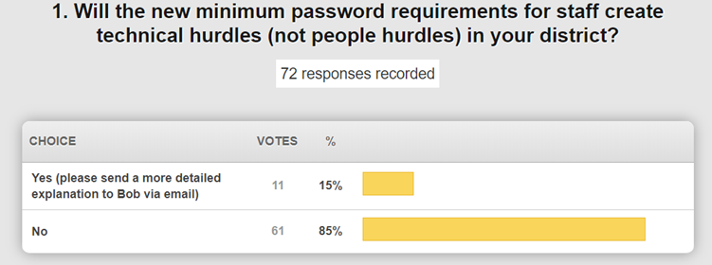

Bob will be sending out a questionnaire and looks forward to receiving your feedback as soon as you can complete it and get it sent back in. Passwords, no matter how strong, degrade over time. If you have already moved to passphrases, we look forward to your feedback. Bob provided some examples using KDE staff accounts that show cyber criminals are very busy and the need for strong passwords is growing in importance.

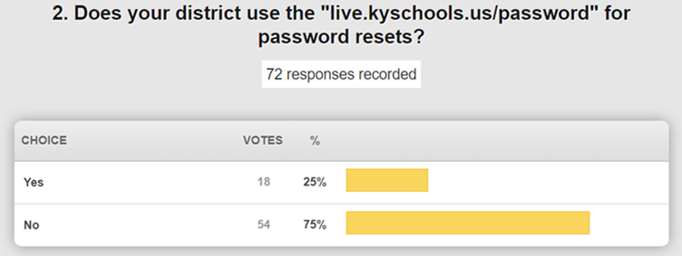

Rory commented that the challenges lie mostly in the people side of things. Her biggest challenge is working with someone when it is time to change their password--explaining the “why” and educating them on how to select a good passphrase password. We talked a little bit about the behind the scenes work and background of why these changes are coming about. Remember that this change impacts primarily staff accounts as you are preparing your comments to the questionnaire.

**(50:57) Internet from a KY K-12 student’s perspective -** During current travel around the state, our Internet service is stable and reliable. However, from a student perspective they look at their Internet experience through the lens of the wireless network and/or from the use of a personal device. Many districts also filter/block several sites that a district has chosen to not allow access to from the school network. Rory described their personal/cellphone device policy for Trigg County. The policy is very open and well communicated; their main reason for not allowing access during instructional time is because they have the 1:1 implementation and students have a device accessible to them. We also spent some time discussing the review and approval process for sites that students/staff find that are blocked but they need access to for an educational purpose. It may be best to ask students what their experience is in using their device on the network and then through the wireless network; it may be deficiencies/limitations of the dense wireless network.

**(1:00:44) State Education Technology Directors Association (SETDA) Update –** We recently attended this leadership forum conference held in Washington, DC; these are valuable conferences where we are able to learn from and interact with our peers and we like to brag on Kentucky accomplishments. They give an annual award, the Student Voice Award, and we are interested in nominating a group or groups next year.

Some of the focus areas were assessment, interoperability, workforce readiness, privacy, security, and network management tools. AT&T was in attendance and talked about FirstNet, a priority communication network for emergency events. Project lead the Way and Pearson were there. There were presentations given by Education Super Highway (ESH) and E-rate.

We have debated the ESH representation of our data and they are listening to us in regard to scalability, etc. This is the last year of their report and they are developing a tool that will produce some reporting – Kentucky has volunteered to be a part of developing that work. A report from SETDA, the [Broadband Imperative](https://www.setda.org/outreach/press-releases/press-release-2019/broadband-imperative-iii/), has issued their third report. We don’t entirely agree with their network bandwidth usage projections, but we do agree that projections and planning for growth and scalability is essential. We encourage you to go and review these reports and provide us with your thoughts and feedback so that we can represent Kentucky K-12 in these conversations.

**(1:09:51) KETS Offers of Assistance Update**

* SY19-20 KETS Offers of Assistance-projected at $19 to $22/ADA
* TAR Submissions -167 TARs received, reviewed, signature pages sent and signature pages received.
* 2 memos sent to SFCC for 1st Offers of Assistance at $9/ADA for 165 districts represented. SFCC reports all letters have been sent. Second is projected to be $7/ADA and the third one will be $5/ADA.

**(1:10:28) E-rate– Awareness & Action**

* FY2020 - Planning for winter trainings under way. Schedule TBD
* The filing window will open in January, but the exact has not yet been determined
* There are some rulemaking decisions that the FCC will be acted on before the next window opens; we aren’t expecting any large changes

**(1:11:20) Review of pilot and waiver management, process, expectations, and responsibilities of both the districts and KDE -** We are all part of an enterprise environment and pilots and waivers have important considerations within that environment. A **pilot** is usually something that we haven’t done before and will likely cause us to implement, modify or adopt a new standard. A **waiver** is an exception to a technology or product standard that we already have in place for the enterprise. We try to be open to these waivers, but they come with challenges. Please don’t bypass the waiver process; we aren’t intentionally becoming intrusive but it allows us to be aware. It is not a guarantee that what you are wanting to do is sound and will work well in our current enterprise environment; it is an acknowledgement that the district has chosen to try/do something different. We are working on reviewing and revising the waiver process and more discussion will happen through your field staff meetings.

**(1:18:43) Contracts/Bids Update**

* KETS Instructional Device contracts- will be expiring June 30, 2020 with no renewal options. Anticipate releasing RFB for Replacement.
* KETS Voice Hardware and Services Contracts final expiration will be 2/28/2020, guidelines and standards document will be released to districts in early December.

**(1:20:37) Phil Coleman Updates/Items:**

* Internet Health Report - We looked at uptime during instructional hours. Our numbers continue to improve over time and we are still striving to get to 99.999%
* DDoS service update - 1% of the instructional time was impacted due to our mitigation services; otherwise, this would have been up to 10% of the instructional time.
* Report on KEN Bandwidth Upgrades and Switch Replacement project – We have completed several pilots and we are now beginning the actual rollout. Jody has been involved in a few recent ones and the delivery of the components is being worked out.

**(1:25:43)** **Dede Conner Updates/Items:**

* School Report Card (SRC) 2018-2019
  + Accountability data refresh planned for week of Nov. 18; this did impact a few school districts and the data is now current.
  + SRC one-pager in process – encourages parents, etc. to see what’s available and points them to where they can see more specifics. This should roll out in late November or early December.
  + The SRC regulation is current open and being reviewed; this process may require some additional feedback as it goes through the various review/approval steps.
* SRC 2019-2020
  + Working with BrightBytes to gather feedback from focus groups and users to continue improvement of the card’s usability and value. Opportunities to schedule one-on-one or be part of focus group communicated out on KDE Facebook page and through twitter. Feedback will be accepted through the end of December.
* For details and current information on training opportunities, go to the [KSIS Training webpage](https://education.ky.gov/districts/tech/sis/Pages/KSIS-Training.aspx).
* December 12-13 – Infinite Campus Interchange 2019, Downtown Marriott, Louisville. As of Nov. 12, there were 420 registered participants representing only 100 school districts. Districts are encouraged to send at least one participant from their district to take part in this training opportunity.
* January 8 – Infinite Campus 2019-2020 mid-year training, KDE Media Portal and State Board Room. The U.S. Department of Education is proposing a revision to the mandatory 2019-2020 Civils Rights Data Collection (CRDC) and is inviting comments. Comments must be submitted on or before Nov. 18. For details, see the [9/19/2019 Federal Register](https://www.federalregister.gov/documents/2019/09/19/2019-20292/agency-information-collection-activities-comment-request-mandatory-civil-rights-data-collection).

Trigg County is very supportive of the SRC and believes the one-pager will be very helpful for lay people and they have also begun using the Remind program which sends text messages and has the capability to use attachments, insert links and pictures, etc. It keeps a record of every interaction and allows staff to communicate with parents without using personal cell numbers.

Thanks for being with us today!