**Summary of the August Webcast for KY K-12 Education**

**Technology Leaders from Grayson County Schools**

**In case you missed it or want a refresher, the following is what we talked about during the August 27, 2019 webcast from Grayson County Middle School.**

Access the digital video and audio copy for this webcast through our webpage at:

<https://mediaportal.education.ky.gov/featured/2019/08/edtech-august-2019/>

Public viewing of the archived webcasts and written summaries are also available on the KDE Media Portal at:

<http://mediaportal.education.ky.gov/>. Numbers in **RED** indicate the timestamp for that portion of the discussion so it can be easily located on the full digital recording.

In attendance from KDE’s Office of Education Technology were David Couch, Mike Leadingham, DeDe Conner, Marty Park, Robert Hackworth and Phil Coleman joined in via Skype. Damon Jackey, a neighboring KETS field staff member, was also in attendance for our back-to-school edition of the district edtech leaders’ webcast. There were four GoSoapBox questions posed during today’s webcast along with a discussion question.

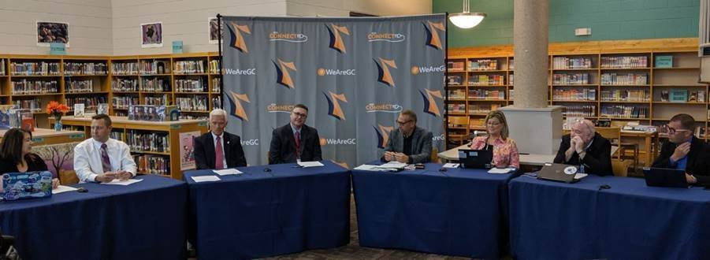

We spent a moment in remembrance of Terry Orr and the impact he had on so many of our large scale projects. His behind the scenes work over the years has played a huge role in our success. [O. Leonard “Len” Press](https://www.courier-journal.com/story/news/local/2019/08/01/kentucky-educational-television-founder-o-leonard-press-dies-97/1886741001/), Founder of KET, also passed away recently at the age of 97.

**(7:00) Grayson County Background –** We began today’s webcast with a short video depicting the revitalization/growth of the STLP program and work-based learning programs in the district. Some local Grayson County highlights were covered with emphasis on their booth at the recent Kentucky State Fair—Happy Cow/Bel Brands USA and the Clarkson Honeyfest.

 

 

Superintendent Doug Robinson talked about Rough River and Nolin Lake that brings a lot of tourism to their area. Grayson County Schools has a total of 600 full time employees and has wonderful partnerships in the surrounding communities. Also in attendance today from Grayson County Schools were:

* State Senator Stephen Meredith – Sen. Meredith joined us today for his second webcast (he also joined us from Hart County)! He will get an official “KY K-12 Edtech webcast badge of honor” whenever he attends his third webcast.
* CIO Jerrod Graybeal – Jerrod took a moment to thank Karen Lewis, their district’s PR leader, for putting the introduction video together that really shows the revitalization of the STLP program. STLP has been a big initiative at Grayson County Schools.
* Technology Integration Specialist DeeDee Webb – DeeDee feels like she has the best job in the district and still gets to go into the classrooms. She’s known as the “Google Girl” and can’t wait to see all the successes in the future.

**(12:47) EdWeek Magazine/KETS Product Standards Mention -** KY K-12 edtech was identified in a positive way in a recent Edweek Magazine article in regards to KETS product standards. The article focused on the major issues with financial management systems used across the nation and Kentucky was pointed out as a positive exception because we have standardization across the state with MUNIS and we are able to provide reports and data when requested. We often take this for granted but we are doing this extremely well in comparison to the other states. You can read the full article at <https://www.edweek.org/ew/articles/2019/07/15/gaping-holes-in-how-states-track-k-12.html>.

**(15:05) SY 2019-2020 Edtech Needs & Operational Plan Update –** This was covered in detail during our July webcast and received board approval during the August 7th KBE meeting. The next step is approval by the School Facilities Construction Commission (SFCC) at their upcoming, September 4th meeting. After this final approval, the initial KETS offers of financial assistance can begin going to districts for this school year. We are still estimating a $21/ADA offer for the school year with the first offer being $9/ADA.

**(17:14) Additional Budget Request (ABR) for KY K-12 in 2020 –** We put out a call to action for all 172 KY K-12 CIOs/edtech leaders to approach and educate their district leadership team (e.g., Supts., CFOs). This is one of KDE’s top four priorities right now for the upcoming legislative/budget session. It is important for all CIOs to talk with their Superintendent on the five items listed below. We are good stewards of our KETS funding; however, every six to eight years we reach the point where we have to request additional funding to maintain and sustain our current levels of service. It is an awesome call out to these critical areas and Jerrod commented with their need to find some additional resources or risk not being able to refresh a large number of devices.

Since 2010, the KETS allocation has been steadily reduced from $19.5M to $15.4M. Similarly, the previous and most recent budget cuts have also impacted the state’s K-12 Internet funds during a time over the past five years where there has been a 140% increase in Internet usage by our students and teachers. During the 2020 legislative session, there is a need to address the additional budget request (ABR) for the following reasons:

1. To help properly address the people side of edtech in districts so there are the right number of technicians, digital learning coaches and other basic edtech leadership responsibilities in districts (data accuracy, cybersecurity/cybersafety/cyberprivacy, strategic planning, emerging technology) that help ensure the school technology is kept reliable for students and teachers, is maximized in instruction, is cybersecure/cybersafe and is of high quality (e.g., data);
2. To address the rapid annual increase in the numbers (e.g., districts going to 1 to 1) and types of tech devices (e.g., HVAC using the Internet, phones over the Internet, school safety devices that use the Internet) and services (e.g., KY K-12 Internet bandwidth service) being used by over 750,000 KY K-12 students & adults for instructional, communication, physical safety, cybersafety and cybersecurity purposes;
3. To address the needs of schools for online daily formative testing, intermediate/quarterly testing and end of year high-stakes summative testing that provide quick feedback/results to both students and teachers;
4. To restore the significant cuts (i.e., $5M+) of over the past 10 years to the basic KY K-12 edtech funding. The legislature has provided a KETS allocation each year since the Kentucky Education Reform Act which remained at $19.5 million from SY 1992-SY 2009. Through a series of budget reductions, the KETS allocation was reduced to $15.4 million from SY2013-SY2019; and,
5. There have been zero increases to counteract the effects of inflation to KETS since 1992 which is very unrealistic if the expectation is to maintain basic high-quality services for schools and districts.

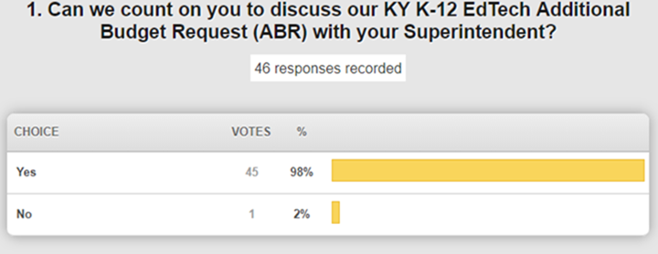

Senator Meredith commented that budget discussions with legislators and educating them is a priority in getting funding requests recognized. Using the interim before session is very valuable to get sufficient time and audience with legislators. He plans to meet with all his Superintendents prior to session to listen to their concerns and requests; he was thrilled to hear/learn that we are being recognized for our standardized financial management system.

**(29:34) Kentucky High School Athletic Association (KHSAA) eSports Update/Next Steps –** I’m always very upfront that I’m a 1000 year old dad on this subject and am not comfortable for a variety of reasons with battle/combat games being played by KY K-12 students while at their school. However, KDE leaves it up to the KHSAA and the districts to make the determination and choice of offering a sport, playing or not playing that sport in their district, and this includes eSports. Having said that, the KHSAA board of control, in July, approved eSports to be played during this next school year by KY K-12 students from their school buildings.

See following article about that meeting in the Lexington Herald: <https://www.kentucky.com/news/local/education/article232502437.html>.

The name eSports can be misleading to the average person over 30 years old, including me, because the games included in the eSports portfolio are not just traditional sports games (e.g., soccer) but also combat/battle games where the student’s digital character selects from a large variety of weapons to be used against their opponents from other KY K-12 schools during each combat/battle. None of these weapons selected and used by the students during their eSports battle/combat would normally be permitted to actually be brought into a school by a K-12 student. To me, it would be more appropriate for the name to be “eSports and battle/combat games” for those above 30 years old but they are just called eSports.

The KHSAA will work with the Center for School Safety and KDE to create communication for Superintendents, Principals, and parents that is very upfront and plain spoken about the pluses and downsides of battle/combat games being played by KY K-12 students from a KY K-12 building. KY K-12 Superintendents, Principals and parents wanting to move forward with the combat/battle games in the eSports portfolio being played by their KY K-12 students from the school will need to acknowledge in writing that they have read and understand the communication and want to proceed. A really high percentage of KY K-12 Supts are either totally unaware of what is considered an eSports game (i.e., the portfolio includes both a soccer game played with cars and a battle/combat game like League of Legends (LoL)). I felt every KY K-12 Supt I’ve spoken with in confidence on this topic sincerely didn’t know combat/battle games were part of the eSports portfolio and they didn’t know the specifics about League of Legends (LoL). A few other state’s K-12 athletic associations in other 6 other states also piloted eSports last year, so I contacted my K-12 state DOE level counterpart in another state and he experienced the same exact total lack of awareness that combat/battle games are considered eSports in a K-12 setting when he spoke with a sample of his Supts that had eSports (including LoL) being playing in x number of their districts. In stark contrast to Supts, I suspect a very high percentage of the parents of the K-12 students wanting to participate in the district’s eSports program are already very knowledgeable of what will be in the communication since their child is likely already spending lots of time playing LoL at their home and will have very little issue with signing the approval for their child to participate. The Principals are more likely to be a balanced mixture of these two extremes. Senator Meredith was also under the impression that the eSports games were sports games versus combat/battle games.

1. It is important that KHSAA eSports games are not played during core instructional hours on the KY K-12 Internet network; therefore, we will be asking and directing that all KHSAA eSports games are played within certain hours of the day (e.g., M-F, 4pm to 7 pm) and districts have the digital tools available right now to contain play to just those days of the week and hours.
2. From the cybersecurity aspect, we have to educate these battle/combat manufacturers that we cannot and will not change our cybersecurity measures in order for their game to work on our KY K-12 Internet network; Therefore, the eSports manufactures will have to change their software code so their products will work without the district or KDE having to turn off security settings so the game works.
3. The eSports team coaches in KY K-12 schools really need to closely monitor the language/behavior used by the KY K-12 students during game play and also promote good sportsmanship.
4. DDoS attacks are used by gamers. Students can and do learn how to do a DDoS attack through video gaming. Just a reminder a DDoS attack is a KY felony. If we find a KY K-12 eSports coach/student(s)/team directly or indirectly is part of launching a DDoS attacks against their opponent’s school location before/during their eSports competition to try to slow/disrupt their opponent’s KY K-12 Internet connection during the competition or because the student is/gets mad at their opponent during/after an eSports competition, then that is a cause for immediately removing that entire team & school from being permitted to use the KY K-12 Internet network to play eSports for x amount of time (e.g., 12 months, years, etc.) since DDoS attacks not only impact that one school that is attacked but also all the schools in that district and districts around the state. We will also inform the KY State Police of the DDoS attack since it is a KY felony. Each DDoS attack on KY K-12 requires lots of our OET staff time, the district’s edtech staff time and our KIH3 contract vendor staff (i.e., AT&T) time to quickly identify and fix/address the DDoS attack.  If we find DDoS attacks related to the KY K-12 eSports participants/competitions to be extremely common then it puts the entire KHSAA eSports service in jeopardy of continuing to be played from KY K-12 schools. So this needs to be a continual point of education and emphasis by the Supts, Principals and eSports coaches to their eSports K-12 students/players throughout the year since KDE will have an extremely low tolerance of DDoS attacks launched by KY K-12 eSports participants on their opponent’s eSports students/teams/schools.
5. It’s our understanding that the KHSAA eSports season starts in the 2020 spring timeframe. The eSports communication discussed briefly above that will be going to Supts, Principals and parents is in the very early stages of being developed. We will continue to keep you posted.

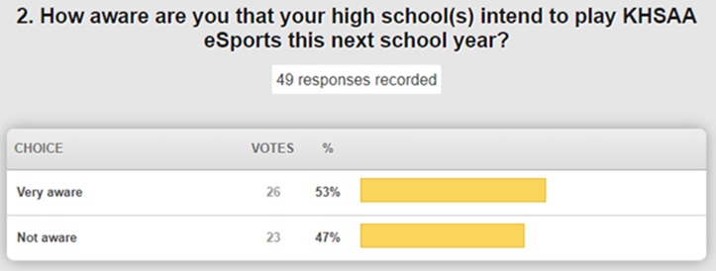

We also identified some of the plus sides we’ve been told on why eSports K-12 students, eSports K-12 coaches and the school’s athletic directors signed up for KHSAA eSports and battle/combat games to be played last year by their KY K-12 students from their K-12 building (e.g., K-12 students must truly work as a team for their school be successful/win in a battle/combat against another school’s eSports team, the battle/combat games requires lots of tactical strategy/savviness, combat/battle games like LoL require lots of time to be spent playing them in order to be competitive in a competition, which means K-12 students that are wanting to be part of their school’s eSports team have to already be spending lots and lots of time outside the school at home honing their combat/battle skills in LoL; so the parents are most likely fine with their child also playing eSports like LoL as part of a KY K-12 school team, eSports like battle/combat games allows a K-12 student who is not into sports all at or any other extracurricular school activity but spends a lot of time outside of school getting very skilled at combat/battle games to be part of school team and thus have a connection with the school that they might not normally wouldn’t have with the school, certain colleges offer financial aid to their higher ed students to come to their college so that higher ed student can play and compete for cash prices for that college in eSports League of Legends competitions, can potentially become a professional in eSports of battle/combat games to make money and there are a growing number of professional competitions and size of purses in eSports competitions is also growing, etc.).

Below is a list of the KY K-12 schools who had KHSAA eSports teams last school year and the number of eSports teams that the school had:

|  |  |  |  |  |  |  |  |  |  |  |  |  |  |  |  |  |  |  |  |  |  |  |  |  |  |  |  |  |  |  |  |  |  |  |  |  |  |  |  |  |  |  |  |  |  |  |  |  |  |  |  |  |  |  |  |  |  |  |  |  |  |  |  |  |  |  |
| --- | --- | --- | --- | --- | --- | --- | --- | --- | --- | --- | --- | --- | --- | --- | --- | --- | --- | --- | --- | --- | --- | --- | --- | --- | --- | --- | --- | --- | --- | --- | --- | --- | --- | --- | --- | --- | --- | --- | --- | --- | --- | --- | --- | --- | --- | --- | --- | --- | --- | --- | --- | --- | --- | --- | --- | --- | --- | --- | --- | --- | --- | --- | --- | --- | --- | --- |
| |  | | --- | | **School Name** | | Bourbon County High School | 1 | | Boyle County High School | 2 | | Central Hardin High School | 1 | | Central High School Magnet | 1 | | Christian County High School | 1 | | Dayton High School | 1 | | Doss High School | 1 | | Eastern High School | 2 | | Elizabethtown High School | 1 | | Fairdale High School | 1 | | Garrard County High School | 1 | | Graves County High School | 2 | | Green County High School | 2 | | Greenup County High School | 1 | | Henry Clay High School | 2 | | John Hardin High School | 1 | | Johnson Central High School | 4 | | Lafayette High School | 1 | | Lincoln County High School | 1 | | Marion County Knight Academy | 1 | | Martha Layne Collins High School | 1 | | McCracken County High School | 2 | | Model Laboratory High School | 1 | | Murray High School | 1 | | Nelson County High School | 3 | | Rockcastle County High School | 2 | | Scott County High School | 3 | | Thomas Nelson High School | 1 | | Warren Central High School | 3 | | Wayne County High School | 2 | | Williamsburg City School | 1 | | Wolfe County High School | 3 | |  |

 **(40:49) SB1 and School Safety Update –** With the passage of SB1, KY’s Homeland Security was tasked with developing and implementing an anonymous reporting tool (text, voice, e-mail) for this upcoming school year. This is in process--they are collecting up to 6 points of contact per school and posters are being distributed to all schools. KDE is working in collaboration with the Center for School Safety and Homeland Security on this initiative. The main method of communication is anticipated to be texting. The application is in place and they are working to build the points of contact for notification purposes in regard to school safety issues.

**(42:39) KY K-12 School Report Card Update -** The upcoming release of the KY K-12 school report card is expected early this fall. With the new accountability model, a lot of the focus will be on accountability and the new accountability dashboard.

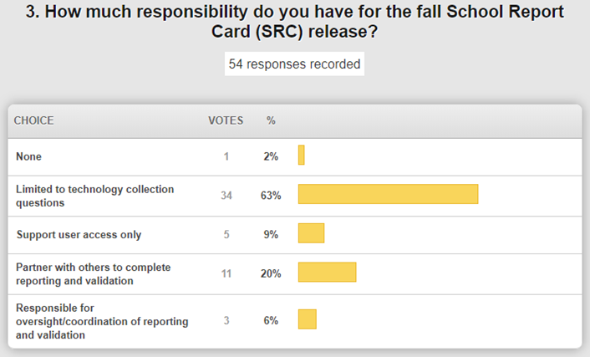

There is variation in CIO levels of involvement. This is the last week of the collection tool being open and we have 800 schools that still have not entered the technology data. The other areas of the collection tool are also due in order to prepare the School Profile Report. You still have through mid-September to validate and review the data before the School Profile Report is due October 1st.  Print and leave time to get SBDM, Principal and Superintendent signatures before the due date. If you just want to monitor, use the download function to see what’s been entered and do some spot checking.

Next week is the deadline for Overview, Educational Opportunity (includes dual credit data —NEW!!) and Transition Readiness (Transition to Adult Life) data review and approval. If you do make a change in Infinite Campus during your review process, please make the KDE data point of contact aware; updating is not an automated process; the files have to be rerun and published to refresh. The next step to SRC release is the Accountability data and that review is done on the QC Day—it will be announced soon.  After that day, the data will be refreshed and we enter the embargo period before it goes public in late September or October.

The Digital Readiness Survey was the previous method for the collection of those ten technology questions, but this method allows us to drill down and get more specifics at the school level. We will be evaluating for accuracy. Jerrod commented that he allows the schools to enter their data and then he provides the review and leads any needed discussions or corrections.

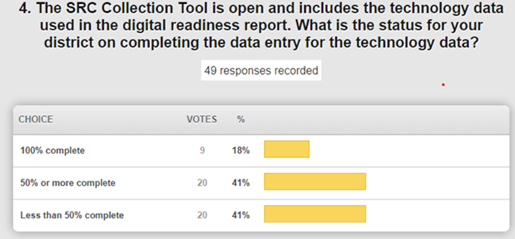

There is still a lot of work to be done! This Friday is a soft close, but please try to get this entered/completed.  Our field staff will be reaching out if we see discrepancies or need to perform some follow-up.

**(53:04) KY K-12 Digital Readiness Report (DRR)/Technology Activity Report (TAR) -** The Digital Readiness Report tool will be open until the end of September and now more closely aligns with the School Report Card data collection. As data stewards for this work, our field staff will be performing the review function for a few weeks after September 30th. There are some new questions this year for computer science and the leadership perspective. The TAR is due in this same timeframe, but must be in before a KETS offer is formally made to a district. These data help us confirm KY K-12 tech needs for upcoming legislative session and for the KBE.

**(57:14) KY K-12 Internet Services, Switch Upgrades and Firewalls Update –** Phil Coleman joined us remotely from Frankfort and provided updates on the following:

* The switch replacement project is a little bit behind, but we feel comfortable that these will still be complete by the end of the calendar year.
* There has been a firewall issue with three of our districts and we appreciate their patience as we have worked through the resolution testing. Once we feel comfortable that the root cause and resolution are in place, we will move forward in implementing across all firewalls.
* As expected, there has been an increase in cyberattacks since the beginning of the school year and we have been able to mitigate those.
* AT&T is involved in a workers’ strike; we are talking with them to ensure that we have our critical services covered throughout this situation. (The strike was resolved the day after our webcast).

**(1:02:07) KY K-12 Cybersecurity Update -** In 2018 we were getting several hundred Distributed Denial of Service (DDoS) attacks. These attacks take up more pipe-space than we can handle on our K-12 network. We work diligently to mitigate these attacks quickly to minimize network unavailability. Proper filtering and patching is important and also helps minimize the impact of these attacks. It is also important for our student population to know that initiating a DDoS attack is a felony; we see a spike in this activity during the initial back-to-school period and during online testing windows.

Digital citizenship and requiring the digital driver license is important. We are launching the [Kentucky Digital Citizenship Academy](https://sites.google.com/warren.kyschools.us/kydigcitacademy/home). The first Academy is being hosted by Warren County on September 12th and we encourage you to register for that. Learning how to be a good digital citizen by our students, parents, and teacher is of great value and worth the investment.

You have about three working days left to get your data system security survey (a/k/a annual cybersecurity healthcheck information for your district) to your local board.

In the May webcast we asked about an implementation timeline for implementing a password policy. Most responses and feedback were on board for the October timeframe. This isn’t just about security; we are pushing toward a better user experience overall. Having a more secure password is really just the first step. We are moving to the usage of passphrases made up of a minimum of 15 characters for staff. We are also looking at a variety of ways to strengthen our network that are NOT replacements for passwords, but all work toward a better, safer user experience. More information will be shared out before the October timeframe.

**(1:19:11) KY K-12 Contracts Update –** Mike Leadingham provided the following updates:

* Educator Licensure and Ethics System – Request for Information (RFI) responses have come in and we will begin preparing a Request for Proposal (RFP) that will take several months to complete. This new system will replace several applications that are aging and unsupported. This has been discussed with other state CIOs and we have some other states to look to that are currently or have recently gone through this process.
* Lightspeed – We had a forecasting and strategy meeting with them yesterday. They will be providing more information and direction to us as we continue to move forward. Contractually, we will likely be making some adjustments to this state shared service. Our field staff will keep you in the loop as we continue this work.
* Phone system contracts will NOT be renewed as discussed during the past few webcasts. A best practice/guidelines document is being prepared for you in regard to these services.
* Responses on the FCC proposed rulemaking on behalf of KY K-12 are complete. One of those was on the funding cap where we responded that we felt like that the funding for E-rate should remain separate from other programs. We also provided a response to the category 2 funding proposed rulemaking and are supportive of this model but made some suggested improvements. September 3rd is the last day for responses.

**(1:26:25) Home Access Inquiry -** KY K-12 is first in the nation to connect all school districts via high speed to the Internet in 1995 and the first to connect all its schools to the Internet not long after that. Our K-12 students with a smartphone and Internet access via wired and/or wireless at their home is better than the national average. ***What are some possible explanations?*** We know that our data is not 100% perfect, but we want to look at why our numbers are significantly higher in KY than the national average. Some of the basis may be the longevity and number of years that we have had Internet access and Wi-Fi availability in our KY K-12 schools. This was posed as a discussion question and we will be reviewing the responses and having further discussion.

**(1:29:19) KY K-12 Computer science, STLP, Tech standards and Computer Science & IT Academy –**

* We have really engaged in computer science growth and the increasing number of computer science positions available across the commonwealth. A national report by code.org will be released soon and we will see some significant growth measures across Kentucky in computer science. We have many initiatives beginning to align that are assisting in bringing this growth and we are developing a comprehensive computer science plan to continue that growth. We are also relaunching the Computer Science and IT Academy and it is targeting ***all*** computer science pathways. We are working to remove barriers; this will also include teacher certifications. Laura Raganas and Ben Maynard are leading this effort right now and bringing a team approach.
* STLP is adding a new regional event due to the growth in this area of the state. This will be in Owensboro and the growth has raised the need to host a second event. Let’s pack that house!
* The Kentucky academic standards for technology group has been doing an awesome job and these standards will be going out for public comment very soon.  These are standards to meet the technology competencies as part of the minimum graduation requirements.

**Other Items:**

* Infinite Campus - Trainings are coming up soon! Please visit the [KSIS Training page](https://education.ky.gov/districts/tech/sis/Pages/KSIS-Training.aspx) and help us get the word out.