**Summary of the May Webcast for KY K-12 Education**

**Technology Leaders from the 300 Building, Frankfort**

**In case you missed it or want a refresher, the following is what we talked about during the May 21, 2019 webcast from the 300 Building in Frankfort.**

Access the digital video and audio copy for this webcast through our webpage at:

https://mediaportal.education.ky.gov/technology/district-technology-leadership-webcast/2019/05/edtech-may-2019/

Public viewing of the archived webcasts and written summaries are also available on the KDE Media Portal at:

<http://mediaportal.education.ky.gov/>. Numbers in **RED** indicate the timestamp for that portion of the discussion so it can be easily located on the full digital recording.

In attendance from KDE’s Office of Education Technology were David Couch, Mike Leadingham, Robert Hackworth and Chuck Austin. Linda Burton and Marty Park joined in as well. There were several GoSoapBox questions posed during today’s webcast along with a few discussion questions that participants responded to throughout the webcast.

**(01:03) KY K-12 Cybersafety and Cybersecurity -** Cybersafety and cybersecurity have always been on our radar but we are seeing some major issues in K-12 nationwide. Cybersecurity attacks have grown in numbers and sophistication with Kentucky experiencing over 4 billion attacks per year. What we are finding is that cyber criminals are taking advantage of our service-oriented nature and they are finding and exploiting these weaknesses. We are experiencing a cybersecurity tsunami and everyone has to step up and be part of the solution.

In the past few months we have had several incidents and cyber criminals are seeing success with the majority of it being aimed at the human aspect. Some examples are:

1. We saw a district who was potentially tricked out of millions of dollars through a very simple communication where someone pretended to be a vendor and redirected funds. Attackers are using our process-oriented environment and transparency to have access to details that make them knowledgeable and credible.
2. Another good example of a bad situation is a district that had a brute force attack to a high-level account. A brute force attack is a trial-and-error method used to obtain information such as a user password.
3. We are also seeing that employee direct deposits are being scammed; they are attempting to change the account information for the direct deposit. Old account information is not being verified and this allows the cyber-criminal to make this redirect.
4. One last example is the Itunes gift card scam. Emails are being sent that appear to have come from a Superintendent or high level school official with instructions for them to purchase gift cards and send the authorization codes.

So, what can we do? Dialog has to happen at ALL levels and we have to ratchet up our security best practices. The best strategy is to not underestimate the power of educating your audience. Other solutions may require more time or take away some of the convenience. We discussed this at our recent CIO Summit and a few of the best practices we are evaluating are:

* Requiring additional verification or a face to face/voice to voice request may be necessary
* One-Pager of “it can happen to you, but don’t let it”; this has been distributed and updated multiple times
* Password Access Control – There are several items included in up’ing our password game:
  + Making minimum requirements for passwords,
  + Account threshold lock-outs,
  + Self-service password reset (SSPR),
  + Multi-factor Authentication (MFA) – especially for accounts that have higher-level permissions,
  + Password complexity using passphrases. Over 15 characters is preferred. This is where KDE is headed and where we recommend our districts move toward. Passphrases don’t have to be changed as often and they are much more secure.
  + Single sign-on capability for major applications housing secure data, like Infinite Campus (IC), will be part of a three-prong approach along with SSPR and MFA moving forward.

We will continue to share this information out to you through the field staff. It will make it easier for the employee to help themselves while making it more difficult, from a technology perspective, for a cyber attack. Our highest risk right now is for our staff accounts versus our student accounts.

There is a sense of urgency for districts to move to SSPR. There is some thought, some planning, and a logical order of implementation for the greatest success. The upcoming annual cyber healthcheck is an excellent time to discuss this with your local board and inform them of these needed security strategies.

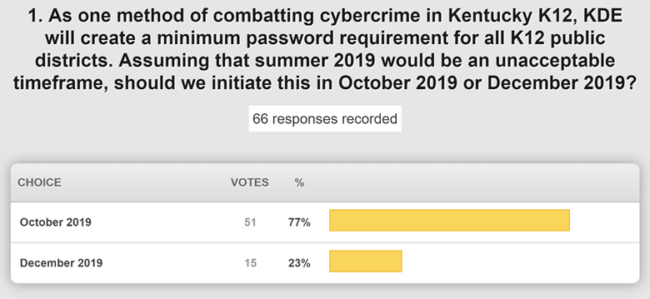

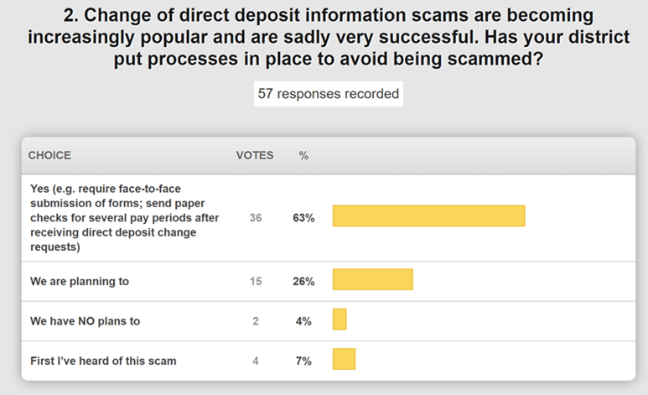

This is great information that will be helpful as we work with our Office of Finance & Operations (OFO) on a communication to our superintendents and finance officers.

**(35:11) KY K-12 School Report Card (SRC) Update -** The School Report Card now has a new finance tab that was released two weeks ago; this will be the last added feature for the 2017-2018 SRC. It also provides a new compare tool that allows district to compare up to four organizations and has received much praise and positive feedback. Keep in mind that financial data is very complex and this is just one small part of the whole school story. We are working with BrightBytes on providing an explanation and directing the person looking at the data to use it to spark productive conversations with local school and district leaders. The four components to the SRC can be found at [raisethebar.education.ky.gov](https://openhouse.education.ky.gov/src).

**(37:29) Online Testing Update -** This is a good story! The operational test has gone very well and been administered to over 73,000 students with minimal roadblocks. The online dictionary access issue was isolated and resolved. The windows patch is not an issue, but happening during the assessment window can present issues. One district has had a unique situation; however, Pearson is responding to all situations very timely. The operational test goes through the June 7th testing window. We are confident but still need to continue to hear from you and receive your feedback.

**(40:22)** **Windows 7 Urgent Patch Update -** While we are very sensitive to moratoriums and the online testing windows, the vulnerabilities/threat level for the patch to this older operating system led us to implement the patch without delay. It was pushed out after testing was completed in conjunction with Pearson and we haven’t been made aware of any major problems. The next normal patch cycle is scheduled for June 10th and this is after the testing window closes. We still have 70,000+ machines with this operating system that goes end-of-life in January 2020.

**(43:19) Budget Request for 2020 Legislative Session Update –** Within the department, we are working to compile a list of additional budget requests that will be considered and prioritized by our board. If our board approves and moves our request forward during the budget/legislative process, it is still a lengthy process. We have prepared a request of $30M for KETS during 2020 legislative session to (a) increase the financial offers of assistance to school districts to buy student/teacher devices and other school technology, (b) better address the people side of KY K-12 edtech in school districts (techs, digital learning coaches, security, data leaders), (c) increase Internet bandwidth for schools to address the growth of # of devices and their video/audio consumption in the classroom, (d) basic cost of living increases that haven’t been addressed since 1992 and (e) restore $6M edtech cuts for schools since 2008.

This $30M request is a $14.7M increase from our current appropriation of $15.3M. This appropriation began in 1992 at $19.5M and was decreased through subsequent budget cuts. We have reached a point where we need the additional funding as outlined above. If we don’t address this during the upcoming budget session, we will have to begin having those hard discussions on how we move forward. Key district leaders delivering this message to local/legislative leaders makes a profound difference.

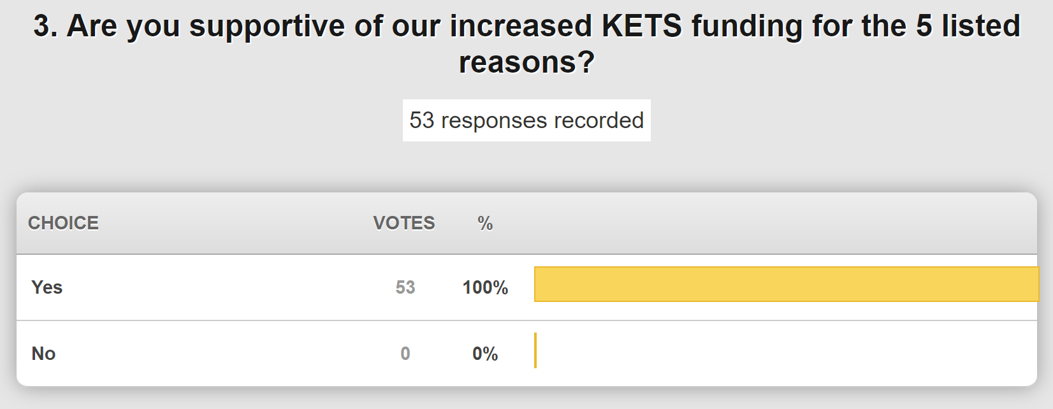

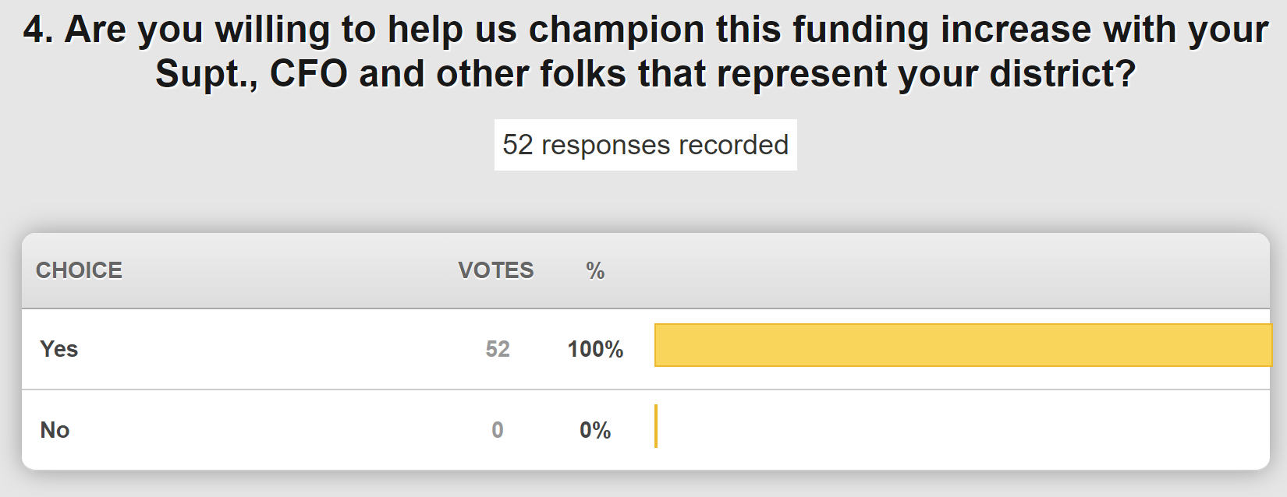

**(49:47) STLP Update -** Every year we face some big challenges with our state championship and we are the single largest one-day event held at Rupp Arena. We had to pick the date for next year and were given three options. None of the options were optimum and there were many things to take into consideration. Next year’s STLP State Championship will be April 8, 2020. The down side of this particular option is that we know we do have districts scheduled on Spring Break during this week. If your district has selected this week for Spring Break, as other have in the past--you may still participate in the championship event, but we realize that it makes it more challenging.

**(53:40) KY K-12 Edtech Academic Standards Update -** Our academic standards for technology team met three weeks ago for the first time. There were 30 folks from all across the state in this meeting and there has been another online meeting. We plan to move quickly and have draft standards out for review. We are leveraging work done by ISTE and other states as well. These are directly tied into the technology competencies as part of the minimum graduation requirements. We are also moving forward with the library media framework that is tied to the standards.

We spend a lot of time focusing on and pushing the people side of things forward and we have several events coming up to support this:

1. East Region Association of Technology Coordinators (ERATC) Retreat
2. Innovations for Learning (IFL) in Fayette County
3. KyGoDigital regional events happening across the state and online

We have an integrated calendar of summer digital leadership and learning events prepared for you at <https://education.ky.gov/school/diglrn/Pages/default.aspx>.

**(57:53) KETSView and KY K-12 Internet Health Update -** We have a new version of KETSView launched on April 9th. We are still maintaining a 99.999 uptime during instructional time. In the past two to three weeks we have experienced several fiber cuts and we are working with AT&T on how we can recover from these unintentional outages more efficiently. Phil reported on our average bandwidth usage and our DDoS protection. We have had 114 DDoS attacks since January 1 of this year (through March) while we had only 118 ALL of last year. Mitigation brought the total network impact down to 7 hours and we continue to work on the time to mitigation as well. These are just a few layers of our network security.

**(1:01:52) KY K-12 Internet Services to School Districts through the KIH3 -** We wanted to take a few minutes to provide some key points in regard to our KY K-12 Internet services:

1. The KIH3 contract is paid monthly by KDE to the KIH3 vendor. That vendor then makes payments to the 14 participating Telco’s for both the middle mile network and the last mile to every KIH3 Internet hub at the school district.
2. Whenever we have completed KIH bids, we look for vendors who are capable of providing high quality, high capacity and extremely reliable Internet services. We have 750,000 users while the rest of state government combined have 30,000. We are also power users of video and audio, so we consume more bandwidth. K-12 is also a national leader in cloud based computing and we must have a stable network.
3. Another key component of a KIH bid is that we ensure it is awarded to an E-rate eligible vendor. This keeps us from risking the loss of up to $800M if we utilize non E-rate eligible vendors; this directly impacts your education technology needs and budgets.
4. The last item is in regard to easements. Easements must be approved by KDE and it requires the local district board approval. This is all BEFORE someone comes onto your district property. If someone attempts to come onto your property to install anything without obtaining these easement rights and not following the proper process, the quick answer should be NO. Please contact your field staff and keep them in the loop if this should occur.

**(1:09:26) Upcoming RFIs; RFPs; and Approaches for Edtech Products, Services and Contracts -** We have several items to discuss and provide updates on under this umbrella:

* Out of band management solution – We are moving on this soon to implement a replacement; we anticipate districts being able to remove a line that currently maintained and it may result in a small saving.
* Switch replacements for the district hub is in motion and that is being transitioned to a service
* Active directory/Infrastructure – We are working on this initiative and haven’t decided fully how that will progress
* Kentucky Education Certification and Ethics System – This is a big initiative for KDE to put all the functions under one common umbrella. It is officially underway and the first steps are to complete an RFI. We also want to leverage data interoperability of this as we proceed.
* Voice contracts/services – There are several possible scenarios we are evaluating: eliminate contracts and move to guidelines and standards; establish new contracts; and/or utilize existing contracts and existing services. We need to verify results of the district survey as we work through and compare these scenarios. It is possible that we have a special webcast on this topic.
* SHI Contract – If you are having or have had any issues with this contract, please make your field staff aware of this.
* Getronics – Pomeroy was acquired by Getronics. There have been some issues and Dell has assumed responsibility for filling their orders and they plan to name a new partner. We will keep you informed and we assume that Dell is communicating directly with customers.
* Tariff Issues/Awareness – The recent tariffs could result in pricing changes; our vendors normally try to absorb these but it could impact districts.
* District with ATCs - We are verifying that we capture all classrooms so expect a conversation with your field staff representative.
* Annual Vendor Partner Meeting – We are scheduling our annual vendor partner meeting; we expect to have a date for this interactive, online meeting very soon. Please submit any agenda suggestions to Jessica Burton.

**(1:19:52) Annual Infinite Campus Renewal –** Invoices have been sent out and those renewals are due no later than August 15th. We discussed the following poll question:

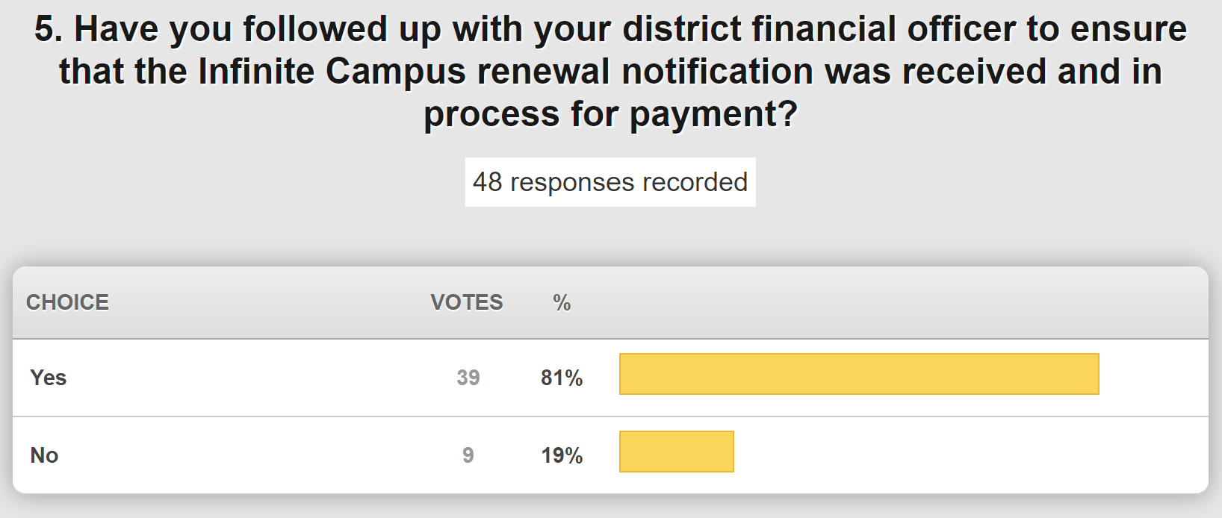

Thanks for joining us today. We will still have our June and July webcasts for those of you who plan to join in. Good luck as you close out the school year and have a great summer!

Social Q&A