**Summary of the February Webcast for KY K-12 Education**

**Technology Leaders from Franklin County**

**In case you missed it or want a refresher, the following is what we talked about during the February 19, 2019 webcast from Franklin County’s Career and Technical Center.**

Access the digital video and audio copy for this webcast through our webpage at:

<https://mediaportal.education.ky.gov/technology/district-technology-leadership-webcast/>

Public viewing of the archived webcasts and written summaries are also available on the KDE Media Portal at:

<http://mediaportal.education.ky.gov/>. Numbers in **RED** indicate the timestamp for that portion of the discussion so it can be easily located on the full digital recording.

In attendance from KDE’s Office of Education Technology were David Couch, Mike Leadingham, Chuck Austin, Marty Park and DeDe Conner. Damon Jackey, KETS Regional Engineer, Bob Hackworth, Lisa Moore and KET staff members joined us on-site today along with the Franklin County staff members. Back at the Frankfort location Phil Coleman was joining the webcast. There were several GoSoapBox questions posed during the webcast.

**(2:22) Franklin County Edtech Highlights –** Superintendent Mark Kopp is in his second year as Superintendent at Franklin County Schools and they are doing some great things. Franklin County staff joining the webcast were:

Jimmy Pack, Director of Technology

Dr. Jim Masters, Director of Curriculum & Instruction

John Sanders, Principal of the [Franklin County Career & Technical Center](http://www.franklin.kyschools.us/franklincountycareerandtechnicalcenter_home.aspx)

The Franklin County Career and Technical Center is expanding students’ offerings and this is John’s first year as Principal. Franklin County is the 22nd largest district in the state and Jimmy Pack is doing a great job in maximizing the use/integration of technology. Stella Pollard is also a recent addition to the district as Franklin County’s Instructional Technology Coordinator; she is helping with the Chromebook implementation. The 1:1 implementation is currently for the 3 – 12 grade students and that is over 6,000 devices.

A few recent district highlights:

1. Western Hills High School’s Wandale Robinson was named Mr. Football and signed with Nebraska’s college football program.
2. Fifth grade teacher Angie Beavin teaches at Peaks Mill Elementary and was recently awarded the [Milken Educator Award](https://www.milkeneducatorawards.org/newsroom/press-releases/view/ky-teacher-angie-beavin-receives-25000-milken-educator-award).  This is a $25000 unrestricted cash prize. She is the only Milken Educator Award winner from Kentucky this year, and is among the 33 honorees nationally.

Franklin County is all about creating opportunities for students and they have created an alternative high school pathway—the William Cofield High School. They wanted to provide a pathway for students needing a different setting that still meets all the attendance and completion requirements. It began in October with 36 students; 15 students have already graduated. It is not about being easier, just different. Jim Masters is the principal of this school and he believes this environment provides the flexibility needed while meeting the needs of the non-traditional student. Abby, a student who has attended more than 15 schools, shared her story and how William Cofield High School helped her succeed.

**(18:45) Kentucky Educational Television (KET) -** Tonya Crum and Tim Bischoff of KET joined us today to talk about several KET projects and initiatives:

1. KET recently aired **School Safety: A KET Forum**, hosted by Renee Shaw. There are additional KET air dates or you can view it at <https://www.ket.org/episode/KJGAP_000104/>. School safety is at the forefront of our current legislative session and it is also a national concern. Parental involvement and engagement is one of the most important factors and the episode stresses the people side versus a technology solution.
2. Tonya shared information regarding PBS Learning Media and how this repository is currently being used by our teachers and shared through KET’s Education Consultants. Franklin County is consistently one of the top 20 users. The education consultants can provide many resources and educational opportunities to our teachers and students.
3. The KET Media Lab provides several media arts workshops and had over 3000 students in last year. Grant funds are available to provide reimbursement for transportation costs. You can apply at <http://KET.org/medialabform>.
4. Tim talked about some big changes at KET that we don’t see! One of those is the FCC broadcast spectrum repacking. This is a congressionally mandated project and it means that stations will be adding more channels. All 16 of KET’s transmitters are being reassigned to new channels. He shared information regarding KET’s Broadcast Network and how this repacking will upgrade services and the tower modifications/reinforcements that are also being completed. It will also require the installation of new transmitters along with the associated transmission lines and antennas. Tim shared the schedule and what will need to be done locally to optimize use. <https://tinyurl.com/KETrepack>
5. KET is celebrating 50 years of service to the Commonwealth! We are also very excited to announce there will be live coverage at the upcoming STLP State Championship event in Lexington on April 18, 2019 at Rupp Arena.

**(44:11) 1.0 of the KY K-12 online School Report Card (SRC) gets an A -**  The new School Report Card is receiving good reviews with crucial information readily available on the landing page. [Kentucky School Talk](https://kentuckyschooltalk.org/2019/01/kentucky-upgraded-its-ancient-school-report-card-site-youre-going-to-love-it/), and [Prichard Committee for Academic Excellence](http://prichardcommittee.org/new-school-report-cards-big-upgrade-still-with-some-challenges/) have both written very positive reviews on the initial release. Work is ongoing and we are soliciting feedback from users and various user groups. The next iteration of the School Report (Version 2.0) is underway and it will focus on school finance data. A survey is open and available through the end of January to provide feedback. Please update your district website to the new School Report Card. The School Report Card is more than the BrightBytes piece so it’s important to keep all portions updated and accessible. Effective and intentional communication is key to notify parents and there are many ways to share that information. The Infinite Campus Parent Portal is an integral part of the overall report card and an excellent way to keep parents engaged.

**(57:31) KY K-12’s Active Directory services in KY K-12 edtech schools going forward** – Chuck Austin spent a few minutes discussing the importance of Active Directory in KY K-12 regardless of whether they are using Microsoft or Google services. We have several planes on the runway that have to be maintained and/or upgraded to continue to provide quality services. Active Directory, in its simplest form, is a technology system that defines who you are, what you have access to, and under what conditions. There is a lot more behind the scenes that most people don’t see and regardless of what platform you are using, is needed. Some users use active directory for even more services and that is where we are headed; we all have access to “stuff” and active directory will allow us to login and gain access using the same user name/password. One set of credentials and one password to leverage for everything! The goal of the upgrade is to improve the overall user experience while building in some efficiencies and security measures. We have a representative from every region identified to work with us on this through an advisory committee and more details will be coming soon.

**(1:08:17) KY K-12 edtech and KY K-12 Telehealth work group –** KDE has been included and part of the telehealth committee meetings. Lisa Moore, Andy Liaupsin, and Megan Osborn have been the representatives from OET and there were two primary points—1) the potential impact on bandwidth, and 2) the importance of product standardization. Damon Jackey and Bob Hackworth has also been included in some of the working sessions and security discussions. Lisa provided an update from the recent board and advisory meetings. Some of the aspects of the telehealth legislation passed in the 2018 session will go into effect on July 1, 2019.  One of those is the ability to receive reimbursement for telehealth services; this will likely increase the number of telehealth services provided at the school level for students and staff. There is no standardization of software so the provider(s) will be responsible for the software selection as well as the security considerations and records retention schedules. We are working on a guidance document to provide some information and resources to all the positions that we will provide to you through the field staff. Keep in mind that these services will take place during instructional time and have the potential to impact bandwidth needs. There are also facilities issues/needs to be considered along with a host of other considerations that we will try to capture for you as you talk with school and district leaders in preparing for telehealth services.

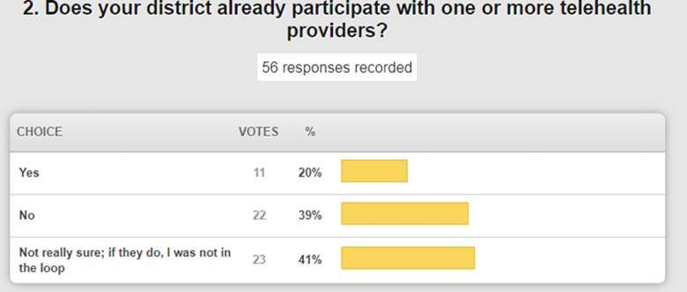

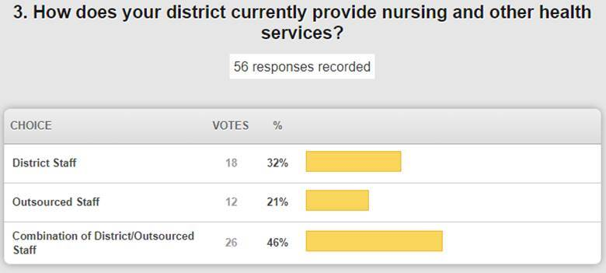

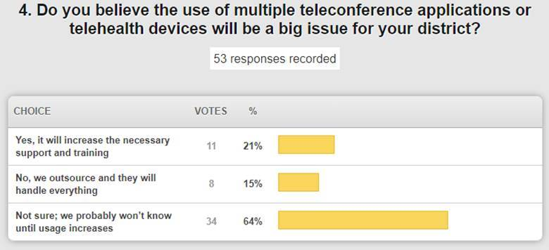

**(1:19:37) Computer Science Standards Update –** The standards are now live on the KDE website for Kentucky Academic Standards for Computer Science. The standards have completed the full approval process and they are K-12, elective standards. There is a traditional PDF document but there is also an interactive form; both are available at <https://education.ky.gov/curriculum/conpro/cs/Pages/default.aspx>

**(1:21:28) Technology (Academic) Standards Update –** We are now ramping up for the work on the technology standards. The teacher application to be on the writing team was sent out through a press release last week. These are different from the computer science academic standards in that these are academic standards for using technologies or digital tools for learning. Revision/writing will start in early April. The Kentucky Academic Standards for Technology are referenced in the proposed graduation requirements.

**(1:22:47) STLP Updates –**

* STLP regional, virtual make-up was amazing! We worked with well over 300 students in about 3 hours one day last week. Students did an awesome job and we had to get creative – but it worked REALLY well!
* STLP State Championship – This event is April 18, 2019, at Rupp Arena in Lexington. We are expecting another record breaking event.

**(1:24:18) Edtech topics for the KY K-12 CIO Summit at KySTE on March 13th -** The KY K-12 CIO Summit provides the best opportunity for OET and districts to get focused feedback on pressing hot topics from a high percentage of district representatives at the same time from a variety of perspectives as districts are intentionally grouped together in tables with their peers from other parts of the state. We typically select topics for the Summit that have a sense of urgency to have an identified statewide approach within the next 3-12 months. Given this statewide approach could positively or negatively impact every district, we want to hear the plusses and minuses from as many districts as possible before we make a decision on whether to move forward or not…and if we do move forward what needs to be considered with the understanding that we most likely will not make every district extremely happy.

For example in year’s past, OET used the CIO to get final feedback before moving forward with (a) creating and finalizing the people side of KY K-12 edtech approach that we use now talk from, (b) the concept of adding Google e-mail as a KY K-12 edtech product standard and (c) new KY K-12 edtech contracts that should be added in the future (e.g., cloud based voice/phone and cloud based printing services), etc. Based upon the feedback that we received from all 173 district CIOs/edtech leaders, all OET employees, the KDE offices and KySTE leadership, we have identified the following areas as having the most pressing need in calendar year 2019 and a good fit for the format of a CIO Summit.

OET identified five topics for consideration at the Summit. Given the time limits of the Summit, we’ll only be able to discuss 2-3 of these topics. Webcast viewers were asked to identify their 1st and 2nd choice of topics from the list of five topics below:

1. Cybersecurity:

* KY K-12’s virus software/service approach going forward.
* KY K-12’s approach to have high quality passwords going forward.
* KY K-12’s approach to stagnant accounts going forward.
* KY K-12’s approach to reduce the success of phishing attacks

1. School Safety:

* School safety equipment/tools (e.g., security cameras, anonymous reporting system, etc.):  Standardization, bids, volume pricing, access of law enforcement and others to cameras.
* Having security without sacrificing data privacy. (e.g., SROs access to data systems, SROs/law enforcement access to security cameras, etc.).
* Pressures, challenges, risks and responsibilities of districts, parents and the behavior of their children while using a variety of technologies (e.g., personal Smartphones/computers, personal social networks, school computer, etc.) at home.

1. People Side of KY K-12 edtech approach has 6 pillars of edtech leadership that someone in a district needs to be overall responsible for. That someone may be 1 person or up to 6 different people in the district.   In certain districts, the district CIO has the primary edtech responsibility for each of the 6 pillars for their district. However in other districts, the main point of contact for edtech in the district may only have overall responsibility for 1 pillar (e.g., daily operations) of those 6 pillars; with the other 5 pillars being spread to at least one other person or no one.

* What should the approach be for district CIOs/edtech leaders to identify to OET (a) who has primary responsibility each of those 6 roles for their district or (b) that no one has been identified to have primary responsibility for x of those 6 roles for their district?
* What should the approach be to bring to the Superintendent’s attention that x number of these 6 roles don’t have an identified leader for the district and the consequences of the lack of someone leading that pillar for their district?  Should it be automatically assumed that the Supt. is filling any of those 6 roles if no one is identified?
* What should OET’s approach be to interact and communicate with the right person in the district that has the primary responsibility for each of those 6 pillars if the primary responsibility for those 6 pillars is spread amongst more than one person in a district?

1. Online testing readiness in KY K-12: Formative, interim and formative online testing in 2019.

1. Best ways to address and get Computer Science going in KY K-12 over the next 1-3 years.

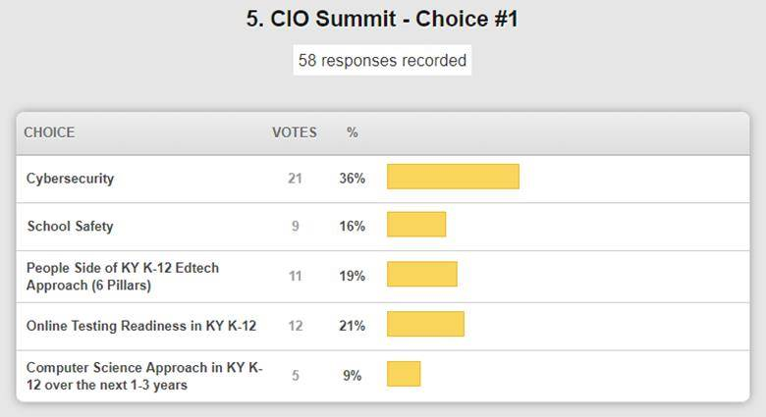

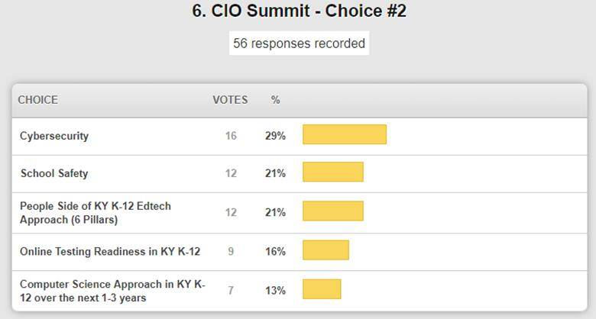

We appreciate your feedback and we will use this to put together a final agenda. Registration will be open soon and we hope you will be able to join us on March 13th!

**(1:25:50) Civil Rights Data Collection (CRDC) Update –** The CRDC data collection begins on February 25th. See the [KSIS CRDC webpage](https://education.ky.gov/districts/tech/sis/Pages/KY-CRDC.aspx) for the latest information and helpful resources. It does have to be collected from every school and it is a comprehensive federal collection. KDE has pre-loaded the information we have available on behalf of the schools/districts, but we do need data reviewed and validated.

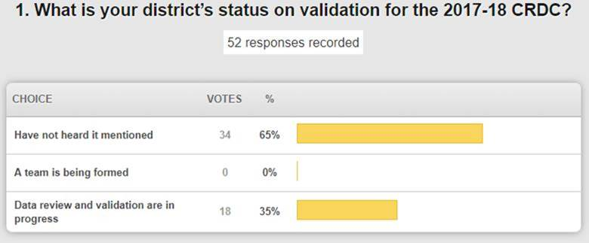

**(1:28:07)** [**Disclosing Student Information During School Emergencies: A Primer for Schools**](https://fpf.org/wp-content/uploads/2018/12/FERPA-Health-Safety-FAQ.pdf) **–** This is a paper published by the Future of Privacy Forum providing guidance to schools on balancing safety measures with privacy protections. The document describes schools’ obligations under FERPA and best practices to help decide when and what to disclose.

**(1:29:14) Other Updates –**

* All KY K-12 Technology Activity Reports (TAR) Submitted
* 1st KETS Offer of Assistance
  + 3rd memo processed for 8 districts 1/4/19 (included with 2nd memo for 2nd Offer of Assistance).
* 2nd KETS Offer of Assistance
  + 1st memo processed for 164 districts 1/4/19
  + 2nd memo processed for 8 districts 1/4/19 (included with 3rd memo for 1st Offer of Assistance)
* 3rd KETS Offer of Assistance March/April
* E-rate Category 2 funding requests
  + The FCC budget-based approach of allocating Category 2 funding provides eligibility of up to $150 per student (pre e-rate discount) to be applied for over a 5 year period.
  + Districts should be tracking and prepared to complete eligible services they identified were needed at schools which took advantage of available expanded Category 2 funding (networking equipment, wireless/WIFI connectivity within a building, cabling, maintenance, etc.) within the 5 year period.
* The FY2019 FCC Form 471 application window closes Wednesday, March 27, 2019 (11:59 pm).
* District Microsoft 365 A3 Licensing – awareness
* Known issues with current District Microsoft EES agreements containing Microsoft 365 A3 licensing have been fixed by Microsoft and SHI.
* Districts that have Microsoft 365 A3 licensing should review their Office 365 Licensing Portal to make sure the correct licenses are listed.
  + - * Online Testing Spring 2019
* Information to be provided with the finalized dates, download sites, installation

Instructions and support contacts within the next few weeks

* Guidance will also be located on the Office of Standards, Assessment and Accountability’s KDE webpage when available.
* Awareness: Statewide School Nutrition and Point-of-Sale (POS) Solution, Teacher Certification & Licensure System RFI. It is our intention to move forward with a Request for Proposal (RFP) to modernize that data system.
* February 28th is **Digital Learning Day** – to date over 40 districts in Kentucky have registered to celebrate with activities.
* Data Visualization tools for KY K-12 schools through Infinite Campus (IC) are now available. If it is not making sense to you, please reach out to DeDe Conner and she can send you a video that you can share with your district staff that could be helpful. Anytime that you can present data in a visual manner is always beneficial and a skill that all education technology leaders will gain from.

Superintendent Kopp presented David with an honorary Franklin County Team Member of the Month hockey puck. Thanks for joining us today and we’ll see you in March.