**Summary of the January Webcast for KY K-12 Education**

**Technology Leaders from Burgin Independent**

**In case you missed it or want a refresher, the following is what we talked about during the January 15, 2019 webcast from Burgin Independent.**

Access the digital video and audio copy for this webcast through our webpage at:

<https://mediaportal.education.ky.gov/uncategorized/2019/01/edtech-webcast-january-2019/>

Public viewing of the archived webcasts and written summaries are also available on the KDE Media Portal at:

<http://mediaportal.education.ky.gov/>. Numbers in **RED** indicate the timestamp for that portion of the discussion so it can be easily located on the full digital recording.

In attendance from KDE’s Office of Education Technology were David Couch, Mike Leadingham, Bob Hackworth and DeDe Conner. Damon Jackey, KETS Regional Engineer, joined us today along with the Burgin Independent staff members. Back at the Frankfort location we had Marty Park, Phil Coleman, and Chuck Austin. There were several GoSoapBox questions and a discussion question posed during the webcast.

**(2:28) Burgin Independent Edtech Highlights –** Superintendent Will Begley introduced Principal Chris Lemonds, Technology Directory Robbie Manning. Burgin Independent is centered on the east side of Mercer County.  The school is about 120 years old and Burgin is a small school district with 515 kids all in one school building. They are one of 53 independent schools left in Kentucky. The board was one of the most experienced boards in the state with almost 100 years of experience. There has been student growth from 375 to 515 students; they have been able to maintain and grow.

Chris is in his 5th year at Burgin Independent. They had a computer lab and as they grew they needed more classroom space. The goal was to get the high school students a device. In his third year they decided to offer the kids an opportunity to purchase a Chromebook versus paying a school fee.  Over fifty percent of the students did this. In year four, they budgeted for the middle school students to have access to a Chromebook; they do not take them home unless they purchased the device.

Robbie Manning has 19 years in the district and plays many roles within the district; this is very typical in a small school district. We discussed Burgin Independent’s 2018 district feedback. They were very pleased with having the choice of Microsoft’s e-mail or Google’s e-mail. Burgin made the choice to go with Google’s Gmail.

Chuck Austin joined remotely via Skype and talked about the Microsoft & Google e-mail project/service and the feedback we received. The planning and implementation phases of the project received very positive feedback. The post-implementation feedback identified areas for improved day-to-day support for managing the Microsoft e-mail environment. In regard to spam and managing the new post-project environment, the Google community has banded together to ensure they train, share and support themselves. We want to nurture this across both platforms. Our intention with the feedback is share specific comments with the vendor.

Burgin Independent also commented that the KY K-12 Internet bandwidth upgrades and bandwidth work well.  We are the national leader in cloud computing in K-12 and state government. It is vital to have an Internet network that has capacity but that is also stable and reliable.

Phil Coleman joined in remotely and shared three things that are important when considering your Internet network: growth, availability, and security. We have had steady growth over the last three years and we monitor the Internet bandwidth. Internet availability has been 99.99%; however, from an instructional impact it is 99.9999%.  Over the last 12 months, we have had 105 DDoS attacks against 31 districts. Phil covered some of the statistics in regard to these attacks and how this impacts the entire state. We also reviewed a chart that shows the DDoS attacks per month for 2018 and the different ways these attacks can be initiated.

Damon commented that while it is not unique to Burgin, small districts have to develop unique ways to implement technology due to their small technology budgets. Robbie spoke about their technology planning for the next five years; availability of the network is essential as well as taking advantage of all funding opportunities.

**(30:44) School Safety Legislation (HB1/SB1) –**The whole element of security is very real. There is a HB1 and a SB1 introduced around school safety during this session, so it is THE top priority of the 2019 session. Burgin has a landline in every classroom and they do have safety concerns by not having cell service at their school building; they are a small town and only have one law enforcement officer. They have requested assistance to get cell service established with their mayor and judge executive.

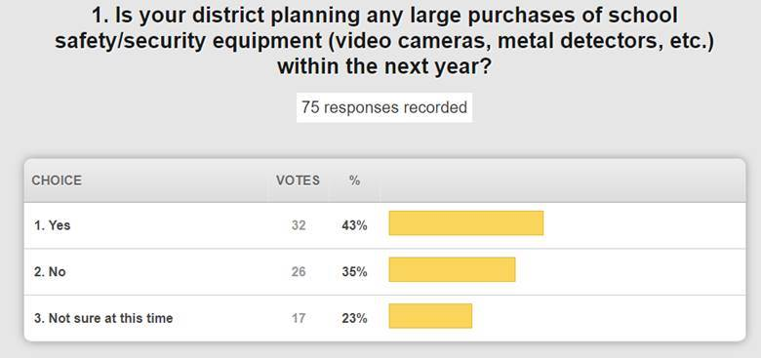

Burgin just purchased cameras and what we are finding is that the area of security should include the technical staff.  If they are not included initially, they are brought in to help maximize the capability. OET includes these areas when OET presents the People Side of KY K-12 Education Technology to the educational cooperatives and various education groups throughout the state. OET can also offer to have someone come and present/discuss with your Superintendent and/or your local board. Overall, this has been a very positive educational effort. Burgin discussed how they have expanded the librarian position to also include the TRT position.

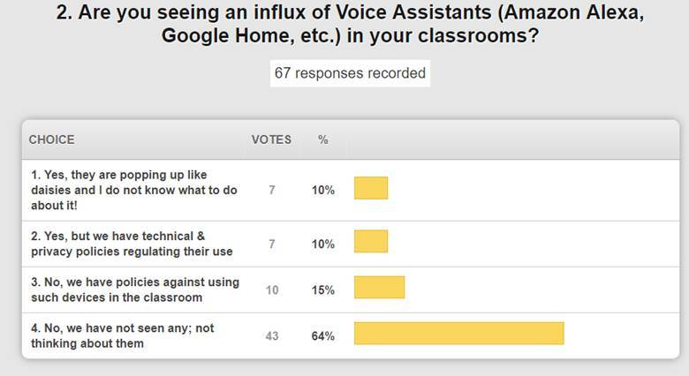

Bob Hackworth shared the concerns for having these devices in the classroom and how it can be a concern and possibly exploited. We will continue to look into the privacy issues surrounding these devices.

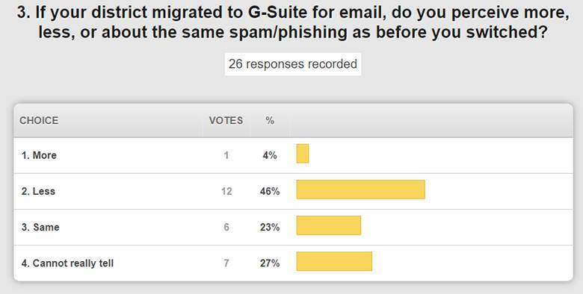

This was a concern via our 2018 feedback and we will work further to get some better guidance and training.

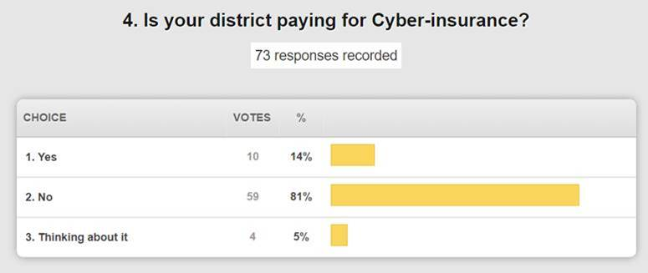

Burgin also included in their district feedback their appreciation of the field staff, help desk services, and E-rate assistance. Our customer facing services/teams always receive positive feedback. We are far from 100% perfect, but we definitely recognize the services that are going well.

**(46:17) Review of 2018 District Feedback -** As we go through our feedback, we truly appreciate your being candid and respectful throughout this process.

**Top trends of most success in calendar year 2018 according to districts:**

KETS Offers of Assistance for school districts remained as high as they could be kept after budget cuts

Increased Internet bandwidth when and where needed to districts

STLP

District firewall to the cloud (Specific firewall model replacement is issue)

Effective communications between OET and districts

KY K-12 Messaging and Active Directory Team

KY K-12 Internet Networking Team

OET’s Digital Learning Team

KY K-12 CIO Summit

KETS Timeline of our achievements in education technology

Lightspeed – mixed with service and reporting (cloud-based configuration backup is great/reporting features are still difficult)

Technology enabled project management services

The 2018-204 KETS Master Plan completed and approved

KETS Building Wiring checklist

Commodity Code Changes in the Technology Activity Report (TAR)

The MUNIS Disaster Recovery test

OETs collaboration and spirit of cooperation with KySTE

Digital Readiness Report (DRR)

ePO rollout

WSUS

Cisco VPN

IT Academy and IT certifications

KySTE’s virtual summit

KETS Offers in email vs paper

eScrap contract

**Top trends of items that should be goals and areas of improvement and/or completion in calendar year according to our districts:**

Self-Service passwords

SHI Microsoft licensing

Stale accounts

KY K-12 virus protection approach solidified

KY K-12 CIO certification/CIO Learning Academy

Phishing/Spam

Single Sign-On

Increase in KY K-12 edtech funding

RFPs for KY K-12 edtech state contracts that are in their last year

VOIP through the Kentucky Educational Internet Network (KEN) rack

KY K-12 switch upgrade in the KEN rack

Staff provisioning solutions for data systems (not a state requirement)

KY K-12 technology component portions of the KY K-12 School Report Card

Hosted cloud services for phone systems Discussions

State Standards for food service and point of sale systems

ILP/EDS and loss of these tools w/o a replacement (funding sources were also removed)

Online testing

KIH3 staff showing up at districts without prior knowledge

Tool or approach for districts to share amongst themselves the edtech products that they use and their costs (has to have a district champion leading that effort).

Digital Driver License (DDL) for adults

Easier K-3 Login

District Planning Tool – Will be released to districts later this week through field staff

**Additional areas of notable interest that occurred in calendar year 2018**

* Major tech related reports released  – Office of Education Accountability (OEA) report on instructional resources, Education Super Highway (ESH) report on KY K-12 Internet services and Auditor of Public Accounts (APA) report on both KY K-12 cybersecurity and their special examination of the KyWired initiative.
* Financial management of edtech funds – Frugal and diversification of KY K-12 edtech funds.
* Computer Science – Big strides have been made and we will continue to see changes in 2019; this includes our IT Academy; the computer science standards should be approved on February 1st; and great planning happening with teacher preparation and higher education.
* OET’s Congressional presentation in Washington DC in May 2018 in regards to KY K-12 edtech successes and approaches going forward; KY K-12 is the pioneer and overall national leader in K-12 education technology.

**Additional areas of focus in calendar year 2019:**

Data visualization

The KETS story (video)

Improve the accuracy of the home Internet access numbers reported by specific districts

Website improvement of OET portion of the KDE website

Kentucky telehealth awareness and guidance

Area Technology Centers (ATCs) technology inventories

Creation of an API Team to help with integration of district data systems for districts that need and want that assistance

**(1:22:03) School Report Card Update –** The suite includes what parents want most. It is a new way of looking at data and we are trying to promote all aspects of our data availability. The only piece remaining is the BrightBytes portion of the School Report Card which will be publicly released this Friday. It’s a critical week and verifying that data is important. Other states define their report card as the Parent Portal, but we have had that in place for several years. We reviewed the measures of success for the overall School Report Card and the continued work that we will do to review the state and federal data elements/requirements.

We appreciate your feedback.  Thanks to Burgin for hosting us today and we’ll see you in February.