To: Algebra 2 teachers
From: Algebra 2 EOC Team

This is a sample question set designed around a real-world scenario.

This particular question set (High Roller) was written by a former high school math teacher who is not an assessment expert. It is not an “exemplar” but is instead an example of what an Algebra 2 teacher, or PLC, may write during a unit about trigonometric functions that fits the criteria for a cluster. Although it is real-world to many high school students who are thinking about Prom, it admittedly does not contain a true “phenomena”, unlike many clusters students will see on the Field Test. It is not the ceiling of what a question set could be, but is instead a starting place, designed to help students see how they might begin interpreting math in context.

The process of designing the “new” Algebra 2 EOC has taken many turns, but we do believe that by presenting students with non-discrete items, they will have the opportunity to explore mathematics as an application and as a problem-solving tool through aspects of mathematical modeling, rather than just something students “do” at school. After the last EOC, many Algebra 2 teachers wanted a test that was written by current Kentucky high school Algebra 2 teachers, and we are pleased to say that this has been accomplished. But, like the sample cluster here, it is imperfect. As we continue to work with the standards and develop a greater understanding of the possibilities within the assessment, the question sets will evolve and reflect that growth. We hope that students will not only show mastery of content but also enjoy experiencing math within context. We hope that teachers will embrace the field test as part of a larger process designed to improve student learning, and will provide feedback as they see fit.

All of the clusters on the EOC will have questions with the following characteristics:
- aligned to Algebra 2 standards
- multiple choice (4 answer choices), multiple select (5 answer choices-2 correct), or constructed response
- must be answered using the context of the problem, not just “word problems”
(For example consider the problem: “Krista has a cat named Boris who eats 2 cans of cat food per day. The amount of food that Boris eats, f, can be represented by a direct variation equation, f = 2d. What is the slope of the graph that this equation represents?” This could be answered correctly without understanding the context and would not be an EOC question.)

What high school math teachers can do:
- Start thinking about things in the world around you that can be modeled using phenomena (population growth, exponential decay, profit analysis, architecture/engineering, manufacturing)
- Align current resources to Algebra 2 standards
- Learn about the modeling cycle
- Try writing a sample cluster with your PLC, starting with questions or content you may already have in your resources

Located in Las Vegas, The High Roller is the world’s tallest observation wheel. Traveling at the speed of 1 foot/second, the High Roller never stops moving and takes 30 minutes to complete one rotation. There are 28 40-passenger cabins (or capsules), so the total capacity for the High Roller at any time is 1,120 people. Here are some other facts about the High Roller:

Height: 550 feet
Diameter: 520 feet
Rotation Speed: 30 minutes/1 revolution
Location: Las Vegas, NV
Opened: March 31, 2014

Item 1

Your friend Miles wants to plan a Prom-posal to occur when the High Roller cabin is exactly 315 feet off the ground, since his girlfriend’s birthday is March 15. In order to do this, he will need to write a function h(t) that represents the height of a cabin on the High Roller over time.  To write the function as a sin(x) function, he needs to first determine the amplitude. What does the amplitude represent in the context of this situation?  - The height from the ground to the top of the High Roller, 550 feet  - The diameter of the High Roller, 520 feet  - The radius of the High Roller, 260 feet  - The sum of the radius of the High Roller and the distance from the ground to the bottom of the High Roller, 290 feet | Standard: F-TF 5. Choose trigonometric functions to model periodic phenomena with specified amplitude, frequency, and midline.  SMP: 2 – Reason abstractly and quantitatively.

Item 2

Below is the graph of sin(x).  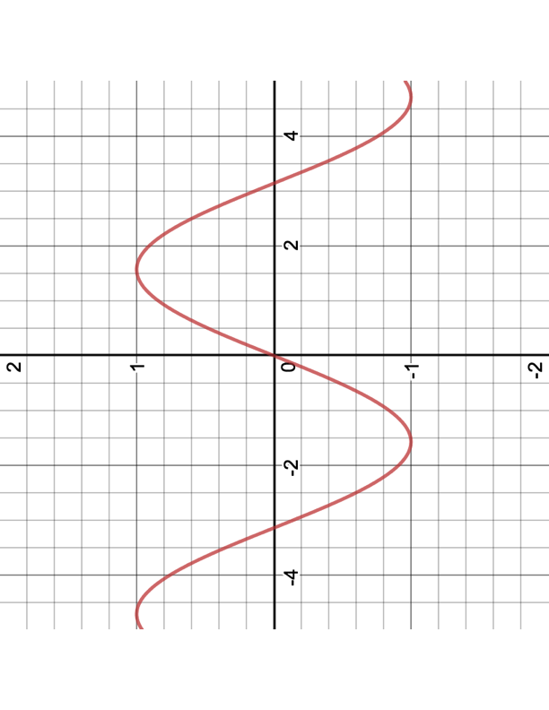  Miles decides that his starting point should represent the height where he boards the ride. Which of the following could represent the appropriate shift to model his decision?  - f(x)+ 290  - f(x)+260  - f(x)+30  - f(x)+520 | Standard: F-BF.3. Identify the effect on the graph of replacing f(x) by f(x) + k, k f(x), f(kx), and f(x + k) for specific values of k (both positive and negative); find the value of k given the graphs.  SMP: 2 – Reason abstractly and quantitatively.

Item 3

Miles also needs to determine the midline of the function. What does the midline represent in the context of this function?  - The height from the ground to the top of the High Roller, 550 feet  - The diameter of the High Roller, 520 feet  - The radius of the High Roller, 260 feet  - The sum of the radius of the High Roller and the distance from the ground to the bottom of the High Roller, 290 feet | Standard: F-TF 5. Choose trigonometric functions to model periodic phenomena with specified amplitude, frequency, and midline. ★  SMP: 2 – Reason abstractly and quantitatively.

Item 4

The graph of Miles’ function, h(t), which models the height of a cabin on the Ferris wheel over time, is below.  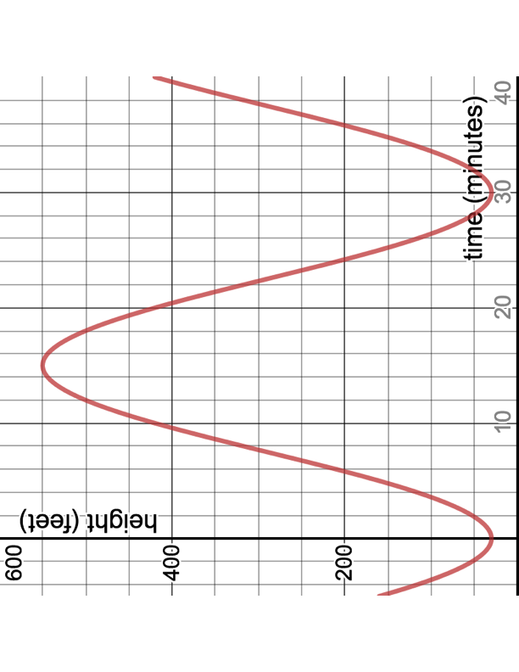  Each cabin is equipped with 8 flat screen TV’s. Miles plans to play a 5-minute video message that contains his Prom-posal. Miles wants to give his girlfriend 1 rose for every foot the height of the cabin changed per minute during the video. Using the graph, if he starts the video 8 minutes into the ride, about how many roses should he order?  - 210  - 40  - 8  - 5 | Standard: F-IF.6 Calculate and interpret the average rate of change of a function (presented symbolically or as a table) over a specified interval. Estimate the rate of change from a graph.★  SMP: 2 – Reason abstractly and quantitatively.

Item 5

Miles also wants to attach a banner that reads “Roll with me at PROM 2018?” to the outside edge of the High Roller. Ever the romantic, he wants the angle of the intercepted arc the banner creates to represent the number of years he has been dating his girlfriend, 1.2, in radians. To the nearest foot, calculate the length of the banner.  - 112 ft  - 312 ft  - 432 ft  - 3079 ft | Standard: F-TF 1. Understand radian measure of an angle as the length of the arc on the unit circle subtended by the angle.  SMP:5- Use appropriate tools strategically.

Item 6

Although the High Roller is currently the world’s tallest observation wheel, it is only 9 feet higher than the Singapore Flyer. What function would represent the height of a cabin on the Singapore Flyer as a function of time?  Height: 541 feet  Diameter: 492 feet  Rotation Speed: 30 minutes/1 revolution  Location: Singapore  Opened: April 15, 2008  A) $s\left(t\right)=295+246sin⁡(\frac{πt}{15}-\frac{π}{2})$  B)$s\left(t\right)=246+295sin⁡(\frac{πt}{15}-\frac{π}{2})$  C)$s\left(t\right)=295+246sin⁡(\frac{πt}{15}+\frac{π}{2})$  D) $s\left(t\right)=246+295sin⁡(\frac{πt}{15}+\frac{π}{2})$ | Standard: F-TF 5. Choose trigonometric functions to model periodic phenomena with specified amplitude, frequency, and midline. ★  SMP: 4- Model with mathematics.

Item 7

Extended Response  You remember learning that all sine functions have a domain of $(-∞,∞)$. However, when you write this as the domain for the sine function that represents the height of a cabin on the High Roller as a function of time, you are told this is not the best answer given the context. State this function’s contextual, or appropriate domain. Justify your reasoning. | Standard: F-IF5. Relate the domain of a function to its graph and, where applicable, to the quantitative relationship it describes. For example, if the function h(n) gives the number of person hours it takes to assemble n engines in a factory, then the positive integers would be an appropriate domain for the function.★  SMP: 2 – Reason abstractly and quantitatively.  SMP-3. Construct viable arguments and critique the reasoning of others.

Solutions:

- C
- A
- D
- B
- B
- A
- Since h(t) is the function of height over time, the domain should only include positive numbers. Time is the input, or the independent variable, and numbers that would make since for this represent number of minutes that the observation wheel are 0 minutes to 30 minutes, or [0, 30]. Since the function is periodic, it is not necessary to extend the x-values past 30, though since the wheel never stops, a domain of [0, ∝), or all real positive numbers, is also correct.

